Unit 3 Family Support Materials
Get acquainted with the topics and concepts your student will be learning during Unit 3

Two-Variable Statistics
In this unit, students use scatter plots to display numerical data in two variables and then try to find the line that best fits the data. A scatter plot is a graph that can be used to show the actual data. The line of best fit is a line that shows the relationship between the points in the scatter plot.

Here’s an example of a table of values and a scatter plot:
- The table shows how much money, in dollars, the coach will make based on how many athletes sign up for one-on-one training
- The graph shows the scatter plot of the data from the table, along with the linear model of the line of best fit, $y=200+25x$, that represents the data.
Athletes  (number) $x$ | Amount  (dollars) $y$
4 | 300
5 | 370
9 | 410
10 | 415
13 | 525
15 | 600
20 | 700
25 | 830
27 | 835
30 | 970
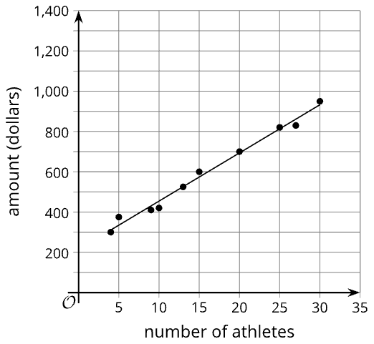
- The actual amount, in dollars, the coach will make after signing up 15 athletes is $600, as determined from the table and as estimated from the scatter plot.
- The estimated amount the coach will make after signing up 15 athletes can be found by substituting 15 for $x$ in the equation: $y=200+25(15)$, $y=200+375$, $y=\$575$
- $700 is both the actual and the estimated amount the coach will make after signing up 20 athletes, according to the table and the equation: $700=200+25x$, $500=25x$, $x=20$
- The slope of the line is 25 and means that for each athlete who signs up, the amount in dollars increases by $25.
- The $y$-intercept is 200 and means that if zero athletes sign up, the coach will make $200. This doesn’t really make sense in this case because if no athletes sign up for one-on-one training, the coach will not make any money.

Apply

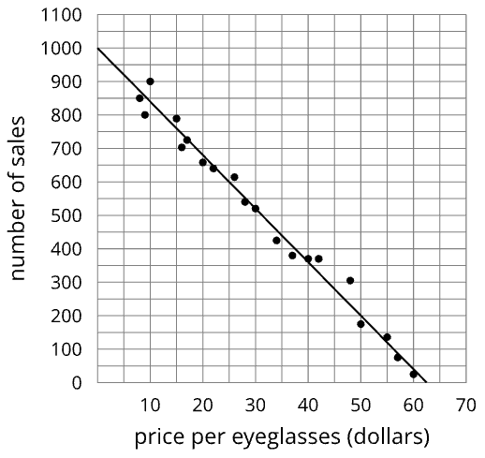
Try this task with your student
- With your student, examine the data collected showing the number of sales of eyeglasses based on the price in dollars.
- Here are a graph and two tables showing the number of sales of eyeglasses based on the price in dollars. The model, represented by $y = 1,000 - 16x$, is graphed with a scatter plot.
Price per eyeglasses (dollars) | 8 | 9 | 10 | 15 | 16 | 17 | 20 | 22 | 26 | 28
Number of sales | 850 | 800 | 900 | 789 | 703 | 725 | 658 | 640 | 614 | 540

Price per eyeglasses (dollars) | 30 | 34 | 37 | 40 | 42 | 48 | 50 | 55 | 57 | 60
Number of sales | 520 | 425 | 380 | 370 | 370 | 305 | 175 | 136 | 75 | 25

Use the graph, tables, and equation to complete the following questions
- What is the predicted number of sales for eyeglasses that have a price of $25? Be prepared to show your reasoning.
- What is the predicted price per eyeglasses when the number of sales is 350? Be prepared to show your reasoning.
- How many sales does the model estimate will be made when the eyeglasses are $50 each? Be prepared to show your reasoning.
- How many sales were actually made when the eyeglasses were $50 each? Be prepared to show your reasoning.
- What is the slope of the linear model? What does that mean in this situation?
- What is the $y$ - intercept of the linear model? What does this mean in this situation? Does this make sense?
*You can find the answers on the next page

Hide the answers until you have attempted the questions
- 600 sales from the equation: $y=1000-16(25),y=600$; or 600 from the linear model graph
- $40.63 is the predicted price; from the equation: $350=1000-16x, x=40.625$; or approximately $40 from the linear model graph
- The estimated number of sales = 200 from the equation: $y=1000-16(50), x=200$; or approximately 200 from the linear model graph
- The number of sales = 175 from the table; or approximately 175 from the scatter plot graph
- The slope = -16. This means that, for every price increase of one dollar for eyeglasses, the number of sales is expected to decrease by about 16.
- The $y$ - intercept = 1,000. This means that eyeglasses that are free would have sales of 1,000. Compare your answer: This doesn’t seem to make sense because something that is free is not likely to follow the pattern of items with a cost.

Review

Video lesson summaries for Unit 3: Two-Variable Statistics
Each video highlights key concepts and vocabulary that students learn across one or more lessons in the unit. The content of these video lesson summaries is based on the written Lesson Summaries found at the end of lessons in the curriculum. The goal of these videos is to support students in reviewing and checking their understanding of important concepts and vocabulary.

Here are some possible ways families can use these videos:
- Keep informed on concepts and vocabulary students are learning about in class.
- Watch with their students and pause at key points to predict what comes next or think up other examples of vocabulary terms

Video Title | Related Lessons
Scatter Plots | - Linear Models  - Fitting Lines  - Residuals
Correlation Coefficient | - The Correlation Coefficient  - Using the Correlation Coefficient  - Casual Relationships

 | If needed, access the digital version of this page at https://openstax.org/r/unit3-family

