per
Unit 3 Student Diagnostic
These materials, when encountered before the denoted lesson, support access to the lesson and identify potential areas where additional support may be required. Note that the content in these lesson diagnostics represents prerequisite skills and does not address the required rigor for full mastery of the on-grade level standards.
Your students may benefit from using these materials in conjunction with the Unit Overview and Readiness page (quiz and mini-lessons).

Lesson 3.1: Linear Models 2
Lesson 3.2: Fitting Lines 4
Lesson 3.3: Residuals 5
Lesson 3.4: The Correlation Coefficient 6
Lesson 3.5: Using the Correlation Coefficient 7
Lesson 3.6: Causal Relationships 8

Lesson 3.1: Linear Models
For questions 1 - 7, use the tables and the scatter plot that represent the number of students’ absences and their final exam scores.
Student | No. of Absences | Final Exam Score
A | 1 | 94
B | 5 | 71
C | 1 | 98
D | 5 | 70
E | 3 | 67
F | 2 | 94
G | 6 | 71
H | 4 | 89
I | 5 | 77
J | 0 | 90
K | 2 | 91
L | 11 | 60
M | 7 | 68
N | 8 | 65
O | 20 | 42
P | 10 | 63
Q | 11 | 63
R | 20 | 50
S | 15 | 67
T | 16 | 40
U | 4 | 86
V | 8 | 82
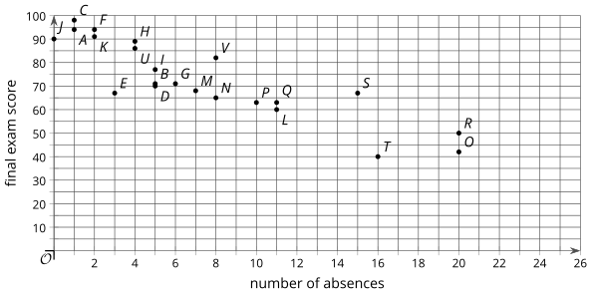
- What are the coordinates of the point in the scatter plot that represents student G?

- What are the coordinates of the point in the scatter plot that represents student R?

- What is the final exam score of the student who has perfect attendance?

- What are the final exam scores of the students with the most absences?

- How many absences does the student with the highest score have?

- How many absences does the student with the lowest score have?

- If student W has 12 absences, what final exam scores do you estimate the student will have?

Lesson 3.2: Fitting Lines
Each situation can be modeled using a linear equation. Describe the rate of change for each situation.
- Andre started his no-interest savings account with $1,000. He makes the same deposit each week, and there is $1,600 in the account after 6 weeks.

- Kiran starts with $748 in his checking account. After 4 weeks of spending the same amount each week, he has $716 left.

Lesson 3.3: Residuals
Priya’s family keeps track of the number of miles on each trip they take over the summer and the amount spent on gas for the trip. The model, represented by $y = 50 + 0.15x$, is graphed with a scatter plot.
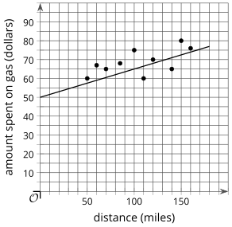
Use the equation to complete the table.
Distance (miles) | Actual Amount Spent on Gas (dollars) | Estimated Amount Spent on Gas (dollars)
50 | 60 | _______
70 | 65 | _______
100 | 75 | _______
60 | 67 | _______
110 | 60 | _______
140 | 65 | _______
80 | 68 | _______
150 | 80 | _______
160 | 76 | _______

Lesson 3.4: The Correlation Coefficient
Order the numbers from least to greatest.
- 20.2, 18.2, 19.2

- -14.6, -16.7, -15.1

- -0.43, -0.87, -0.66

- 0.50, -0..52, 0.05

Lesson 3.5: Using the Correlation Coefficient
For each pair of variables, do you expect there to be a relationship? That is, do you think a change in one variable is accompanied by a change in the other variable? How do you expect the second variable to change if the first variable is increased?
- Hours of sleep and energy level
Relationship (select one) | - Likely | - Not Likely
When the first variable increases … | The second variable …
- Length of hair and energy level
Relationship (select one) | - Likely | - Not Likely
When the first variable increases … | The second variable …
- Number of school events each week and time spent watching videos online each week
Relationship (select one) | - Likely | - Not Likely
When the first variable increases … | The second variable …
- Temperature and watermelon sales
Relationship (select one) | - Likely | - Not Likely
When the first variable increases … | The second variable …

Lesson 3.6: Causal Relationships
For questions 1 - 2, use the following scenario.
Maisy is training for the upcoming track season by running 8 laps around the school track each morning before school. She records her time to complete the 8 laps and notices that she is finishing faster and faster as time goes on. She also notices that she feels better in the morning and her grades in her first class are improving as her times improve.
- In addition to the 2 listed, what other variables are changing in this situation?
- time to complete 8 laps
- number of mornings Mai has run 8 laps

- Select 3 pairs of variables from the list. For each pair determine if they are related, then decide whether you think one variable causes the other to change. Explain your reasoning.

