How to Use Desmos
Desmos graphing calculators allow you to create and evaluate graphs.
We have created a how-to guide with helpful screenshots and links to help you learn to use Desmos. These instructions are applicable to the graphing calculators embedded in OpenStax’s math textbooks as well as the full-screen calculator on the Desmos website.
If you need additional help, view the official Desmos guide.

Desmos Graphing Calculator
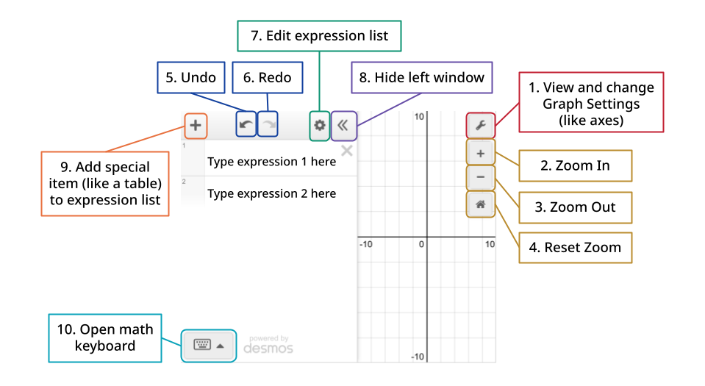
- View and change graph settings:
  - Change limits of the x- and y-axis and the scale for each
  - Toggle display color and font size
  - Toggle between radians and degrees
  - Turn on Braille mode
    - Tip: Press Alt+T (Windows) or Option+T (Mac) to activate Desmos’s Audio Trace feature and hear the graph of a selected expression. Learn more about Desmos’s accessibility features here.
- Zoom in: focus on one part of the graph and see less of the rest of it
- Zoom out: see less of one part of the graph and more of the rest of it
- Reset zoom: return to default window where -10 ≤ x ≤ 10 and -10 ≤ y ≤ 10.
- Undo: undo your last action
- Redo: redo your last action
- Edit expression list:
  - Quickly copy or delete expressions in the expression list
  - Convert expressions to tables
  - Select the colored dot to the left of the expression to change the line’s color, thickness, opacity, and line type
  - Quickly clear graph
- Hide left window: collapse or expand the window containing the expression list
- Add special item to expression list: add an
  - expression, an equation of a line;
  - note, a text description or note about the graph (a good scaffold to support differentiation);
  - table, a basic table where you can input x- and y-coordinates;
  - image, a resizable image from your computer
- Open math keyboard: open a digital keypad that allows you to quickly add special math functions and symbols, like sin or ÷, to your expression. View our guide to the Desmos math keyboard below.
  - Tip: You can use your physical, non-Desmos keyboard to type math and interact with the graph. To learn more, check out these guides: Math Notation Guide by PurpleMath and Desmos Keyboard Shortcuts
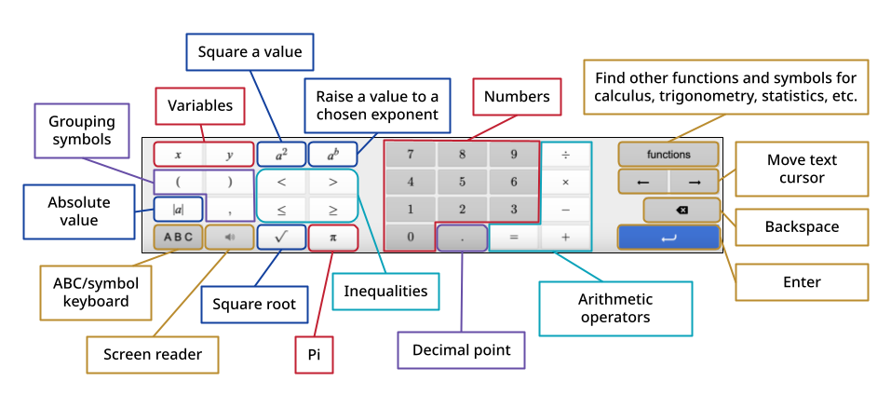

Graphing Regressions Using the Desmos Graphing Calculator
You can use Desmos to graph a regression, regression line, regression curve, scatter plot, stat plot, and create a line of best fit.
If you have additional questions, view the official Desmos regressions guide.
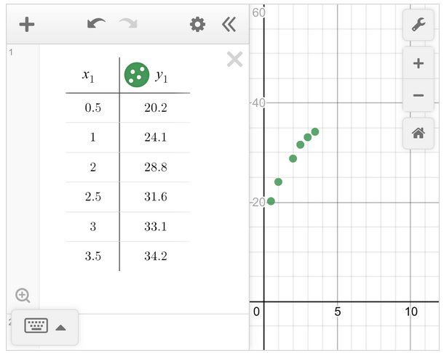 | 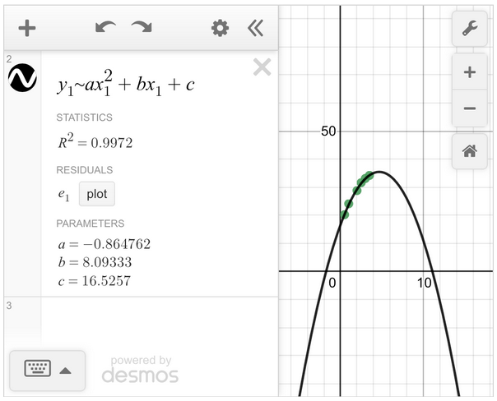

Part 1: Creating a Scatter Plot from a Table
- On the Desmos graphing calculator, click the + button in the top left corner and add a table.
- You can copy and paste an existing table in, or enter it manually. On the left side of the table, type the first x-coordinate from your reference table. On the right side, type the first y-coordinate. This will create a point on your graph.
- Go to the next line of the table and until all coordinates from your reference table have been entered. Inputting all the coordinates will create a graph called a scatter plot, pictured above and left.
  - Tip: If you do not see your point graphed in the Desmos window, you may need to “Zoom,” or change the graph settings for the window using the wrench icon in the top right corner. .

Part 2: Creating a Line of Best Fit on a Scatter Plot
- To create a line or curve that approximates the data trend, calculate a regression. Depending on the type of data (linear, exponential, or quadratic), the format of the regression equation will differ:
  - Linear: y₁ ~ mx₁ + b
  - Exponential: y₁ ~ ax₁^{b}
  - Quadratic: y₁ ~ ax₁² + bx₁ + c
- Click the pointer below the table into entry box #2 to enter a new function. The cursor should start blinking. Enter the correct equation you found in step 4 using the following tips:
  - Notice that when you type the "1" after 𝑦 or 𝑥, Desmos automatically places it as subscript.
  - Also notice that we are not using an equal sign. The symbol ~ means approximately and tells Desmos to approximate a line or curve of best fit. On your keyboard, you can type it with Shift+` (in the top left corner). If you are using the Desmos on-screen keyboard, it will be in the ABC/symbol keyboard.
  - To type an exponent, use the ^ symbol on your physical keyboard. You can type it using Shift+6. You can also use the Desmos keyboard button a² or a^{b}.
- Once you have entered the regression equation, you can press Enter. The graph of the line or curve of best fit will appear. Pictured above and right is a quadratic curve of best fit. Desmos will also report correlation statistics such as r and R², as well as the a value, b value, and c value in the expression list below the quadratic equation you entered.
  - Tip: The window should be appropriately set to display the points in the table, but sometimes you have to adjust the window of the graph in order to properly view your data set. Click and drag the mouse to shift the viewing window. To zoom in or out, use the buttons in the top right or the scrolling wheel on the mouse. Or, edit the graph settings.
  - Tip: If you are having difficulty finding the correlation coefficient, $r$, type the command ‘corr (𝑥₁,𝑦₁)’ on another expression line. It may also be helpful to check the accuracy of the data entered into the 𝑥₁ and 𝑦₁ columns of the table.

