End of Course Countdown Review
The activities in this handbook were designed to help students review the standards most likely to be tested on the STAAR End of Course Exam for Algebra 1.
Each topic consists of three activities. The first two activities were created for students to complete independently and can be chunked into 10-15 minute activities. The third activity usually consists of a game that can take as few as 15 minutes or expanded for as much time as is available. Alternative activities have been provided so teachers have additional choices for how to review the content.
Games (Activity C) are most successful when they are completed after Activities A and B. Also notice that Activity C concludes with an assessment that students complete independently. This helps to identify content that remains to be a challenge for students.

Topic 1 - Solving equations 2
Topic 2 - Slope calculations 10
Topic 3 - Rewriting equations in different forms 16
Topic 4 - Key features of linear functions 25
Topic 5 - Domain and range of linear functions 33
Topic 6 - Properties of exponents 41
Topic 7 - Factoring polynomials 46
Topic 8 - Key features of quadratic functions 52
Topic 9 - Solving quadratic equations 59
Topic 10 - Key features of exponential functions 64
Topic 11 - Domain and range of quadratic and exponential functions 74
Topic 12 - Regressions 80
Topic 13 - Transformations of functions 86

Topic 1 - Solving equations - A1.5A
(AR = Additional Resources page)

Activity objective(s) | Algebra 1 content | Directions - LINK TO RESOURCES
Activity A - Students will practice how to evaluate and solve linear equations. | 1.7.1 Warm Up Activity  1.7.2 Additional Resources [AR] | - Students access 1.7.1 Activity (Determining if Zero is a Solution) and complete the 4 questions.  - Students access 1.7.2 Additional Resources then use the information to cut apart and order the steps for solving an equation.  Do not copy pages front to back. Students will need scissors & glue/tape/staples
Activity B - Students will practice how to solve linear equations, including identities and contradictions. | 1.7.2 AR  1.7.3 AR | - Students refer to steps given in 1.7.2 Additional Resources to cut apart the steps needed to solve 3 equations.  - Students use information on 1.7.3 Additional Resources to explain when an equation is an identity or contradiction.  Do not staple pages together. Students will need scissors & glue/tape/staples
Activity C - Students will practice how to solve linear equations, including identities and contradictions. | Game  Unit 1 Section B quiz | - Place student desks & students into groups of 4. They may want to use their work pages from Week 1, Activities A & B.  - Explain the rules of the Relay Race.  - Play the game.  - Have students complete Unit 1 Section B quiz (5 questions)

Extra Activities
Use if time permits or if you would like a substitute activity.
- Algebra 1 1.7.5 Practice (7 questions)
- Justified List (Lead4Ward) directions (p. 40) & Student sheet
[Answers: Identities: 2, 3, 8; Contradictions: 1, 4, 6, 7; Neither: 5 (x = 0)]

Topic 1 Independent Activity A Student Page

Part 1 - Access the Warm Up Activity 1.7.1 (Unit 1, Lesson 7, Activity 1)
Complete the 4 questions in the activity. Show all of your thinking and work on notebook paper.

- When you are asked if a number is the solution to an equation, what do you do to get the answer?
The first thing I do when trying to determine if a number is the solution to an equation is …

Then, I …

- The x-intercept for a linear equation is where the y-value equals zero. So, similar to the process you used in the warm up, you can find the zero of a linear equation (also called the solution or x-intercept) by substituting 0 for the y-value. So, is the (4, 0) the zero (or solution, or x-intercept) to $y = 2x + 4$? Explain your reasoning.

Part 2 - Cut apart the steps for the problem given on the next page and place them into the correct order.
- Compare your thinking with the information in the Additional Resources page for Unit 1, Lesson 7, Activity 2 [1.7.2 Additional Resources].
- When you have completed analyzing the steps, tape/glue/staple the steps into the correct order on this page.

- What are the steps for solving an equation?

Step 1

Step 2

Step 3

Step 4

Step 5

Cut apart the steps for the problem that are given on this page (their order has been mixed up). Then, tape/glue/staple the steps into the correct order on this page. Remember to use the information provided in the Algebra 1 1.7.2 Additional Resources.

Collect all constant terms on the other side of the equation (Add or subtract)

Check the solution (Substitution)

Simplify each side of the equation as much as possible (Distributive property, combine like terms, etc.)
Collect all the variable terms on one side of the equation (Add or subtract)

Make the coefficient of the variable term equal to 1 (Multiply or divide)

Topic 1 Independent Activity B Student Page

Part 1 - Access the Additional Resources page for Unit 1, Lesson 7, Activity 2
[1.7.2 Additional Resources]. Read the examples in Algebra 1 and use them as models to complete the activity. You may use the steps from Activity A question 3, too.
- Cut apart the steps for the problem that are given on the last page.
- Then, tape/glue/staple the steps into the correct order on this page.
- Fill in the last step of the problem yourself (Step 5).

Problem 1 - Solve
$2(x + 4) = 12 + 4x$

Step 1

Step 2

Step 3

Step 4

Step 5

Problem 2 – Solve
$$2(5 + x) - 1 = 3x + 12$$

Step 1

Step 2

Step 3

Step 4

Step 5

Problem 3 - Solve
$$12 - 8x = 3\left(x + 4\right)$$

Step 1

Step 2

Step 3

Step 4

Step 5

Part 2 - Access the Additional Resources page for Unit 1, Lesson 7, Activity 3 [1.7.3 Additional Resources]. Use the information in Algebra 1 to complete the question below.

- Equations can have 1 solution, 0 solutions, or an infinite number of solutions. In your own words, explain how you can tell if the solution to an equation has infinitely many solutions or no solutions.
I know an equation has no solutions (or I could say it is a contradiction) because …

I know an equation has infinitely many solutions (or I could say it is an identity) because …

Mis-ordered steps for Problem 1
$$2x + 8 - 2x = 12 + 4x - 2x$$
$$8 = 12 + 2x$$

$$-4 = 2x$$
$$\frac{-4}{2} = \frac{2x}{2}$$
$$-2 = x$$
Check the answer for Problem 1 -

$$2x + 8 = 12 + 4x$$

$$8 - 12 = 12 + 2x - 12$$
$$- 4 = 2x$$

Mis-ordered steps for Problem 2
$$9 + 2x - 2x = 3x + 12 - 2x$$
$$9 = x + 12$$

$$9 - 12 = x + 12 - 12$$
$$-3 = x$$

$$-3 = x$$

Check the answer for Problem 2 -

$$10 + 2x - 1 = 3x + 12$$
$$9 + 2x = 3x + 12$$

Mis-ordered steps for Problem 3
$$12 - 8x = 3x + 12$$

$$12 - 8x + 8x = 3x + 12 + 8x$$
$$12 = 11x + 12$$

$$0 = 11x$$
$$\frac{0}{11} = \frac{11x}{11}$$
$$0 = x$$
Check the answer for Problem 3 -

$$12 - 12 = 11x + 12 - 12$$
$$0 = 11x$$

Topic 1 Activity C Teacher Directions
Relay Race Directions - Solving Equations

Place students into groups of 4. Each student should be assigned a number (1 – 4). Students will play the Solving Equations Round Robin Relay.

Provide the following directions to the students: “For each round, you will work on the problems aligned to your assigned number. You must show your work on your own paper – so please get out some notebook paper. You will turn this in at the end of the activity.”

In each round students will be required to solve equations. To ensure they attempt each type of problem at least once, they must complete the same numbered problem each time. Students will need to show their work on their own paper so be sure they have notebook paper ready for use.

To maximize instructional time, place one sheet in the middle of the four desks (that face inward) – be sure the sheet is facing down. Signal for student groups to flip the sheet over. All students will begin working on their problem at the same time - SILENTLY. When all four members have their answer, they write the area measures on the group sheet. One runner brings the sheet to the teacher.


Provide the following directions to the students: “When signaled, you will flip the sheet over. All students in the group will begin working on your assigned problem at the same time - SILENTLY. When all four members have their answer, write the answers on the group sheet. One runner will bring the sheet to me.”

PLACE GROUP SHEET HERE

Desk image created using Concept Draw

The teacher checks the answers … respond by telling the group runner how many questions are correct and how many are wrong. Don’t tell them which ones are incorrect … they need to figure that out as a group and fix it!

Inform the students: “I will check the answers … but I will only tell you how many questions are correct and how many are wrong.”

When the runner returns to the group, they may all talk and work together to identify which ones are wrong and work to correct the mistake on the group sheet. When they think they have made all needed corrections, the runner brings their sheet back to the teacher.

Inform the students: “When the runner returns to the group, you may all talk and work together to identify which problems are wrong and work to correct the mistake on the group sheet. When you think you have made all needed corrections, the runner brings the sheet back to me.”

Again, only indicate how many are correct/incorrect. Groups continue the process until all problems are correct. The group that finishes all 4 problems correctly gets 1 point, the second-place group gets 2 points, etc.

At the end of all 4 rounds, the group that has the lowest score wins the game.

Inform the students: “Groups continue the process until all problems are correct. The group that finishes all 4 problems correctly gets 1 point, the second-place group gets 2 points, etc. At the end of all 4 rounds, the group that has the lowest score wins the game.”

Play the game.

Topic 2 - Slope calculations - A1.3A, A1.3B
(AR = Additional Resources page)

Activity objective(s) | Algebra 1 content | Directions - LINK TO RESOURCES
Activity A - Students will review different ways to calculate the slope of a line (determine the rate of change). | 1.10.2 AR  4.7.2 AR | - Have students access 1.10.2 Additional Resources. Students are asked to find the MISTAKE in the given steps in Activity A and then correct them using examples 1 and 2 as models.  - Have students access 4.7.2 Additional Resources and repeat the process of correcting the steps in Activity A using example 3 as a model.  - For questions 4 - 5, students are asked to compare the process for determining the slope from a graph, given two points, and a table and identify the “method” they prefer.
Activity B - Students will practice finding the slope of horizontal or vertical lines. | 1.10.2 AR  4.7.2 Activity | - Have students explain how lines can have a slope of 0 or be undefined by accessing 1.10.2 Additional Resources.  - Students should practice how to calculate slope from two points, a table, and a graph using the activity found in 4.7.2 Finding Slope from Tables, Graphs, and Points. You can have them record their answers on the provided student page or complete the calculations as a whole class using white boards.
Activity C - Students will practice calculating the slope of a line and finding other key characteristics. | Game  4.7.4 Cool Down Activity | - Play the Slope Pyramid Game. The game includes questions about how to calculate slope - WARNING - it also includes additional questions about key characteristics of linear graphs (intercepts, zeros, etc.)  - Have students access 4.7.4 Writing Equations from Two Points. This set of questions shows students how to use point-slope to arrive at slope-intercept and standard forms. *It may be helpful to review the 3 formulas with students.*

Extra Activities
Use if time permits or if you would like a substitute activity.
- Calculating Slopes Matching activity
- Do Algebra 1 Practice 1.11.5 (10 questions - incorporates info from previous week, too)
- Do Algebra 1 Practice 4.7.5 (10 questions)
- Texas Gateway: Determining the Meaning of Slope and Intercepts

Topic 2 Independent Activity A Student Page
Part 1 - Correct the mistake!
- Review the steps for how to find the slope from a graph that are listed below. THERE IS A MISTAKE IN THE LIST.
- Find the mistake and circle it.
- Then, rewrite a correct version of the steps in the provided table to the right.
If you need a hint, read example 1 in the 1.10.2 Additional Resources.
How to determine slope from a GRAPH - incorrect version | How to determine slope from a GRAPH - corrected version
Step 1 - Locate two points on the line whose coordinates are integers. | Step 1 -
Step 2 - Starting with one point, sketch a square, going from the first point to the second point. | Step 2 -
Step 3 - Count the rise and the run on the legs of the triangle. | Step 3 -
Step 4 - Take the ratio of the rise to run to find the slope: $m = \frac{rise}{run}$ | Step 4 -

- Review the steps for how to find the slope from two points that are listed below. THERE IS A MISTAKE IN THE LIST.
- Find the mistake and circle it.
- Then, rewrite a correct version of the steps in the provided table to the right.
If you need a hint, read example 2 in the 1.10.2 Additional Resources.
How to determine slope from a TWO POINTS - incorrect version | How to determine slope from TWO POINTS  - corrected version
Step 1 - Label the coordinates in two points as $(x_{1}, y_{1})$ and $(x_{2}, y_{2})$ | Step 1 -
Step 2 - Write down the slope formula: $m = \frac{y_{2}- y_{1}}{x_{2} - x_{1}}$ | Step 2 -
Step 3 - Substitute the values into the formula. The $y$ of the second point minus the $y$ of the first point. Then, the $x$ of the first point minus the $x$ of the second point. | Step 3 -
Step 4 - Simplify. | Step 4 -
Step 5 - Verify the slope on the graph. | Step 5 -
- Review the steps for how to find the slope from a table that are listed below. THERE IS A MISTAKE IN THE LIST.
- Find the mistake and circle it.
- Then, rewrite a correct version of the steps in the provided table to the right.
If you need a hint, read example 3 in the 4.7.2 Additional Resources.

How to determine slope from a TABLE - incorrect version | How to determine slope from TABLE - corrected version
Step 1 - Locate two points on the line whose coordinates are integers. | Step 1 -
Step 2 - Label the two points $(x_{1}, y_{1})$ and $(x_{2}, y_{2})$ | Step 2 -
Step 3 - Substitute the values into the formula. $m = \frac{x_{2 }- x_{1}}{y_{2} - y_{1}}$ | Step 3 -
Step 4 - Simplify. | Step 4 -

- Review the steps for determining the slope of a line that you wrote down in responses 1 - 3 and in your own process from part 1. Describe something that is similar amongst all the methods.

- Which “method” do you prefer? Do you prefer to find the slope of a line by using a graph, two given points, or a table of values? Explain your preference.

Part 2 - Write down the steps you use to determine the slope of the line that goes through the following points and graph (they both represent the same line):

$$x$$ | $$y$$
0 | 3
4 | 0
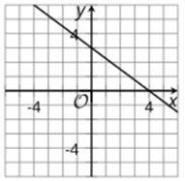

Topic 2 Independent Activity B Student Page
Part 1 - Access Algebra 1 1.10.2 Additional Resources. Use the explanations on this page to answer the following questions.

- Explain when a line has a slope of zero.

- Give an example set of points for a line that has a slope of zero. Graph your line on the provided graph.

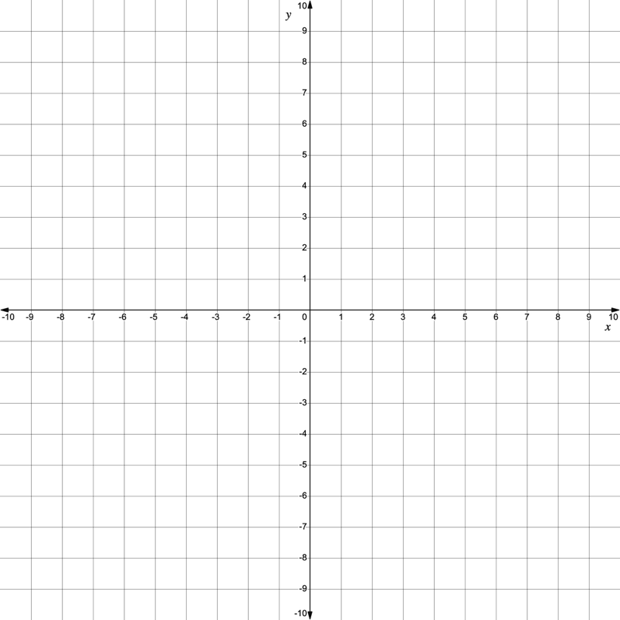

- Explain when a line has an undefined slope.

- Give an example set of points for a line that has an undefined slope. Graph your line on the provided graph.

Part 2 - Access 4.7.2 Practice then, complete the questions. Remember, the questions allow you multiple attempts. When you have finished all of the questions, write your final answers below.

1. Final answer =

2. Final answer =

3. Final answer =

4. Final answer =

5. Final answer =

6. Final answer =

7. Final answer =

8. Final answer =

9. Final answer =

10. Final answer =

11. Final answer =

Topic 2 Activity C - Pyramid Game Teacher Directions

Use the Slope Pyramid Problems to review questions aligned to TEKS 3B (calculating slope) and some of 3A (finding slope from slope-intercept form). Copy the sheets double sided so that point values are on one side and questions are on the other.

This game may be completed competitively or with a cooperative goal of building the full pyramid by the end of the time limit.

- Place students into groups of 2-3 members and give each member a STAAR Reference Sheet and graph paper, if desired.

- All groups should be given problem 1 to begin (place the sheet with the problem facing down and announce when groups can start the game). Inform students: Leave your problem face down and do not begin until I signal the game has begun.

- Inform students: After being signaled to begin … As your group finishes the problem, a runner brings the problem to me (the teacher) to check for accuracy.
- Inform students: If the group is correct, the runner is given a piece of tape and the next problem. They tape their correct problem to the wall with the point value facing out. Then, they begin the next problem.
- Inform students: If the group is incorrect, I will return the problem to the runner for the group to rework the problem until they get the answer.

- Repeat steps 3 & 4 until students have completed the pyramid.

- The winning team has the most points!

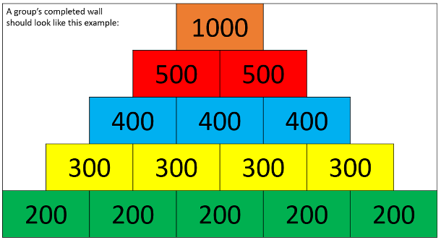
It is helpful but not necessary to run copies of the same level problems
on colored sheets of paper.
Image created using MS PowerPoint

Topic 3 - Rewriting equations in different forms - A1.3A
(AR = Additional Resources page)

Activity objective(s) | Algebra 1 content | Directions - LINK TO RESOURCES
Activity A - Students will practice writing an equation in slope-intercept form (and identifying the slope). | 1.10.3 AR  1.10.5 Practice | - Have students access 1.10.3 Additional Resources and complete the table for how to find the slope from an equation.  - Additional questions ask students to identify how the steps might be different if the equation given to them is not in standard form.  - Have students access 1.10.5 Practice and complete the 8 quesitons.
Activity B -  Students will practice writing equations in different forms. | 1.12.4 AR  1.12.3 AR | - Have students access 1.12.4 Additional Resources to write down the different types of equations. As part of the activity, have students identify the parent function of linear equations using given information.  - Next, have students use 1.12.3 Additional Resources to practice substituting information into the different forms and simplifying/rewriting the equations as requested. Students should try the problems on their own first, then check their work with the Algebra 1 page.
Activity C - Students practice writing equations in different forms. | Points/Equations Activity (1.12.6 Cool Down)  1.12.7 Practice | - Have students participate in the Points/Equations Activity from 1.12.6 Cool Down.  - Have students complete all of the questions from the 1.12.7 Practice.

Extra Activities
Use if time permits or if you would like a substitute activity.
- Algebra 1 Cool Down Activity 1.11.2 (4 questions)
- Algebra 1 1.11.3 Additional Resources (Standard Form to Slope-Intercept Form video and 3 questions)
- Algebra 1 Activity 1.14.2 (12 questions)

Topic 3 Independent Activity A Student Page
Part 1 - Access 1.10.3 Additional Resources.

- Read the example. The steps for solving the equation $9x - 3y = 15$ for y are given. Write down the steps for how to determine the slope of a line from an equation.

How to determine slope from an EQUATION | $$9x - 3y = 15$$
Step 1 - | $$9x - 9x - 3y = 15 - 9x$$
Step 2 - | $$-3y = 15 - 9x$$
Step 3 - | $$\frac{-3y}{-3} =\frac{15-9x}{-3}$$
Step 4 - | $$y = -5 + 3x$$  $$y = 3x - 5$$

- Use the steps to solve the equation $6x + 2y = 14$ for y.

How to determine slope from an EQUATION | $$6x + 2y = 14$$
Step 1 -

Step 2 -

Step 3 -

Step 4 -

- If the given equation was $2y = -6x + 14$, how would the steps be different from those given above? Why are they different?

- If the given equation was $0.25x = 12 - y$, how would the steps be different from those given above? Why are they different?

- Slope-intercept form is defined as: $y = mx + b$. Which variable represents the slope? Explain how you know where to find it in the equation.

Part 2 - Access 1.10.5 Practice then, complete the questions. Remember, the questions allow you multiple attempts. When you have finished all of the questions, write your final answers below.

1. Final answer =

2. Final answer =

3. Final answer =

4. Final answer =

5. Final answer =

6. Final answer =

7. Final answer =

8. Final answer =

Topic 3 Independent Activity B Student Page
Part 1 - Types of Linear Equations - Access 1.12.4 Additional Resources. Linear equations can be written in all different types of formats.

- Write down the equation for each type of equation below.
- Then, describe what the equation tells us. Use highlighters or colored pencils to help identify the parts of the equation.

Equation Type | Equation | What do the letters stand for?  What information does the equation tell us?
Slope-intercept form

Standard form

Point-slope form

- To find the parent function of linear equations, substitute a slope of 1 and y-intercept of (0, 0) into any of the different forms.

What is your simplified answer in slope-intercept form?

Part 2 - Using Different Types of Equations - Use the given information to write an equation of the line described. Access 1.12.3 Additional Resources to check your answers.

- Given a line with slope $m = \frac{1}{3}$ that contains the point $(6, -4)$. What is the equation of the line in slope-intercept form?

Step 1 - What is the slope, $m$?

Step 2 - What is the point, $(x_{1}, y_{1})$?

Step 3 - Substitute the values into point-slope form. $y - y_{1} = m(x - x_{1})$

Step 4 - Simplify and write the equation in slope-intercept form. $y = mx + b$

- What is the equation of a horizontal line that contains the point (-2, -6)? Give the answer in slope-intercept form.

Step 1 - What is the slope, $m$?

Step 2 - What is the point, $(x_{1}, y_{1})$?

Step 3 - Substitute the values into point-slope form. $y - y_{1} = m(x - x_{1})$

Step 4 - Simplify and write the equation in slope-intercept form. $y = mx + b$

- Write the equation of a line with slope $m = -\frac{2}{5}$ that contains the point (10, -5). Give the answer in slope-intercept form.

Step 1 - What is the slope, $m$?

Step 2 - What is the point, $(x_{1}, y_{1})$?

Step 3 - Substitute the values into point-slope form. $y - y_{1} = m(x - x_{1})$

Step 4 - Simplify and write the equation in slope-intercept form. $y = mx + b$

Topic 3 Activity C Teacher Directions

In this activity, students examine the point-slope form of a line. Students work in groups of 2. Each group is given 8 slips of paper. Two of the slips have a pair of points listed. Each partner takes one of the Points slips. The rest of the slips have equations, written in point-slope form. The goal for students is to find which of the equations represent an equation of a line that goes through the points on their slip. There are 2 equations that do not match either of the given points.

Make a copy of the Points/Equation Activity slips paper, one for each group.
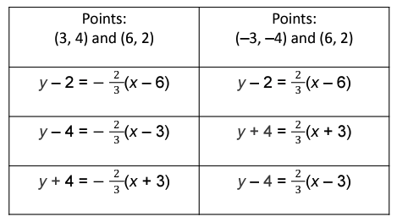

- Cut out each sheet into 8 slips. Distribute the set of 8 slips to each group.
- You may want to start with a brief review of the forms of equations and when to use them.
- Students start by each partner choosing one of the two Points slips in the set. They can set the Equation slips aside for the second part of the activity.
- Ask students to find the slope of the line containing the points given on their slip.
- Next, have students take turns choosing slips from the pile to see if the equation on the slip represents the line formed by the points on their Points slip.
  - One partner chooses an Equation slip from the pile. Decide if the equation represents a line through the points on their Points slip. If it does, explain to their partner how they know. Keep the slip. If it does not represent a line through the points, give the Equation slip to the partner.
  - The second partner should verify the equation represents a line through the points on their partner’s Points slip. Discuss and reach an agreement. If the equation does not represent a line through either partner’s points, set it aside.
  - Take turns choosing Equation slips until they are all gone. (There are 6 Equation slips.) Each partner should end with a total of 2 Equation slips that match. There will be 2 Equations slips that do not match either set of points.
  - Which equations represent a line through your points?
- Have students identify which form that these equations are given in. Then, rewrite their given equations in slope-intercept form and standard form.
Topic 3 Activity C Student Page
Part 1 - Points/Equation Activity
With your partner, each of you should select a set of points from the slips given to you. Place the slips of paper with equations on them into a separate pile.

- What are the points on your slip?

- What is the slope of the line containing the points on your slip? Show your calculations.

Select an equation from the pile. Determine if you think the equation does/does not represent a line through your points. When you have found two equations that represent a line for your points, write your explanations below.

- What is an equation that represents the line for your points? Explain how you know it is the line that contains your points.

- What is a second equation that represents the line for your points? Explain how you know it is the line that contains your points.

- Both of the equations have been given in which form? (Standard form, Slope-Intercept form, Point-Slope form)

- Use either equation (from question 3 or 4 above), then rewrite your equation in slope-intercept form.

- Rewrite the equation in standard form.

Some of your answers can be checked using Algebra 1 1.12.6 Cool Down.
Part 2 - Access 1.12.7 Practice then, complete the questions. Remember, the questions allow you multiple attempts. When you have finished all of the questions, write your final answers below.

1. Final answer =

2. Final answer =

3. Final answer =

4. Final answer =

5. Final answer =

6. Final answer =

7. Final answer =

Topic 4 - Key features of linear functions - A1.3C
(AR = Additional Resources page)
Activity objective(s) | Algebra 1 content | Directions - LINK TO RESOURCES
Activity A - Students will identify terms about the key features of linear functions that have meaning outside mathematics. | 4.6.4 AR | - Have students access the online mathematics dictionary, Math is Fun. This interactive dictionary may help them for both Activity A and Activity B.  - Next, have students access the Multiple Meaning Words in Activity A. In this activity, students will fill in “every day meanings'' for some words then match the mathematical definition and graph.  NOTE: When making copies, you need to copy the pages on separate sheets of paper.
Activity B - Students will practice defining key features of linear functions. | 4.6.4 AR  4.11.2 AR  4.12.3 AR | - Have students access 4.6.4 Additional Resources (Unit 4, Lesson 6, Activity 4 Additional Resources page). They may use information on that page to complete the crossword puzzle to review key features of linear functions.  - The following Additional Resource pages may also help students: 4.11.2 Additional Resources and 4.12.3 Additional Resources.  - Students complete the Linear Crossword Puzzle.  Note: students may need help determining equations that should be entered into the crossword (such as x = 2, y = 5, or y = x).
Activity C - Students will practice how to identify the key features of linear functions. | Game  Unit 4, Section C Quiz (5 questions) | Play the SWAT game  - Clear a space on the wall or whiteboard on which you can project the PPT. Display or describe the directions. Play the game.  - Complete the Unit 4 Section C Quiz (5 questions)

Extra Activities
Use if time permits or if you would like a substitute activity.
- Algebra 1 4.6.4 Activity - Key Features of Linear Functions (12 questions)
- Algebra 1 4.6.6 Practice (5 questions)
- Flippity (vocabulary game) - some terms may need to be changed if students are unfamiliar with entire list

Topic 4 Independent Activity A Student Page
Key Characteristics of Linear Functions Introduction

Part 1 - Multiple Meaning Words. Many words in mathematics have a more specific meaning than in general English.
- To complete the second column, describe what the term means in the “real world.”
- To complete the third column, cut out the specific mathematical description or definition of the term from the following page and paste/tape/staple it with the informal definition.
- Cut out the image of each term from the following page and paste/table/staple it with the English and mathematical definitions.

Term | Describe the informal meaning of the word.  What is the “real world” definition? | Describe the formal mathematical meaning of the word.  What is the math definition? | What image illustrates the meaning of the word in mathematics?  What does it look like in math?
Maximum
Minimum
Increasing
Decreasing

Mathematical definitions & Images (order has been mixed up) - Cut them apart and tape with the appropriate terms and your everyday descriptions.

As the graph of a function approaches positive infinity, the graph trends “down.” As the x-values increase, the y-values decrease. | 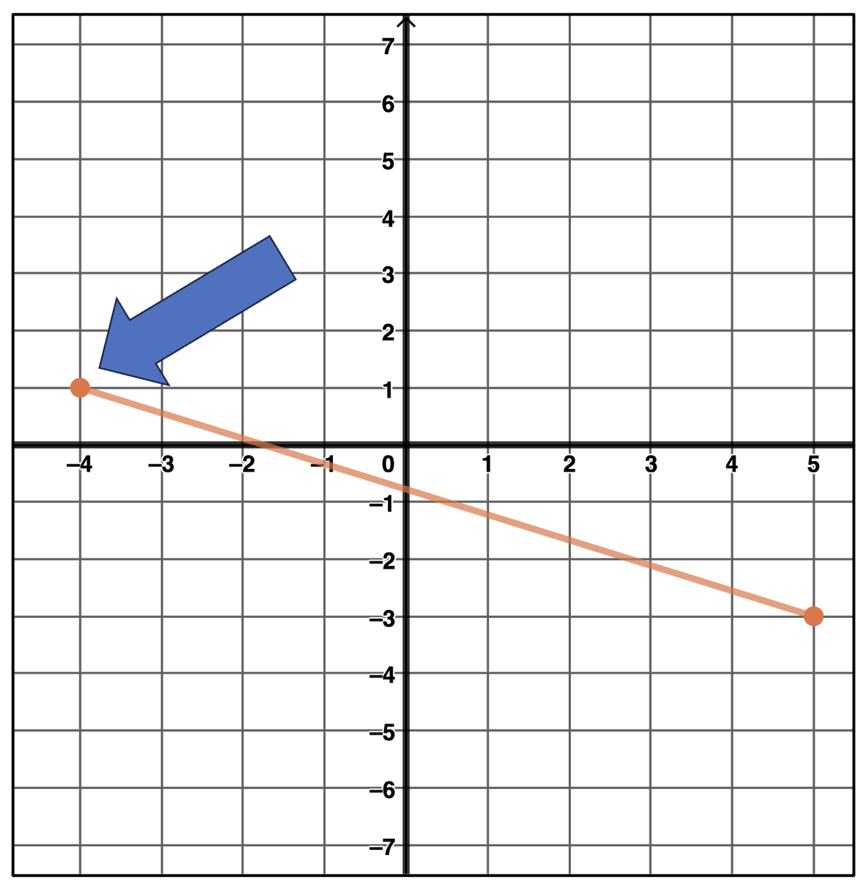
Largest value possible. | 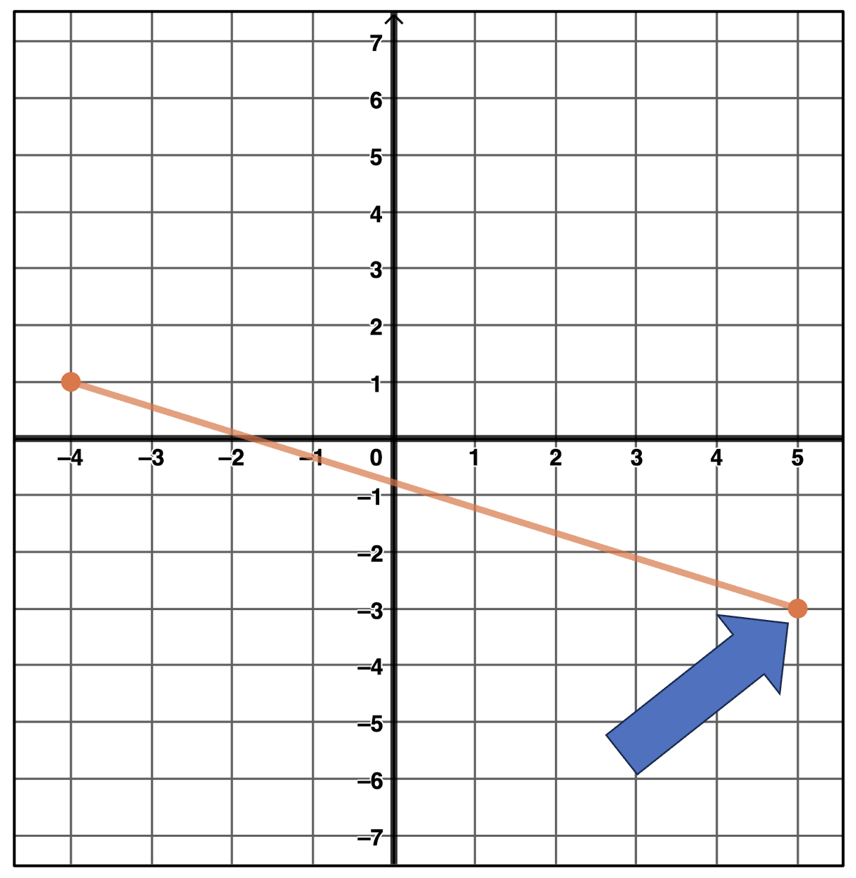
As the graph of a function approaches positive infinity, the graph trends “up.” As the x-values increase, the y-values increase, too. | 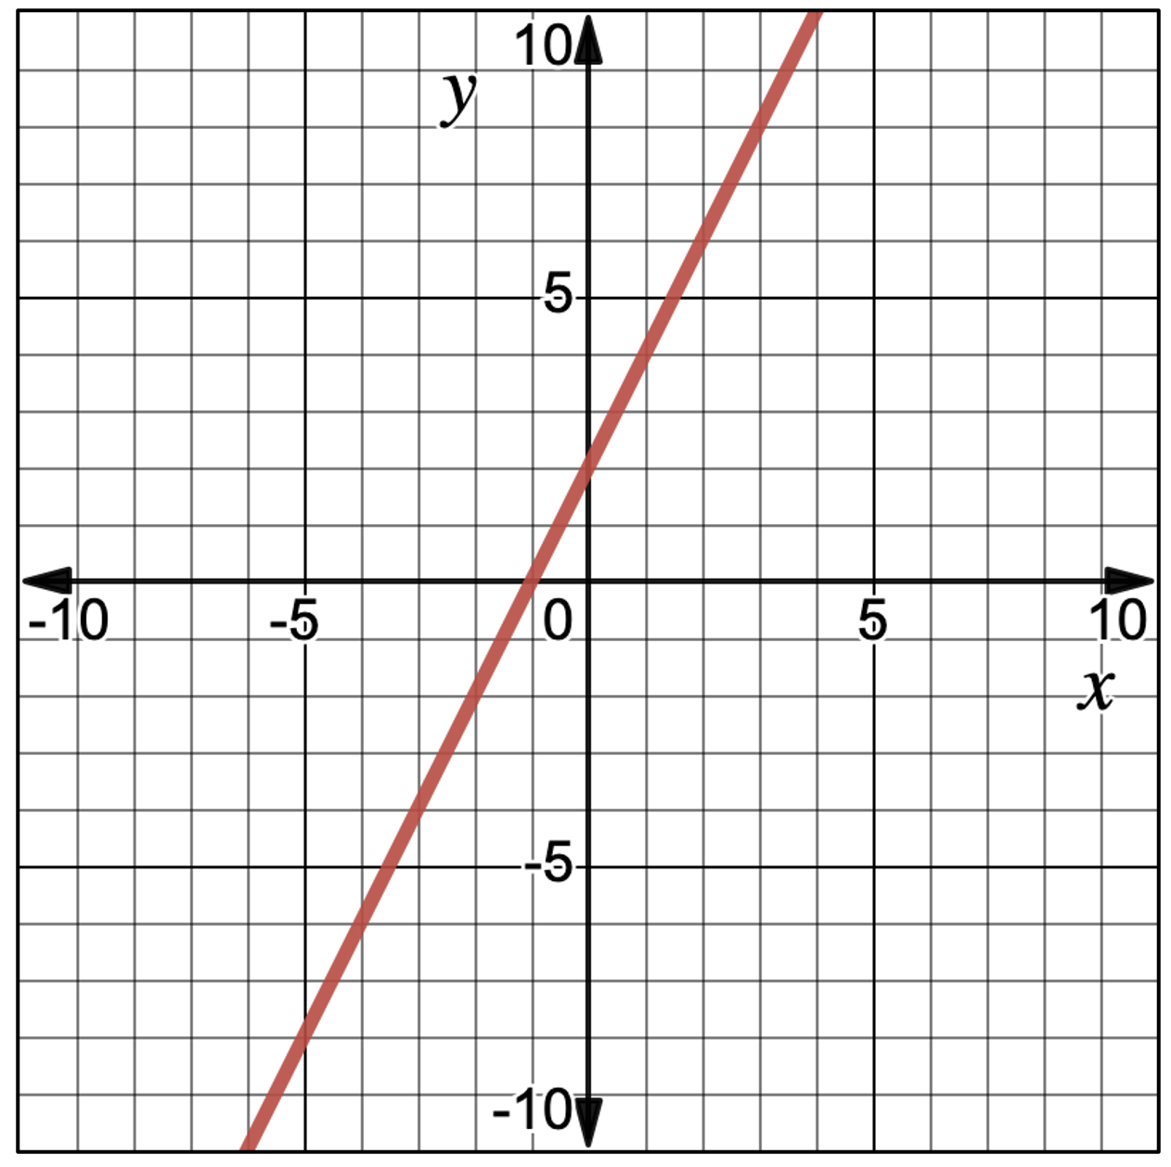
Smallest value possible. | 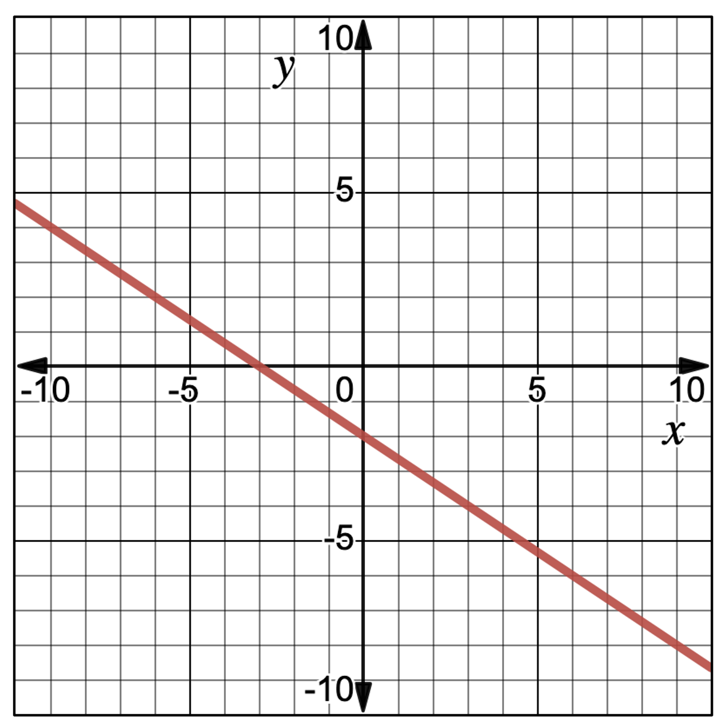

Topic 4 Independent Activity B Student Page
Linear Crossword Puzzle

Access 4.6.4 Additional Resources. Use the information in Algebra 1 to complete the crossword puzzle below. You may also find helpful terms in the Additional Resources for 4.11.2 or 4.12.3 Additional Resources.

Across
1. where a line crosses the x-axis; could also be called a solution
4. calculated by finding the rise over the run or the change in y values over the change in x values
5. The largest value possible for a function
9. the rate of change for this function is a constant value
10. the linear parent function
11. the vertical line that passes through (2, 0)
14. slope intercept form
16. where the line crosses the y-axis; could also be called "b"
17. this describes the graph of a function that has rising range values over time

Down
2. all the possible output values for a function
3. all the possible input values for a function
6. where the line crosses an axis
7. all the function values occur above this point
8. standard form for a linear equation
11. where the line crosses the x-axis
12. the slope of this line measures zero and the line goes through (2, 5)
13. the range values for a function fall as the domain progresses
15. equation for a line perpendicular to the x-axis through the origin

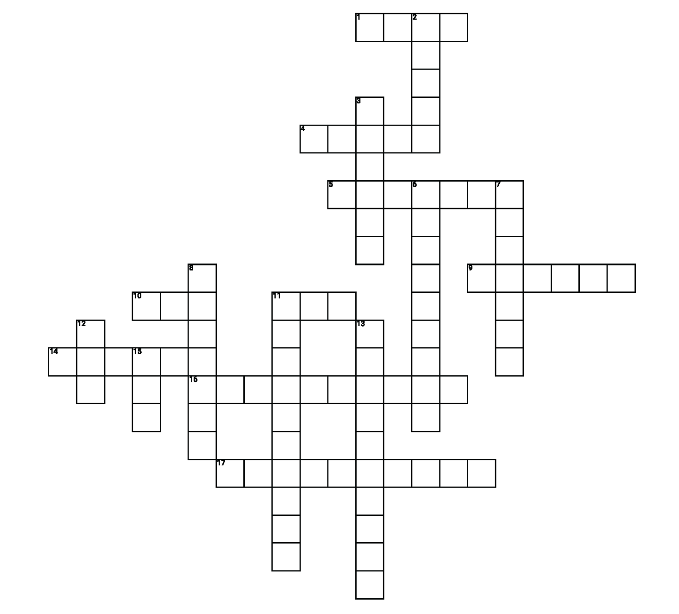

For students with learning differences or visual impairment, provide this substitute fill in the blank activity.
- where a line crosses the x-axis; could also be called a solution (4 letters)
- calculated by finding the rise over the run or the change in y values over the change in x (5 letters)
- the largest value possible for a function (7 letters)
- the rate of change for this function is a constant value (6 letters)
- the linear parent function (3 letters)
- the vertical line that passes through (2, 0) (3 letters)
- slope intercept form (6 letters)
- where the line crosses the y-axis; could also be called "b" (10 letters)
- this describes the graph of a function that has rising range values over time (10 letters)
- all the possible output values for a function (6 letters)
- all the possible input values for a function (6 letters)
- where the line crosses an axis (9 letters)
- all the function values occur above this point (7 letters)
- standard form for a linear equation (7 letters)
- where the line crosses the x-axis (10 letters)
- the slope of this line measures zero and the line goes through (2, 5) (3 letters)
- the range values for a function fall as the domain progresses (3 letters)
- equation for a line perpendicular to the x-axis through the origin (10 letters)

Topic 4 Independent Activity C Teacher Directions
SWAT directions - Key features of linear graphs

Preparation for the game:
- Clear a space on the wall or whiteboard on which you can project the PPT.
- You should not use a board that responds to touch since students will be swatting the board.
- Student competitors will need fly-swatters - so procure 2-4 swatters.
- (You may also wish to mix up the order of the slides so the same graphs are not grouped together.)
Directions:
- Place students into 2 groups.
- Have a student representative from each group proceed to the wall and receive a swatter. Display a slide.
- As fast as possible, swatting students should determine what is being described or portrayed and SWAT the appropriate location (on the graph or vocabulary word) that represents the answer to the question. Possible questions are provided on the slides. A “blank” slide that contains each graph has also been provided (and hidden) so that you can add other questions you would like to pose to the students.

Extensions:
After students have answered the question (such as where is the x-intercept?), ask them to identify the coordinates of the point, identify the domain, etc.
After the question has been answered, ask students in other groups to draw -
- A line that is parallel/perpendicular to the given line (if using a whiteboard). If projecting on a wall, have students use a yardstick or piece of yarn/string to draw the parallel/perpendicular line.
- Or, you could ask them to draw the parent function.
- Or, ask them to show how to calculate the slope of the lines.
- Or, ask them to draw a line that is steeper/flatter (and determine the equation).
- Etc.
Additional points could be added to a team’s score for any correct answer provided.
Alternative implementation of the game:
- To prepare for this implementation, write the vocabulary words on index cards ($x$-intercept, $y$-intercept, increasing, decreasing, etc.). Each group will need a set - so that every student in the class will have a card. If you would prefer, string yarn through 2 holes (you punch on the cards) so students can wear the card as a sign/label.
- To prepare for the scoring of the game, write integer values from -10 to 10 on the back of sticky notes and place them on the wall. Be sure the numbers cannot be seen through the other side of the note or that the sticky note is posted in a way that students can see the numbers.
- Place students into groups of 4. Assign each student with a vocabulary word and provide them with the corresponding cards/signs.
- Display the images from the powerpoint.
- As fast as possible, students determine the answer to the question without talking to their group members. If the answer is their assigned card/word, they stand. The first correct student that stands scores the win for their team.
- The winning group goes to the “points wall” and selects a sticky note. This is the number of points they get for a correct response. (Keep in mind, some values are negative, so student groups have a chance to win even if they are not always the first ones to respond.)
- Repeat the steps 4-6.

Topic 5 - Domain and range of linear functions - A1.2A
(AR = Additional Resources page)

Activity objective(s) | Algebra 1 content | Directions - LINK TO RESOURCES
Activity A - Students will practice writing the domain and range of linear functions as inequalities. | 4.12.2 AR  4.12.3 AR | - Have students access 4.12.2 Additional Resources (Unit 4, Lesson 12, Activity 2 Additional Resources page). Have them read the information, then answer the questions in part 1 of the student page. Students will be learning about the domain of a function.  - Have students access 4.12.3 Additional Resources and repeat the process. Students will be learning about the range of a function.
Activity B - Students will practice writing the domain and range of linear functions as inequalities. | 4.13.3 Activity | - Have students complete the Algebra 1 Activity 4.13.3 Finding Domain and Range Using a Graph (4 questions). If students struggle to answer the questions, a video discussing the questions is available.  - Have students complete the Cut-A-Part activity that uses graphs from released STAAR exams. The guiding questions students encounter in the Algebra 1 activity should provide hints to help students complete the cut-a-parts.  - What is the maximum/minimum y-value of the graph?  - When does the graph reach the farthest point to the left? To the right?
Activity C - Students will practice | 4.13.4 Activity  Bluff game | - Have students complete Algebra 1 4.13.4 Real-World Domain and Range. This will prepare them for the following game.  - Place students into teams and play the Bluff game. Teams earn points based on how many students on the team are confident that they know the answer.

Extra Activities
Use if time permits or if you would like a substitute activity.
- Texas Gateway: Determining Reasonable Domains/Ranges (Verbal & Graph)
- Texas Gateway: Determining Domain & Range for Linear Functions
- Algebra 1 4.12.5 Using Functions to Answer Real World Questions - Cool Down Activity (4 questions)
- Algebra 1 4.12.6 Practice (9 questions)
- Algebra 1 4.13.6 Practice (7 questions - includes non-linear graphs too)

Topic 5 Independent Activity A Student Page

Part 1 - Access 4.12.2 Additional Resources. Use the information to answer the following questions.

- How would you define the domain of a function (in your own words)?
The domain of a function is …

Examine the following graph, then answer the questions.

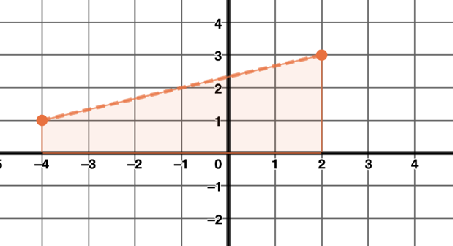
A dashed line segment is given.

To determine the domain, shading has been added to the image to show the $x$-values for which the line segment has been defined.

- What is the smallest value of the domain (what is the smallest number the shading reaches on the $x$-axis)?

- What is the largest value of the domain (what is the largest number the shading reaches on the $x$-axis)?

- Describe if one or both of the endpoints of the segment are “filled in” or open.

To write the domain as an inequality -
- Place the two values in order (from least to greatest).
- Indicate that the domain is “all the $x$-values” in between (put an $x$ in the middle).
- Because the numbers have been ordered from least to greatest, the inequality should be “less than” symbols.
- Determine if the inequality is
  - inclusive (filled in endpoints indicate the values are part of the domain), or
  - exclusive (open endpoints indicate the values are NOT part of the domain).

- Write the domain for the dotted line segment.
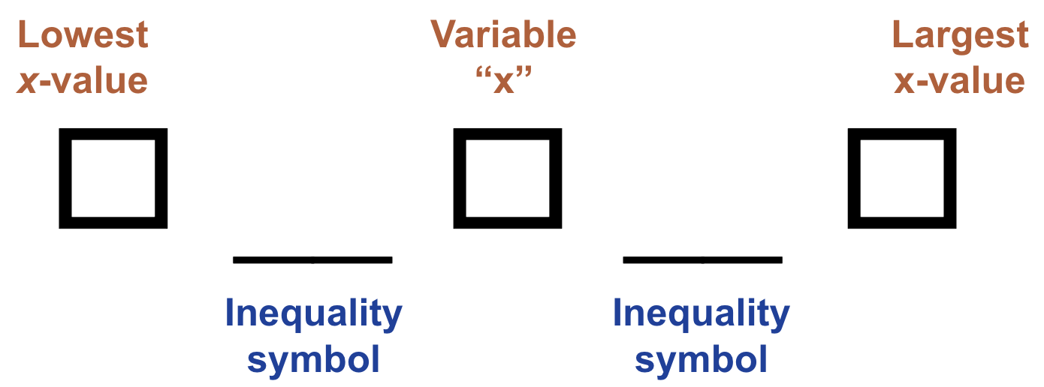

Part 2 - Access 4.12.3 Additional Resources. Use the information to answer the following questions.

- How would you define the range of a function (in your own words)?
The range of a function is …

Examine the following graph, then answer the questions.
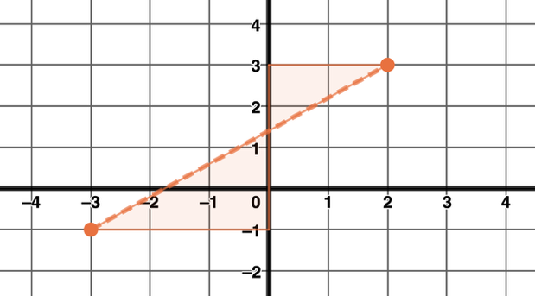

A dashed line segment is given.

To determine the range, shading has been added to the image to show the $y$-values for which the line segment has been defined.

- What is the smallest value of the range (what is the smallest number the shading reaches on the $y$-axis)?

- What is the largest value of the range (what is the largest number the shading reaches on the $y$-axis)?

- Describe if one or both of the endpoints of the segment are “filled in” or open.

To write the range as an inequality -
- Place the two values in order (from least to greatest).
- Indicate that the range is “all the $y$-values” in between (put a $y$ in the middle).
- Because the numbers have been ordered from least to greatest, the inequality should be “less than” symbols (<).
- Determine if the inequality is
  - inclusive (filled in endpoints indicate the values are part of the range), <, or
  - exclusive (open endpoints indicate the values are NOT part of the range), <.
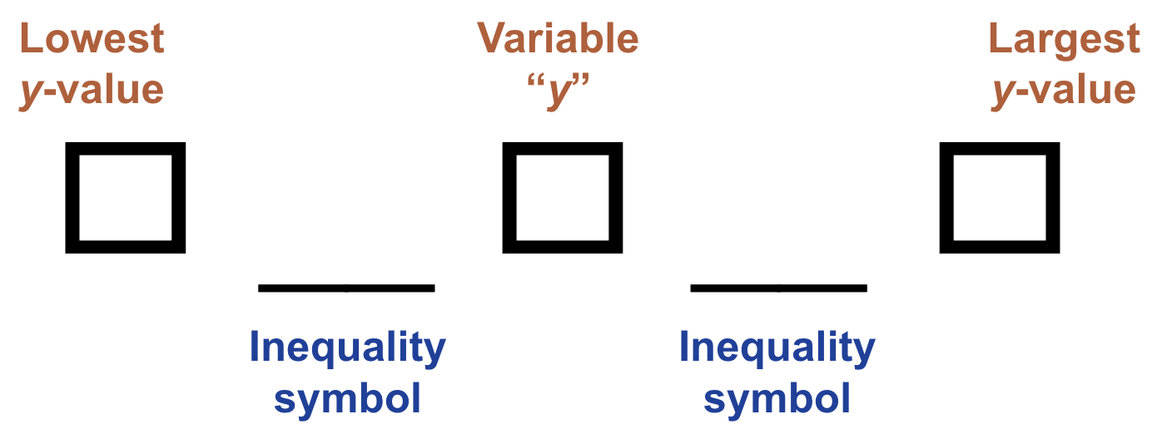
- Write the range for the dotted line segment.

Topic 5 Independent Activity B Student Page
Domain and Range Cut-A-Parts, page 0 (this page will be cut apart and discarded)
- Cut out each of the domain and range descriptions given below.
- Match the correct descriptions for the domain and range to each graph. Be careful! There are extra descriptions that are incorrect!
- Tape/glue/staple your matches on the provided table.
- Fill in the information that rewrites the domain and range descriptions as inequalities.

Domain descriptions:

The $x$-values can be any real number. | The $x$-values are as small as 0 and no bigger than 28. | The $x$-values can only be 2.5.
The smallest $x$-value is -7 and the largest x-value is 6. | The $x$-values can only equal 6. | The $x$-values between -2 and 6.
Any value of $x$ between 16 and 19. | Only the whole numbers between 0 and 14. (0, 1, … 14). | The $x$-values can be any real number.
The $x$-values are as small as 0 and no bigger than 14. | The smallest $x$-value is -4 and the largest $x$-value is 5. | Any real number can be x.

Range descriptions:

The $y$-values start at 16 and go to 19. | The smallest $y$-value is -7 and the largest $y$-value is 6. | The $y$-values can be any real number.
The $y$-values can only equal 2.5. | The $y$-values can be any real number. | The smallest $y$-value is -4 and the largest $y$-value is 5.
Any $y$-value between 0 and 19. | The y-values between 1 and 7. | Only the whole numbers between 0 and 9. (0, 1, … 9).
The $y$-values can only equal 6. | Any real number can be $y$. | The $y$-values are as small as 0 and no bigger than 9.

Topic 5 Activity B Student Page
Domain and Range Cut-A-Parts, page 1 - Paste the descriptions in the table below. Then, write the inequalities that represent the descriptions of the domain and range.

Graphs | Paste your domain and range descriptions in the cells below. | Write the domain and range for each graph as inequalities.
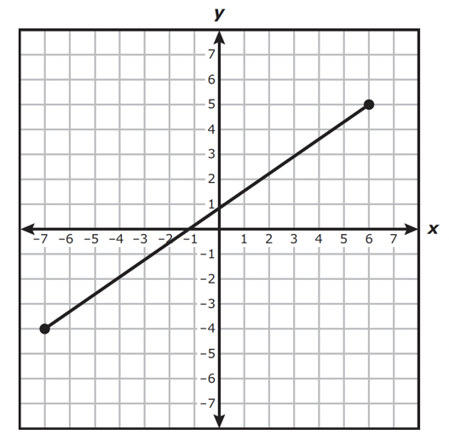 | Paste Domain description here  Paste Range description here | Domain:
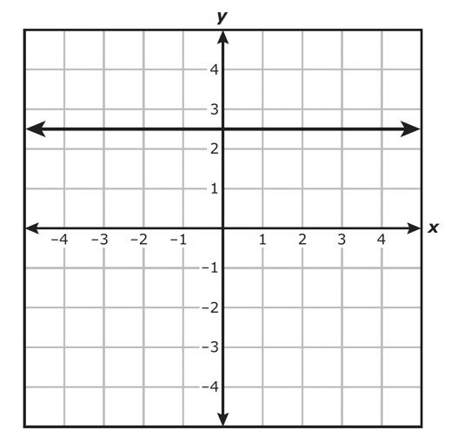 | Paste Domain description here  Paste Range description here | Domain:

Topic 5 Activity B Student Page
Domain and Range Cut-A-Parts, page 2

Graphs | Paste your domain and range descriptions in the cells below. | Write the domain and range for each graph as inequalities.
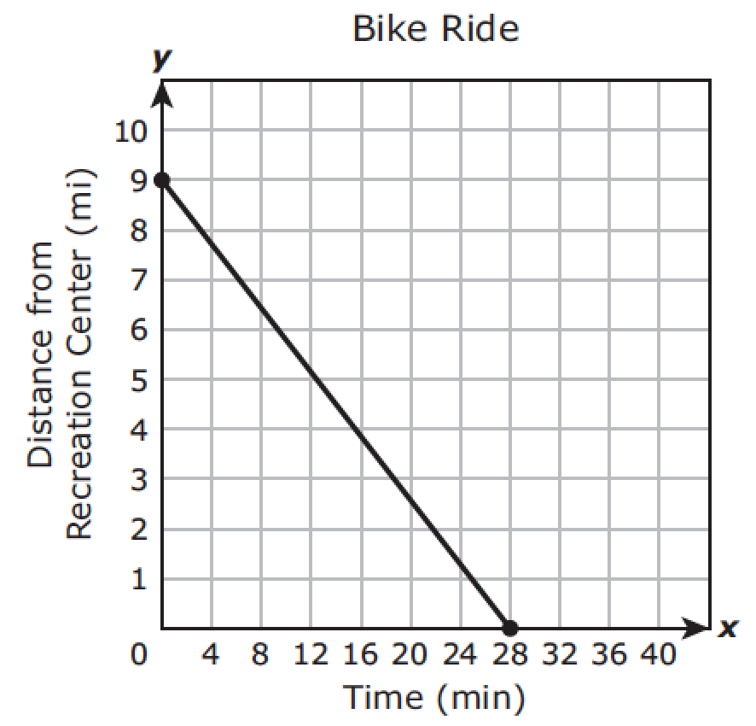 | Paste Domain description here  Paste Range description here | Domain:  Range:
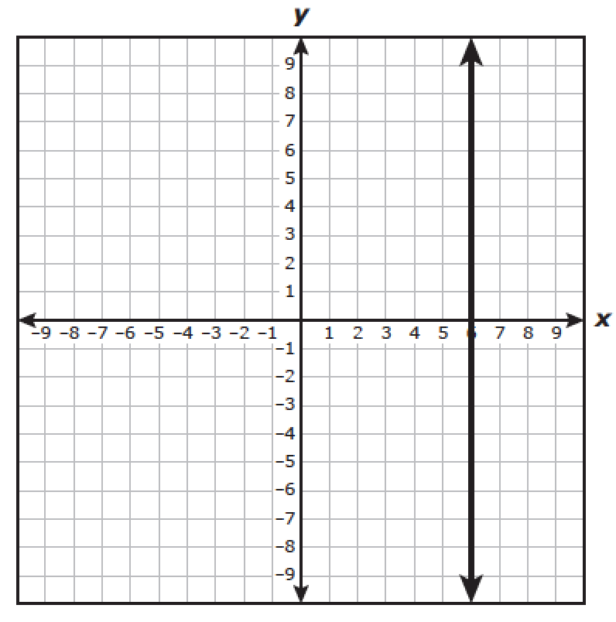 | Paste Domain description here  Paste Range description here | Domain:  Range:

Topic 5 Activity B Student Page
Domain and Range Cut-A-Parts, page 3

Graphs | Paste your domain and range descriptions in the cells below. | Write the domain and range for each graph as inequalities.
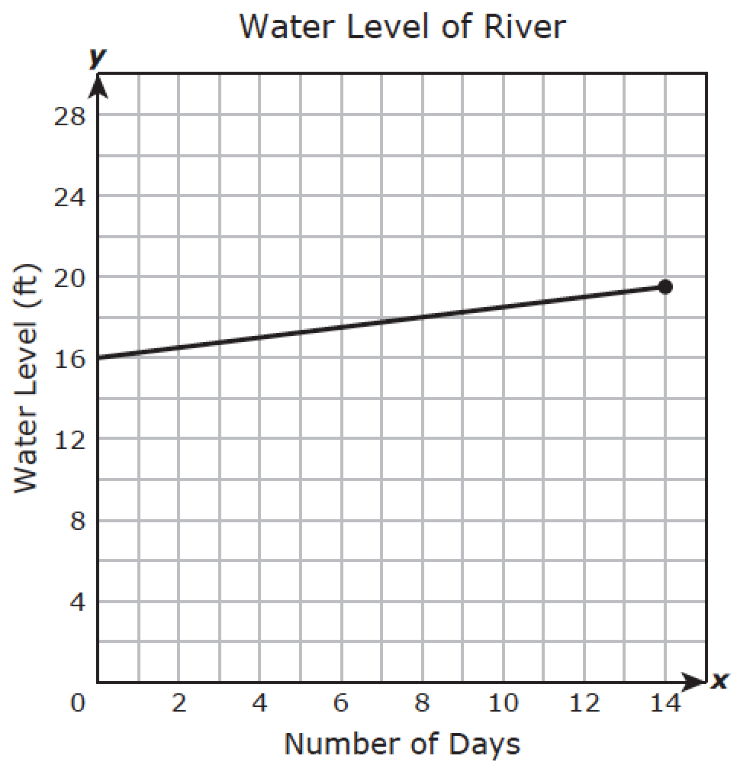 | Paste Domain description here  Paste Range description here | Domain:  Range:
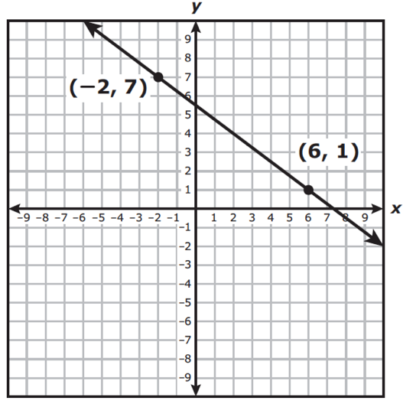 | Paste Domain description here  Paste Range description here | Domain:  Range:

Topic 5 Activity C Teacher Directions
Bluff Game - (game directions from Hoff Math)

Materials:
- A set of questions in a Google Slides presentation.
- The printed answers to the questions.
- Dice. A standard set of 6-sided dice is fine, but it would be useful to also have an 8-sided or even 12-sided die. (Alternatively, use a random number generator or pull the numbers from a bag.)

Directions:
- Divide the class into two teams: Team A and Team B.
- A question is displayed. Students cannot confer once the question is shown. Give the students time to determine the answer.
- The teacher chooses one of the teams to answer the question (let's say it was Team A).
- Any student on Team A that thinks they know the answer (or wants to bluff that they do) must stand up. Everyone else remains seated. If 5 students stand up, that team is eligible for 5 points. If 3 students stand up, they're eligible for 3 points, and so on. (At this point, the teacher numbers the players - the player number will change every round).
- The teacher rolls a die. If 5 people standing and the die shows a 4, then player number 4 must answer the question. (If you have more than 6 people standing, this is when an 8-sided or 12-sided die is useful.)
- If that player (player 4 in this scenario) gets the question right, that team earns the points (5 points in this scenario).
- If player 4 gets the question wrong, the question is thrown to the other team and they are eligible for that many points (5 points in this scenario). Any single person on Team B can answer the question, but the first person to answer from Team B must be correct. If Team B gets the question wrong, then neither team earns any points.
- Repeat the process with a new question and offer the question to Team B first.
- Play continues until you run out of time, you run out of questions, or the students run out of steam.

When asking students to identify the domain and range, it may be helpful to include scaffold questions such as -
- What is the point on the graph that represents $f(0)$? What does this point represent?
- When does the graph equal 0? In other words, when is $f(x) = 0$?
- What is the highest point on the graph?
- What is the lowest point on the graph?
- On the graph, what is the farthest point to the left?
- On the graph, what is the farthest point to the right?

Topic 6 - Properties of exponents - A1.11B
(AR = Additional Resources page)

Activity objective(s) | Algebra 1 content | Directions - LINK TO RESOURCES
Activity A - Students will review vocabulary associated with exponents. | Unit 5 Overview & Readiness: Evaluating Exponential Expressions Mini-Lesson Review | - Have students review the definitions of base, exponent and power by accessing the Unit 5 Overview and Readiness lesson. Be sure they can navigate to the Evaluating Exponential Expressions Mini Lesson Review tab.  - Extend students’ thinking by having them answer the questions based on the examples in the Mini Lesson.
Activity B - Students will review how to simplify exponential expressions (positive integer exponents only). | 5.1.2 AR  5.1.3 AR  5.1.4 AR  5.1.6 Practice | - Have students describe ways they will remember the different exponent rules by completing the Q3SA Exponent Rules activity that directs them to 5.1.2 Additional Resources, 5.1.3 Additional Resources, and 5.1.4 Additional Resources.  - Then, have them practice the rules by completing the questions in 5.1.6 Practice.  - If students need additional practice, consider using the problems in activities Algebra 1 5.1.2, 5.1.3, and 5.1.4.
Activity C - Students will practice | 5.1.5 Cool Down  X factor game | - Have students review the rules for simplifying exponential expressions by completing the 5.1.5 Cool Down activity.  - Have students play the X factor game.

Extra Activities
Use if time permits or if you would like a substitute activity.
- Partner Writing Task
- Rational Exponents - Algebra 1 5.2.3 Activity & Additional Resources

Topic 6 Independent Activity A Student Page
Unit 5 Overview and Readiness - Evaluating Exponential Expressions

- Examine the expression below, then, annotate it using the following directions:
- Underline the exponent
- Draw a circle around the base
- Put a box around the power
$$5^{3}$$

Check your annotations by accessing the Unit 5 Overview and Readiness section, then use the right menu guide to access the tab marked: Evaluate Exponential Expressions Mini Lesson Review.

- Explain why 15 is incorrect when $5^{3}$is simplified.

- Explain why we do not multiply the 7 and 3 before applying the exponent when simplifying ${7(3)}^{4}$.

Topic 6 Independent Activity B Teacher Directions
Q3SA Directions -

This strategy helps students use academic language during conversation. The teacher asks the essential question that will be addressed in the conversation. Students show a signal when they are ready to respond and are given a sentence stem to use for their response. After sharing with a partner, students are chosen randomly to share with their own group.

- Question: Present class with a question to answer. In this scenario, ask students to read one of the additional resource pages and ask them how they will be able to remember the information. In other words, pose the question: How will you remember how to use the _____?

- Signal: Provide thinking time while students work on the question. Ask students to give you a response signal when they are ready to answer the question. For example, “ Display a “thumbs up” on your chest when you have a response.”

- Stem: Provide sentence stems to get the students ready to share their ideas. "I will remember how to use the ________ by (or because) …”

- Share: Have students share their responses with other students in pairs, triads, or groups. For example, have students share with their elbow partner.

- Assess: Determine the quality of student discussions and the level of understanding by randomly selecting students to share aloud or by having all students write their responses on the student page/note catcher.

As an extension, place students into a group of 4 and have them create an anchor chart for all of the properties of exponents, using three or four student ideas (the best ones they heard or their own). Ask each group to present their anchor charts and to vote on the best one to post (or create a new class anchor chart combining the best ideas from all those presented).

Topic 6 Independent Activity B Student Page

Q3SA Exponent Rules
Read each Additional Resource, then consider the question (Q) posed for each page. Complete the sentence stem (S) with your idea for how to remember what to do for each exponent property. You will be prompted to display a signal (S) when you are ready to share your sentence. Prepare to share (S) your idea with a partner. You will collect the best ideas to create an anchor chart (assess = A).

Read 5.1.2 Additional Resources page about the Product Property of Exponents | Consider: How will you remember how to use the product property of exponents?  Stem: I will remember how to use the product property of exponents by (or because) …
Read 5.1.2 Additional Resources page about the Quotient Property of Exponents | Consider: How will you remember how to use the quotient property of exponents?  Stem: I will remember how to use the quotient property of exponents by (or because) …
Read 5.1.3 Additional Resources page about the Zero Exponent Property | Consider: How will you remember how to use the zero exponent property?  Stem: I will remember how to use the zero exponent property by (or because) …
Read 5.1.3 Additional Resources page about the Property of Negative Exponents | Consider: How will you remember how to use the property of negative exponents?  Stem: I will remember how to use the property of negative exponents by (or because) …
Read 5.1.4 Additional Resources page about the Power Property of Exponents | Consider: How will you remember how to use the power property of exponents?  Stem: I will remember how to use the power property of exponents by (or because) …

Topic 6 Activity C Teacher Directions
X-factor Game PPT
- Place students into groups of 2-4 members (fewer members is better with more groups is better, but sometimes hard to manage).

- Provide each group with a poster (placed on the wall) that is accessible and visible to all groups. Each group should have 10 large Xs written on their poster.

- This game gets to be very fast paced - be prepared with your answer sheet!

- If students need additional support, you may wish to provide the “second” slide that is hidden (odd numbered slides instead of the even numbered slides). It contains possible answer choices for students to select from.

- TO SAVE PAPER - print out slides as handouts with at least 2 slides per page and cut apart the slides. Each group will need their own set of problems. (It may be helpful to print slides/handouts on different color paper to help each group keep their problems separate.)

- Provide directions to students:
  - The goal of X-Factor is for each group to delete all of their Xs first! But there is a catch!

  - Each group will be given one assessment item - placed face down on the desk and a different marker color. Additional assessment items will be placed in stacks near the teacher. Only get your problems from your team’s stack! (Teacher, it is helpful to label the stacks or make sure students know from which stack to get their problems.)

  - When signaled, turn the paper over and cooperatively complete the problem. As soon as the group has determined the answer, one of your group members will take the problem to the teacher to check.

  - If correct, then your group may scratch 2 Xs off of your own poster and place them on another group’s poster. FYI - you may place both Xs on another poster or place one on two different groups’ posters. The group will then receive another problem and continue the process.

  - If the problem is wrong, the group member returns to the group and you have a chance to correct the mistake. Remember - never give up ... everyone makes a mistake. It's more important to learn from them.

  - Don’t forget, the group that deletes all of their Xs first, wins the game.

Topic 7 - Factoring polynomials - A1.10D
(AR = Additional Resources page)

Activity objective(s) | Algebra 1 content | Directions - LINK TO RESOURCES
Activity A - Students will practice multiplying binomials. | 8.6.2 AR | - Have students access 8.6.2 Additional Resources to review how to multiply binomials. Have them complete Independent Activity A.  For students who struggle, consider pulling them into a small group and use algebra tiles (free digital version) with the same problems. Then, have them transfer their understanding to using “box” graphic organizers.
Activity B - Students will review how to factor trinomials using grouping (“ac” method). | 6.5.4 AR  8.6.3 AR  8.6.5 Practice (optional) | - Have students access 6.5.4 Additional Resources. Then, use the information to complete the tables/graphic organizer for Example 1 and the Try It problem.  - Students should try to complete the process for an example problem on their own. The problem is Example 1 from 8.6.3 Additional Resources, so students can check their work after their attempt.  - If you would like students to complete additional factoring problems, consider having them complete 8.6.5 Practice.
Activity C - Students will practice | 8.6.4 Cool Down  Thumbs Up, Thumbs Down | - Have students complete Cool Down Activity 8.6.4 to review how to multiply and factor trinomials with leading coefficient = 1.  - Have students play Thumbs Up, Thumbs Down. This activity asks students to identify if the factors and the simplified polynomial are equivalent.

Extra Activities
Use if time permits or if you would like a substitute activity.
- Adapted 3-2-1 Protocol for multiplying binomials (aligned to Algebra 1 6.2.2 Additional Resources)
- Algebra 1 Practice 8.7.5
- Algebra 1 Practice 6.5.6 (problems 8 & 9 include more difficult polynomials)
- Algebra 1 Unit 6 quiz
- Algebra 1 Unit 6 STAAR review

Topic 7 Independent Activity A - Student Page
Access 8.6.2 Additional Resources. Use the information to complete the graphic organizers for Examples 1-2 and the Try It problems.

Example 1 - Multiply $(x + 3)(x$
 | $$x$$ | $$+ 3$$
$$x$$
$$+ 5$$

Simplified polynomial = _______________________________

Example 2 - Multiply $(x - 6)(x - 9)$
 | $$x$$ | $$-9$$
$$x$$
$$-6$$

Simplified polynomial = _________________________________

Try It Problem 1 - Multiply $(x + 2)(x + 7))$
 | $$x$$ | $$+ 7$$
$$x$$
$$+2$$

Simplified polynomial = _________________________________

Try It Problem 2 - What are the factors that were multiplied to arrive at $x^{2} - 11x + 24$?

HINTS:
- Break -11x into two terms: $-3x$ and $-8x$.
- Then, notice how they are placed into the diagram.
- Next, use the diagram to find the GCF of each set of factors, horizontally and vertically.
 | $$x^{2} = x⋅x$$ | $$-3x = - 3 ⋅x$$
 | $$-8x = -8 ⋅x$$ | $$24 = -3 ⋅ -8$$

Factors = _________________________________
Topic 7 Independent Activity B Teacher Directions
Access 6.5.4 Additional Resources. Use the information to complete the tables for Ex. 1 and the Try It problem.

Example 1: ${6x}^{2} + 7x + 2$

Step 1 - | Factor any GCF.
Step 2 - | Find the product of $a⋅c$.    And what is $b$?  
Step 3 - | List all the factors, $m$ and $n$, that —  - Multiply to $a⋅c$: $mn = ac$  Which of the factors, $m$ and $n$ —  - Add to $b$: $m + n = b$
Step 4 - | Split the middle term using $m$ and $n$. Place the terms into “the box.”  
Step 5 - | Factor by grouping —  Pull the GCF from the horizontal terms.  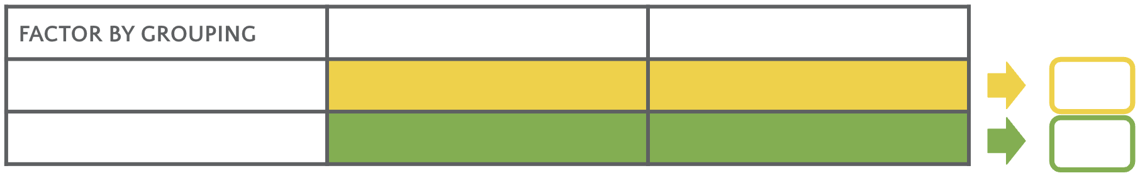  Pull the GCF from the vertical terms.  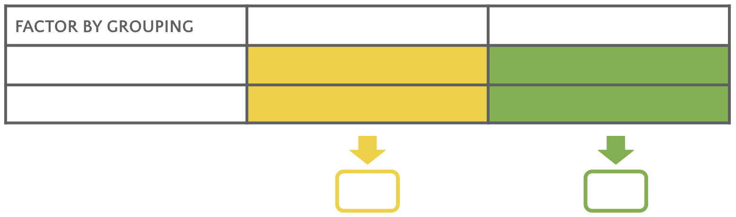  
Step 6 - | Check by multiplying the factors.  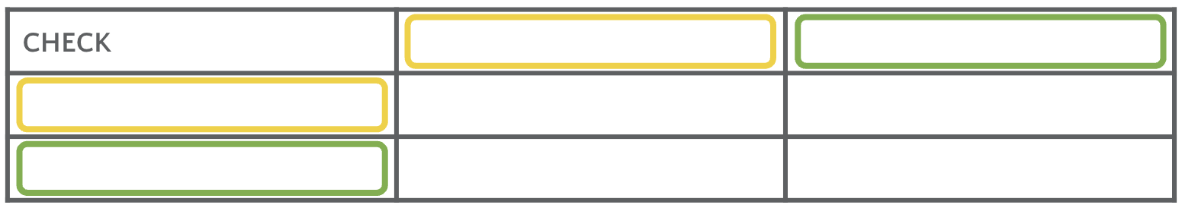
Try It Problem: ${10y}^{2} - 55y + 70$
Step 1 - | Factor any GCF.
Step 2 - | Find the product of $a⋅c$.  And what is $b$?
Step 3 - | List all the factors, $m$ and $n$, that —  - Multiply to $a⋅c$: $mn = ac$  Which of the factors, $m$ and $n$ —  - Add to $b$: $m + n = b$
Step 4 - | Split the middle term using $m$ and $n$. Place the terms into “the box.”
Step 5 - | Factor by grouping —  Pull the GCF from the horizontal terms.  Pull the GCF from the vertical terms.
Step 6 - | Check by multiplying the factors.

Now try to factor the given problem on your own.
Problem: $x^{2} + 16x + 63$

Step 1 - | Factor any GCF.
Step 2 - | Find the product of $a⋅c$.  And what is $b$?
Step 3 - | List all the factors, $m$ and $n$, that —  - Multiply to $a⋅c$: $mn = ac$  Which of the factors, $m$ and $n$ —  - Add to $b$: $m + n = b$
Step 4 - | Split the middle term using $m$ and $n$. Place the terms into “the box.”
Step 5 - | Factor by grouping —  Pull the GCF from the horizontal terms.  Pull the GCF from the vertical terms.
Step 6 - | Check by multiplying the factors.

If you need some hints, access 8.6.3 Additional Resources.

Topic 7 Activity C Teacher Directions
Thumbs Up, Thumbs Down PPT
Share the following directions with the students (slide 2 of the slide deck):
- A set of binomials to be multiplied will be displayed.
- Determine if each set of binomials have been multiplied correctly.
- When signaled, display a “thumbs up” if the answer is correct … or a “thumbs down” if the answer is incorrect.
- Be prepared to verify your selection.

If you would like to make this competitive, divide the class into groups. Assume there are 7 people in each group and 5 of the members display “thumbs up” while 2 of them display “thumbs down.” If the answer is “thumbs up,” then that group earns 5 points. In other words, the group earns the number of points aligned to the number of members who had the correct answer.

As an alternative, have students use white boards to answer the problems. This would allow you to assess each individual students’ level of understanding. Then, make a copy of the slides and delete either the factors or the simplified polynomial and ask students to determine the missing information. Use a running roster or anecdotal notes to record which students get which problems correct. This information can be used to pull small groups at a later time.

Topic 8 - Key features of quadratic functions - A1.7A, A1.6A
(AR = Additional Resources page)

Activity objective(s) | Algebra 1 content | Directions - LINK TO RESOURCES
Activity A - Students will practice identifying and explaining key features of quadratic functions. | 7.6.3 AR | - Have students access 7.6.3 Additional Resources about the parts of a parabola and how they relate to the scenario of a projectile. Have them complete Independent Activity A.  Students will need highlighters: green, blue, yellow, and pink. It may be easier for students to complete the activity if the pages for the activity are not copied back-to-back.
Activity B - Students will practice determining the domain and range of quadratic functions. | 7.6.2 AR  7.6.5 Practice | - Have students access 7.6.2 Additional Resources about the quadratic equation that represents projectile motion: $h(t) = h_{0} + v_{0}t - 16t^{2}$ where $h_{0}$ represents the initial height and $v_{0}$represents the initial velocity (and -16 represents ½ gravity in ft/sec²) to complete Independent Activity B.  - Have students complete the 7.6.5 Practice questions.
Activity C - Students will practice using the terminology associated with the key features of quadratics. | Game  Unit 7, Section B Quiz | - Have students play the Adapted Pictionary (linear and quadratic terms) game. Vocabulary includes terminology from weeks 2 & 3 as well as this week’s content.  - Have students complete Unit 7, Section B Quiz

Extra Activities
Use if time permits or if you would like a substitute activity.
- SWAT game for quadratics
- Two Truths and a Lie for quadratics and linear

Topic 8 Independent Activity A Student Page

The function graphed below represents an air rocket that is launched from a platform.

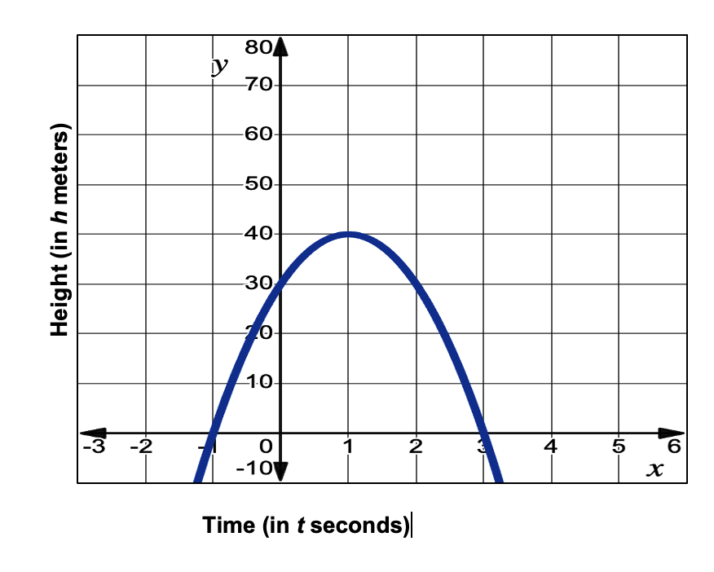

Access 7.6.3 Additional Resources. Use the information to identify the key features of the quadratic function graphed above.

- Use the designated highlighter color to identify the following points on the graph:

Maximum point the rocket reaches - use a green highlighter
Height at t = 0 - use a blue highlighter
When the rocket hits the ground - use a yellow highlighter

There are special names and coordinates for the points you highlighted from the graph.

- What are the coordinates of the vertex? What color did you use to highlight the vertex?

- Is the vertex a maximum value or a minimum? How do you know?

- What are the coordinates of the y-intercept? What color did you use to highlight the y-intercept?

- What are the coordinates of the root(s)? What color did you use to highlight the root(s)?

- What is at least one other name or vocabulary term for the root(s) of the function (there are 3 other possible names/terms)?

- Why does one of the roots not make sense in the context of this problem?

- Explain if this function is considered to be increasing or decreasing and how you know.

- Use a pink highlighter to identify the axis of symmetry. What is the equation for the axis of symmetry?

Topic 8 Independent Activity B Student Page

Part 1 - Access 7.6.2 Additional Resources. Use the information to label the parts of the quadratic equation given below.

- Label what h₀, v₀, and -16 represent in the quadratic equation for an object that is thrown into the air. 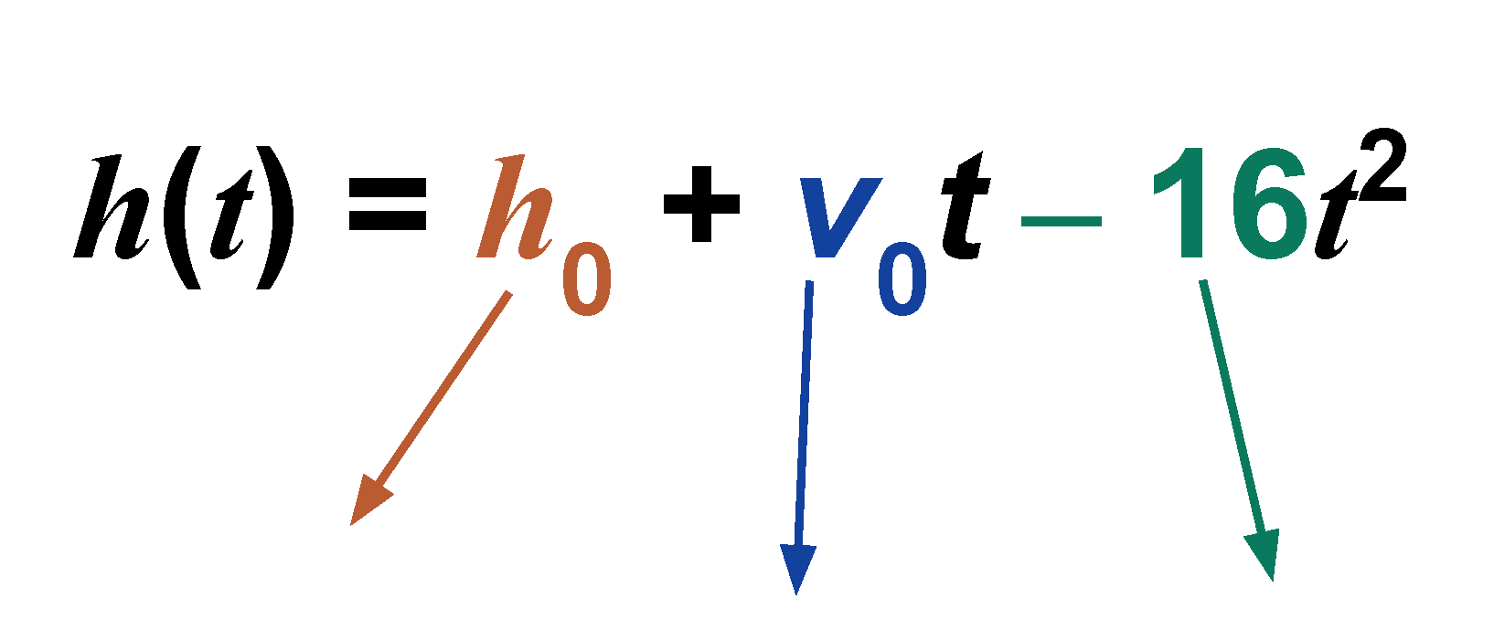

- Which of the key characteristics on the graph of a parabola are affected when the h₀ is changed?

- Which of the parameters [h₀, v₀, or -16] determines if the parabola opens “up” or opens “down”?

Note: The lead coefficient is usually -16 because the force of gravity on earth is a constant -32 ft/sec². The coefficient, -16, is ½ of that amount. If the units are changed or the object is not on earth, this number will change.
Part 2 - Access 7.6.5 Practice then, complete the questions. Remember, the questions allow you multiple attempts. When you have finished all of the questions, write your final answers below.

- Final answer =

2a. Final answer =

2b. Final answer =

2c. Final answer =

3a. Final answer =

3b. Final answer =

3c. Final answer =

4a. Final answer =

4b. Final answer =

Topic 8 Activity C Teacher Directions
Adapted Pictionary vocabulary game -

Designed for use to review vocabulary associated with key features of linear, quadratic, and exponential graphs. Note that this activity reviews terms from previous weeks.

This activity will not only review student understanding of vocabulary terms associated with algebraic graphs, it will also provide you with a pre-assessment of which terms are more/less familiar to students.

Preparation: The day before the game, place the words from the vocabulary list on separate index cards or slips of paper. Have a bag, box, or hat in which to place the cards so that students can pull a word during each round of the game tomorrow. Be sure to bring a timer, too.

Directions:
- Place students into groups of 4 - 5 members. Prepare a timer for 60 seconds.
- Determine which group will begin the game and have them select a member to be the first artist.
  - The artist will select a word from the bag and has 15-20 seconds to think about the word. Then, they have 60 seconds to illustrate it.
  - Only members of his/her group can answer.
  - Pictures cannot contain letters, numbers, “sounds-like” illustrations, and no verbal clues.
- Scoring:
  - If the group guesses correctly, they get 1 point. Then, move to the next group.
  - If the group guesses incorrectly, allow the next group to provide one guess. If they get the correct answer, they get the point. If they do not get the correct answer, the next group provides a guess and so on.
  - If no one guesses correctly, then no points are given and move play to the next group. (Note any words that fall in this category as content that will need to be reviewed with the full class.)
- Adaptations:
  - You may choose to ask another group to define the word or explain how to determine the value of the word. Each response could earn the group additional points.
  - If a student pulls a word that they do not know or are unsure of, step aside and discuss the term with the student before they draw it. Alternatively, allow them to put the word back into the bag and select another one.

EOC review - Vocabulary list for Key Features of graphs

General terms
Equation
Function
Coefficient
Variable
Domain
Range
$y$-intercept
$x$-intercept
Discrete
Continuous
Constant
Point
Coordinates
Increasing
Decreasing
Zero
Solution

Linear terms
Slope
Rate of change
Parallel
Perpendicular
Slope-intercept form
Standard form
Point-slope form
Intersecting
Coincident

Inequality terms
Inequality
Inclusive
Exclusive

Quadratic terms
Parabola
Maximum value
Minimum value
Vertex
Axis of symmetry
Root

Exponential terms
Initial value
Asymptote
Decay rate
Growth rate

Topic 9 - Solving quadratic equations - A1.8A
(AR = Additional Resources page)

Activity objective(s) | Algebra 1 content | Directions - LINK TO RESOURCES
Activity A - Students will practice solving quadratic equations by graphing or taking the square root. | 8.5.2 AR  8.5.3 AR  8.5.5 Practice | - Have students read 8.5.2 Additional Resources and 8.5.3 Additional Resources and use the information on the pages to complete the Q3SA Solving Quadratics (steps 1-2). On Activity C day, students will share their information with partners to prepare for the game.  - Have students complete 8.5.5 Practice problems (10 questions).  Note, students will need access to graphing calculators (either TI calculators or Desmos)
Activity B - Students will practice solving quadratic equations using the quadratic formula. | 9.6.3 AR  9.6.5 Practice | - Have students read 9.6.3 Additional Resources that describes the steps for how to solve a quadratic equation using the quadratic formula. Then, have students use that information to complete the Clarify, Critique, Correct activity.  - Have students complete 9.6.5 Practice problems (12 questions)
Activity C - Students will practice solving quadratic equations by graphing, taking the square root, and using the quadratic formula. | Game  Unit 8 Section B Quiz | - To help students review how to solve quadratics using graphs and taking the square root, complete steps 3-5 of the Q3SA activity (see above) by having students share their summaries with a partner.  - Now, have students stay in a group with their last partner. Have each pair of students complete the Here is/Where is scavenger hunt. You may ask them to show all of their work on notebook paper and be prepared to turn it in.  - Ask students to complete the Unit 8, Section B quiz.  Note: Print the Here is/Where is game with 1 slide per page.

Extra Activities
Use if time permits or if you would like a substitute activity.
- Adapted Just the Facts (inspired from Lead4ward) directions p. 22

Topic 9 Independent Activity A Student Page
Q3SA Solving Quadratics
- Read each Additional Resource, then consider the question (Q) posed for each page.
- Complete the sentence stem (S) with your idea for how to remember what to do when you solve a quadratic equation using the specified method.
- Later, you will be prompted to display a signal (S) when you are ready to share your sentence.
- Be prepared to share (S) your idea with a partner.
- You will discuss the ideas in class or collect the best ideas to create an anchor chart (assess = A).
Read 8.5.2 Additional Resources page about how to solve quadratic equations using graphs. DESMOS | Consider: How do you solve quadratic equations by using graphs?  Stem: To solve quadratic equations using graphs, first …  Then …
Read 8.5.2 Additional Resources page about how to solve quadratic equations using graphs.  DESMOS | Consider: All the examples (1-3) required us to make sure the equation equals zero (= 0) before solving. How will you remind yourself to set quadratic equations equal to 0 before solving?  Stem: I will remember to set quadratic equations equal to zero in order to solve them. To help me remember what to do, I will …
Read 8.5.3 Additional Resources page about how to solve quadratic equations using square roots.  DESMOS | Consider: How do you solve quadratic equations using the square root property?  Stem: To solve quadratic equations using square roots, first I …  Next, I …  Then, I …

Read 8.5.3 Additional Resources page about how to solve quadratic equations using square roots.  DESMOS | Consider: When solving using the square root property, the squared term has to be isolated - or be “by itself” on one side of the equation. How will you remind yourself to isolate the squared term before solving using this method?  Stem: I will remember to isolate the squared term when solving with square roots. To help me remember what to do, I will …
BONUS - Read 8.5.3 Additional Resources page about how to solve quadratic equations using the zero product property.  DESMOS | Consider: How do you solve quadratic equations using the zero product property?  Stem: To solve quadratic equations using the zero product property, first I …  Then I …

Topic 9 Independent Activity B Student Page
Clarify, Critique, Correct - Solving quadratics

Access Algebra 1 9.6.3 Additional Resources. Read the steps for how to solve a quadratic equation using the Quadratic Formula. Use that information to help you answer the questions below.

A t-shirt is launched into the stands at a soccer game.
- The equation $h(t) = -16t^{2} + 80t + 64$ represents the height, in feet, of the t-shirt $t$ seconds after it has been launched.

- The first t-shirt reaches a fan that is 40 feet off of the ground. To determine when the t-shirt reaches the fan, the equation $40 = -16t^{2} + 80t + 64$ can be solved.

John determined the following:I used the quadratic formula to get 5.28 seconds since $t = \frac{80 ± \sqrt{{80}^{2} + 4⋅ 16 ⋅ 24}}{2 ⋅ 16}$.

John’s response is incorrect. Identify his error(s) in reasoning, critique the reasoning, and then write a correct explanation. Use the following sentence stems to guide your responses.

- John made an error in his reasoning when …

- When he made this error, John was thinking/not thinking about …

- Instead, John needs to …

- So his answer should have been …

Topic 9 Activity C Teacher Directions
Here is/Where Is scavenger hunt

Preparation -
Mix up the slides and place them on the wall around the room or in the hallway.

Directions -
- Place students into partners or trios.
- Have student groups begin at any posted slide and work out the problem listed in the “Where is” section.
- When students complete the problem, they need to find the slide that contains the answer in the “Here is” section. Then, they work the problem that is listed in the “Where is” section of that slide.
- Have students show their work on a sheet of paper. If they complete the process right, they will end up back at the slide they started at.

Note to teachers -
- The given slides are correctly ordered - mix them up before using.

- Print with one slide per page.

- As students work the problems on their own paper, have them write down the letter next to the problem they are working out. (The letter is located in the upper right hand corner.)

If students correctly complete the problems in order, then the word spells “PICKLES.” This will help you to grade the work or identify where students have made a mistake. Remember, they may start at any letter in this word (so “CKLESPI” is also correct).

Topic 10 - Key features of exponential functions - A1.9D, A1.9C
(AR = Additional Resources page)
Activity objective(s) | Algebra 1 content | Directions - LINK TO RESOURCES
Activity A - Students will review vocabulary associated with the key features of exponential functions. | 5.4.3 AR  5.4.4 AR | - Have students graph the given table of values for an exponential function.  - Then, have them identify the characteristics of the function. To save time, only have students cut out the characteristics AFTER identifying them. Students can check their answers by reviewing the Additional Resources for 5.4.3 and 5.4.4.  NOTE - The cut-a-part characteristics should be printed on a single sheet of paper. And, as an alternative to cutting out the characteristics, they could shade them.
Activity B - Students will review key characteristics of exponential functions and describing the “a” and “b”  ($f(x) = ab^{x}$). | 5.5.3 AR  5.7.2 AR | - Similar to Activity A, students graph a given exponential function from a table of values. Then, they identify the characteristics. Note that Activity A is a growth function while Activity B is a decay function.  - Have students read and complete the questions in 5.7.2 Additional Resources.  NOTE - The cut-a-part characteristics should be printed on a single sheet of paper. And, as an alternative to cutting out the characteristics, they could shade them.
Activity C - Students will practice identifying key characteristics of exponential functions. | 3-2-1 summary  Unit 1 STAAR Review Quiz | - Have students complete the Adapted 3-2-1 protocol.  - Have students complete the Unit 1 STAAR Review Quiz.

Extra Activities
Use if time permits or if you would like a substitute activity.
- Magnificent Trio vocabulary activity - can scaffold to meet different levels of need; also, could use any set of key terms
- Rock and Roll Vocabulary (Lead4Ward) directions p. 45 (need dice)
- Adapted Quiz-Quiz-Trade
- X-factor - it reviews key characteristics of graphs for linear, quadratic, and exponential graphs!

Topic 10 Independent Activity A Student Page
Access Algebra 1 5.4.3 Additional Resources about exponential functions. Use the information to help complete the following questions.

- Use the table of values to plot points on an exponential growth curve defined by $f(x) = 4{(3)}^{x}$.

$$x$$ | -3 | -2 | -1 | 0 | 1 | 2 | 3
$$f(x)$$ | $$\frac{4}{27} ≈ 0.15$$ | $$\frac{4}{9} ≈ 0.44$$ | $$\frac{4}{3} ≈ 1.3$$ | 4 | 12 | 36 | 108

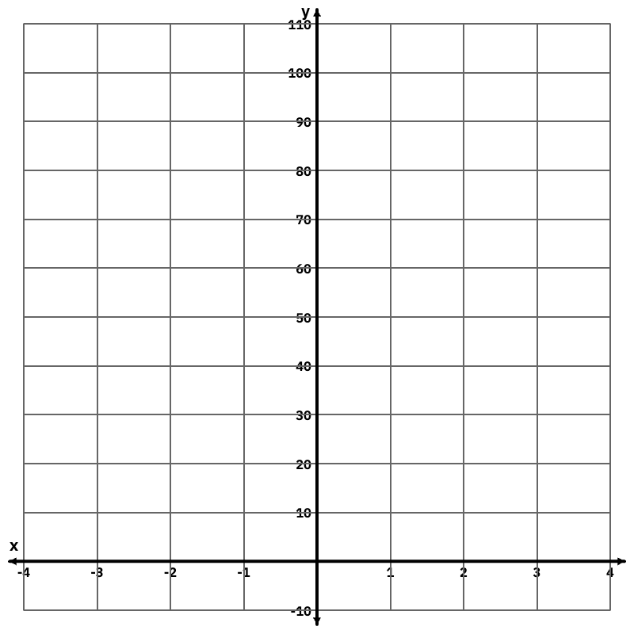

- Examine the list of characteristics given on the next page (use the color coding to help identify the descriptions). Only some of the characteristics are true for this function.
  - Determine which characteristics accurately describe the function:
    - A description of the domain (dark green)
    - Domain as an inequality (red)
    - A description of the range (dark blue)
    - Range as an inequality (orange)
    - Identification of the function as growth/decay (light blue)
    - Identification of the y-intercept (light green)
    - Identification of the asymptote (black)
    - Identification of the x-intercept (gray)
  - Darken or black out any characteristic that is NOT TRUE for this graph.

For use with Topic 10 Activity A - From the characteristics listed below. Cut out the ones that apply to the given data. Discard the characteristics that do not apply.
Only positive numbers can be used as input values. So, only positive real numbers can be in the domain.
Only negative numbers can be used as input values. So, only negative real numbers can be in the domain.
All positive and negative numbers can be used as input values. So, all real numbers can be in the domain.
The resulting output values are only positive numbers. So, only positive real numbers can be in the range.
The resulting output values are only negative numbers. So, only negative real numbers can be in the range.
All positive and negative numbers can occur as the output values. So, all real numbers can be in the range.
As the x-values in the domain increase, the y-values in the range increase. Thus, the exponential graph represents a growth function.
As the x-values in the domain increase, the y-values in the range decrease. Thus, the exponential graph represents a growth function.
As the x-values in the domain increase, the y-values in the range increase. Thus, the exponential graph represents a decay function.
As the x-values in the domain increase, the y-values in the range decrease. Thus, the exponential graph represents a decay function.

The y-intercept for this function is  _________________ (fill in the blank). | This function does not have a y-intercept.
The asymptote for this function is  _________________ (fill in the blank). | This function does not have an asymptote.
The x-intercept for this function is  _________________ (fill in the blank). | This function does not have an x-intercept.

Range: $-∞ < y < ∞$ | Range: $0 < y < ∞$ | Range: $-∞ < y < 0$
Domain: $-∞ < x < ∞$ | Domain: $0 ≤x < ∞$ | Domain: $-∞ < x ≤ 0$
You may want to check your work by accessing 5.4.4 Additional Resources.

Topic 10 Independent Activity B Student Page
Access Algebra 1 5.5.3 Additional Resources about exponential functions. Use the information to help complete the following questions or check your work.

- Use the table of values to plot points on an exponential growth curve defined by
$g(x) = 100,000{( \frac{4}{5} )}^{x}$.

x | -3 | -2 | -1 | 0 | 1 | 2 | 3
f(x) | 195,312.5 | 156,250 | 125,000 | 100,000 | 80,000 | 64,000 | 51,200

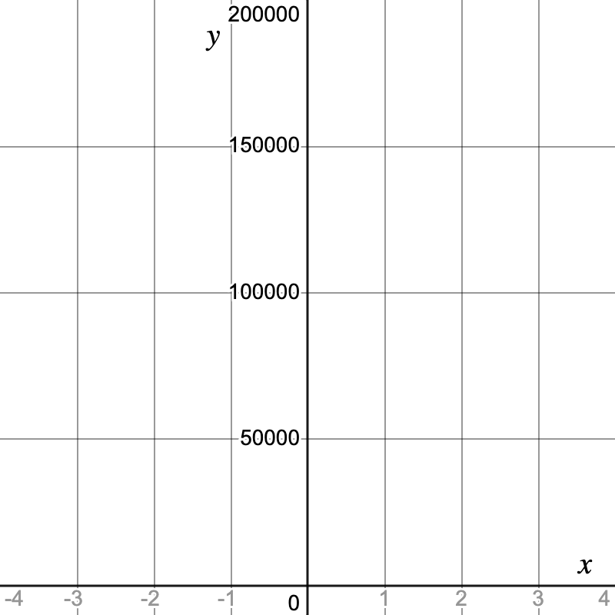

- Examine the list of characteristics given on the next page. Only some of the characteristics are true for this function.
- Determine which characteristics accurately describe the function (use the color coding to help identify the descriptions):
    - A description of the domain (dark green)
    - Domain as an inequality (red)
    - A description of the range (dark blue)
    - Range as an inequality (orange)
    - Identification of the function as growth/decay (light blue)
    - Identification of the y-intercept (light green)
    - Identification of the asymptote (black)
    - Identification of the x-intercept (gray)
b. Darken or black out any characteristic that is NOT TRUE for this graph.

- Compare the equations for a set of exponential functions.

$f(x) = 4{( 3 )}^{x}$ This is an exponential GROWTH function
$g(x) = 4{( \frac{1}{3} )}^{x}$ This is an exponential DECAY function

How can you identify if an exponential function represents growth or decay without looking at the graph?
For use with Topic 10 Activity B - From the characteristics listed below. Cut out the ones that apply to the given data. Discard the characteristics that do not apply.

Only positive numbers can be used as input values. So, only positive real numbers can be in the domain.
Only negative numbers can be used as input values. So, only negative real numbers can be in the domain.
All positive and negative numbers can be used as input values. So, all real numbers can be in the domain.
The resulting output values are only positive numbers. So, only positive real numbers can be in the range.
The resulting output values are only negative numbers. So, only negative real numbers can be in the range.
All positive and negative numbers can occur as the output values. So, all real numbers can be in the range.
As the x-values in the domain increase, the y-values in the range increase. Thus, the exponential graph represents a growth function.
As the x-values in the domain increase, the y-values in the range decrease. Thus, the exponential graph represents a growth function.
As the x-values in the domain increase, the y-values in the range increase. Thus, the exponential graph represents a decay function.
As the x-values in the domain increase, the y-values in the range decrease. Thus, the exponential graph represents a decay function.

Domain: $-∞ < x < ∞$ | Domain: $0 ≤x < ∞$ | Domain: $-∞ < x ≤ 0$
Range: $-∞ < y < ∞$ | Range: $0 < y < ∞$ | Range: $-∞ < y < 0$

The y-intercept for this function is  _________________ (fill in the blank). | This function does not have a y-intercept.
The asymptote for this function is  _________________ (fill in the blank). | This function does not have an asymptote.
The x-intercept for this function is  _________________ (fill in the blank). | This function does not have an x-intercept.

Topic 10 Activity C Teacher Directions
Adapted 3-2-1 Protocol for Algebra 1

Directions –

- Post the 3-2-1 questions and their sentence stems:
  - Summarize the 3 characteristics of the general exponential function
($y = ab^{x}$).
    - The intercepts of the general exponential graph are …
    - The domain of the general exponential graph is …
    - The range of the general exponential graph is …
  - Reflect on the 2 pieces of information needed to write the equation of a specific exponential function.
    - I need the value of “a” because … It represents the …
    - I need the value of “b” because … It represents the …
  - Explain 1 difference between exponential functions that represent growth and the ones that represent decay.
    - One difference I noted between the graphs/equations/verbal descriptions about growth and decay exponential functions is …

- Have students read the Additional Resources for the following Algebra 1 lessons in order to answer each of the questions.
5.4.3 AR
5.4.4 AR
5.5.2 AR
5.5.3 AR

- Once students have answered all of the questions individually, have them find 2 other team members (to make a group with 3 members) and share their 3 summaries about the characteristics of a general exponential function’s graph. Encourage students to revise or add to their summaries if they like something one of their classmates says. Select 3 students to share one of each of the summaries with the whole class.

- Now have students find one other team member (creating a group with 2 members). Allow them to share their 2 reflections about how to write exponential equations and the two components needed to do this. Listen for which students feel comfortable with the academic vocabulary (such as initial value, growth rate, decay rate, etc.). Select 2 students to share their summaries with the whole class (one about “a” and one about “b”).

- Now have student pairs find another set of partners (creating a group with 4 members). Allow them to share the differences between exponential growth and decay functions. Select 4-5 students to share their commitment statements with the whole class. Try to select students who describe differences in -
- the equations (highlighting the role that “b” plays in growth v. decay),
- the graphs (highlighting that growth functions are increasing v. decreasing for decay functions)
- the verbal descriptions that describe things that increase or decrease by a common ratio
If needed, copies of a student page have been provided.

Adapted 3-2-1 Protocol – Exponential Functions that Grow and Decay Student page

Read the Additional Resources for the following lessons and answer each of the prompts using the provided sentence stems.

- For Exponential Functions that GROW:
  - 5.4.3 Additional Resources
  - 5.4.4 Additional Resources
- For Exponential Functions that DECAY:
  - 5.5.2 Additional Resources
  - 5.5.3 Additional Resources

3  Summarize the 3 characteristics of the general exponential function. | GENERAL EXPONENTIAL FUNCTION: $f(x) = a^{x}$  The intercepts of the general exponential graph are …  The domain of the general exponential graph is …  The range of the general exponential graph is …
2  Reflect on 2 pieces of information needed to write the equation of a specific exponential function. | SPECIFIC EXPONENTIAL FUNCTION: $f(x) = ab^{x}$  I need the value of “$a$” because … It represents the …  I need the value of “$b$” because … It represents the …
1  Explain 1 difference between exponential functions that represent growth and the ones that represent decay. | One difference I noted between the graphs/equations/verbal descriptions about growth and decay exponential functions is …

Vocabulary list for Key Features of graphs

General terms
Equation
Function
Coefficient
Variable
Domain
Range
$y$-intercept
$x$-intercept
Discrete
Continuous
Constant
Point
Coordinates
Increasing
Decreasing
Zero
Solution

Linear terms
Slope
Rate of change
Parallel
Perpendicular
Slope-intercept form
Standard form
Point-slope form
Intersecting
Coincident

Inequality terms
Inequality
Inclusive
Exclusive

Quadratic terms
Parabola
Maximum value
Minimum value
Vertex
Axis of symmetry
Root

Exponential terms
Initial value
Asymptote
Decay rate
Growth rate

Topic 11 - Domain and range of quadratic and exponential functions - A1.6A, A1.9A
(AR = Additional Resources page)

Activity objective(s) | Algebra 1 content | Directions - LINK TO RESOURCES
Activity A - Students will practice identifying key features of quadratic and exponential functions, specifically domain and range. | 7.7.2 AR  5.9.3 AR | - Have students access 7.7.2 Additional Resources about the domain and range of a parabola. Have them complete the Independent Activity A which revisits a process for using highlighters to identify key components they previously encountered in week 8.  - Then, have students access 5.9.3 Additional Resources to examine the domain and range of an exponential function. Students are asked to focus on how the scenario dictates what is or is not included as part of the domain and range.
Activity B - Students will practice identifying the domain and range of a quadratic function dictated by real world scenarios. | 7.7.3 Activity | Have students access the activity in 7.7.3 - not the Additional Resources. They should complete the 12 questions. If you would like, have them record their final answers on Activity B, part 1.  The goal is for students to understand how the scenario may inform the domain (rather than just depending on the graph).  Part 2 of the activity can be used to assess student understanding of domain and range dictated by a scenario.
Activity C - Students will practice identifying the domain and range of quadratic and exponential functions. | Domain and Range game  7.7.4 Cool Down Activity | - Have students participate in the Domain and Range matching game. You may choose between several different methods for using this game with students.  - Have students complete the 7.7.4 Cool Down Activity.

Extra activities (use if time permits or if you would like a substitute activity)
- Sage and Scribe activity
- Texas Gateway Determining the Domain and Range of Quadratic Functions
- Texas Gateway Determining the Domain and Range of Quadratic Functions: Restricted Domain/Range
- Algebra 1 7.6.5 Practice problems (maybe)

Topic 11 Independent Activity A Student Page
Part 1 - Access 7.7.2 Additional Resources. Use the information and graph from the Additional Resources page to answer the questions below.

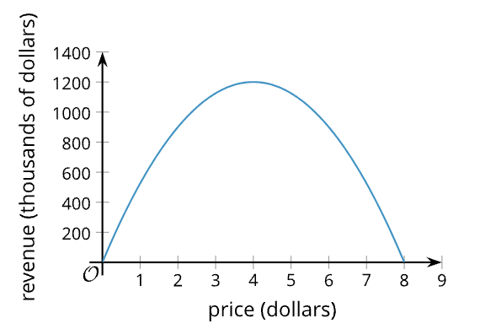

- What is the greatest amount of revenue that can be collected from selling the raffle tickets?

- What is the least amount of revenue that can be collected from selling the raffle tickets?

- Use a green highlighter to show on the $y$-axis the range of the function. What is the inequality that represents the range of this graph?

- What is the largest price charged for the raffle tickets?

- What is the least amount charged for the raffle tickets?

- Use an orange highlighter to show on the $x$-axis the domain of the function. What is the inequality that represents the range of this graph?

- Using the information from the graph, in order to maximize the revenue, what should be the price of the raffle tickets?

Part 2 - Access 5.9.3 Additional Resources. Use the information and graph from the Additional Resources page to answer the questions below.
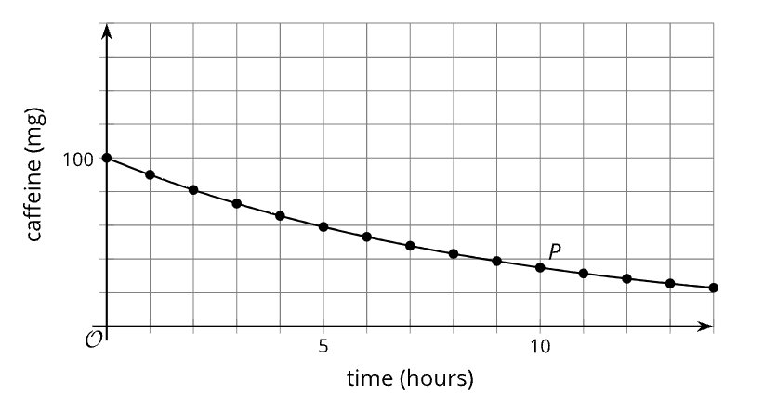
- The graph above displays the amount of caffeine in a person’s body. The domain for this graph is $t ≥ 0$. Why can the value of $t$ not be less than zero?

- The range for the graph is defined as $0 < c ≤ 100$. Explain why 0 is not included as part of the range, but 100 is included.

Topic 11 Independent Activity B Student Page
Part 1 - Access 7.7.3 The Domain, Vertex, and Zero of Quadratic Functions. Answer questions 1 - 12. Write the answers to the questions below,

Part 2 - The function graphed below represents an air rocket that is launched from a platform.
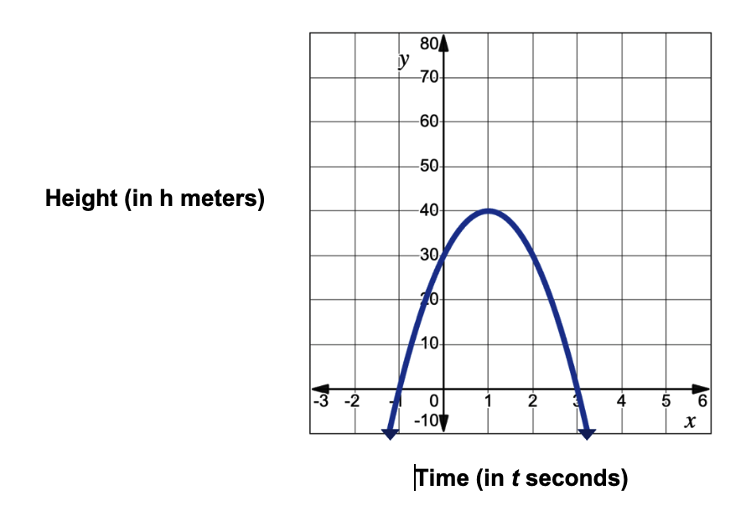
- Use a green highlighter to show on the $y$-axis the range of the function. What is the inequality that represents the range of this graph?

- Does it make sense for the range of the function to extend beyond 0 meters? Why or why not?

- Use an orange highlighter to show on the $x$-axis the domain of the function. What is the inequality that represents the range of this graph?

- Does it make sense for the domain of the function to be all real numbers? Why or why not?

Topic 11 Activity C - Teacher Directions
Domain Range matching game

Trio Match Activity:
- Make one copy of the Domain Range game, preferably on card stock. Then, cut apart the cards.
- Give each student in the class one of the cards - either a graph, a domain definition, or a range definition.
- At your signal, students move around the classroom to find their triad partners. Each triad will contain a domain, range, and graph.
- As an alternative, you may wish to provide students with only the graph and domain definitions. Students will then be attempting to form partners. Once they find their match, ask them to write the missing range definition.

Individual Student Activity:
- Copy the Domain Range game. Each student will get 1 copy of all the sheets.
- Provide each student with a copy of the Domain Range game sheets, scissors, and tape/glue/stapler.

HINT: To save time, suggest students only cut apart the domain and range definitions and tape them over the graphs.

- After students cut apart the individual cards, they need to match each graph with a domain and a range definition.
- Students will tape/glue/staple their triads to a sheet of paper when they have completed their matches.

4-Questions Activity: (variation of 20 questions)
- Place students into groups with 3 members.
- Provide students with a copy of page 1 or page 2 of the Domain Range game (graphs only).
- Student groups should draft a series of questions to ask the teacher.
  - The goal is to craft questions that can be answered with either “yes” or “no” only.
  - Students will be limited to 4 questions at most.
  - Based on the answers to their questions, students will try to determine the chosen graph.
  - Student groups that can determine the graph with the fewest questions could be awarded small prizes or points.

Fact or Fib:
- Provide students with a copy of page 1 or page 2 of the Domain Range game (graphs only).
- Identify a specific graph for students to examine.
- Make a statement about the graph (it could be true or false).
- Have students signal “thumbs up” if the statement is a fact or “thumbs down” if it is a fib.

Topic 12 - Regressions - A1.4C, A1.8B , A1.9E
(AR = Additional Resources page)

Activity objective(s) | Algebra 1 content | Directions - LINK TO RESOURCES
Activity A - Students will review the meaning of parts of a line of best fit including the correlation coefficient. | 3.1.5 Cool Down Activity  3.4.2 AR | - Have students review their understanding to linear equations by completing the six questions in the 3.1.5 Cool Down Activity.  - Then, have students access 3.4.2 Additional Resources that shows how the correlation coefficient describes data. The students should complete the Frayer-like model provided in Activity A to solidify their understanding.
Activity B - Students will review the process of entering a regression into Desmos (using quadratic equations). | 8.12.2 AR | - Have students access 8.12.2 Additional Resources to review how to calculate a regression for quadratic data and complete the flow chart in Activity B, part 1.  - Because the process is similar to what they would do for a linear or exponential regression, too, have students complete part 2 of the Activity.
Activity C - Students will practice using vocabulary associated with regressions and calculating the regressions in Desmos. | Discussion Supports - Card Sort  Calculating Lines of Best Fit | - Have students use the Discussion Supports activity to explore the linear Card Sort graphs.  - Then, have students practice calculating regressions using the Calculating Lines of Best Fit activity.  FYI - Desmos testing calculator link

Extra Activities
Use if time permits or if you would like a substitute activity.
- Algebra 1 Unit 3 project - Linear regressions
- Working Backwards - Finding Data Sets
- Summary Salad (Lead4ward) directions
p. 28 for how to calculate a quadratic regression (use with 8.12.2 Activity)
- Algebra 1 8.12.5 Practice problems (10 questions)
- Algebra 1 8.12.3 Additional Resources - make predictions using quadratic regression equations
- Have students create a Venn Diagram or Double Bubble that compares the process for calculating a linear regression with a quadratic regression.

Topic 12 Independent Activity A Student Page
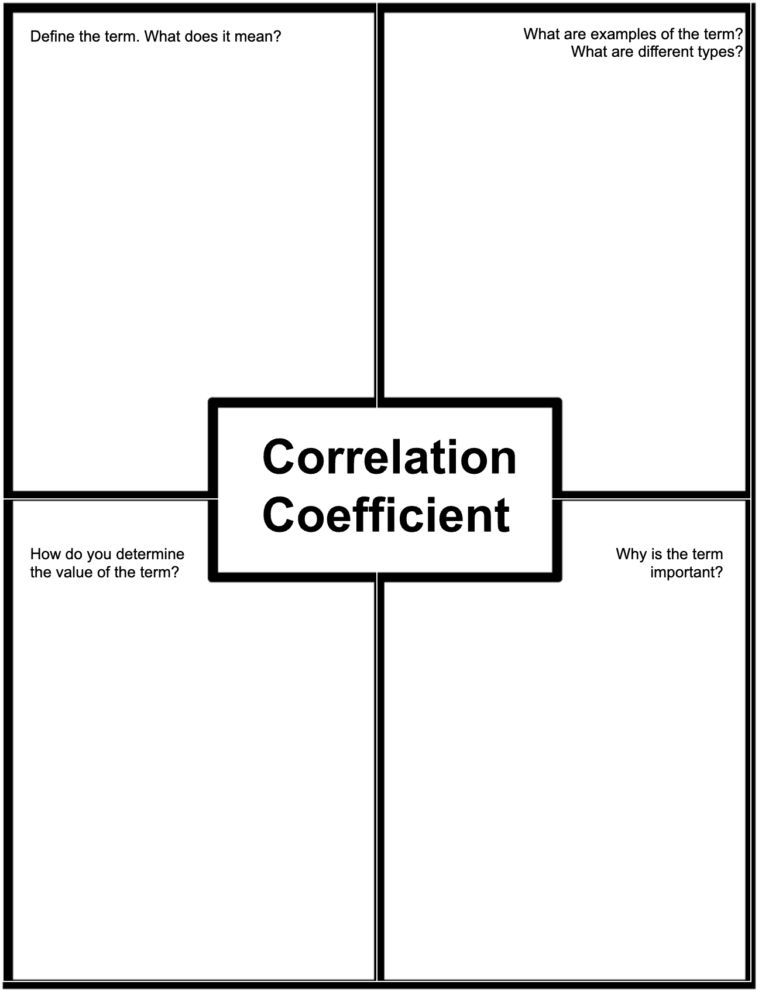

Topic 12 Independent Activity B Student Page
Part 1 - Access 8.12.2 Additional Resources in Algebra 1 and read the directions for how to calculate a quadratic regression using Desmos. Complete the flowchart below.
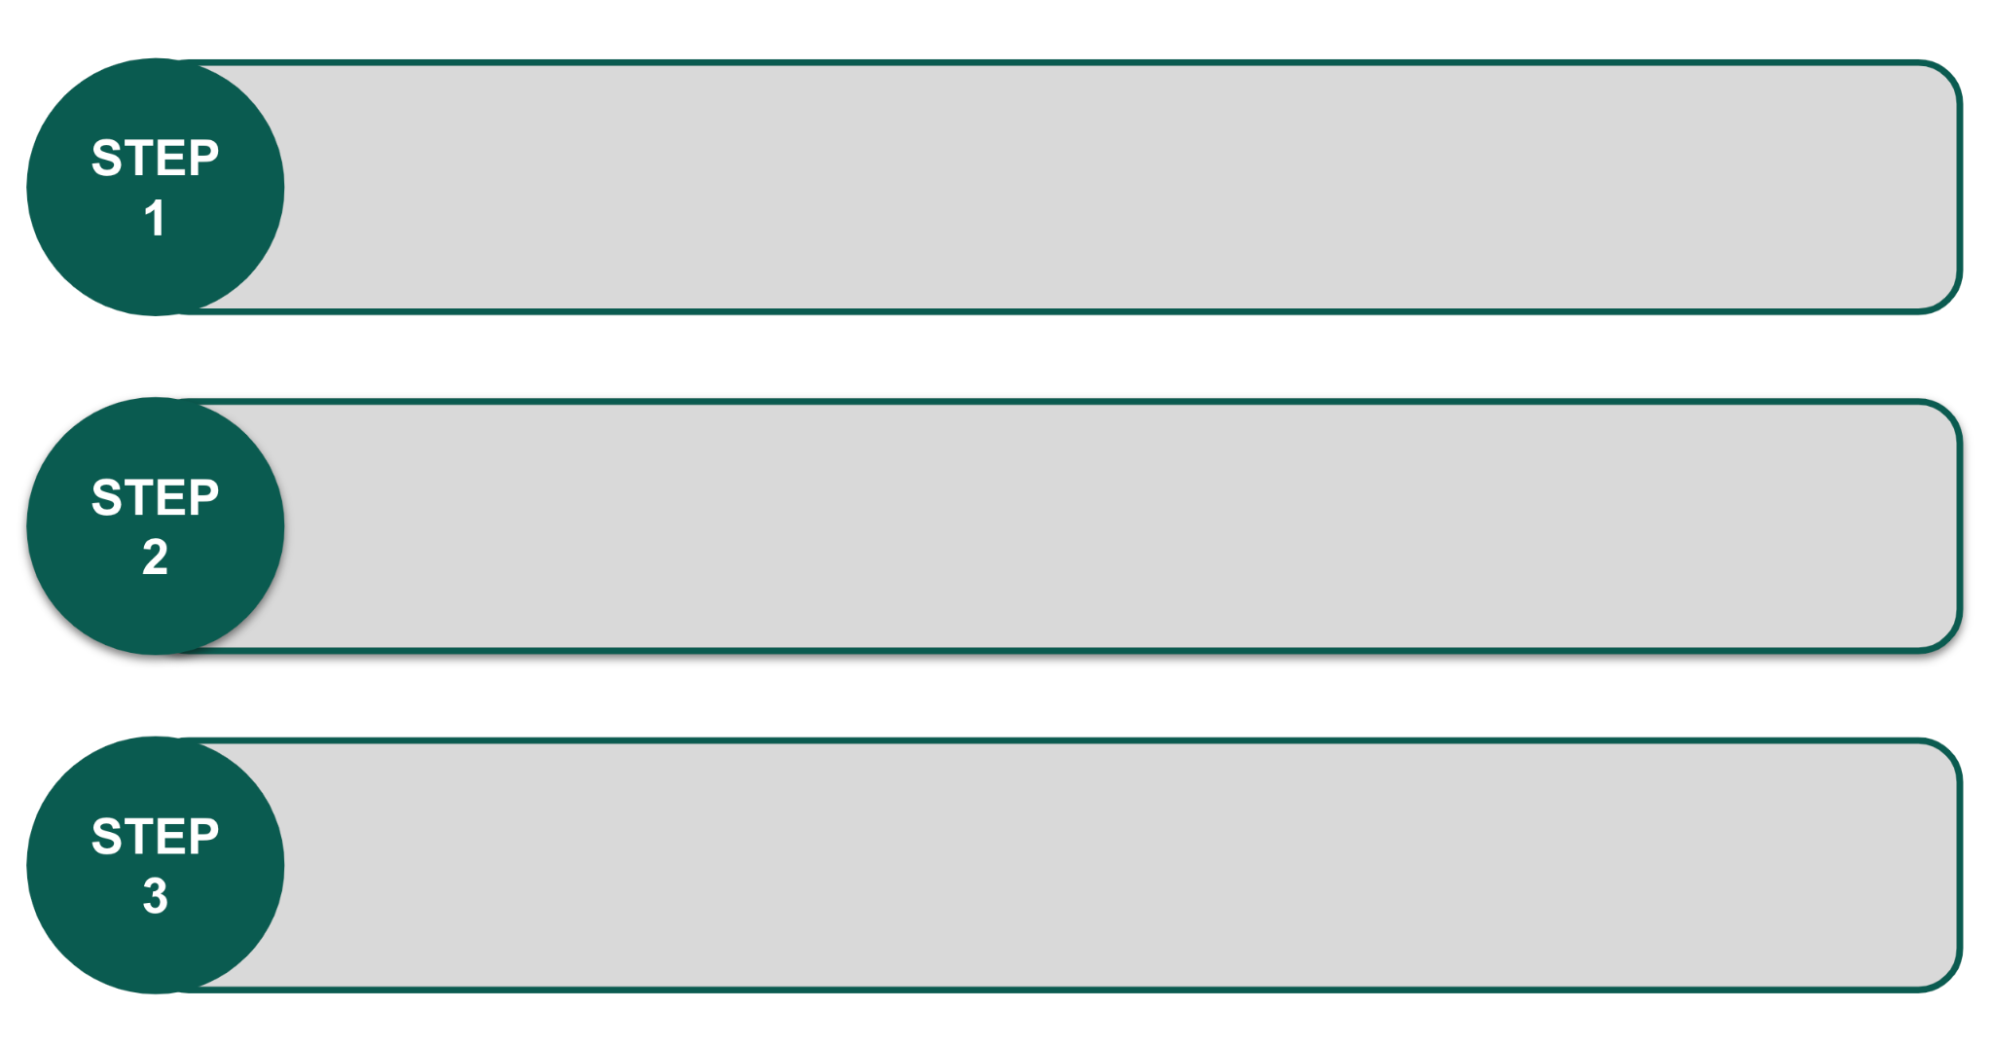

Part 2 - The process of calculating regressions for linear functions and exponential functions in Desmos is very similar to the process you just summarized for quadratic data.

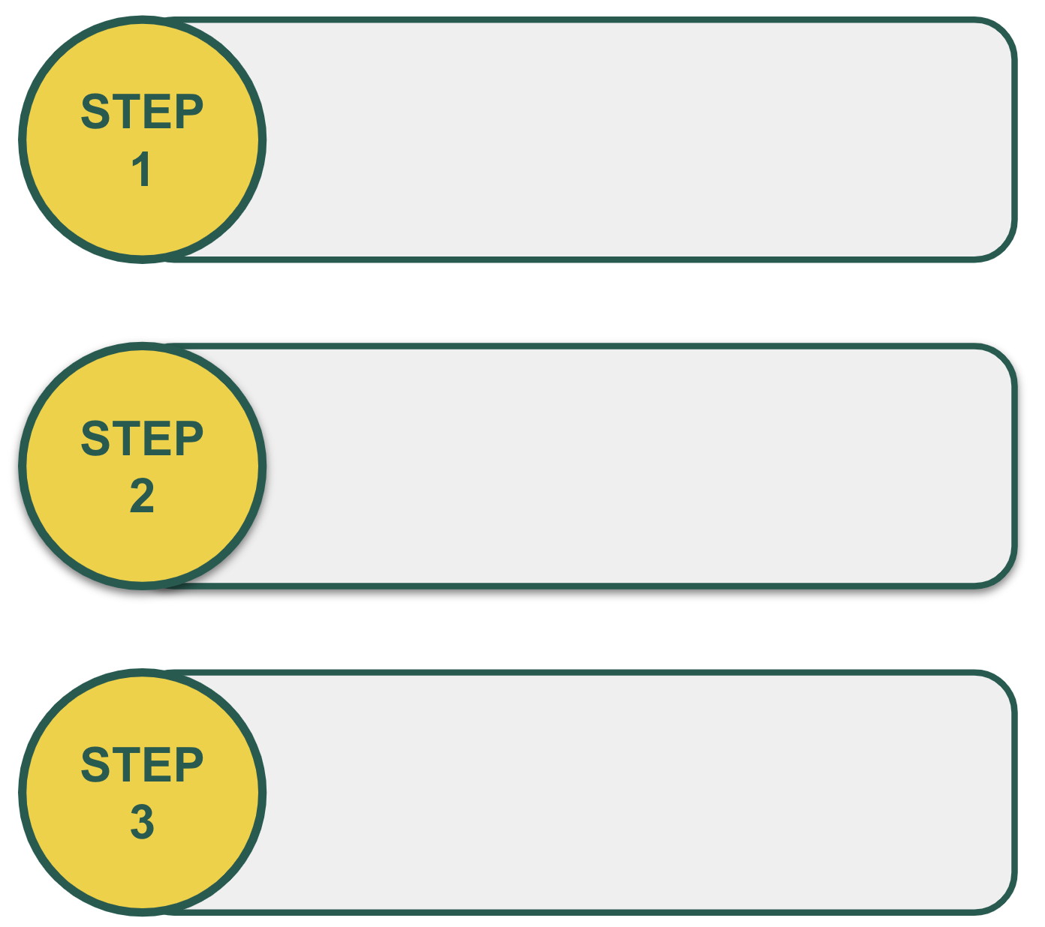
- Rewrite the steps above, but substitute the line of best fit equation $y_{1} \sim mx_{1} + b$ for the regression calculation in step 2. Use the steps to determine the line of best fit for the data given.
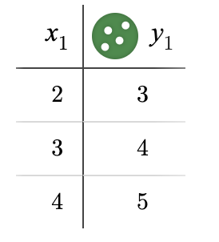

Line of best fit = _____________________
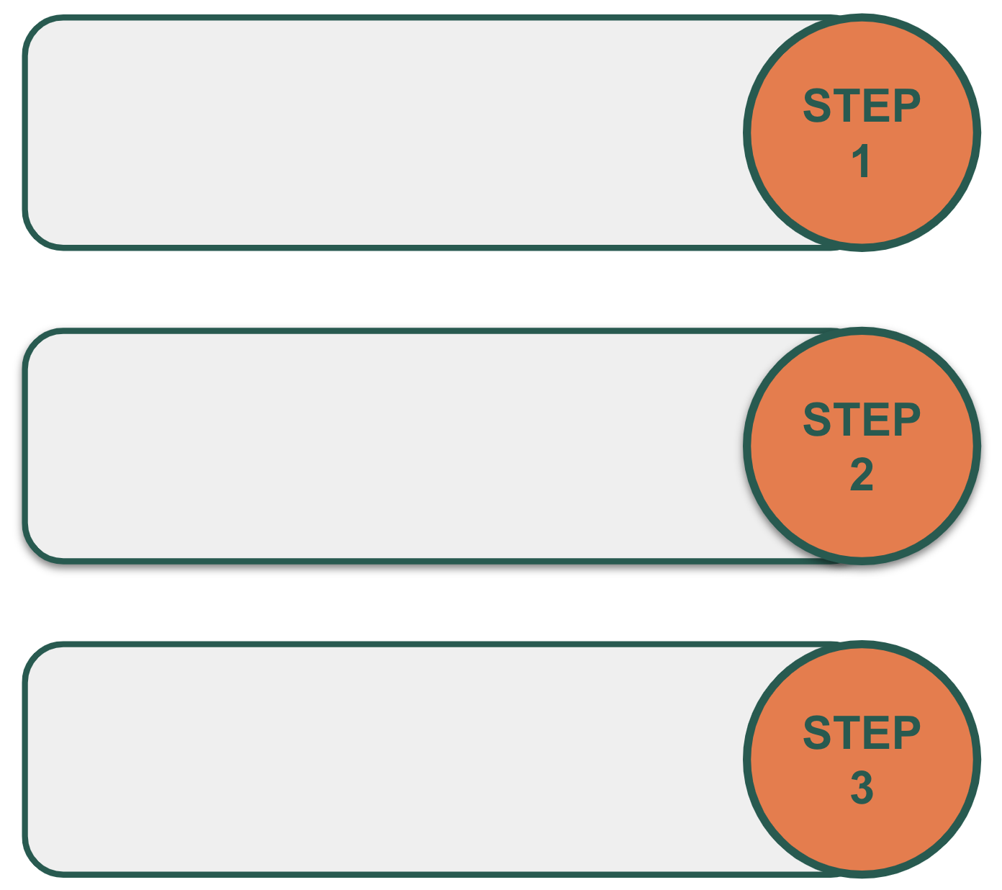
- Rewrite the steps above, but substitute the line of best fit equation $y_{1} \sim ab^{x_{1}}$ for the regression calculation in step 2. Use the steps to determine the curve of best fit for the data given.
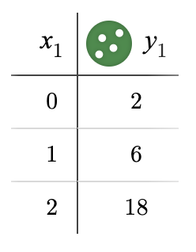

Line of best fit = _____________________

Topic 12 Activity C - Card Sort Activity
Part 1 - Engage with Vocabulary - Discussion Supports

- Place students into partners. Then, provide each student with the graphs for the Card Sort activity.
Card Sort graphs

- Ask students to sort the cards in three different ways:
  - Best to worst for representing with a linear model
  - Least to greatest slope of a linear model that fits the data well
  - Least to greatest y-intercept of a linear model that fits the data well

- Students should then explain their reasoning to their partner. Display the following sentence stems to support the interactions:
  - “___ should be before __ because …”
  - “I noticed ___, so I …”

- As students discuss their arrangements, listen for students that disagree with the sorting. Encourage them to challenge each other and use prompting questions to help them clarify their thinking, if needed.

- Then, have students write a sentence for each card that describes how y changes as x increases and whether the linear model is a good fit for the data or not.

Part 2 - Calculating Lines of Best Fit

- Have students remain with their partners from the previous activity (Engage with Vocabulary - Discussion Supports).

- Provide student pairs with the data for each card. Card Sort tables

- Have students calculate the lines of best fit for each data set.

Answers:
Card A: 𝑦=1.1979𝑥+1.3196
Card B: 𝑦=−0.4337𝑥+12.288
Card C: 𝑦=0.9749𝑥+4.6529
Card D: 𝑦=−2.063𝑥+16.144
Card E: 𝑦=1.1979𝑥+5.8196
- Ask students to explain the meaning of the value of the slope for each equation.

Answers:
- Card A: 𝑦=1.1979𝑥+1.3196. When 𝑥 is zero, 𝑦 is 1.3196. As 𝑥 increases by 1, 𝑦 increases, on average, by 1.1979.
- Card B: 𝑦=−0.4337𝑥+12.288. When 𝑥 is zero, 𝑦 is 12.288. As 𝑥 increases by 1, 𝑦 decreases, on average, by 0.4337.
- Card C: 𝑦=0.9749𝑥+4.6529. When 𝑥 is zero, 𝑦 is 4.6529. As 𝑥 increases by 1, 𝑦 increases, on average, by 0.9749.
- Card D: 𝑦=−2.063𝑥+16.144. When 𝑥 is zero, 𝑦 is 16.144. As 𝑥 increases by 1, 𝑦 decreases, on average, by 2.063.
- Card E: 𝑦=1.1979𝑥+5.8196. When 𝑥 is zero, 𝑦 is 5.8196. As 𝑥 increases by 1, 𝑦 increases, on average, by 1.1979.

- Give each set of partners an index card, then have student pairs create a “recipe card” that identifies the “ingredients” and steps they need to take to calculate the linear regression of a data set. Be sure they include specific academic vocabulary terms and how they know the strength of the correlation.

Topic 13 - Transformations of functions - A1.3E, A1.7C
(AR = Additional Resources page)

Activity objective(s) | Algebra 1 content | Directions - LINK TO RESOURCES
Activity A - Students will review the definitions associated with transformations of quadratic functions. | 7.12.2 AR  7.17.2 AR | - Have students complete a Self Assessment Anticipation guide in Activity A, part 1 for each vocabulary term listed below.  Vertical shift, Horizontal shift, Vertical stretch/compression, Horizontal stretch/compression, Standard form, Vertex form, Factored form (Root form)  - Then, have students access 7.12.2 Additional Resources and 7.17.2 Additional Resources and complete the Vocabulary Definition Cards for Vertical Shift and Horizontal Shift in Activity A, part 2.
Activity B - Students will review the definitions associated with transformations of quadratic functions. | 7.12.2 Activity  7.12.2 AR | - Have students access the activity on 7.12.2 Transformations with Quadratic Functions and complete questions 1-7. Encourage them to pay special attention to the questions about coefficients.  - Then, have them complete the Vocabulary Definition Cards for Vertical Stretch/Compression and Horizontal Stretch/Compression in Activity B. (If needed, it may be helpful for students to glance back at 7.12.2 AR.)  NOTE: Stretch and compressions may also be referred to as dilations
Activity C - Students will practice identifying transformations of quadratic functions. | Transformation Match game  Unit 7, Section D quiz | - Have students create transformation groups using the Transformation Match Game cards. This activity can be done virtually or with paper cards. Alternatively, it can be completed as a hand signal game.  - Have students complete the Unit 7 Section D quiz. (6 questions)

Extra Activities
Use if time permits or if you would like a substitute activity.
- SWAT - Quadratic Transformations game
- Quad Transformations Pyramid game
- Algebra 1 7.17.6 Practice problems
- Algebra 1 Unit 7 Quiz
- Algebra 1 4.11.2 AR - transformation of linear equations & Algebra 1 4.11.5 Practice
- Algebra 1 5.12.2 Activity - transformation of exponential equations

Topic 13 Independent Activity A - Student Page
Part 1 - Self-assessment anticipation guide - Transformations
Complete the Self Assessment Anticipation guide for each vocabulary term listed below.

Rate the following terms as follows:
- I’ve never heard the term before.
- I’ve heard the term, but I don’t know what it means.
- I understand the meaning of this term, but I cannot use it correctly in a sentence or explanation.
- I can apply this term correctly in a mathematics problem or graph.

Vertical shift | 1 2 3 4
Horizontal shift | 1 2 3 4
Vertex form | 1 2 3 4
Factored form (Root form) | 1 2 3 4
Vertical stretch/compression | 1 2 3 4
Horizontal stretch/compression | 1 2 3 4
Standard form of a quadratic | 1 2 3 4

Part 2 - Vocabulary Definition Cards
Access 7.12.2 Additional Resources and 7.17.2 Additional Resources and complete the Vocabulary Definition Cards for Vertical Shift and Horizontal Shift.
Vocabulary Word/Concept | Vertical shift
My Understanding (circle one): | - I’ve never heard the term before.  - I’ve heard the term, but I don’t know what it means.  - I understand the meaning of this term, but I cannot use it correctly in a sentence or explanation.  - I can apply this term correctly in a mathematics problem or graph.
Explanation/Description

Why I scored it the way I did:

Illustration

How to determine/find the word in a problem:

Vocabulary Word/Concept | Horizontal shift
My Understanding (circle one): | - I’ve never heard the term before.  - I’ve heard the term, but I don’t know what it means.  - I understand the meaning of this term, but I cannot use it correctly in a sentence or explanation.  - I can apply this term correctly in a mathematics problem or graph.
Explanation/Description

Why I scored it the way I did:

Illustration

How to determine/find the word in a problem:

Topic 13 Independent Activity B - Student Page
Access the activity on 7.12.2 Transformations with Quadratic Functions and complete questions 1-7. Pay special attention to the questions about coefficients.

Then, complete the Vocabulary Definition Cards for Vertical Stretch/Compression and Horizontal Stretch/Compression.

Vocabulary Word/Concept | Vertical stretch/compression  (Vertical dilation)
My Understanding (circle one): | - I’ve never heard the term before.  - I’ve heard the term, but I don’t know what it means.  - I understand the meaning of this term, but I cannot use it correctly in a sentence or explanation.  - I can apply this term correctly in a mathematics problem or graph.
Explanation/Description

Why I scored it the way I did:

Illustration

How to determine/find the word in a problem:

Vocabulary Word/Concept | Horizontal stretch/compression  (Horizontal dilation)
My Understanding (circle one): | - I’ve never heard the term before.  - I’ve heard the term, but I don’t know what it means.  - I understand the meaning of this term, but I cannot use it correctly in a sentence or explanation.  - I can apply this term correctly in a mathematics problem or graph.
Explanation/Description

Why I scored it the way I did:

Illustration

How to determine/find the word in a problem:

Topic 13 Activity C - Teacher Directions

Match Game - Transformations

- To prepare cards, create a print out of slides 2 - 35 - select “handouts - 9 slides per page.” To save time, pre-cut the cards for students and place them in baggies.
- Place students into groups of 2. Provide each pair of students with a set of cards.
- Ask students to create groups of cards based on the following categories:
  - Mathematical terms
  - Everyday understanding
  - Hand icons/representations
  - Sample equations
  - Sample graphs
Some cards may be included in more than one group.
NOTE: Students may struggle with identifying/comparing vertical stretches with horizontal compressions, etc.
Alternative implementation: Students can also group the cards together digitally. Have them select the View tab then, Grid View. Students can then drag and drop the slides into any order they prefer.

Alternative implementation: Display slides 2-7 to review the categories of transformations. Then, review the hand motions that can be used to demonstrate each of the transformations with slides 14 - 19. Now - display different equations (slides 20-27) or graphs (slides 28-35) and have students use the hand signals to denote the type of transformation that is displayed.

