1.12.5 Activity Slips

Instructions
Print a set of slips for each group. Cut the slips so each group has 8 slips.

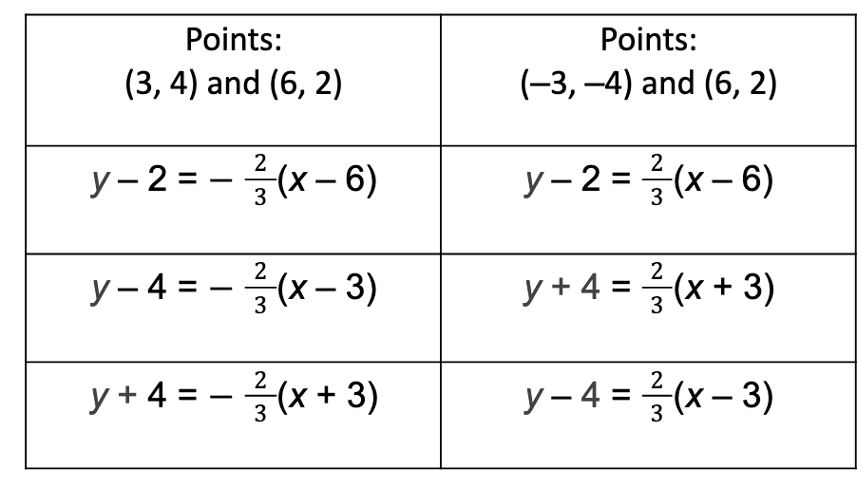Accessible Table Content:
Column 1 | Column 2
Points: $\left(3,4\right)$ and $\left(6,2\right)$ | Points: $\left(-3,-4\right)$ and $\left(6,2\right)$
Equation: $y-2=-\frac{2}{3}(x-6)$ | Equation: $y-2=\frac{2}{3}(x-6)$
Equation: $y-4=-\frac{2}{3}(x-3)$ | Equation: $y+4=\frac{2}{3}(x+3)$
Equation: $y+4=-\frac{2}{3}(x+3)$ | Equation: $y-4=\frac{2}{3}(x-3)$

