Unit 5 Family Support Materials
Get acquainted with the topics and concepts your student will be learning during Unit 5

Introduction to Exponential Functions
In this unit, your student is introduced to exponential relationships. Earlier, your student studied what mathematicians call linear relationships, where they start with a quantity and add or subtract the same amount repeatedly. In an exponential relationship, they start with a quantity and multiply by the same amount repeatedly.
Exponential relationships are represented by equations in the form $y=a∙b^{x}$, where $a$ is the quantity you start with, $b$ is the growth factor that you are going to multiply it by, and $x$ is how many times you are going to multiply by $b$. If $b$ is greater than 1, the amount is growing and if $b$ is less than 1 and greater than zero, the amount is shrinking. When $b$ is equal to 1, the amount is staying the same.

Here’s an example of an exponential relationship
If you start with 50 bees in your apiary (bee garden), and the number of bees doubles each year, how many bees would you have in 5 years?
- Let $y$ represent the number of bees and $x$ represent time in years.
- The starting amount is 50 bees and the multiplier is 2.
$$y=a∙b^{x}$$
$=50∙2^{5}$
$=50∙2∙2∙2∙2∙2$
$=1600$bees after 5 years

Let’s try it using a graph

- While multiplication works well for a situation like this, where we are multiplying by 2 five times, a graph can also be a useful tool. If you wanted to know how many bees you would have in 10 years, you could graph $y=50∙2^{x}$ and see how many bees there are in 10 years.  - Graphing is especially helpful when looking a long way into the future or when you want to know when something will happen, like when the bee population will reach 1 million. | 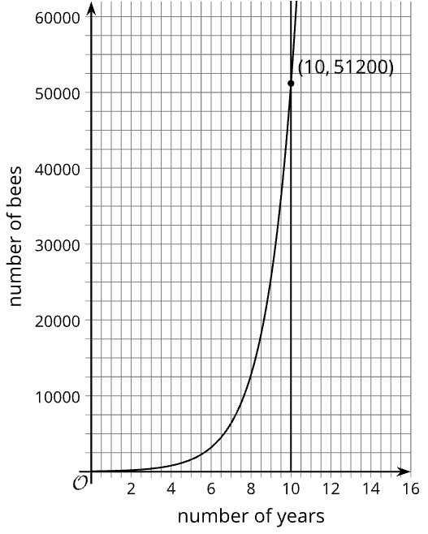

Apply

Try this task with your student
Florida is having a problem with a toxic green algae that is floating on their waterways, contaminating the water and killing the marine life. Kiran lives on a small lake in south Florida. One day he noticed the algae floating on a 3 square meter area of the lake. A month later, the algae had doubled in size, growing to 6 square meters.

Complete the following questions
- If the doubling pattern continues, how many square meters of the lake will be covered in algae in 4 months?
- If the surface area of the lake is about 1,500 square meters, after how many months will the entire lake be covered?

Use this space to experiment with strategies to solve the questions

*You can find the answers on the next page

Hide the answers until you have attempted the questions
- This can be solved using a variety of strategies. You could use a table, an equation, or a graph. Let $x$ represent the time in months and $y$ represent the area in square meters. $y=3∙2^{x}$. Substitute 4 for $x$ and solve for $y$, which yields 48.
Time (months) | Area (square meters)
0 | 3
1 | 6
2 | 12
3 | 24
4 | 48
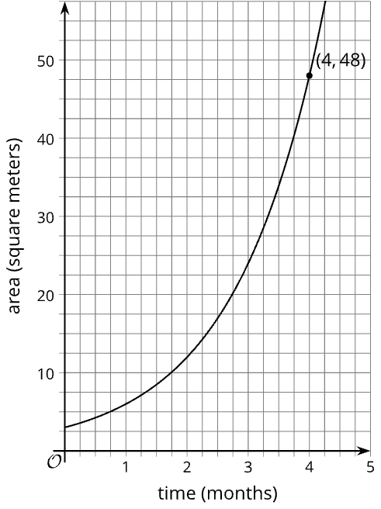
- Just as with the first question, there are several strategies for finding when the algae will cover the whole lake.
- Extending the graph, adding the graph of $y=1500$, and finding where they intersect is a nice way to find the month.
- In just under 9 months, the algae will cover 1,500 square meters of the lake.
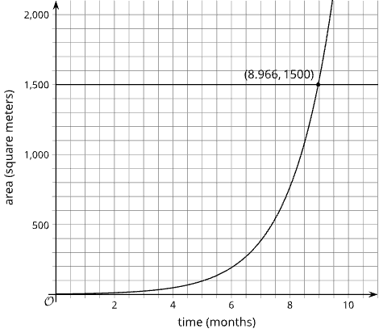

Review

Video lesson summaries for Unit 5: Introduction to Exponential Functions
Each video highlights key concepts and vocabulary that students learn across one or more lessons in the unit. The content of these video lesson summaries is based on the written Lesson Summaries found at the end of lessons in the curriculum. The goal of these videos is to support students in reviewing and checking their understanding of important concepts and vocabulary.

Here are some possible ways families can use these videos:
- Keep informed on concepts and vocabulary students are learning about in class.
- Watch with their students and pause at key points to predict what comes next or think up other examples of vocabulary terms

Video Title | Related Lessons
Exponential Relationships | - Representing Exponential Growth  - Representing Exponential Decay  - Negative Exponents and Scientific Notation  - Analyzing Graphs
Defining Exponential Functions | - Exponential Situations as Functions  - Interpreting Exponential Functions  - Looking at Rates of Change  - Changes Over Equal Intervals
Graphs of Exponential Functions | - Modeling about Exponential Behavior  - Reasoning about Exponential Graphs, Part(s) 1 & 2  - Which One Changes Faster?  - Changes Over Equal Intervals

 | If needed, access the digital version of this page at https://openstax.org/r/unit5-family

