Unit 4 Student Diagnostic
These materials, when encountered before the denoted lesson, support access to the lesson and identify potential areas where additional support may be required. Note that the content in these lesson diagnostics represents prerequisite skills and does not address the required rigor for full mastery of the on-grade level standards.
Your students may benefit from using these materials in conjunction with the Unit Overview and Readiness page (quiz and mini-lessons).

Lesson 4.1: Describing and Graphing Situations 2
Lesson 4.2: Function Notation 3
Lesson 4.3: Interpreting & Using Function Notation 4
Lesson 4.4: Using Function Notation to Describe Rules, Part 1 5
Lesson 4.5: Using Function Notation to Describe Rules, Part 2 6
Lesson 4.6: Features of Graphs 7
Lesson 4.7: Finding Slope 8
Lesson 4.8: Using Graphs to Find Average Rate of Change 9
Lesson 4.9: Interpreting and Creating Graphs 10
Lesson 4.10: Comparing Graphs 12
Lesson 4.11: Graphing a Function Using Transformations 13
Lesson 4.12: Domain and Range, Part 1 14
Lesson 4.13: Domain and Range, Part 2 15
Lesson 4.14: Sequences 17
Lesson 4.15: Introducing Geometric Sequences 18
Lesson 4.16: Different Types of Sequences 20
Lesson 4.17: Sequences are Functions 21
Lesson 4.18: The nth Term of an Arithmetic Sequence 23

Lesson 4.1: Describing and Graphing Situations
Match the graph to the description of the situation.
Graph A  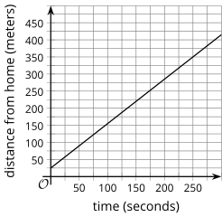 | Graph B  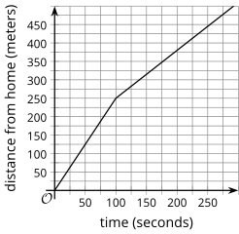 | Graph C  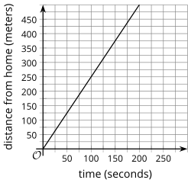
Graph D  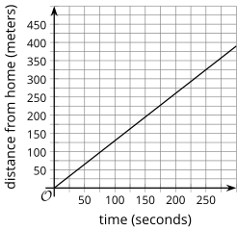 | Graph E  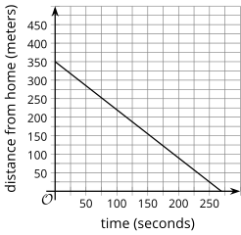 | Graph F  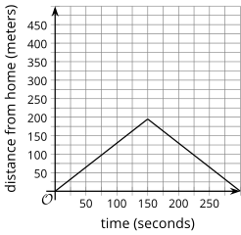
- Mai begins at home and walks away from her home at a constant rate.

- Jada begins at a neighbor’s house and walks away from home at a constant rate.

- Clare begins her walk at school and walks home at a constant rate.

- Elena begins at home and runs away from her home at a constant rate.

- Lin begins at home and walks away from home for a while, then walks back home.

- Priya begins at home and runs away from home, then walks for a while.

Lesson 4.2: Function Notation
For questions 1 - 4, use the following scenario.
The temperature for a city is a function of time after midnight. The graph shows the values on a particular spring day.
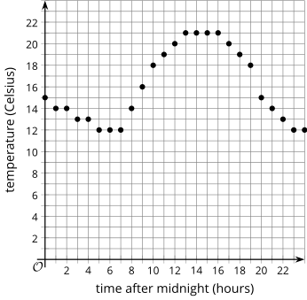
- What does the point on the graph where $x = 15$ mean?

- What is the temperature at 5 p.m.?

- What is the hottest it gets on this day?

- What is the coldest it gets on this day?

Lesson 4.3: Interpreting & Using Function Notation
For questions 1 - 5, use the following information to write each of the coordinate pairs in function notation.
A function is given by the equation $y = f(x)$.
- (2, 3)

- (-1, 4)

- (0, 3)

- (4, 0)

- ($\frac{2}{3}$, $\frac{3}{4}$)

For questions 6 - 8, use the following information to write the coordinate pair for the point associated with the given values in function notation.
A function is given by the equation $h(x) = 5x - 3$.
- $h(3)$

- $h(-4)$

- $h(\frac{2}{5})$

Lesson 4.4: Using Function Notation to Describe Rules, Part 1
For question 1 - 4, use the following scenario.
A machine in a laboratory is set to steadily increase the temperature inside. The temperature in degrees Celsius inside the machine after being turned on is a function of time, in seconds, given by the equation $f(t) = 22 + 1.3t$.
- What does $f(3)$ mean in this situation?

- Find the value of $f(3)$ and interpret that value.

- What does the equation $f(t) = 35$ mean in this situation?

- Solve the equation to find the value of $t$ for the previous question.

Lesson 4.5: Using Function Notation to Describe Rules, Part 2
Use the equations to complete the table of values.
$$y = 3x - 2$$ | $$y = 5 - 2x$$
  $$x$$ | $$y$$
  1 | _
  3 | _
  -2 | _
  $$x$$ | $$y$$
  0 | _
  3 | _
  5 | _
$$y = \frac{1}{2}x + 2$$ | $$y = 2x - 10$$
  $$x$$ | $$y$$
  -4 | _
  3 | _
  6 | _
  $$x$$ | $$y$$
  3 | _
  7 | _
  -8 | _

Lesson 4.6: Features of Graphs
This graph shows the percentage of the workforce that is unemployed in the United States and Michigan for several years.
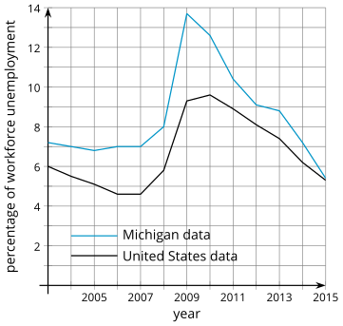
- For the United States, what is the highest point on the graph?

- What do the values for the highest point mean in the situation?

- For the United States, what is the lowest point on the graph?

- What do the values for the lowest point mean in the situation?

- For Michigan, what is the highest point on the graph? What does the point mean in this situation?

- For Michigan, what is the lowest point on the graph? What does the point mean in this situation?

Lesson 4.7: Finding Slope
Examine the graphs of the lines given below.
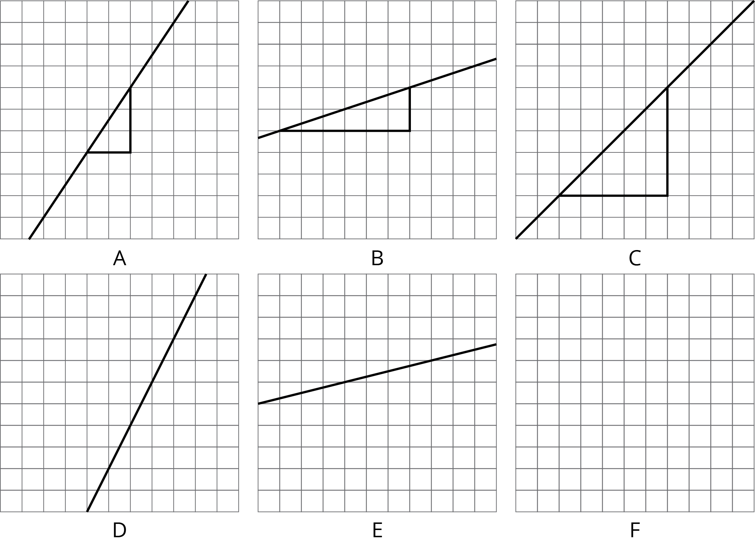
- Label each line shown with a slope from this list:
  - 1/3
  - 2
  - 1
  - 0.25
  - 3/2
  - 1/2
- One of the given slopes does not have a line to match. Draw a line with this slope on the empty grid.

Lesson 4.8: Using Graphs to Find Average Rate of Change
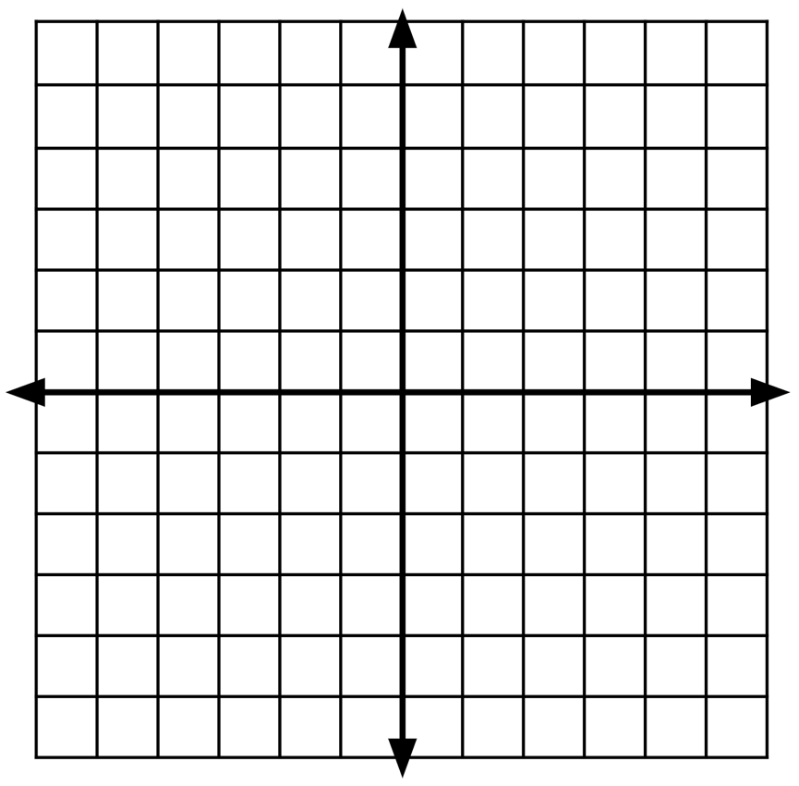
Find the slope of the line that connects the given points. If needed, use the provided graph.
- (0, 0) and (3, 2)

- (4, 2) and (10, 7)

- (1, -2) and (2, 5)

- (-3, 4) and (-5, -2)

- (8, 3) and (10, -9)

Lesson 4.9: Interpreting and Creating Graphs
For questions 1 - 3, examine the following graphs representing how busy restaurants are at different times of the day.
Restaurant A  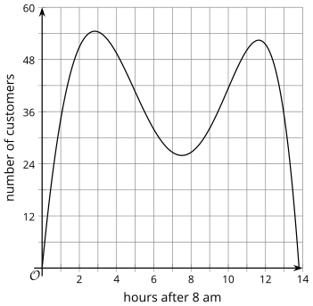 | Restaurant B  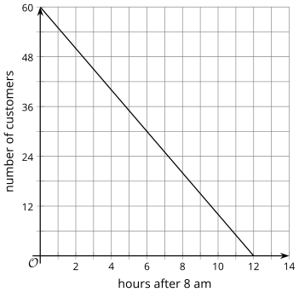
Restaurant C  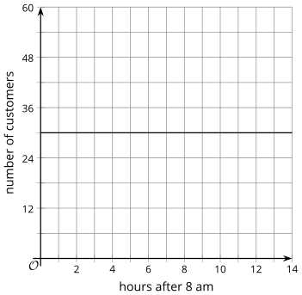 | Restaurant D  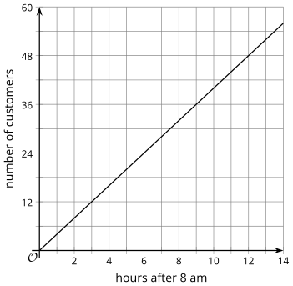

For each situation, select the best restaurant and explain your reasoning.
- Which restaurant is busy in the morning, then has fewer customers in the evening?
- Restaurant A
- Restaurant B
- Restaurant C
- Restaurant D
Explanation:

- If Lin’s mom wants to go to a popular dinner restaurant, which restaurant should Lin take her mom to eat?
- Restaurant A
- Restaurant B
- Restaurant C
- Restaurant D
Explanation:

- Noah’s dad prefers breakfast places with few customers so that he can start on work while eating. Which restaurant should Noah’s dad go to for breakfast?
  - Restaurant A
  - Restaurant B
  - Restaurant C
  - Restaurant D
Explanation:

Lesson 4.10: Comparing Graphs
For each pair of numbers, write =, < or > in the blank to make a true equation or inequality. Be prepared to share your reasoning.
- -6 ________ -9

- $\frac{7}{3}$ ________ $\frac{13}{6}$
- 5.2 ________ $\frac{53}{11}$
- 5(3 – 6) ________ 15 – 6
For questions 5 - 7, use the following function.
$$f(x) = 5 - 2x$$

- $f(3)$ _________ $f(5)$

- $f(-3)$ _________ $f(-4)$

- $f(-1)$ _________ $f(1)$

Lesson 4.11: Graphing a Function Using Transformations
The following linear equations are given in point-slope form. Identify the point and slope that is given in each equation.
Equation | Point | Slope
$$(y - 3) = \frac{2}{3}(x - 6)$$ | _ | _
$$(y + 1) = -2(x - 7)$$ | _ | _
$$(y - 2) = -\frac{1}{2}(x + 4)$$ | _ | _
$$y - 4 = \frac{5}{2}(x + 8)$$ | _ | _
$$y - 0 = 1(x - 0)$$ | _ | _

Lesson 4.12: Domain and Range, Part 1
For each function, draw a line to all of the possible inputs that could be used in the function. Be prepared to explain your reasoning for whether you include each input or not.
↓ Functions | Possible Inputs ↓
$f(person height) =$ the person’s height in feet | 0
$$g(x) = 2x + 1$$ | -1
$C(\#students in class)$ = 1.99 $∙$(# students in class) | 6
$P(equilateral triangle's side length) =$ 3 $∙$ (side length) | 9.3

Lesson 4.13: Domain and Range, Part 2
For questions 1-3, examine the graph. Then, for the graph, give an example value that is in the domain, is not in the domain, is in the range, and is not in the range.
1.  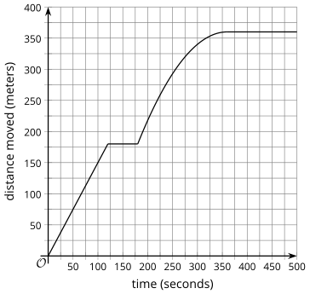 | Example in domain:
 | Example NOT in domain:
 | Example in range:
 | Example NOT in range:

2.  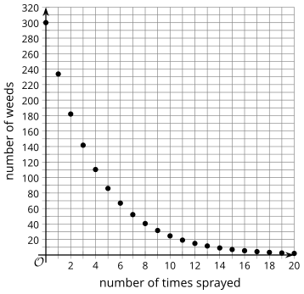 | Example in domain:
 | Example NOT in domain:
 | Example in range:
 | Example NOT in range:

3.  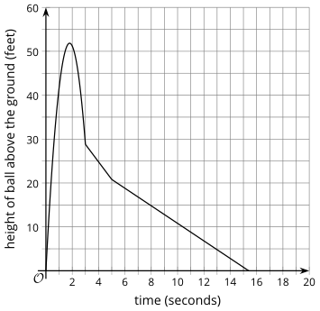 | Example in domain:
 | Example NOT in domain:
 | Example in range:
 | Example NOT in range:

Lesson 4.14: Sequences
For questions 1 - 4, fill in the blanks to continue the patterns.
1) 3, 6, 9, ______, ______

2) 1, ______, 9, 13, ______

3) 3, 6, 12, ______, ______

4) 128, 64, ______, ______, 8

Lesson 4.15: Introducing Geometric Sequences
- Identify all the expressions that are equivalent to $2 ∙ 2 ∙ 2 ∙ 2 ∙ 2 ∙ 2$.
Expression | Equivalent | Not Equivalent
$$2^{6}$$ | _ | _
$$2 ∙ 6$$ | _ | _
$${(2^{2})}^{3}$$ | _ | _
$$2^{3} + 2^{3}$$ | _ | _
$$2^{2} + 2^{2} + 2^{2}$$ | _ | _
$$6^{2}$$ | _ | _
$$2^{3} ∙ 2^{3}$$ | _ | _
$${(2^{3})}^{2}$$ | _ | _
- Which expressions equal $8^{0}?$ Select four equivalent expressions.
- $1$
- $0$
- $8^{3} ∙ 8^{-3}$
- $\frac{8^{2}}{8^{2}}$
- ${11}^{0}$

- Which expressions equal $3^{10}?$ Select four equivalent expressions.
- $3^{5} ∙ 3^{2}$
- ${(3^{5})}^{2}$
- $3^{7} ∙ 3^{3}$
- $3^{13} ∙ 3^{-3}$
- $\frac{3^{10}}{3^{0}}$

Lesson 4.16: Different Types of Sequences
For questions 1 - 2, examine the patterns with their first 5 terms listed. For each pattern, describe a way to produce each new term from the previous term.
- Pattern A: 5, 8, 11, 14, 17, …

- Pattern B: ½ , 1, 2, 4, 8, …

For each of the equations in questions 3 - 4, find the value of $y$ when $x = 1$, 2, and 3.
- $y = 3x - 4$

- $y = 10 - 2x$

Lesson 4.17: Sequences are Functions
For questions 1 - 3, use the following function.
$$f(x) = -3x + 7.$$

- What is $f(0)$?

- What is $f(-5)$?

- What is $x$ when $f(x) = -20$?

For questions 4 - 6, use the following scenario.
A city bus charges $0.25 per ride if you first buy the $10 discount card. Let B be the total cost, in dollars, of taking n rides on the bus.
- Complete the table of values for function $B$ for several inputs.
$$n$$ | $$B$$
0 | 10
2 | _
4 | _
10 | _
- Sketch a graph of the total cost $B$, in dollars, for the number of bus rides from 0 to 10.
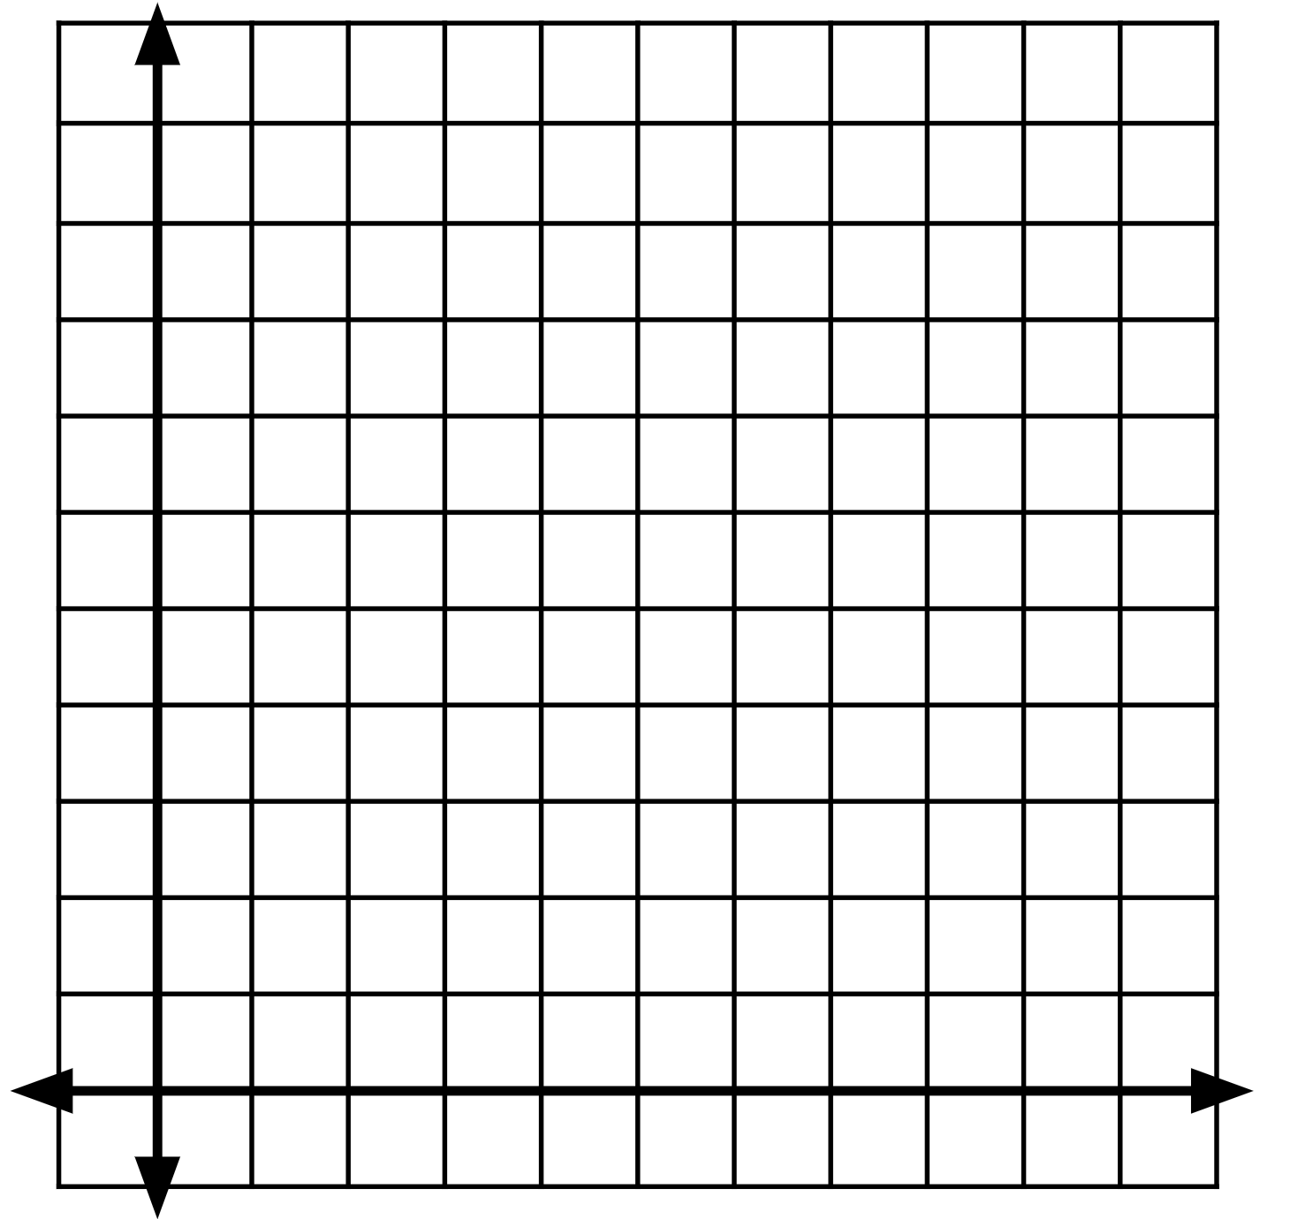
- Write an equation for $B$ as a function of $n$.

Lesson 4.18: The nth Term of an Arithmetic Sequence
Examine the graph of a pattern of numbers where $V$ is a function of $n$.
The first point is (0, 1).
- Plot the next 2 points on the graph that follow the pattern. 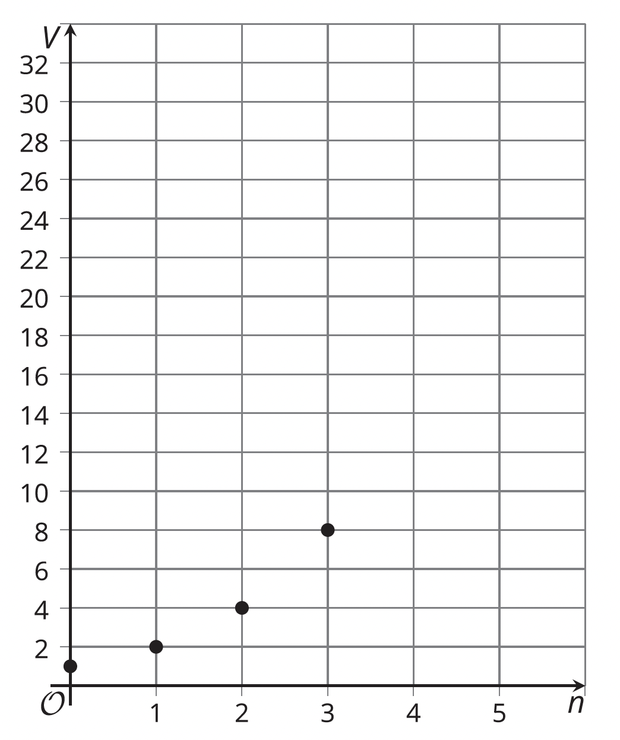
- Write an equation to describe the relationship between $V$ and $n$.

