Unit 7 Family Support Materials
Get acquainted with the topics and concepts your student will be learning during Unit 7.

Introduction to Quadratic Functions
In this unit, students learn about quadratic functions. Earlier, they learned about linear functions that grow by repeatedly adding or subtracting the same amount and exponential functions that grow by repeatedly multiplying by the same amount.
Quadratic functions also change in a predictable way. Here, the number of small squares in each step is increasing by 3, then 5, then 7, and so on. How many squares are in Step 10? How many in Step n?
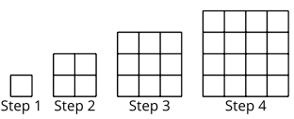

Here is a table that shows the pattern
Step number | 1 | 2 | 3 | 4 | 10 | $$n$$
Number of small squares | 1 | 4 | 9 | $4∙4$ or $16$ | $10∙10$ or $100$ | $n∙n$or $n^{2}$

In this unit, students will also learn about some real-world situations that can be modeled by quadratic functions.  For example, when you kick a ball up in the air, its distance above the ground as time passes can be modeled by a quadratic function. Study the graph. The ball starts on the ground because the height is 0 when time is 0. The ball lands back on the ground after 2 seconds. After 1 second, the ball is 5 meters in the air. | 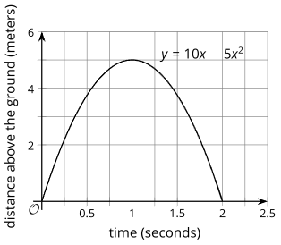
Both of the following expressions give the ball’s distance above the ground: $5x(2-x)$and $10x-5x^{2}$, where $x$ represents the number of seconds since it was thrown. Quadratic expressions are most recognizable when you can see the “squared term,” $-5x^{2}$, as shown in $10x-5x^{2}$.
Your student will learn how to solve quadratics in the next two units.

Apply

Try this task with your student
The equation $h=1+25t-5t^{2}$ models the height in meters of a model rocket $t$ seconds after it is launched in the air. Here is a graph representing the equation.
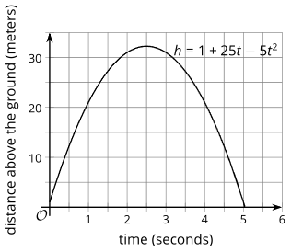

Complete the following questions
- What was the approximate height of the rocket above the ground at the time it was launched?
- About how high did it go into the air?
- Approximately when did the rocket land back on the ground?
*You can find the answers on the next page

Hide the answers until you have attempted the questions
- 1 meter
- about 32 meters
- a little more than 5 seconds after launch

Review

Video lesson summaries for Unit 7: Introduction to Quadratic Functions
Each video highlights key concepts and vocabulary that students learn across one or more lessons in the unit. The content of these video lesson summaries is based on the written Lesson Summaries found at the end of the lessons in the curriculum. The goal of these videos is to support students in reviewing and checking their understanding of important concepts and vocabulary.

Here are some possible ways families can use these videos:
- Families can stay informed on concepts and vocabulary students are learning about in class.
- Families can watch with their students and pause at key points to predict what comes next or think up other examples of vocabulary terms.

Video Title | Related Lessons
Introducing Quadratic Functions | - Introduction to Quadratic Relationships  - Building Quadratic Functions from Geometric Patterns  - Comparing Quadratic and Exponential Functions
Building Quadratic Functions | - Building Quadratic Functions to Describe Situations, Part(s) 1& 2  - Domain, Range, Vertex, and Zeros of Quadratic Functions
Working with Quadratic Expressions | - Equivalent Quadratic Expressions  - Standard Form and Factored Form
Graphing Quadratic Equations | - Graphs of Functions in Standard and Factored Form  - Graphing from the Factored Form
Graphing Standard Form | - Graphing the Standard Form, Part(s) 1 & 2  - Graphs that Represent Situations
Vertex Form | - Vertex Form  - Graphing from the Vertex Form  - Changing the Vertex

 | If needed, access the digital version of this page at https://openstax.org/r/unit7-family

