Unit 4 Family Support Materials
Get acquainted with the topics and concepts your student will be learning during Unit 4

Functions
In this unit, students learn about functions, building on their work in middle school. A function is a relationship between an input and an output, where for every input there is exactly one output.

Here are some examples of functions:
- The relationship between a name (input) and the number of letters in it (output). If the input is “Maya Angelou,” the only possible output is 11.
- The relationship between the number of seconds since an oven was turned on (input) and the temperature in the oven (output). For example, 50 seconds after the oven was turned on, the temperature in the oven was 124 degrees Fahrenheit.
We often use the phrase “(output) is a function of (input)” to express how the input and output sets are related. For example, “the number of letters in a name is a function of the name,” or “the temperature in the oven is a function of time since it was turned on.”
To make it easier to talk about and work with functions, we often use letters to name them, and we use function notation to represent their input and output.
Suppose $f$ is a function that tells us the distance, in feet, that a child ran over time, $t$, in seconds. So: $f$ is the name of the function, time is the input, and distance is the output.

Here is how we represent this information in function notation
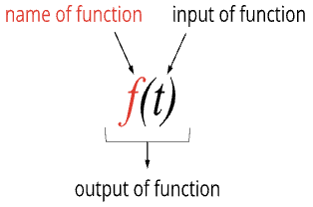 | The notation is read “$f$ of $t$.“

Here are examples of some things we can say with function notation
Statement | Meaning | Interpretation
$$f(t)$$ | The output of $f$ when $t$ is the input | The distance run after $t$ seconds
$$f(3)$$ | The output of $f$ when 3 is the input | The distance run after 3 seconds
$$f(6)=14$$ | When the input is 6, the output of $f$ is 14. | In 6 seconds, the child ran 14 feet.
$$f(t)=50$$ | When the input is $t$, the output of 𝑓 is 50. | In $t$ seconds, the child ran 50 feet.

A function can also be represented with a graph, here is a graph of function $f$.
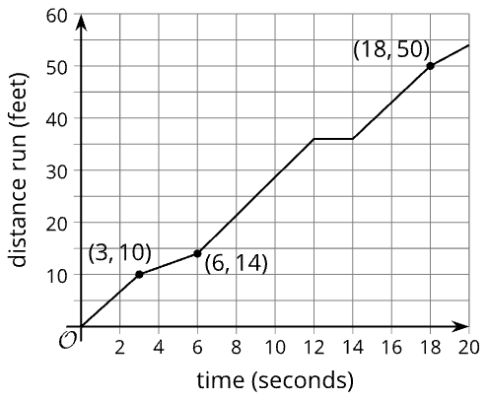 | - We can use it to estimate the input and output values of the function.  - For instance, the graph shows that $f(3)=10$, which means that 3 seconds after she started running, the child has run 10 feet.  - We can also use the graph to find out the time when the child has run 50 feet, or the value of $t$ in $f(t)=50$. We can see that it happened when $t=18$ seconds.
Sometimes a rule, or equation, tells us what to do to the input of a function to get the output.
- Suppose function $g$ gives the dollar cost of buying $x$ burritos at $5 each.
- To get the output (the cost), we multiply the input (the number of burritos) by 5. We can write: $g(x)=5x$.

Apply

Try this task with your student
The height of a plant in centimeters is a function of its height in inches, $h$. Let $p$ represent this function.

Complete the following questions
- What is the input and output of 𝑝?
- What does $p(10)$ mean in this situation?
- What about $p(h)=50.8$?
- Because there are 2.54 centimeters in 1 inch, a rule that defines $p$ is $p(h)=2.54h$. What is the value of $p(10)$using the defined rule?
- Using the defined rule, what is the value of $h$ when $p(h)$ is 50.8?

*You can find the answers on the next page

Hide the answers until you have attempted the questions
- The input is height in inches. The output is height in centimeters.
- $p(10)$ represents the plant’s height in centimeters when its height is 10 inches.
- $p(h)=50.8$ tells us that the plant is 50.8 centimeters tall when its height is $h$ inches.
- 25.4 centimeters, because $p (10)=2.54(10)=25.4$
- 20 inches

Review

Video lesson summaries for Unit 4: Functions
Each video highlights key concepts and vocabulary that students learn across one or more lessons in the unit. The content of these video lesson summaries is based on the written Lesson Summaries found at the end of lessons in the curriculum. The goal of these videos is to support students in reviewing and checking their understanding of important concepts and vocabulary.

Here are some possible ways families can use these videos:
- Keep informed on concepts and vocabulary students are learning about in class
- Watch with their students and pause at key points to predict what comes next or think up other examples of vocabulary terms

Video Title | Related Lessons
Functions and Function Notation | - Describing and Graphing Situations  - Function Notation
Interpreting Function Notation | - Interpreting & Using Function Notation  - Using Function Notation to Describe Rules, Part(s) 1 & 2
Graphs of Functions | - Features of Graphs  - Finding Slope
Making and Interpreting Graphs | - Using Graphs to Find Average Rate of Change  - Interpreting and Creating Graphs  - Comparing Graphs
Domain and Range | - Domain and Range, Parts(s) 1 & 2

 | If needed, access the digital version of this page at https://openstax.org/r/unit4-family

