Unit 1 Student Diagnostic
These materials, when encountered before the denoted lesson, support access to the lesson and identify potential areas where additional support may be required. Note that the content in these lesson diagnostics represents prerequisite skills and does not address the required rigor for full mastery of the on-grade level standards.
Your students may benefit from using these materials in conjunction with the Unit Overview and Readiness page (quiz and mini-lessons).

Lesson 1.1: Exploring Expressions and Equations 2
Lesson 1.2: Writing Equations to Model Relationships, Part 1 3
Lesson 1.3: Writing Equations to Model Relationships, Part 2 4
Lesson 1.4: Equations and Their Solutions 5
Lesson 1.5: Equations and Their Graphs 6
Lesson 1.6: Equivalent Equations Answers 7
Lesson 1.7: Explaining Steps for Rewriting Equations 9
Lesson 1.8: Choosing the Correct Variable to Solve For, Part 1 10
Lesson 1.9: Choosing the Correct Variable to Solve For, Part 2 11
Lesson 1.10 : Connecting Equations to Graphs, Part 1 12
Lesson 1.11: Connecting Equations to Graphs, Part 2 13
Lesson 1.12: Writing the Equation of a Line 14
Lesson 1.13: Lines from Tables and Graphs 15
Lesson 1.14: Writing Equations of Parallel and Perpendicular Lines 17
Lesson 1.15: Direct Variation 18

Lesson 1.1: Exploring Expressions and Equations

For questions 1-2, use the following scenario.
Kiran is helping his aunt and uncle plan a cookout. Kiran’s uncle is in charge of the food. He tells Kiran he plans to use ¼ pounds of ground beef per person and 2 ears of corn per person. Kiran’s aunt is getting plates and paper towels. She plans on buying one plate per person, plus 10 extra plates, just in case, and she’s going to buy one roll of paper towels for every 10 people.
- List quantities from this situation that can vary and which ones cannot.
Quantities that can vary | Quantities that cannot vary
Answers | Answers
- Explain what constraints exist or might exist for this situation.

- A zookeeper is preparing to care for snakes in an exhibit. She needs two mice for each snake, plus one extra mouse. Which expression represents the number of mice needed for x number of snakes?
- $(2 + 1)x$
- $x + 2$
- $2x + 1$
- $2x$

Lesson 1.2: Writing Equations to Model Relationships, Part 1
For questions 1-2, use the following scenario.
Claire is in charge of getting snacks for a road trip with her friends and her dog. She has $35 to go to the store to get some supplies. The snacks for herself and her friends cost $3.25 each, and her dog’s snacks cost $9 each.
- List quantities from this situation.
  - If it’s a known quantity, write the number and a short description of what it represents.
  - If it’s an unknown quantity, assign a variable to represent it and write a short description of what that variable represents.

- List the quantities from this situation that can vary and which ones cannot.
Quantities that can vary | Quantities that cannot vary
Answers | Answers

Lesson 1.3: Writing Equations to Model Relationships, Part 2
- Examine the given table of values. Identify at least one thing you notice and one thing you wonder about the values in the table.
$$x$$ | $$y$$
0 | 6
1 | 9
2 | 12
4 | 18
10 | 36
100 | ?
- Complete the table so that each pair of numbers make the equation $y = 3x$ true.
$$x$$ | $$y$$
5 | ?
? | 96
⅔ | ?
- Complete the table so that each pair of numbers make the equation $s = \frac{t - 1}{3}$ true.
$$t$$ | $$s$$
0 | ?
? | 4
? | 52

Lesson 1.4: Equations and Their Solutions
For questions 1-3, use the following scenario.
For a fundraiser, a school club is selling raffle tickets for $2 each and healthy snacks for $1.50 each.
- What is the cost of -
3 tickets?
5 tickets?
$x$ tickets?

- What is the cost of -
2 snacks?
6 snacks?
$y$ snacks?

- What is the cost of -
10 tickets and 8 snacks?
7 tickets and 5 snacks?
$x$ tickets and y snacks?

Lesson 1.5: Equations and Their Graphs
- Sketch the graph representing each of the following equations.
Graph of  $$y = 2x$$ | Graph of  $y = \frac{1}{2}x$ | Graph of  $$y = x + 2$$
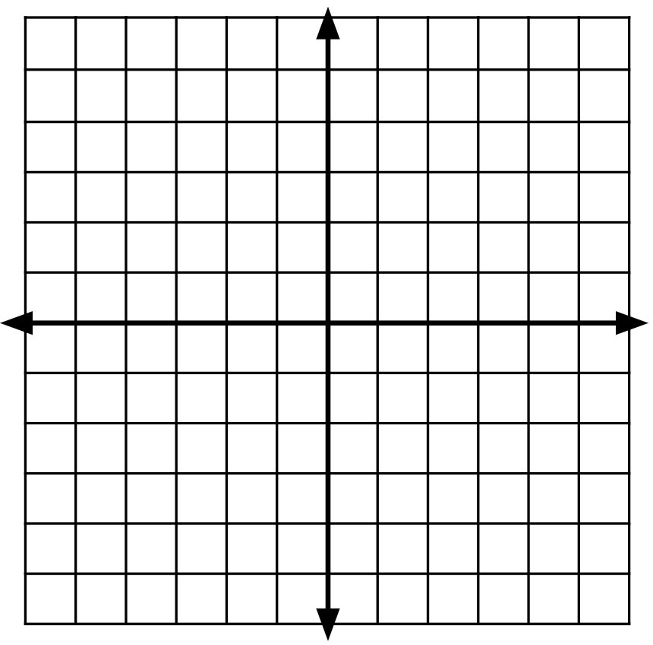

- For each set of coordinates, plot each point and which graph or graphs it is on.
(1, 3) (0, 0) (3, 6) (3, 1.5)

Lesson 1.6: Equivalent Equations Answers
The hanger with the mobile containing 1 square and 2 circles is in balance.
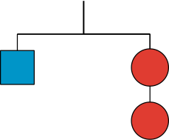
Which of the following hangers should also be in balance? Explain your reasoning.
- Hanger A | - Hanger A | - Hanger A
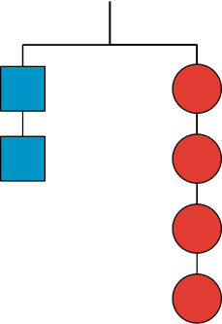 | 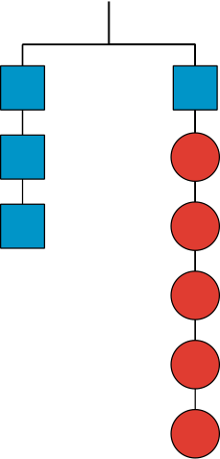
Answer: | Answer: | Answer:

- Hanger D | - Hanger E | - Hanger F
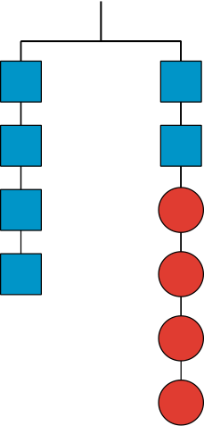 | 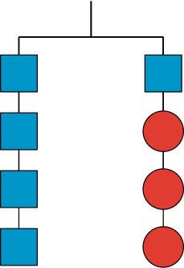 | 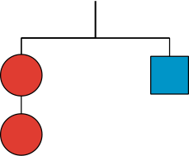
Answer: | Answer: | Answer:

Lesson 1.7: Explaining Steps for Rewriting Equations
For each pair of equations in questions 1-5, decide whether the given value of $x$ is a solution to one or both equations. Check the box that corresponds to your answer.
- Is $x = 2$ a solution to:
- $x(2 + 3) = 10$
- $2x + 3x = 10$
- Both equations
- Is $x = -1$ a solution to:
  - $x+ 3 = 2$
  - $3 + x = 2$
  - Both equations
- Is $x = 3$ a solution to:
- $x - 4 = 1$
- 4 − 𝑥 = 1
- Both equations
- Is $x = -2$ a solution to:
  - $7x= -14$
  - 𝑥 ∙14 = −28
  - Both equations
- Is $x = \frac{1}{2}$ a solution to:
- $5(x + 1) = \frac{15}{2}$
- $5x + 1 = \frac{15}{2}$
- Both equations

Lesson 1.8: Choosing the Correct Variable to Solve For, Part 1
Use the formula below and the given information to figure out one of the measurements.
As you work, look for patterns or a set of steps that you could use to quickly figure out one measurement, given the others.
Perimeter of a Rectangle, $P$, where $l$ represents length and $w$ represents width:
$$P = 2l + 2w$$

- A rectangle has a length of 3.5 units and a width of 9 units. Find its perimeter.

- A rectangle has a perimeter of 25 units and a width of 9 units. Find its length.

- A rectangle has a perimeter of 18 units and a width of 4 units. Find its length.

- Look at your steps and answers so far. Are there any patterns you could use to help you solve the next two problems easily?

- A rectangle has a perimeter of 24 units and a width of 11 units. Find its length.

- A rectangle has a perimeter of 15 units and a width of 3 units. Find its length.

- How would you teach someone else to find the length of a rectangle using the patterns you noticed?

Lesson 1.9: Choosing the Correct Variable to Solve For, Part 2
Tyler is practicing finding different equivalent equations that match the story. For each of the problems below, he gets one equation right but the other equation wrong. For each one, explain the error, give the correct equivalent equation, and explain your reasoning.
- Situation: The yogurt at Sweet Delights costs $0.65 per pound and $0.10 per topping. The total cost of a purchase was $1.70. Let $p$ be the weight of the yogurt in pounds and $t$ be the number of toppings bought.
Tyler’s first and correct equation: $0.65p + 0.10t = 1.70$
Tyler’s second and incorrect equation: $t = (1.70-0.65p) ∙ 0.10$
  - What is the error?

  - What is a correct second equation Tyler could have written?

  - What might Tyler have been thinking that led to his mistake?

- Situation: For a fundraiser, a school is selling flavored waters for $2.00 each and pretzels for $1.50 each. The school has a fundraising goal of $200. Let $w$ be the number of waters sold and $p$ be the number of pretzels sold.
Tyler’s first and correct equation: $2w + 1.5p = 200$
Tyler’s second and incorrect equation: $1.5p = 198w$
- What is the error?

- What is a correct second equation Tyler could have written?

- What might Tyler have been thinking that led to his mistake?

Lesson 1.10: Connecting Equations to Graphs, Part 1
For questions 1-3, examine the following graph. Then, determine an answer to each question and check the box that corresponds to your answer.
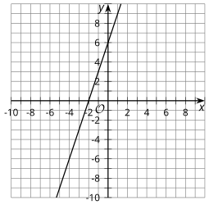
- Does the graph have a $y$-intercept of 6 or -2?
- Does the graph have a slope of 3 or ½?
- The graph represents the equation $2y - 6x = 12$. Which other equations could the graph represent?
- $y -3x = 6$
- $y = 3x + 6$
- $y = -3x + 6$
- $2y = -6x + 12$
- $4y - 12x = 12$
- $4y - 12x = 24$

Lesson 1.11: Connecting Equations to Graphs, Part 2
For each equation, identify the slope and y-intercept of its graph.
- $y = 3x -8$
Slope =
$y$-intercept =

- $y = 10 - 2x$
Slope =
$y$-intercept =

- $y = \frac{x}{2} + 1$
Slope =
$y$-intercept =

- $y + 1 = 9x$
Slope =
$y$-intercept =

- $y = \frac{1}{3}(9x + 12)$
Slope =
$y$-intercept =

Lesson 1.12: Writing the Equation of a Line
For questions 1 - 4, examine the following graph.
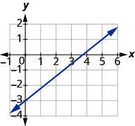
- What is the $y$-intercept of the line?
- What is the $x$-intercept of the line?
- What is the slope of the line?

- How can the intercepts be used to determine the slope of the line?

- Graph the points (1, 2) and (4, 5) and then find the slope of the line between the points.

Lesson 1.13: Lines from Tables and Graphs
For questions 1-5, use the following scenario.

Sewage pipes must slope down ¼ inch per foot in order to drain properly.
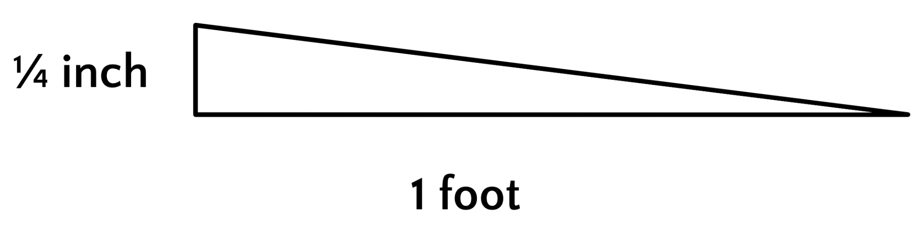
- Complete the table to find how far the sewage pipe must drop for the different lengths of pipe.
Length of pipe (ft) | Height drop of pipe (in)
1 | _______
2 | _______
3 | _______

- If a plumber must install a pipe that is 10 feet long to reach from a house to the city sewer line, how much should the pipe drop from its beginning height?

- What is the required slope, in inches per foot?

- Convert the length of the pipe to inches. HINT: Remember there are 12 inches in each foot.
Length of pipe (in) | Height drop of pipe (in)
12 | _______
24 | _______
36 | _______
- What is the required slope, using inches for both measurements?

Lesson 1.14: Writing Equations of Parallel and Perpendicular Lines
Sketch each pair of given lines using the provided information. Place both lines on the same graph.
Line A: A line through (1, -2) with a slope of $\frac{3}{4}$
Line B: A line with a slope of $\frac{-4}{3}$ and a y-intercept of (0,5)
Line C: A line through (1, -1) with a slope of $\frac{1}{2}$
Line D: $y = -2x + 1$

Lesson 1.15: Direct Variation
For questions 1 - 3, recall that two numbers are multiplicative inverses if their product is 1.
Multiplicative Inverse Formula: $a ∙ \frac{1}{a} = 1$

- Find the multiplicative inverse of -8

- Find the multiplicative inverse of $\frac{5}{8}$

- Find the multiplicative inverse of 2.

- Solve $45 = 20k$

- Solve $\frac{1}{3}k = -6$

- Solve $4k = 11$

