Supporting Students with Disabilities in Algebra 1 Handbook
Universal Design for Learning (UDL): Supporting Students with Disabilities 2
Differentiation for Students with Disabilities 3
Curriculum Features Supporting Access 5
Instructional Strategies Supporting Access 6
Strategies to Support Mathematical Processes 7
Inclusion in Texas Learning Abilities 9
Differentiation in the Math Classroom 9
Modifications & Accommodations for Specific Learning Disabilities 12
Navigating Integrated Support Resources 15
Algebra 1 Content-Specific Samples 16
Links to Algebra 1 Content-Specific Support Materials 17
Factor Pairs 1-100 18
References 19
Throughout the OpenStax Algebra 1 curriculum, you’ll be introduced to sample strategies based on a Universal Design for Learning [UDL] and differentiated learning to support students with disabilities. An infinite number of teaching and learning combinations could be implemented for each lesson and activity.

Our goal is for you to become familiar with different strategies matched to different types of learners, so that you can pack them into your own “library of resources.” Then, as you plan for a lesson, you can select a combination of the strategies, tools, and learning products to scaffold all students to demonstrate their growth in learning Algebra 1.
This sample contains general information as well as specific content aligned to Unit 8, Section A of Openstax’s Algebra 1 curriculum.

Universal Design for Learning (UDL): Supporting Students with Disabilities
Universal Design for Learning (UDL) is an inclusive educational framework that ensures all students, including those with disabilities, have equal opportunities to learn. Rooted in cognitive neuroscience, UDL recognizes that learners process information in diverse ways and removes barriers to learning by proactively designing flexible instructional approaches. Students with disabilities benefit from UDL with a reduction in learning barriers, independence, and multiple pathways through three core principles of UDL:

Multiple Means of Engagement (The “Why” of Learning)
- Recognizes that students are motivated differently based on interests, background knowledge, and cognitive abilities.
- Provides choices in learning activities, self-regulation strategies, and relevant responsive materials.
- Uses varied teaching methods such as gamification, peer collaboration, and real-world applications to sustain motivation.
- Encourages goal setting and self-reflection to build student ownership of learning.

Multiple Means of Representation (The “What” of Learning)
- Acknowledges that students perceive and comprehend information in different ways.
- Offers content through multiple formats, such as text, audio, video, Braille, and tactile graphics.
- Uses visual aids, graphic organizers, captions, and adaptive technology to enhance comprehension.
- Ensures accessibility by providing alternative text, adjustable font sizes, and screen reader compatibility.

Multiple Means of Action & Expression (The “How” of Learning)
- Allows students to demonstrate understanding in various ways based on their abilities and preferences.
- Provides options such as oral presentations, written essays, multimedia projects, hands-on activities, or assistive technology tools (e.g., speech-to-text software).
- Supports students in developing executive functioning skills like organization, time management, and self-monitoring.
- Encourages scaffolding, guided practice, and choice-based assessments to measure progress effectively.
By embedding UDL principles into curriculum design, educators create a more equitable and effective learning environment that benefits all students, not just those with disabilities.

Differentiation for Students with Disabilities
Once you implement the UDL guidelines in your classroom, you’ll find many opportunities to differentiate learning for each student. Differentiation is when you adjust the approach or method of learning to fully support learners of all ability levels, strengths, and weaknesses.
In the classroom, differentiating instruction may look like a teacher presenting the same material to all students differently, or it may require delivering lessons with varying difficulty levels based on student’s readiness. Differentiation gives students opportunities to demonstrate their knowledge and skills in different ways. Remember that differentiation does not replace a student’s Individualized Education Program (IEP) or “504 Plan.” According to the NCTM, teachers should:
Focus on the differences that exist, value diversity, and allow each student the opportunity to shine.
Teachers can differentiate content, process, or product according to a student's readiness, interests, and learning styles; all from within a classroom environment designed to maximize individual growth.
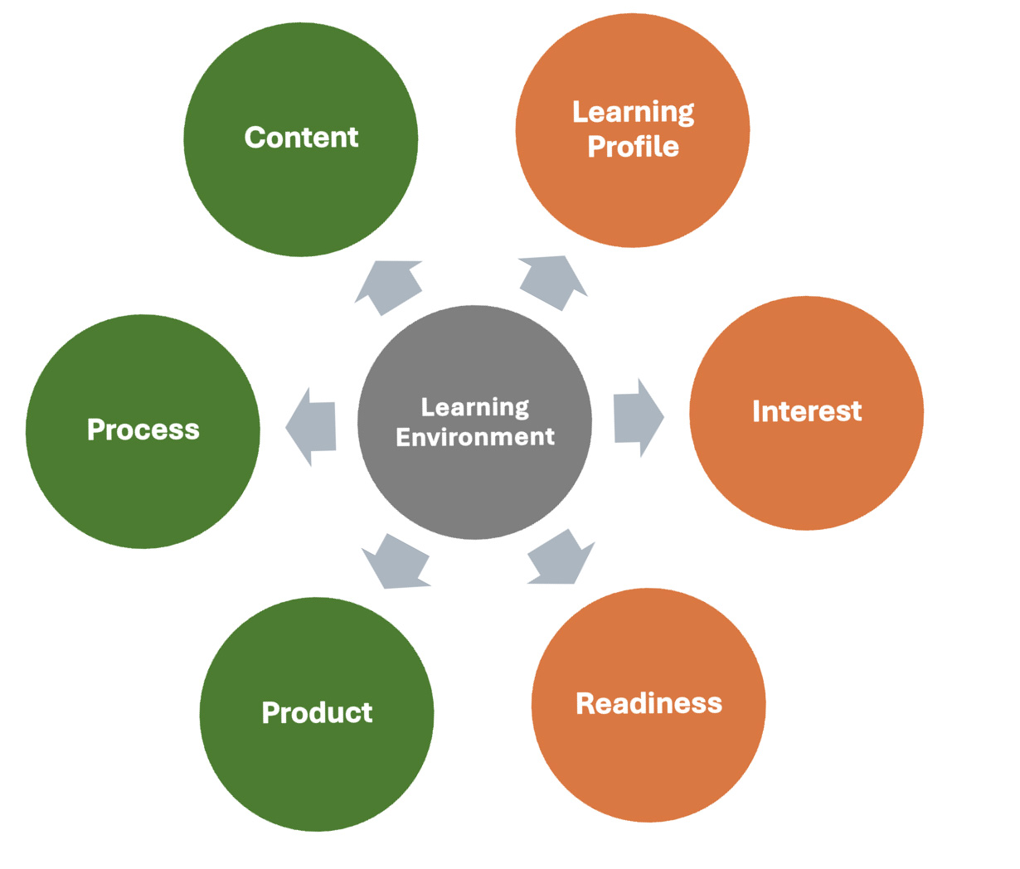

Learning Environment
- The climate and feel of the classroom set the stage for building an atmosphere where students can thrive with differentiated instruction.
- Differentiating the learning environment in a math classroom may look like:
  - Providing relevant learning materials for a diverse classroom
  - Setting up spaces where students can work independently and in small groups
  - Expanding the learning space to include outdoors, library, computer labs, or personal spaces where students feel the most comfortable
  - Creating a culture of continual assessment where informal and formative assessments are just classroom norms

Content
- The content is the desired standards and outcomes that are expected based on the student's academic level, adjusted to best suit the student’s current knowledge and skills.
- Differentiating content in a math classroom may look like this:
  - Pretesting students to determine who may not need direct instruction or who may have gaps in foundational prerequisite knowledge and skills
  - Reviewing IEPs to determine what content may not be appropriate based on Admission, Review, and Dismissal (ARD) committee decisions
  - Adjusting the reading levels of content materials

Process
- The learning process is how a student makes sense of the content and internalizes the new information and skills.:
- Differentiating the learning process in a math classroom may look like this:
  - Providing graphic organizers, maps, diagrams, and charts to organize information
  - Setting up mini-lessons to target skill development for gaps in learning
  - Implementing manipulatives to make abstract content more concrete
  - Allowing varying amounts of time struggling learners to complete assignments
  - Encouraging advanced learners to go more in-depth into a topic

Product
- Students can demonstrate the knowledge and skills they have gained in different ways. Some excel with written work, while others may be more effective by creating visual works.
- Differentiating the product in a math classroom may look like:
  - Giving students options for their modes of expression
  - Supporting the use of technology in the creation of various products
  - Matching rubrics to support and extend students’ varied levels

Learning Profile
- Students have learning profiles and preferences for how they access new information and demonstrate new knowledge and skills.
- Differentiation based on learning profiles may look like:
  - Providing visual and auditory support for content
  - Offering choices and flexibility in how students document knowledge gains
  - Creating student contracts that give flexibility in the product medium
  - Differentiating based on learning profiles can help build efficiency in the learning process.

Interest
- Engaging students by identifying their interest levels can increase motivation and personalization of learning.
- Differentiating based on student’s interest may look like:
  - Implementing interest inventories to connect mathematics to future career choices
  - Offering authentic projects where students can choose from multiple approaches
  - Asking multiple students to demonstrate differing real-world applications of math

Readiness
- All students are ready to learn new content in the instructional sequence at different times. They may lack the prerequisite knowledge, skills, or abilities to progress further. Additionally, in the case of your “gifted and talented” students, they could be ready before much of the class.
- Differentiating based on readiness may look like:
  - Breaking into mini-groups to focus on skill gaps or extending the learning
  - Scaffolding learning activities by assigning tasks based on student characteristics
  - Providing instructional supports for the memory of factors, formulas, or math terms

Curriculum Features Supporting Access
All students are individuals who can know, use, and enjoy mathematics. These materials empower students with activities that capitalize on their existing strengths and abilities to ensure that all learners can participate meaningfully in rigorous mathematical content. Lessons support a flexible approach to instruction and provide teachers with options for additional support to address the needs of a diverse group of students.

Access for Students with Disabilities
Each lesson in OpenStax’s Algebra 1 is carefully designed to maximize engagement and accessibility for all students. Purposeful design elements that support access for all learners but are especially helpful for students with disabilities

Lesson Structures are Consistent
The structure of every lesson is the same: “warm up,” “activities,” “synthesis,” “cool-down.” By keeping the components of each lesson similar from day to day, the flow of work in class becomes predictable for students. This structure similarity reduces cognitive demand and enables students to focus on the mathematics at hand rather than the mechanics of the lesson.

Concepts Develop from Concrete to Abstract
Mathematical concepts are introduced simply, concretely, and repeatedly, with complexity and abstraction developing over time. Students begin with concrete examples and transition to diagrams and tables before relying exclusively on symbols to represent the mathematics they encounter.

Individual to Pair, or Small Group to Whole Class Progression
Providing students with time to think through a situation or question independently before engaging with others allows students to carry the weight of learning, with support arriving just in time from the community of learners. This progression will enable students to activate what they already know and continue to build from this base with others.

Opportunities to Apply Mathematics to Real-World
Giving students opportunities to apply the mathematics they learn clarifies and deepens their understanding of core math concepts and skills and provides motivation and support. Mathematical modeling is a powerful activity for all students, especially students with disabilities. Each unit has a culminating activity designed to explore, integrate, and apply all the units’ big ideas. Centering instruction on these contextual situations can provide students with disabilities an anchor on which to base their mathematical understandings.

Instructional Strategies Supporting Access
The following general instructional strategies can be used to enhance access for all students to rigorous, grade-level content:

Eliminate Barriers
Eliminate any unnecessary barriers that students may encounter that prevent them from engaging with the critical mathematical work of a lesson. This requires flexibility and attention to areas such as the classroom's physical environment, access to tools, organization of lesson activities, and means of communication.

Processing Time
Increased time engaged in thinking and learning leads to mastery of grade-level content for all students, including students with disabilities. Frequent switching between topics creates confusion and does not allow content to be deeply embedded in the learner's mind. Mathematical ideas and representations are carefully introduced in the materials in a gradual, purposeful way to establish a base of conceptual understanding. Some students may need additional time, which should be provided as required.

Assistive Technology
Assistive technology can be vital for students with learning disabilities, visual-spatial needs, sensory integration, and autism. The materials suggest assistive technology supports designed to enhance or support learning or bypass unnecessary barriers.

Manipulatives
Physical manipulatives help students connect concrete ideas with abstract representations. Often, students with disabilities benefit from hands-on activities that allow them to make sense of the problem at hand and communicate their own mathematical ideas and solutions.

Visual Aids
Visual aids such as images, diagrams, vocabulary anchor charts, color coding, or physical demonstrations are suggested throughout the materials to support conceptual processing and language development. Keeping relevant visual aids posted in the classroom promotes independence by allowing students to access them as needed, especially for students with working or short-term memory challenges.

Graphic Organizers
Word webs, Venn diagrams, tables, and other metacognitive visual supports provide structures that illustrate relationships between mathematical facts, concepts, words, or ideas. Graphic organizers can help students organize thoughts and ideas, plan problem-solving approaches, visualize ideas, sequence information, and compare and contrast ideas.

Brain Breaks
Brain breaks are short, structured, two to three-minute movement breaks taken between activities or to break up a longer activity (approximately every 20–30 minutes during class). Brain breaks are a quick, effective way of refocusing and re-energizing students' physical and mental state during a lesson. Brain breaks have also been shown to positively impact student concentration and stress levels, resulting in more time engaged in mathematical problem-solving. This universal support benefits all students, especially those with attention challenges or disorders.

Strategies to Support Mathematical Processes
Content-specific instructional strategies, labeled “Support for Students with Disabilities,” are included in each lesson of OpenStax’s Algebra 1. They are designed to help teachers meet the individual needs of a diverse group of learners. Each is aligned to one of the three principles of Universal Design for Learning, to provide multiple means of engagement, representation, or action and expression, and includes a suggested strategy to increase access and eliminate barriers. These lesson-specific supports can help students succeed with a specific activity without reducing the task's mathematical demand. They can also fade out as students gain understanding and fluency.
The following areas of cognitive functioning are integral to learning mathematics (Addressing Accessibility project, Brodesky et al., 2002). They are indicated in each access support so that teachers can leverage students’ strengths to address potential barriers or challenges in the learning environment. Additional support for students with disabilities was designed using the Universal Design for Learning Guidelines.

Universal Design for Learning | TEA Supporting Strategies for Learning Abilities
Conceptual processing: Perceptual reasoning, problem-solving, and metacognition. | Thinking & Reasoning
Language: Auditory and visual language processing and expression. | Vocabulary Knowledge
Visual-spatial processing: Understanding the relations in the space of visual, mathematical representations, and geometric concepts. | Visual Spatial Reasoning
Organization: Organizational skills, attention, and focus. | Processing Speed
Memory: Working memory and short-term memory. | Working Memory  Efficiency of Learning  Retrieval of Information
Attention: Paying attention to details, maintaining focus, and filtering out extraneous information. | n/a
Social-emotional functioning: Interpersonal skills and the cognitive comfort and safety required to take risks and make mistakes. | n/a
Fine motor skills: Tasks that require small muscle movement and coordination, such as manipulating objects (graphing, cutting with scissors, and writing). | n/a
The UDL areas of cognitive functioning listed above align and supplement the TEA Supporting Strategies for Learning Abilities.


ADDITIONAL RESOURCES
For more about the UDL, go to udlguidelines.cast.org or scan the QR code below.


ADDITIONAL RESOURCES
For more about the TEA Supporting Strategies for Learning Abilities, access the PDF here or scan the QR code below.


Inclusion in Texas Learning Abilities
TEA’s Inclusion in Texas Learning Abilities describes strategies within seven different categories. Many teaching and learning strategies you integrate into your classroom for students with disabilities will fall into multiple categories. These strategies are also beneficial for all learners to scaffold them to success. Do not be afraid to include in your resources for all students.
- Thinking & Reasoning (TR) uses deliberate and controlled procedures (often requiring focused attention) to solve novel, on-the-spot problems that cannot be solved using previously learned habits, schemas, and scripts. (McGrew and Schneider, 2018)
- Processing Speed (PS) is the ability to control attention automatically, quickly, and fluently perform simple, repetitive cognitive tasks. (McGrew and Schneider, 2018)
- Efficiency of Learning (EoL) is the ability to learn, store, and consolidate new information over periods of time measured in minutes, hours, days, and years. (McGrew and Schneider, 2018)
- Retrieval of Information (RoI) is the rate and fluency at which individuals can access information stored in long-term memory. (McGrew and Schneider 2018)
- Working Memory (WM) is the ability to maintain and manipulate information in active attention. The mind's mental "scratchpad" or “workbench.” (McGrew and Schneider 2018)
- Vocabulary Knowledge (VK) is directly related to background knowledge. Vocabulary knowledge includes knowledge of the definitions of words and the concepts that underlie them. (McGrew and Schneider 2018)
- Visual Spatial Reasoning (VSR) is the ability to use simulated mental imagery (often in conjunction with currently perceived images) to solve problems. (McGrew and Schneider 2018)

Differentiation in the Math Classroom
The resources located on the next two pages were collected to sample teaching and learning strategies that are especially beneficial in the mathematics classroom broadly and for Algebra 1 specifically. For more scaffolds and suggestions, read the PDF linked in the previous section, ‘Strategies to Support Mathematical Processes.’
Category | Strategy | TR | PS | WM | EoL | RoI | VK | VSR
Vocabulary | Pre-teach new vocabulary and refresh memory on recently learned vocabulary before the lesson starts |  |  |  | X | X | X
Vocabulary | Highlight and label specific components of a word problem, including words and numbers |  |  |  | X | X | X | X
Instructional Materials | Provide a cover sheet or work window to help students focus on one problem at a time |  |  |  |  |  |  | X
Instructional Materials | Provide additional white space on problems for students to show work |  |  |  |  |  |  | X
Instructional Materials | Provide exemplars of algebra steps and processes | X |  | X |  |  |  | X
Instructional Materials | Use colors appropriate for accessibility to differentiate, highlight, or emphasize |  |  | X | X |  |  | X
Instructional Materials | Create study cards with process steps to essential vocabulary critical to achieving mastery |  |  |  | X
Instructional Materials | Support documents: Charts of math facts, multiplication tables, formula charts, key vocabulary terms |  |  | X | X
Instructional Strategies | Activate prior knowledge for both content and processes | X |  | X |  |  | X
Instructional Strategies | Gain attention during instruction by calling out essential knowledge, skills, and connections between content areas to help access long-term and short-term memory |  |  | X | X | X
Instructional Strategies | Demonstrate to learners how to work through a math process by talking themselves through the steps with "self-talk" | X | X |  | X
Instructional Strategies | Providing real-world, concrete examples to help build an understanding of quantitative concepts | X | X | X | X | X |  | X
Instructional Strategies | Provide support for step-by-step instructions, including visual, auditory, and oral repetition |  |  | X | X
Instructional Strategies | Use manipulatives to provide tangible items that represent quantitative values | X |  | X | X |  |  | X
Instructional Strategies | Provide formulas as a hand-out |  | X | X |  | X
Problem Solving Support | Create graphic organizers, charts, or drawings to help organize problem information and break down steps |  |  | X | X | X
Problem Solving Support | Use graph paper or lined paper turned sideways to maintain alignment during calculations |  | X |  |  |  |  | X
Problem Solving Support | Differentiate between types of cognitive assignments by working on number problems and word problems separately |  | X |  | X | X |  | X
Problem Solving Support | Visually differentiate quantities and key words in story problems |  |  | X |  |  |  | X
Problem Solving Support | Provide concrete manipulatives to support problem solving |  |  |  | X
Problem Solving Support | Provide calculators when computation isn't the standard being assessed |  | X | X | X
Assessment Strategies | Extended time on assignments, projects, and assessments | X | X | X | X |  |  | X
Assessment Strategies | Provide rubrics ahead of time to show the components of projects and how the work will be assessed | X |  |  | X
Assessment Strategies | Reduce assignment length by evens, odds, or select problems within the same TEKS standard |  | X |  | X
Assessment Strategies | Group like activities together on worksheets, assignments, and assessments |  | X |  | X |  |  | X

Modifications & Accommodations for Specific Learning Disabilities

Math & Dyslexia
According to TEC § 38.003(d)(1)-(2) (1995):
Dyslexia is a disorder of constitutional origin manifested by difficulty learning to read, write, or spell, despite conventional instruction, adequate intelligence, and sociocultural opportunity.
Dyslexia impacts a student’s math learning by causing difficulty with accuracy, fluency, spelling, and decoding. Students also need support with reading comprehension, vocabulary, and background knowledge. The following instructional accommodations can directly support students with dyslexia in the math classroom.
- Copies of notes, including graphic examples, to support the narrative
- Word banks and explain key terminology in problem-solving to help with vocabulary building
- Formula charts (such as the one on p. 18) to help with retrieval of information and working memory
- Grid or graph paper to help align for problem-solving

Math & Dysgraphia
According to Berninger (2015):
Dysgraphia is a neurodevelopmental disorder manifested by illegible and inefficient handwriting due to difficulty with letter formation. This difficulty is the result of deficits in graphomotor function (hand movements used for writing) and storing and retrieving orthographic codes (letter forms).
Dysgraphia impacts a math student’s ability to clearly write equations, change written information with erasures, quickly and accurately capture notes during class, and align place values for long-form calculations. The following instructional accommodations can directly support students with dysgraphia in the math classroom.
- Handouts and notes reduce the time, effort, and anxiety when capturing information and increase accuracy.
- Calculators to reduce long-form calculations when other skills are being assessed.
- Grid or graph paper to help align for problem-solving.
- Oral or visual assessments to reduce reliance on written work.
- Digital interactive worksheets that allow students to type answers into blanks.
The TEA’s “Supporting Strategies for Learning Abilities” includes other strategies to help dysgraphia students succeed across the curriculum. For more about these strategies, reference the PDF linked in the previous section, ‘Strategies to Support Mathematical Processes.’

Supports for Math & Dyscalculia
While dyslexia affects a learner’s ability to read, dyscalculia affects a learner’s ability to do math. Dyscalculia is a specific learning disorder impacting how a learner builds an understanding of quantitative information and mathematics. Their brains don’t process numbers and math information in the same way other learners do. This learning disability typically appears in childhood when learners struggle to perform basic math procedures. Dyscalculia can also be a root of math anxiety.
The following skills are needed to help build knowledge and skills in the mathematics classroom. If a student has dyscalculia and difficulty in these skill areas, they may need accommodations and modifications.
- Visual processing: A math problem often has many pieces. Students must see them all, process them, and then decide what to do with what they see.
- Short-term memory: Short-term memory helps a student retain, retrieve, and use the details and quantities of problems to solve for an answer.
- Language: Math has language, vocabulary, and symbols unique to each topic students study. Algebraic language is different from geometric language. Students must use the processing part of their brain to translate language into action.
- Long-term memory: Once a student learns a mathematical process, it is stored in their long-term memory. They must retrieve and use that information efficiently for fluency and accuracy.
- Understanding of quantities and amounts: Students need to be able to quantify a numeral’s symbolic meaning. They usually learn this principle by manipulating or using other tangible items to build that cognitive skill.
- Calculation: Pulling all these skills together helps a student solve written problems for a numeric answer.

Supports for Students with Visual Impairments
Features built into these Algebra 1 materials that make them more accessible to students with visual impairments include:
- A color palette using colors that are distinguishable to people with the most common types of color blindness
- Tasks and problems designed such that success is independent of the ability to distinguish between colors
- Where possible, text associated with images is not part of the image file but instead included as an image caption accessible to screen readers
- “Alt text” on all images makes the materials more accessible to interpret for users with screen readers
If students with visual impairments are accessing the materials using a screen reader, it is essential to understand:
- All images in the curriculum have alt text: a concise indication of the image’s contents so that the screen reader doesn’t skip over as if nothing is there
- Some images have a longer description to help students with visual impairments recreate the image in their minds

Navigating Integrated Support Resources
The support resources for students with disabilities are formatted similarly to the support section for English Language Learner (ELL) students. Embedded within the curriculum are instructional routines and practices to help teachers differentiate the learning to meet the needs of diverse students with intellectual and learning disabilities.
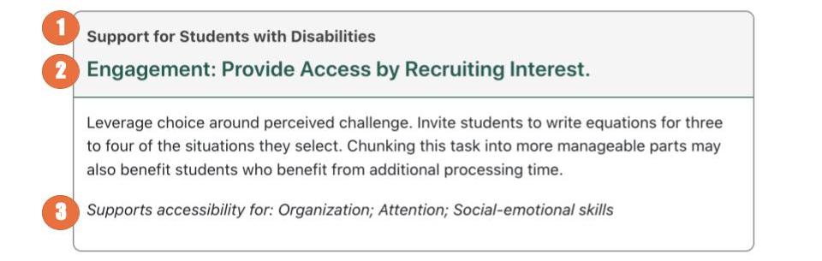
- Each gray box (in the teacher’s guide, activity within a lesson) will say either “Support for English Language Learners” or “Support for Students with Disabilities.”
- Universal Design for Learning: Additional support for students with disabilities was designed using the Universal Design for Learning Guidelines (UDL). Each strategy increases access and eliminates barriers, aligning with one of the three principles of UDL:
  - Engagement
  - Representation
  - Action and expression
- Support Mathematical Processes: Each activity to support students with disabilities will be aligned to one of the eight areas of cognitive functioning integral to learning mathematics. These areas align with or supplement the TEA Supporting Strategies for Learning Abilities.
- Conceptual Processing  - Language  - Visual-Spatial Processing  - Organization | - Memory  - Attention  - Social-Emotional  - Fine Motor Skills
For more about the UDL and the TEA Supporting Strategies for Learning Abilities, access the resources linked above and in the previous section, ‘Strategies to Support Mathematical Processes.’

Algebra 1 Content-Specific Samples
Below is a sample of the content-specific resources for students with disabilities from Section A of Unit 8: Quadratic Equations.
Location | UDL Principle | Instructions | Supports for Accessibility
8.1.2: Modeling a Quadratic Problem | Representation: Access for Perception | Display and read the directions aloud. Students who both listen to and read the information will benefit from additional processing time. Check for understanding by inviting students to rephrase directions in their own words. | Language  Memory
8.1.3: Formulating a Quadratic Equation to Represent the Model | Action & Expression: Internalize Executive Functions | Represent the same information through different modalities by using diagrams. Provide students with graph paper and suggest that they draw and label their diagrams with everything they know so far. Invite students to suggest types of diagrams that might be helpful to draw, such as the strips of framing material, and the picture both with and without the frame. | Conceptual processing  Visual-spatial processing
8.2.2: Exploring Non-Graphing Strategies to Solve Quadratic Equations | Representation: Internalize Comprehension | Use color and annotations to illustrate student thinking. As students share their reasoning about methods to find a solution, scribe their thinking on a visible display. Display sentence frames for students to use during the discussion, such as: “This method works/doesn’t work because . . . .” and “Another strategy would be _____ because . . . .” | Conceptual processing  Visual-spatial processing
8.2.3: Solving a Quadratic Equation Set Equal to Zero | Representation: Internalize Comprehension | Use color and annotations to illustrate student thinking. As students share their reasoning about finding the solutions for which the ticket sales would equal zero, scribe their thinking on a visible display. Consider highlighting each factor separately and annotating to show that when one factor equals zero, the entire expression equals zero regardless of the value of the other factor. | Visual-spatial processing  Conceptual processing

Links to Algebra 1 Content-Specific Support Materials

Course-Level Resources

Pre-Algebra Resources from OpenStax
As you work with individual students and find gaps in their prior learning, you can pull remedial or reinforcing content from the OpenStax Pre-Algebra textbook. Each unit has specific Pre-Algebra lessons aligned to best support students with pre-requisite skills.
Access at openstax.org/r/unit8-overview.

Algebra 1 Vocabulary Word Wall Cards
Mathematics vocabulary word wall cards provide a display of mathematics content words and associated visual cues to assist in vocabulary development. The cards should be used as an instructional tool for teachers and then as a reference for all students. The cards are designed for print use only by the Virginia Department of Education (2018).
Access at openstax.org/r/lesson8.1-teacher.

Unit-Level Resources

Unit 8 Vocabulary Quizlets

To support newcomers or students identified at the beginning level of language proficiency, share the following Quizlet links to help students gain an understanding of the academic vocabulary. Use the Spanish versions to anchor student understanding before bridging to the English versions.
Access at openstax.org/r/lesson8.1-teacher.

Unit 8 Family Support Materials

Print ready materials in both English and Spanish can be shared with students' families to help support student engagement and encouragement at home. Videos are linked to demonstrate key mathematical skills and explain mathematical language.
Access at openstax.org/r/unit8-family.

Lesson-Level Resources

Lesson Level Diagnostic Assessments
The purpose of these instruments is to formally help teachers monitor student progress and identify student preparedness for the lesson content using a variety of question types and item styles.
Access at openstax.org/r/student-assessments.

Factor Pairs 1-100
1 | 2 | 3 | 4 | 5 | 6 | 7 | 8 | 9 | 10
1x1 | 1x2 | 1x3 | 1x4,  2x2 | 1x5 | 1x6,  2x3 | 1x7 | 1x8,  2x4 | 1x9,  3x3 | 1x10,  2x5

11 | 12 | 13 | 14 | 15 | 16 | 17 | 18 | 19 | 20
1x11 | 1x12, 2x6,  3x4 | 1x13 | 1x14,  2x7 | 1x15,  3x5 | 1x16,  2x8,  4x4 | 1x17 | 1x18,  2x9,  3x6 | 1x19 | 1x20,  2x10,  4x5

21 | 22 | 23 | 24 | 25 | 26 | 27 | 28 | 29 | 30
1x21 | 1x22, 2x11 | 1x23 | 1x14,  2x7 | 1x25,  5x5 | 1x26,  2x13 | 1x17,  3x9 | 1x28,  2x14,  4x7 | 1x29 | 1x30,  2x15,  3x10,  5x6

31 | 32 | 33 | 34 | 35 | 36 | 37 | 38 | 39 | 40
1x31 | 1x32,  2x16,  4x8 | 1x33,  3x11 | 1x34,  2x17 | 1x35,  5x7 | 1x36,  2x18,  3x12,  4x9,  6x6 | 1x37 | 1x38,  2x19 | 1x39,  3x13 | 1x40,  2x20,  4x10,  5x8

41 | 42 | 43 | 44 | 45 | 46 | 47 | 48 | 49 | 50
1x41 | 1x42,  2x21,  3x14,  6x7 | 1x43 | 1x44,  2x22,  4x11 | 1x45,  3x15,  5x9 | 1x46,  2x23 | 1x47 | 1x48,  2x24,  3x16,  4x12,  6x8 | 1x49,  7x7 | 1x50,  2x25,  5x10

51 | 52 | 53 | 54 | 55 | 56 | 57 | 58 | 59 | 60
1x51,  3x17 | 1x52,  2x26,  4x13 | 1x53 | 1x54,  2x27,  3x18,  6x9 | 1x55,  5x11 | 1x56,  2x28,  4x14,  7x8 | 1x57,  3x19 | 1x58,  2x29 | 1x59 | 1x60,  2x30,  3x20,  4x15,  5x12,  6x10

61 | 62 | 63 | 64 | 65 | 66 | 67 | 68 | 69 | 70
1x61 | 1x62,  2x31 | 1x63,  3x21,  7x9 | 1x64,  2x32,  4x16,  8x8 | 1x65,  5x13 | 1x66,  2x33,  3x22,  6x11 | 1x67 | 1x68,  2x34,  4x17 | 1x69,  3x23 | 1x70,  2x35,  5x14,  7x10

71 | 72 | 73 | 74 | 75 | 76 | 77 | 78 | 79 | 80
1x71 | 1x72,  2x36,  3x24,  4x18,  6x12,  8x9 | 1x73 | 1x74,  2x37 | 1x75,  3x25,  5x15 | 1x76,  2x38,  4x19 | 1x77,  7x11 | 1x78,  2x39,  3x26,  6x13 | 1x79 | 1x80,  2x40,  4x20,  5x16,  8x10

81 | 82 | 83 | 84 | 85 | 86 | 87 | 88 | 89 | 90
1x81,  3x27,  9x9 | 1x82,  2x41 | 1x83 | 1x84,  2x42,  3x28,  4x21,  6x14,  7x12 | 1x85,  5x17 | 1x86,  2x43 | 1x87,  3x29 | 1x88,  2x44,  4x22,  8x11 | 1x89 | 1x90,  2x45,  3x30,  5x18,  6x15,  9x10

91 | 92 | 93 | 94 | 95 | 96 | 97 | 98 | 99 | 100
1x91,  7x13 | 1x92,  2x46,  4x23 | 1x93,  3x31 | 1x94,  2x47 | 1x95,  5x19 | 1x96,  2x48,  3x32,  4x24,  6x16,  8x12 | 1x97 | 1x98,  2x49,  7x14 | 1x99,  3x33,  9x11 | 1x100,  2x50,  4x25,  5x20,  10x10

References
Brodesky et al. (2002). Accessibility strategies toolkit for mathematics. Education Development Center. https://courses.edtechleaders.org/smi_3/documents/2020/MathAccessStrategies.pdf

CAST (2018). Universal design for learning guidelines version 2.2. Retrieved from http://udlguidelines.cast.org.

For additional information about the Universal Design for Learning framework or to learn more about supporting students with disabilities, visit the Center for Applied Special Technology (CAST) at https://www.cast.org/impact/universal-design-for-learning-udl.

