Unit 1 Student Diagnostic Answer Key
These materials, when encountered before the denoted lesson, support access to the lesson and identify potential areas where additional support may be required. Note that the content in these lesson diagnostics represents prerequisite skills and does not address the required rigor for full mastery of the on-grade level standards.
Your students may benefit from using these materials in conjunction with the Unit Overview and Readiness page (quiz and mini-lessons).

Lesson 1.1: Exploring Expressions and Equations 2
Lesson 1.2: Writing Equations to Model Relationships, Part 1 4
Lesson 1.3: Writing Equations to Model Relationships, Part 2 5
Lesson 1.4: Equations and Their Solutions 7
Lesson 1.5: Equations and Their Graphs 8
Lesson 1.6: Equivalent Equations 9
Lesson 1.7: Explaining Steps for Rewriting Equations 11
Lesson 1.8: Choosing the Correct Variable to Solve For, Part 1 12
Lesson 1.9: Choosing the Correct Variable to Solve For, Part 2 13
Lesson 1.10 : Connecting Equations to Graphs, Part 1 15
Lesson 1.11: Connecting Equations to Graphs, Part 2 16
Lesson 1.12: Writing the Equation of a Line 17
Lesson 1.13: Lines from Tables and Graphs 19
Lesson 1.14: Writing Equations of Parallel and Perpendicular Lines Check-in 21
Lesson 1.15: Direct Variation 23

Lesson 1.1: Exploring Expressions and Equations

Q# | Standard
1-3 | MATH.6.9(A) Write one-variable, one-step equations and inequalities to represent constraints or conditions within problems.
For questions 1-2, use the following scenario.
Kiran is helping his aunt and uncle plan a cookout. Kiran’s uncle is in charge of the food. He tells Kiran he plans to use ¼ pounds of ground beef per person and 2 ears of corn per person. Kiran’s aunt is getting plates and paper towels. She plans on buying one plate per person, plus 10 extra plates, just in case, and she’s going to buy one roll of paper towels for every 10 people.
- List quantities from this situation that can vary and which ones cannot.
Answer:
Quantities that can vary | Quantities that cannot vary
- $p$ represents the total number of people attending the cookout.  - $C$ the total cost of the cookout. | - ¼ pounds of ground beef is needed for each person.  - 2 ears of corn are needed for each person.  - Each person gets 1 plate.  - 10 extra plates are needed.  - 1 roll of paper towels for every 10 people (each person gets ⅒ a roll of paper towels).
- Explain what constraints exist or might exist for this situation.
Answer: Answers may vary, but here are some samples.
- There may be a limit as to how many people will fit into the space where the cookout is being held.
- There may be a limit as to how much money the family can spend on the cookout.
- There may be a limit as to how much meat Kiran’s uncle can buy.

- A zookeeper is preparing to care for snakes in an exhibit. She needs two mice for each snake, plus one extra mouse. Which expression represents the number of mice needed for x number of snakes?
- $(2 + 1)x$
- $x + 2$ [Answer]
- $2x + 1$
- $2x$

Lesson 1.2: Writing Equations to Model Relationships, Part 1
Q# | Standard
1-2 | MATH.7.10(A) Write one-variable, two-step equations and inequalities to represent constraints or conditions within problems.
For questions 1-2, use the following scenario.
Claire is in charge of getting snacks for a road trip with her friends and her dog. She has $35 to go to the store to get some supplies. The snacks for herself and her friends cost $3.25 each, and her dog’s snacks cost $9 each.
- List quantities from this situation.
  - If it’s a known quantity, write the number and a short description of what it represents.
  - If it’s an unknown quantity, assign a variable to represent it and write a short description of what that variable represents.
Answer:
- $35 is the amount of money Clare has to spend on snacks.
- $3.25 is the cost of each snack for Clare and her friends.
- $9 is the cost of each of the dog's snacks.
- $f$ represents the number of Clare's friends attending the road trip.
- $p$ represents the total number of people attending the road trip.
- $s$ represents the number of snacks for the dog.
- List the quantities from this situation that can vary and which ones cannot.
Answer:
Quantities that can vary | Quantities that cannot vary
- $f$ represents the number of Clare's friends attending the road trip.  - $p$ represents the total number of people attending the road trip.  - $s$ represents | - $35 is the amount of money Clare has to spend on snacks.  - $3.25 is the cost of each snack for Clare and her friends.  - $9 is the cost of each of the dog's snacks.

Lesson 1.3: Writing Equations to Model Relationships, Part 2

Q# | Standard
1-3 | MATH.7.7(A) Represent linear relationships using verbal descriptions, tables, graphs, and equations that simplify to the form y = mx + b.
- Examine the given table of values. Identify at least one thing you notice and one thing you wonder about the values in the table.

$$x$$ | $$y$$
0 | 6
1 | 9
2 | 12
4 | 18
10 | 36
100

Answer:
Things students may notice:
- The $x$’s don’t go up by the same amount each time.
- Not all the rows are filled out.
- The $y$’s go up by threes at first, and then by multiples of 3.
Things students may wonder:
- Why do they skip some numbers?
- I wonder if the missing number is 306?
- I wonder if the missing number is 360?

- Complete the table so that each pair of numbers make the equation $y = 3x$ true.
$$x$$ | $$y$$
5 | Answer: 15
Answer: 32 | 96
⅔ | Answer: 2

- Complete the table so that each pair of numbers make the equation $s = \frac{t - 1}{3}$ true.

$$t$$ | $$s$$
0 | Answer: -⅓
Answer: 13 | 4
Answer: 157 | 52

Lesson 1.4: Equations and Their Solutions
Q# | Standard
1-3 | MATH.5.4(B) Represent and solve multi-step problems involving the four operations with whole numbers using equations with a letter standing for the unknown quantity.
For questions 1-3, use the following scenario.
For a fundraiser, a school club is selling raffle tickets for $2 each and healthy snacks for $1.50 each.
- What is the cost of –
  - 3 tickets Answer: $6.00
  - 5 tickets Answer: $10.00
  - $x$ tickets Answer: $2x$
- What is the cost of –
  - 2 snacks? Answer: $3.00
  - 6 snacks? Answer: $9.00
  - $y$ snacks? Answer: $1.50y$
- What is the cost of –
  - 10 tickets and 8 snacks? Answer: $32.00
  - 7 tickets and 5 snacks? Answer: $21.50
  - $x$ tickets and $y$ snacks? Answer: $2x + 1.50y$

Lesson 1.5: Equations and Their Graphs

Q# | Standard
1 | MATH.6.6(C) Represent a given situation using verbal descriptions, tables, graphs, and equations in the form $y = kx$ or $y = x + b$.
2 | MATH.8.9(A) Identify and verify the values of $x$ and $y$ that simultaneously satisfy two linear equations in the form $y = mx + b$ from the intersections of the graphed equations.
- Sketch the graph representing each of the following equations.

Answer:
Graph of  $$y = 2x$$ | Graph of  $y = \frac{1}{2}x$ | Graph of  $$y = x + 2$$
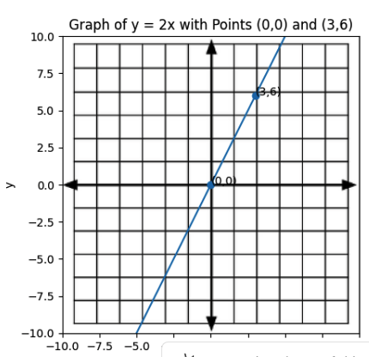 | 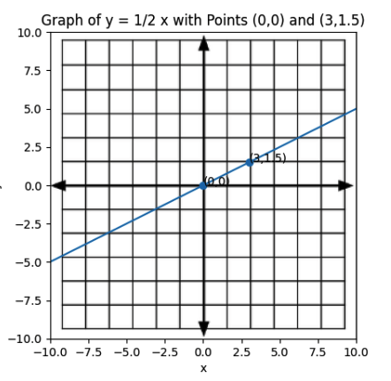 | 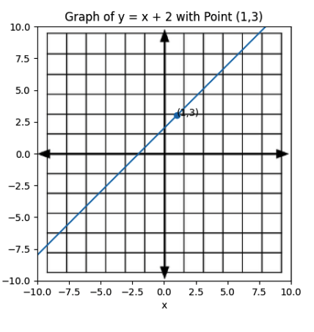
- For each set of coordinates, plot each point and which graph or graphs it is on.
(1, 3) (0, 0) (3, 6) (3, 1.5)

Lesson 1.6: Equivalent Equations
Lesson 1.6: Equivalent Equations
Q# | Standard
A-F | MATH.6.4(B) Apply qualitative and quantitative reasoning to solve prediction and comparison of real-world problems involving ratios and rates.
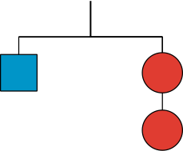
The hanger with the mobile containing 1 square and 2 circles is in balance.
Which of the following hangers should also be in balance? Explain your reasoning.

- Hanger A | - Hanger A | - Hanger A
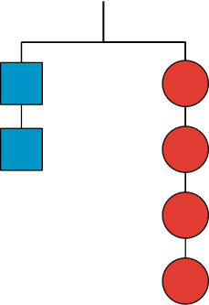 | 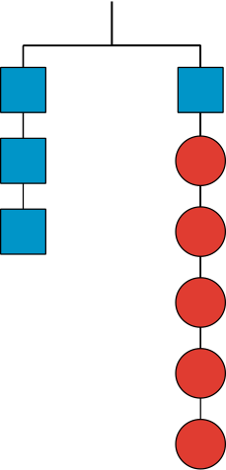
Answer:  Yes, this is also in balance because both sides of the hanger have been doubled. | Answer:  Yes, this is also in balance because both sides of the hanger have been tripled. | Answer:  No, this is not in balance because two squares have been added to the left side while one square and three circles have been added to the right side. It would have still been balanced if the blue square on the right side would have been a circle instead.

- Hanger D | - Hanger E | - Hanger F
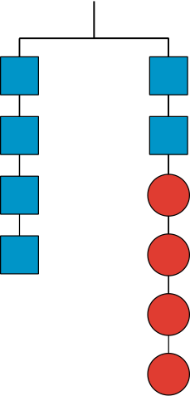 | 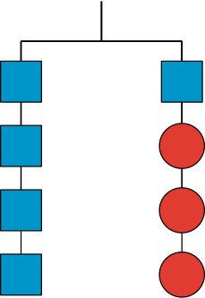 | 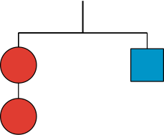
Answer:  Yes, this is also in balance because two blue squares are added to both sides of the hanger and then another set with 1 blue square on the left and 2 circles on the right are also added so everything is kept in balance. | Answer:  No, this is not in balance because three blue squares are added to the left and on the right, only one square and one circle have been added. | Answer:  Yes, this is also in balance because the sides of the hanger have been “switched.”

Lesson 1.7: Explaining Steps for Rewriting Equations

Q# | Standard
1-5 | MATH.6.10(B) Determine if the given value(s) make(s) one-variable, one-step equations or inequalities true.
For each pair of equations in questions 1-5, decide whether the given value of x is a solution to one or both equations. Check the box that corresponds to your answer.
- Is $x = 2$ a solution to:
- $x(2 + 3) = 10$
- $2x + 3x = 10$
- Both equations [Answer]
- Is $x = -1$ a solution to:
- $x+ 3 = 2$
- $3 + x = 2$
- Both equations [Answer]
- Is $x = 3$ a solution to:
- $x - 4 = 1$
- $4 - x = 1$ [Answer]
- Both equations
- Is $x = -2$ a solution to:
- $7x= -14$
- $x ∙14 = -28$
- Both equations [Answer]
- Is $x = \frac{1}{2}$ a solution to:
- $5(x + 1) = \frac{15}{2}$ [Answer]
- $5x + 1 = \frac{15}{2}$
- Both equations

Lesson 1.8: Choosing the Correct Variable to Solve For, Part 1

Q# | Standard
1-7 | MATH.5.4(H) Represent and solve problems related to perimeter and/or area and related to volume.  MATH.7.11(A) Model and solve one-variable, two-step equations and inequalities.

Use the formula below and the given information to figure out one of the measurements.
As you work, look for patterns or a set of steps that you could use to quickly figure out one measurement, given the others.
Perimeter of a Rectangle, $P$, where $l$ represents length and $w$ represents width:
$$P = 2l + 2w$$
- A rectangle has a length of 3.5 units and a width of 9 units. Find its perimeter.
Answer: 25 units
- A rectangle has a perimeter of 25 units and a width of 9 units. Find its length.
Answer: 3.5 units
- A rectangle has a perimeter of 18 units and a width of 4 units. Find its length.
Answer: 5 units
- Look at your steps and answers so far. Are there any patterns you could use to help you solve the next two problems easily?
Answer: Answers will vary.
- A rectangle has a perimeter of 24 units and a width of 11 units. Find its length.
Answer: 1 unit
- A rectangle has a perimeter of 15 units and a width of 3 units. Find its length.
Answer: 4.5 units
- How would you teach someone else to find the length of a rectangle using the patterns you noticed?
Answer: Possible shortcut for finding rectangle length given perimeter and width: divide the perimeter by 2 and subtract the width.

Lesson 1.9: Choosing the Correct Variable to Solve For, Part 2

Q# | Standard
1-2 | ALG.2(C) Write linear equations in two variables given a table of values, a graph, and a verbal description.

Tyler is practicing finding different equivalent equations that match the story. For each of the problems below, he gets one equation right but the other equation wrong. For each one, explain the error, give the correct equivalent equation, and explain your reasoning.
- Situation: The yogurt at Sweet Delights costs $0.65 per pound and $0.10 per topping. The total cost of a purchase was $1.70. Let $p$ be the weight of the yogurt in pounds and $t$ be the number of toppings bought.
Tyler’s first and correct equation: $0.65p + 0.10t = 1.70$
Tyler’s second and incorrect equation: $t = (1.70-0.65p) ∙ 0.10$
  - What is the error?
Answer: Tyler multiplied the total minus the yogurt price by the price of one topping.
  - What is a correct second equation Tyler could have written?
Answer: $t = (1.70 - 0.65p) ÷ 0.10$
  - What might Tyler have been thinking that led to his mistake?
Answer: Maybe he was thinking of trying to do the same thing to each side, but instead of dividing by 0.10 to make the coefficient of $t$ be 1, he multiplied instead.
- Situation: For a fundraiser, a school is selling flavored waters for $2.00 each and pretzels for $1.50 each. The school has a fundraising goal of $200. Let $w$ be the number of waters sold and $p$ be the number of pretzels sold.
Tyler’s first and correct equation: $2w + 1.5p = 200$
Tyler’s second and incorrect equation: $1.5p = 198w$
- What is the error?
Answer: Tyler subtracted $2w$ from both sides, but he cannot combine 200 and $-2w$ to get $198w$ because they are not like terms.
- What is a correct second equation Tyler could have written?
Answer: $1.5p = 200 - 2w$or $2w = 200 - 1.5p$
- What might Tyler have been thinking that led to his mistake?
Answer: He might have been thinking that you can’t leave $200 - 2w$ as is and tried to combine the 200 and the -2.

Lesson 1.10 : Connecting Equations to Graphs, Part 1
Q# | Standard
1-2 | MATH.7.7(A) Represent linear relationships using verbal descriptions, tables, graphs, and equations that simplify to the form $y = mx + b$.
3 | MATH.6.7(D) Generate equivalent expressions using the properties of operations: inverse, identity, commutative, associative, and distributive properties.

For questions 1-3, examine the following graph. Then, determine an answer to each question and check the box that corresponds to your answer.

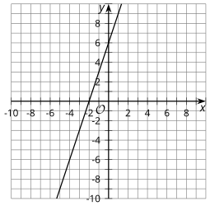

    - Does the graph have a $y$-intercept of 6 or -2? 6 [Answer]

    - Does the graph have a slope of 3 or ½? 3 [Answer]
    - The graph represents the equation $2y - 6x = 12$. Which other equations could the graph represent?
- $y -3x = 6$ [Answer]
- $y = 3x + 6$ [Answer]
- $y = -3x + 6$
- $2y = -6x + 12$
- $4y - 12x = 12$
- $4y - 12x = 24$ [Answer]

Lesson 1.11: Connecting Equations to Graphs, Part 2

Q# | Standard
1-5 | MATH.7.7(A) Represent linear relationships using verbal descriptions, tables, graphs, and equations that simplify to the form $y = mx + b$.
For each equation, identify the slope and y-intercept of its graph.
- $y = 3x -8$
Answer:
Slope = 3
y-intercept = (0, -8)
- $y = 10 - 2x$
Answer:
Slope = -2
y-intercept = (0, 10)
- $y = \frac{x}{2} + 1$
Answer:
Slope = ½
y-intercept = (0, 1)
- $y + 1 = 9x$
Answer:
Slope = 9
y-intercept = (0, -1)
- $y = \frac{1}{3}(9x + 12)$
Answer:
Slope = 3
y-intercept = (0, 4)

Lesson 1.12: Writing the Equation of a Line
Q# | Standard
1-4 | ALG.3(C) Graph linear functions on the coordinate plane and identify key features, including $x$-intercept, $y$-intercept, zeros, and slope, in mathematical and real-world problems.

For questions 1 - 4, examine the following graph.
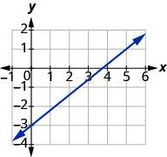
- What is the y-intercept of the line?
Answer: (0, -3)
- What is the x-intercept of the line?
Answer: (3.5, 0)
- What is the slope of the line?
Answer: $\frac{3}{3.5}$
- How can the intercepts be used to determine the slope of the line?
Answer: Answers may vary, but here are some samples.
- You may use the points and substitute them into the slope formula.
- You can put the y-intercept over the x-intercept and simplify.
- Graph the points (1, 2) and (4, 5) and then find the slope of the line between the points.
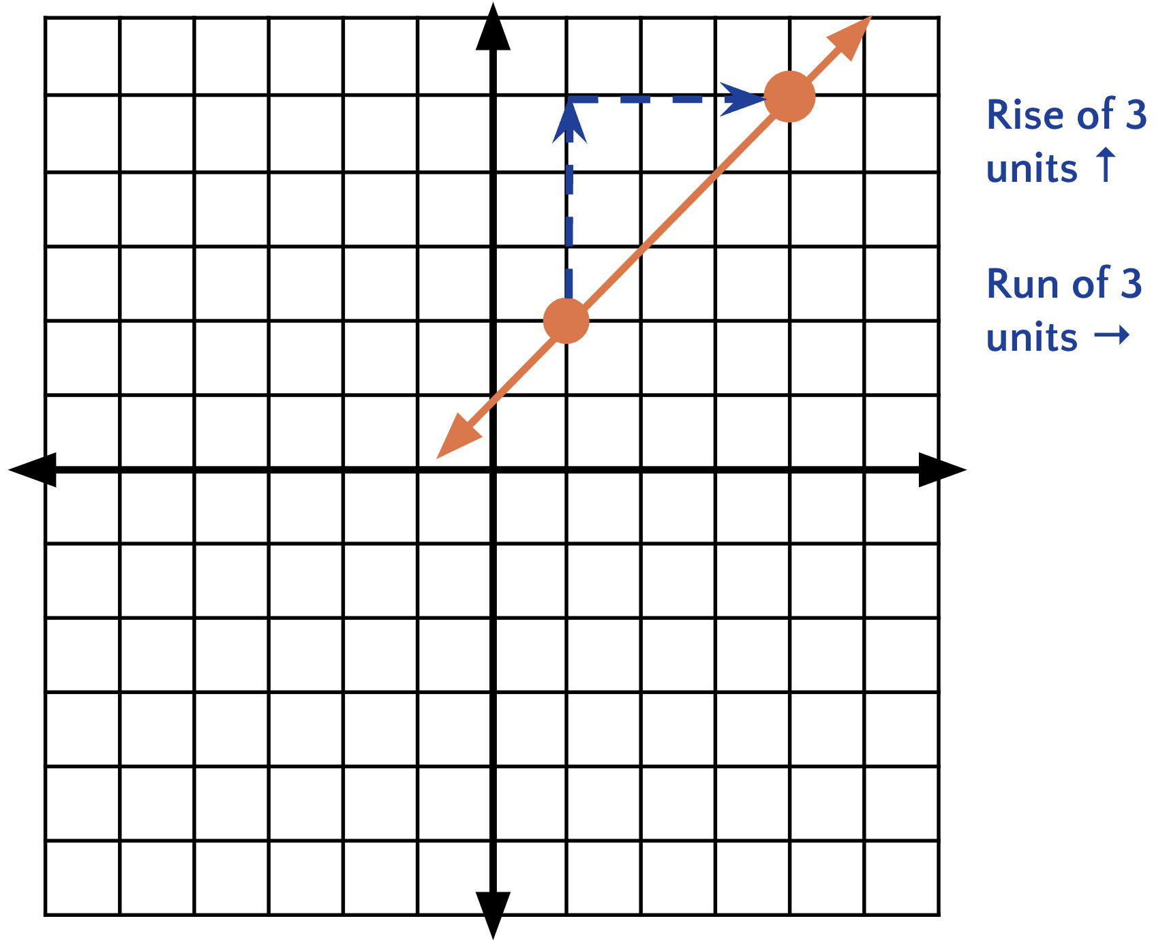
Answer: $\frac{3}{3}= 1$

Lesson 1.13: Lines from Tables and Graphs
Q# | Standard
1-3 | MATH.8.4(C) Use data from a table or graph to determine the rate of change or slope and $y$-intercept in mathematical and real-world problems.
4 | MATH.6.4(H) Convert units within a measurement system, including the use of proportions and unit rates.
5 | MATH.8.4(C) Use data from a table or graph to determine the rate of change or slope and $y$-intercept in mathematical and real-world problems.

For questions 1-5, use the following scenario.
Sewage pipes must slope down ¼ inch per foot in order to drain properly.
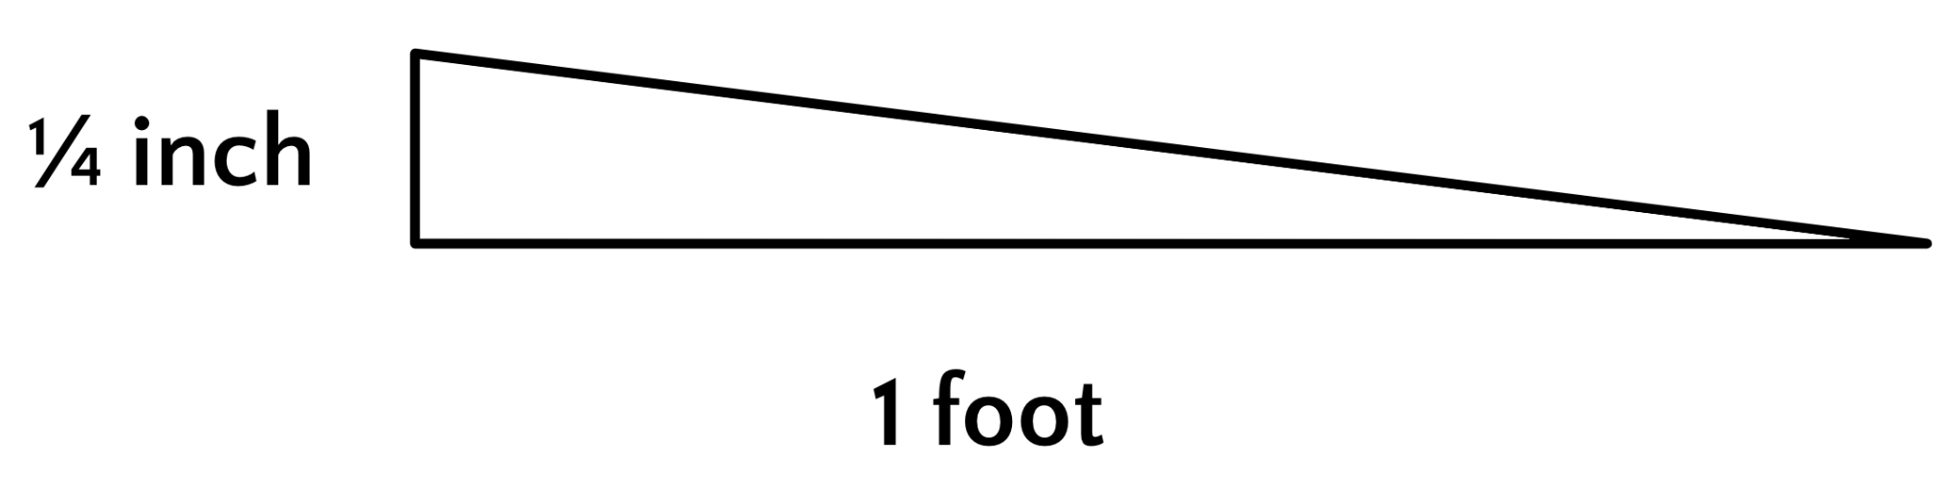
- Complete the table to find how far the sewage pipe must drop for the different lengths of pipe.
Answer:
Length of pipe (ft) | Height drop of pipe (in)
1 | Answer: -¼
2 | Answer: -½
3 | Answer: -¾
- If a plumber must install a pipe that is 10 feet long to reach from a house to the city sewer line, how much should the pipe drop from its beginning height?
Answer:
$$\frac{-10 }{4 } = -2.5 inches$$

- What is the required slope, in inches per foot?
Answer:
$-\frac{1}{4} or -0.25$ inches per foot

- Convert the length of the pipe to inches. HINT: Remember there are 12 inches in each foot.
Answer:
Length of pipe (in) | Height drop of pipe (in)
12 | Answer: -¼
24 | Answer: -½
36 | Answer: -¾
- What is the required slope, using inches for both measurements?
Answer: $\frac{\frac{-1}{4} in}{1 ft} = \frac{\frac{-1}{4} in}{12 in} = \frac{-1}{48}$

Lesson 1.14: Writing Equations of Parallel and Perpendicular Lines Check-in
Q# | Standard
A-F | MATH.7.7(A) Represent linear relationships using verbal descriptions, tables, graphs, and equations that simplify to the form $y = mx + b$.

Sketch each pair of given lines using the provided information. Place both lines on the same graph.

Line A: A line through (1, -2) with a slope of $\frac{3}{4}$
Line B: A line with a slope of $\frac{-4}{3}$ and a y-intercept of (0,5)
Answer:
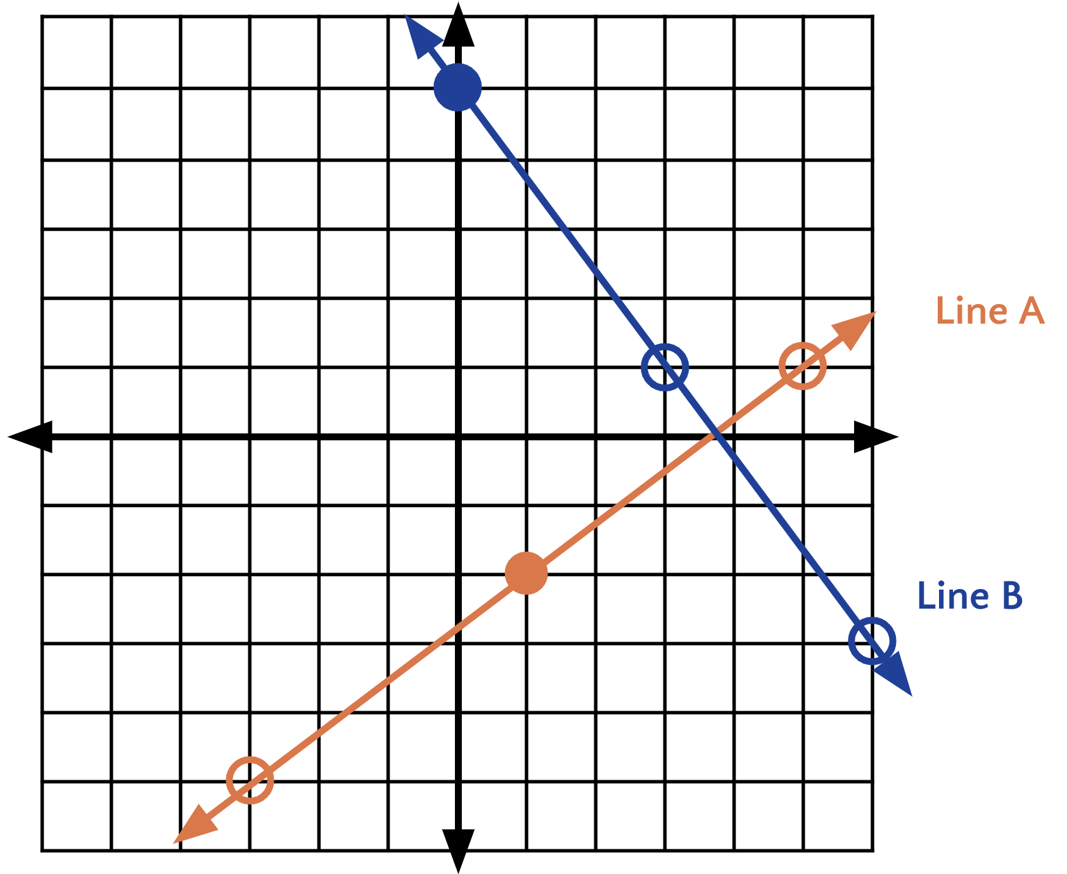
Line C: A line through (1, -1) with a slope of $\frac{1}{2}$
Line D: $y = -2x + 1$
Answer:
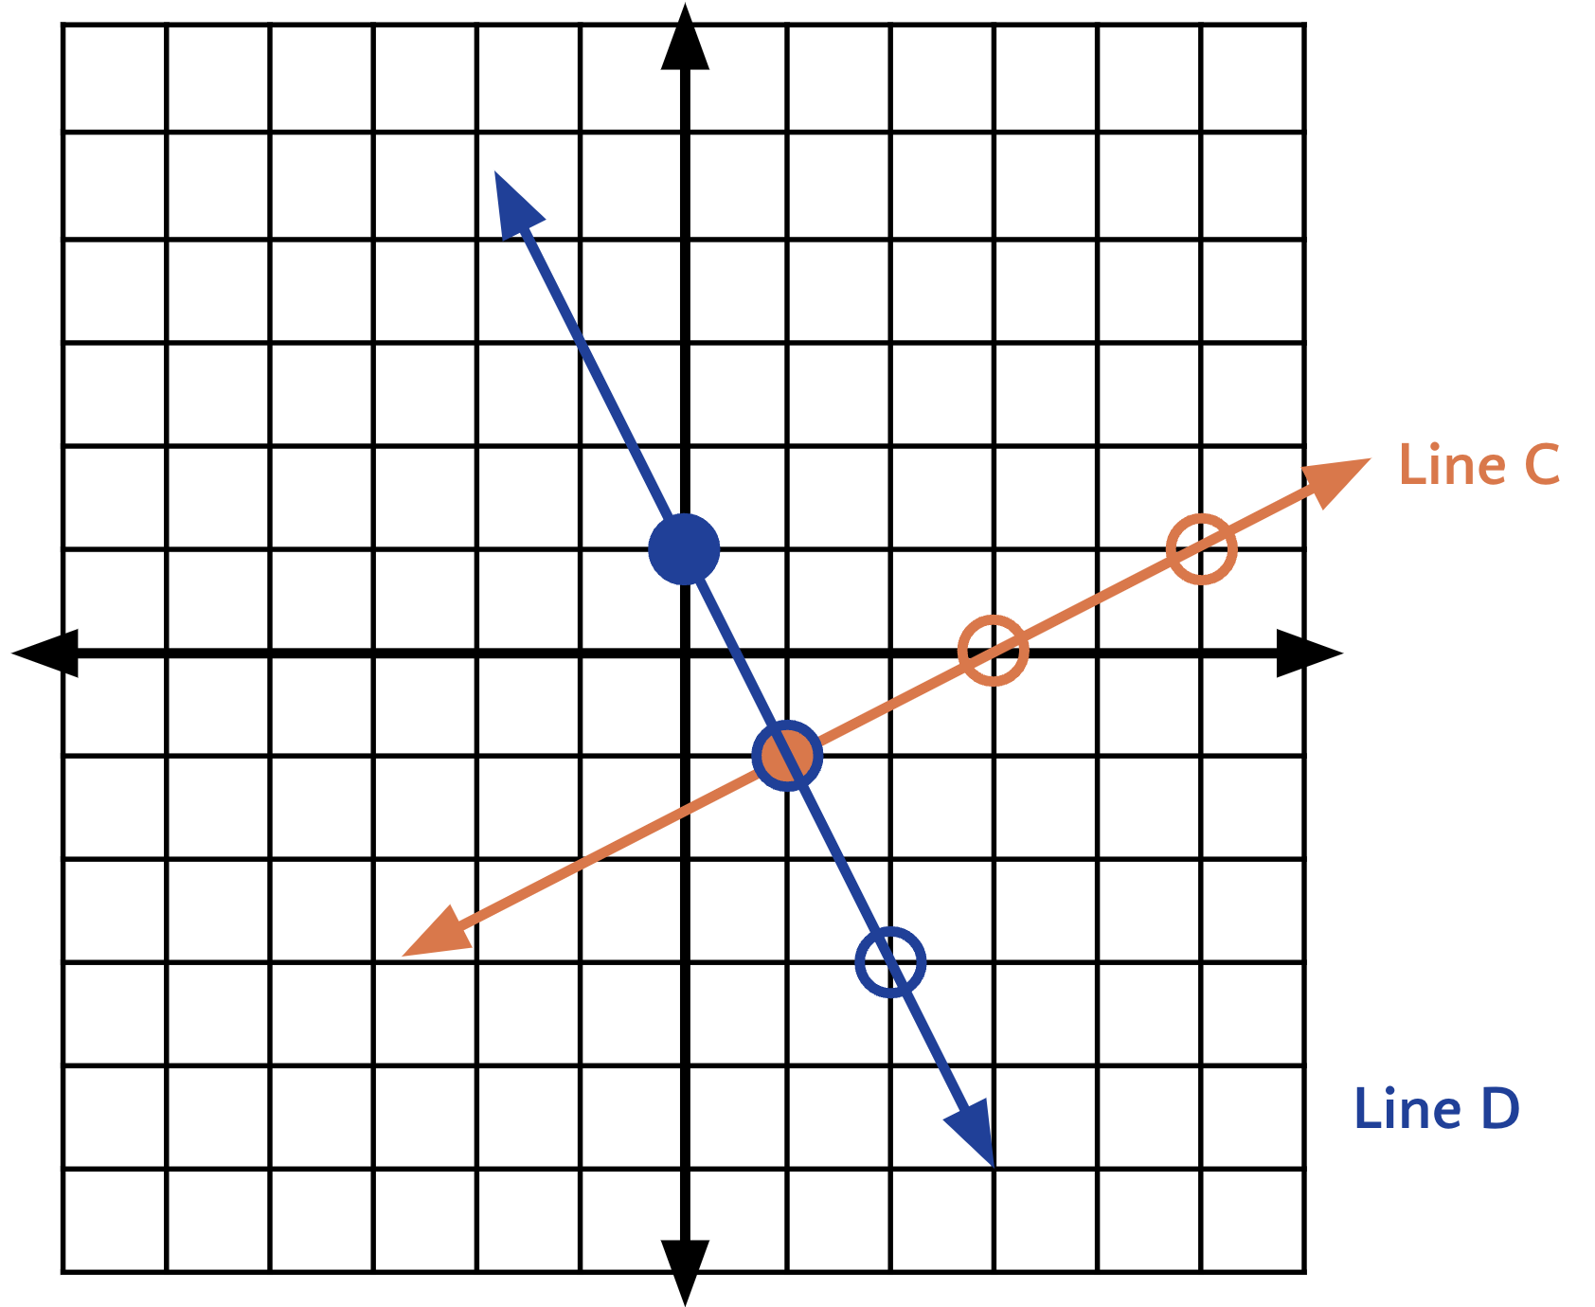

Line E: A line with slope $\frac{-1}{2}$ and passing through (1, 4)
Line F: $y - 3 =\frac{-1}{2} (x + 3)$
Answer:
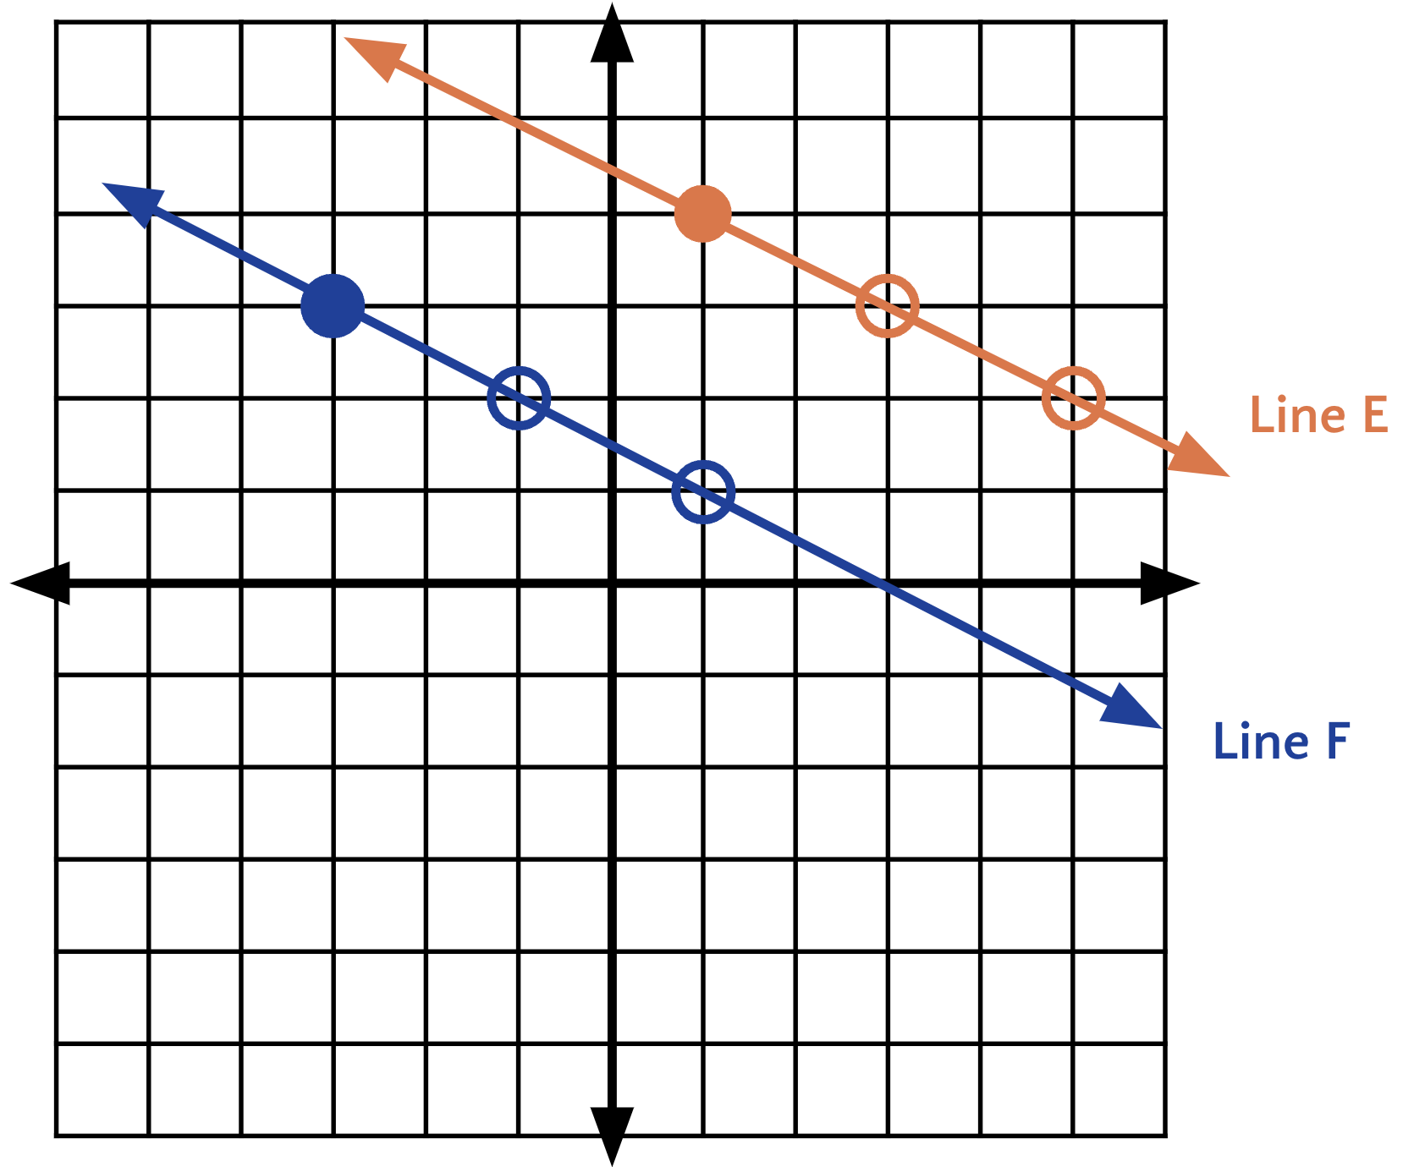

Lesson 1.15: Direct Variation

Q# | Standard
1-3 | MATH.6.3(A) Recognize that dividing by a rational number and multiplying by its reciprocal result in equivalent values.
4-6 | MATH.6.10(A) Model and solve one-variable, one-step equations and inequalities that represent problems, including geometric concepts.

For questions 1 - 3, recall that two numbers are multiplicative inverses if their product is 1.

Multiplicative Inverse Formula: a ∙ 1/a = 1

- Find the multiplicative inverse of -8. Answer: $\frac{-1}{8}$
- Find the multiplicative inverse of $\frac{5}{8}$. Answer: $\frac{8}{5}$
- Find the multiplicative inverse of 2. Answer: $\frac{1}{2}$
- Solve $45 = 20$ Answer: $k = \frac{9}{4}$
- Solve $\frac{1}{3}k = -6$ Answer: k = -18
- Solve $4k = 11$ Answer: $k = \frac{11}{4}$

