Unit 7 Student Diagnostic Answer Key
These materials, when encountered before the denoted lesson, support access to the lesson and identify potential areas where additional support may be required. Note that the content in these lesson diagnostics represents prerequisite skills and does not address the required rigor for full mastery of the on-grade level standards.
Your students may benefit from using these materials in conjunction with the Unit Overview and Readiness page (quiz and mini-lessons).

Lesson 7.1: Patterns of Change 2
Lesson 7.2: Introduction to Quadratic Relationships 3
Lesson 7.3: Building Quadratic Functions from Geometric Patterns 4
Lesson 7.4: Comparing Quadratic and Exponential Functions 5
Lesson 7.5: Building Quadratic Functions to Describe Situations, Part 1 6
Lesson 7. 6: Building Quadratic Functions to Describe Situations, Part 2 8
Lesson 7.7: Domain, Range, Vertex, and Zeros of Quadratic Functions 10
Lesson 7.8: Equivalent Quadratic Expressions. 11
Lesson 7.9: Standard Form and Factored Form 12
Lesson 7.10: Graphs of Functions in Standard and Factored Forms 13
Lesson 7.11: Graphing from the Factored Form 15
Lesson 7.12: Graphing the Standard Form, Part 1 16
Lesson 7.13: Graphing the Standard Form, Part 2 17
Lesson 7.14: Graphs That Represent Situations. 18
Lesson 7.15: Vertex Form 19
Lesson 7. 16: Graphing from the Vertex Form 20
Lesson 7.17: Changing the Vertex 21

Lesson 7.1: Patterns of Change

Q# | Standard
ALL | MATH.5.4(H) Represent and solve problems related to perimeter and/or area and related to volume.
Rectangle A has a side length of 5 cm. Complete the table for Rectangle A and be prepared to explain your reasoning.
Answers:
Length (cm) | Width (cm) | Perimeter (cm) | Area (sq cm)
5 | 1 | Answer: 12 | Answer: 5
5 | 2 | Answer: 14 | Answer: 10
5 | 4 | Answer: 18 | Answer: 20
5 | Answer: 5 | 20 | Answer: 25
5 | Answer: 8 | Answer: 26 | 40
5 | Answer: 9 | 28 | Answer: 45
5 | Answer: 10 | Answer: 30 | 50
5 | $$x$$ | Answer: 10 + $2x$ | Answer: $5x$

Lesson 7.2: Introduction to Quadratic Relationships

Q# | Standard
1-4 | MATH.5.4(D) Recognize the difference between additive and multiplicative numerical patterns given in a table or graph.
Examine the pattern of dots.
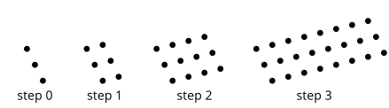
- Describe how you see the pattern growing.
Answer: Answers will vary.
- Draw or describe the next step.
Answer: A figure with 48 dots (3 rows and 16 columns).
- Complete the table to continue the pattern.
Answers:
Step | 0 | 1 | 2 | 3 | 4 | 6 | $$n$$
No. of Dots | 3 | 6 | Answer: 12 | Answer: 24 | Answer: 48 | Answer: 192 | Answer: $3∙2^{n}$
- Is the relationship between step number and number of dots linear, exponential, or neither? Explain how you know.
Answer: Exponential, because the number of dots double with each new step.

Lesson 7.3: Building Quadratic Functions from Geometric Patterns

Q# | Standard
1-4 | MATH.5.4(H) Represent and solve problems related to perimeter and/or area and related to volume.
A rectangle is partitioned into smaller rectangles. Explain why each of these expressions represents the area of the entire rectangle.
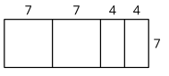
- $7(7+7+4+4)$
Answer: The length of the entire top of the rectangle is $7+7+4+4$, and the height is $7$. Since the area of a rectangle is length times width, the area of this rectangle is $7(7+7+4+4)$.

- $7(2∙7 + 2∙4)$
Answer: Starting from the previous expression, replace $7+7$ with $2∙7$, and $4+4$ with $2∙4$.

- $7^{2} + 7^{2} + 4∙7 + 4∙7$
Answer: This is the area of each of the 4 smaller rectangles, added up.

- $2(7^{2}) + 2(4∙7)$
Answer: Starting from the previous expression, combine like terms.

Lesson 7.4: Comparing Quadratic and Exponential Functions

Q# | Standard
1-5 | MATH.6.7(A) Generate equivalent numerical expressions using order of operations, including whole number exponents and prime factorization.
Evaluate each expression.
- $4∙2^{x}$ when $x$ is 3
Answer: 32

- $19 + x^{2}$ when $x$ is 9
Answer: 100

- $16∙2^{x}$ when $x$ is 0
Answer: 16

- $\frac{1}{2}∙2^{x}$ when $x$ is 4
Answer: 8

- $x^{2} + 1$ when $x$ is 7
Answer: 50

Lesson 7.5: Building Quadratic Functions to Describe Situations, Part 1

Q# | Standard
1-4 | MATH.7.7(A) Represent linear relationships using verbal descriptions, tables, graphs, and equations that simplify to the form $y = mx + b$.
For problems 1 - 4, use the following scenario.
A person is walking from home to a part that is 2.473 feet away. They are walking 280 feet per minute.
- How far away from home are they after 0, 1, 2, 3, 5, $t$ minutes?
Answers:
Minutes | 0 | 1 | 2 | 3 | 5 | $$t$$
Distance from Home (ft) | Answer: 0 | Answer: 280 | Answer: 560 | Answer: 840 | Answer: 1400 | Answer: $280t$
- How far away from the park are they after 0, 1, 2, 3, 5, $t$ minutes?
Answers:
Minutes | 0 | 1 | 2 | 3 | 5 | $$t$$
Distance from Park (ft) | Answer: 2473 | Answer: 2193 | Answer: 1913 | Answer: 1633 | Answer: 1073 | Answer: $2473 - 280t$

- Create a rough sketch of a graph for how far away a person is from home over time. Label the coordinates of the intercepts.
Answer:
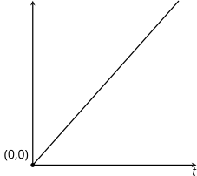

- Create a rough sketch of a graph for how far away a person is from the part over time. Label the coordinates of the intercepts.

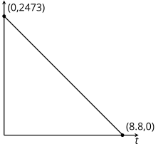

Lesson 7. 6: Building Quadratic Functions to Describe Situations, Part 2

Q# | Standard
1-3 | MATH.7.7(A) Represent linear relationships using verbal descriptions, tables, graphs, and equations that simplify to the form $y = mx + b$.
4 | ALG.2(A) Determine the domain and range of a linear function in mathematical problems; determine reasonable domain and range values for real-world situations, both continuous and discrete; and represent domain and range using inequalities.
A tank has 50 gallons of water and drains at a constant rate of 2 gallons per minute. Below and to the right is a graph representing the situation.
- Label each axis to show what it represents. Be sure to include units.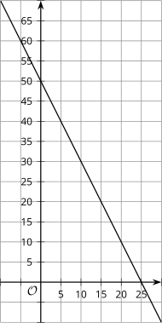
Answer: The horizontal axis is time in seconds, and the vertical axis is the volume of water in the tank in gallons.

- Complete the table.
Answers:
$$t$$ | $$v(t)$$
0 | Answer: 50
1 | Answer: 48
2 | Answer: 46
3 | Answer: 44
10 | Answer: 3-
20 | Answer: 10
$$t$$ | Answer: $50-2t$

- Write a function modeling this situation.
Answer: $v(t) = 50 - 2t$
- What is a reasonable domain for this function, based on the situation it models?
Answer: $0 ≤ t ≤ 25$

Lesson 7.7: Domain, Range, Vertex, and Zeros of Quadratic Functions

Q# | Standard
1-3 | MATH.7.7(A) Represent linear relationships using verbal descriptions, tables, graphs, and equations that simplify to the form $y = mx + b$.
4 | ALG.2(A) Determine the domain and range of a linear function in mathematical problems; determine reasonable domain and range values for real-world situations, both continuous and discrete; and represent domain and range using inequalities.
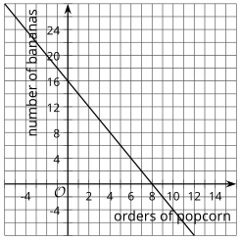
For questions 1 - 4, use the following scenario.
At the concession stand, popcorn costs $2 and bananas cost $1. Carla spent $16 on popcorn and bananas for her family. For questions 1 - 3, explain why each of the points on the graph do not make sense in the situation.
- (-2, 20)
Answer: Someone would not order -2 orders of popcorn.
- (1.5, 13)
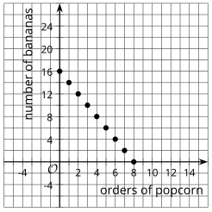
Answer: It is unlikely that it is possible to order 1.5 orders of popcorn.
- (10, -4)
Answer: Someone would not order -4 bananas.
- Sketch a graph that better represents the situation. Explain your reasoning.
Answer: (see right)

Lesson 7.8: Equivalent Quadratic Expressions.

Q# | Standard
1 | MATH.6.7(D) Generate equivalent expressions using the properties of operations: inverse, identity, commutative, associative, and distributive properties.
2-5 | ALG.10(D) Rewrite polynomial expressions of degree one and degree two in equivalent forms using the distributive property.
- Select the four expressions that are equivalent to $4(2 + 3x)$. Be prepared to explain or show how you know.
- $8 + 12x$ [Answer]
- $8 + 3x$
- $4(5x)$
- $12x + 8$ [Answer]
- $2(4) + 3x(4)$ [Answer]
- $12x + 2$
- $2(2 + 3x) + 2(2 + 3x)$ [Answer]

For questions 2 - 5, each of the expressions represents the area of a rectangle. Name a possible length and width of each rectangle. Be prepared to explain or show how you know.
- $3x + 21$
Answer: 3 and $x+7$
- $4(9) + 4(20)$
Answer: 4 and 29
- $8^{2} + 8a$
Answer: 8 and $a + 8$
- $(30)(30) + 30(4) + 30(b)$
Answer: 30 and $34 + b$

Lesson 7.9: Standard Form and Factored Form

Q# | Standard
ALL | ALG.10(D) Rewrite polynomial expressions of degree one and degree two in equivalent forms using the distributive property.
In each row, write the equivalent expression. If you get stuck, use a diagram to organize your work.
- The first row is provided as an example.
- Diagrams are provided for the first three rows.
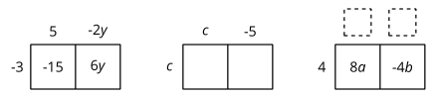
Answers:
Factored | Expanded
$$-3(5 - 2y)$$ | $$-15 + 6y$$
$$c(c - 5)$$ | Answer: $c^{2}- 5c$
Answer: $4(2a - b)$ | $$8a - 4b$$
$$-3(2w - 7z)$$ | Answer: $-6w + 21z$
$$-(3y - 2x)$$ | Answer: $-3y + 2x$
Answer: $2x(6 - 7x)$ | $$12x - 14x^{2}$$

Lesson 7.10: Graphs of Functions in Standard and Factored Forms

Q# | Standard
A-F | ALG.2(C) Write linear equations in two variables given a table of values, a graph, and a verbal description.
Examine the graphs below.
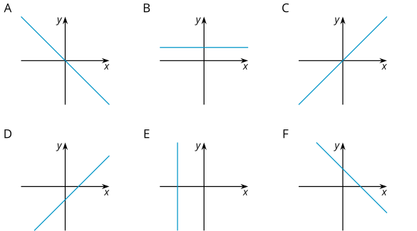
Match each graph to one or more equations that it could represent. Complete as many as you can in the time allowed.

Answers:
 | A | B | C | D | E | F
$$y = 8$$ | ¨ | Yes | ¨ | ¨ | ¨ | ¨
$$y = 3x - 2$$ | ¨ | ¨ | ¨ | Yes | ¨ | ¨
$$x + y = 6$$ | ¨ | ¨ | ¨ | ¨ | ¨ | Yes
$$0.5x = -4$$ | ¨ | ¨ | ¨ | ¨ | Yes | ¨
$$y=x$$ | ¨ | ¨ | Yes | ¨ | ¨ | ¨
$$-\frac{2}{3}x = y$$ | Yes | ¨ | ¨ | ¨ | ¨ | ¨
$$12 - 4x = y$$ | ¨ | ¨ | ¨ | ¨ | ¨ | Yes
$$x - y = 12$$ | ¨ | ¨ | ¨ | Yes | ¨ | ¨
$$2x + 4y = 16$$ | ¨ | ¨ | ¨ | ¨ | ¨ | Yes
$$3x = 5y$$ | ¨ | ¨ | Yes | ¨ | ¨ | ¨

Lesson 7.11: Graphing from the Factored Form

Q# | Standard
ALL | ALG.12(B) Evaluate functions, expressed in function notation, given one or more elements in their domains.
Examine the functions and some possible inputs for the functions. Check the box for each input that would give an output of 0 for the functions.
Answers:
 | -5 | -3 | -2 | -1 | 0 | 1 | 2 | 3 | 5
$$a(x) = x-5$$ | ¨ | ¨ | ¨ | ¨ | ¨ | ¨ | ¨ | ¨ | Yes
$$b(x) = x + 5$$ | Yes | ¨ | ¨ | ¨ | ¨ | ¨ | ¨ | ¨ | ¨
$$c(x) = x - 3$$ | ¨ | ¨ | ¨ | ¨ | ¨ | ¨ | ¨ | Yes | ¨
$$g(x) = 3x + 6$$ | ¨ | ¨ | Yes | ¨ | ¨ | ¨ | ¨ | ¨ | ¨
$$h(x) = (x + 5)(x + 3)$$ | Yes | Yes | ¨ | ¨ | ¨ | ¨ | ¨ | ¨ | ¨

Lesson 7.12: Graphing the Standard Form, Part 1

Q# | Standard
1-4 | MATH.6.7(A) Generate equivalent numerical expressions using order of operations, including whole number exponents and prime factorization.
Evaluate each expression when $x$ is -5.
- $-2x$
Answer: 10

- $x^{2}$
Answer: 25

- $-2x^{2}$
Answer: -50

- $-x^{2}$
Answer: -25

Lesson 7.13: Graphing the Standard Form, Part 2

Q# | Standard
1-2 | ALG.7(A) Graph quadratic functions on the coordinate plane and use the graph to identify key attributes, if possible, including $x$-intercept, $y$-intercept, zeros, maximum value, minimum values, vertex, and the equation of the axis of symmetry.
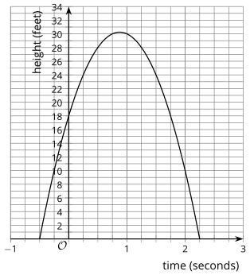
- An archer shoots an arrow. The arrow’s height above the level ground, in feet, is modeled by the equation $h(t) = (1 + 2t)(18-8t)$, and also represented by the graph below. The time $t$ is measured in seconds. On the graph, label the $x$- and $y$-intercepts, vertex, and axis of symmetry.
- Use the critical points from question 1 to identify -
  - The height at which the arrow is launched.
  - The maximum height the arrow reaches.
  - The time when the arrow hits the ground.
  - The time at which the arrow reaches its maximum height.
Answers:
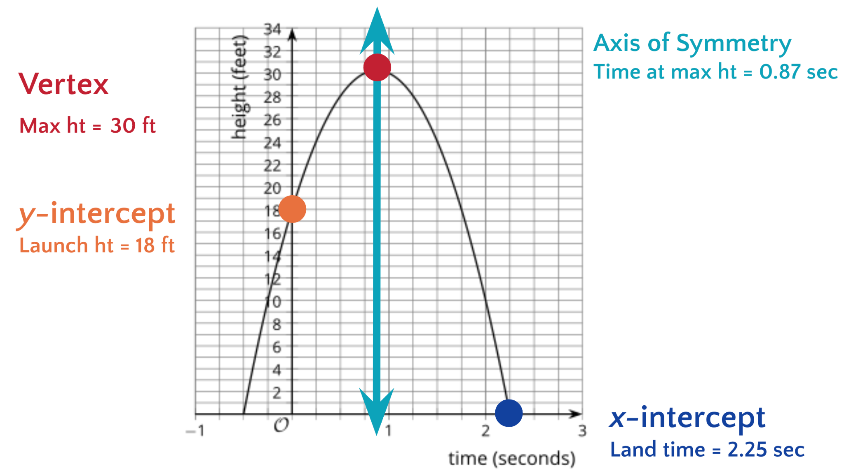

Lesson 7.14: Graphs That Represent Situations.

Q# | Standard
1-4 | ALG.7(A) Graph quadratic functions on the coordinate plane and use the graph to identify key attributes, if possible, including $x$-intercept, $y$-intercept, zeros, maximum value, minimum values, vertex, and the equation of the axis of symmetry.

An object is thrown into the air. The height of the object in meters, is modeled by the function $p$, represented by the graph.
- What is the time at which the object hit the ground?
Answer: 2 seconds
- What is the height from which the object was thrown?
Answer: 4 meters
- What is the maximum height of the object?
Answer: 12.1 meters
- What is the time at which the object reached its maximum height?
Answer: 0.9 seconds
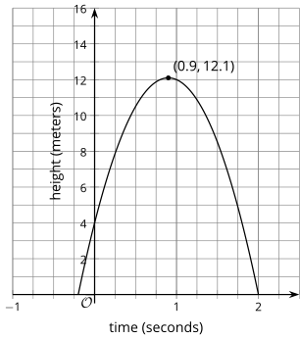

Lesson 7.15: Vertex Form

Q# | Standard
1-4 | ALG.3(C) Graph linear functions on the coordinate plane and identify key features, including $x$-intercept, $y$-intercept, zeros, and slope, in mathematical and real-world problems.
Without graphing, predict the location of the $x$- and $y$-intercepts of the graphs of these equations.
- $y = 4x + 8$
Answer: $x$-intercept: (-2, 0); $y$-intercept: (0, 8)

- $y = 4(x + 8)$
Answer: $x$-intercept: (-8, 0); $y$-intercept: (0, 32)

- $y = 5x - 10$
Answer: $x$-intercept: (2, 0); $y$-intercept: (0, -10)

- $y = 5(x - 10)$
Answer: $x$-intercept: (10, 0); $y$-intercept: (0, -50)

Lesson 7. 16: Graphing from the Vertex Form

Q# | Standard
1-4 | MATH.6.7(A) Generate equivalent numerical expressions using order of operations, including whole number exponents and prime factorization.
Evaluate each expression when $x$ is -7.
- $x + 4$
Answer: -3
- ${(x + 4)}^{2}$
Answer: 9
- $-{(x+4)}^{2}$
Answer: -9
- $-{(x + 4)}^{2} + 5$
Answer: -4

Lesson 7.17: Changing the Vertex

Q# | Standard
1-5 | ALG.7(C) Determine the effects on the graph of the parent function $f(x) = x^{2}$ when $f(x)$ is replaced by $af(x)$, $f(x) + d$, $f(x - c)$, $f(bx)$ for specific values of $a$, $b$, $c$, and $d$.
The parent quadratic function is $f(x) = x^{2}$. Draw a line to match the function that will affect the original graph in the way described.
Shift Description | Matching Function
- Shift the vertex of the graph left 1 unit. | $$y = x^{2} + 1$$
- Shift the vertex of the graph up 1 unit. | $$y = {(x+ 1)}^{2}$$
- Shift the vertex of the graph right 1 unit and up 1 unit. | $$y = {3x}^{2}$$
- Make the graph of the parent function narrower. | $$y = {(x-1)}^{2} + 1$$
- Make the graph of the parent function narrower and shift the vertex 1 unit to the right. | $$y = {3(x-1)}^{2}$$
Answers:
- Shift the vertex of the graph left 1 unit. >> $y = {(x+ 1)}^{2}$
- Shift the vertex of the graph up 1 unit. >> $y = x^{2} + 1$
- Shift the vertex of the graph right 1 unit and up 1 unit. >> $y = {(x-1)}^{2} + 1$
- Make the graph of the parent function narrower. >> $y = {3x}^{2}$
- Make the graph of the parent function narrower and shift the vertex 1 unit to the right. >> $y = {3(x-1)}^{2}$

