Unit 8 Family Support Materials
Get acquainted with the topics and concepts your student will be learning during Unit 8.

Quadratic Equations
In this unit, your student will be learning how to solve quadratic equations using several methods. In the previous unit, students saw how quadratic functions can represent a variety of situations, such as the height of a ball thrown into the air over time.

Here’s an example of a quadratic function in a situation
The graph shows that the ball is 10 feet above the ground at about 0.28 seconds, and again at about 2.22 seconds after being thrown. Notice that graphs can provide us with approximations, but they are not always the best way to find the exact solution to the equation.
The solutions to the equation $-16x^{2}+40x=10$ would give us the exact times when the ball is 10 feet above the ground. However, finding those exact solutions can be challenging. | 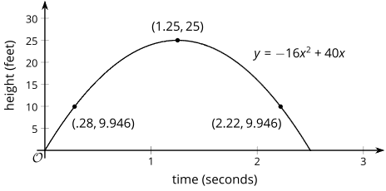
To learn how to solve these more complicated equations, students first reason about solving equations like$(x-1)^{2}=9$. Can you figure out the solutions to this equation, $(x-1)^{2}=9$?
You probably noticed that one solution to $x^{2}=9$ is 3 because $3^{2}=9$. Also, $-3$ is a solution because ${(-3)}^{2}$ is also equal to $9$. By similar reasoning, the solutions to $(x-1)^{2}=9$ are $4$ and $-2$. You can check those solutions because $4-1=3$ and $-2-1=-3$.
Later in the unit, your student will learn to rewrite expressions to quickly find the values that make an equation equal to 0. A diagram can be useful.

Here is a diagram showing $x^{2}+3x$ is equal to $x(x+3)$
 | $$x$$ | $$3$$
$$x$$ | $$x^{2}$$ | $$3x$$
You may remember using something similar in the factoring unit we completed earlier in the course.
That means solutions to the equation $x^{2}+3x=0$ are the same as the solutions to the equation $x(x+3)=0$. Can you “see” from the second equation that the solutions are 0 and $-3$?

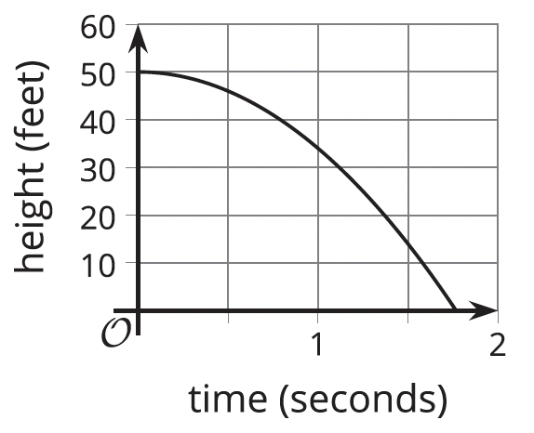
Apply

Try this task with your student
The graph shows a basketball that is dropped from the roof of a building and its height in feet modeled by the function $h$.

Complete the following questions
- Using the graph, approximate when the ball has dropped 5 feet and is about 45 feet in the air.

- Using the graph, find the approximate time when the basketball lands on the ground after first being dropped.

- Solve the equation $x^{2}-4x+3=0$ by factoring.

Hint: Rewrite it in factored form. Here is a diagram to help you.
 | $$x$$ | $$-3$$
$$x$$ | $$x^{2}$$ | $$-3x$$
$$-1$$ | $$-x$$ | $$-3$$

*You can find the answers on the next page

Hide the answers until you have attempted the questions
- 0.5 seconds
- 1.75 seconds
- $(x-1)(x-3)=0$, and the solutions are $x=1$ and $x=3$.

Review

Video lesson summaries for Unit 8: Quadratic Equations
Each video highlights key concepts and vocabulary that students learn across one or more lessons in the unit. The content of these video lesson summaries is based on the written Lesson Summaries found at the end of lessons in the curriculum. The goal of these videos is to support students in reviewing and checking their understanding of important concepts and vocabulary.

Here are some possible ways families can use these videos:
- Families can stay informed on concepts and vocabulary students are learning about in class.
- Families can watch with their students and pause at key points to predict what comes next or think up other examples of vocabulary terms.
Video Title | Related Lessons
Solutions to Quadratic Equations | - Finding Unknown Inputs  - When and Why Do We Write Quadratic Equations?  - Solving Quadratic Equations by Reasoning  - Solving Quadratic Equations with the Zero Product Property  - How Many Solutions?
Factored Form | - Rewriting Quadratic Expressions in Factored Form, Part(s) 1, 2, & 3  - Solving Quadratic Equations by Using Factored Form  - Rewriting Quadratic Expressions in Factored Form, Part 4

 | If needed, access the digital version of this page at https://openstax.org/r/unit8-family

