Unit 4 Student Diagnostic Answer Key
These materials, when encountered before the denoted lesson, support access to the lesson and identify potential areas where additional support may be required. Note that the content in these lesson diagnostics represents prerequisite skills and does not address the required rigor for full mastery of the on-grade level standards.
Your students may benefit from using these materials in conjunction with the Unit Overview and Readiness page (quiz and mini-lessons).

Lesson 4.1: Describing and Graphing Situations 3
Lesson 4.2: Function Notation 5
Lesson 4.3: Interpreting & Using Function Notation 6
Lesson 4.4: Using Function Notation to Describe Rules, Part 1 7
Lesson 4.5: Using Function Notation to Describe Rules, Part 2 8
Lesson 4.6: Features of Graphs 9
Lesson 4.7: Finding Slope 10
Lesson 4.8: Using Graphs to Find Average Rate of Change 12
Lesson 4.9: Interpreting and Creating Graphs 13
Lesson 4.10: Comparing Graphs 15
Lesson 4.11: Graphing a Function Using Transformations 16
Lesson 4.12: Domain and Range, Part 1 17
Lesson 4.13: Domain and Range, Part 2 18
Lesson 4.14: Sequences 20
Lesson 4.15: Introducing Geometric Sequences 21
Lesson 4.16: Different Types of Sequences 23
Lesson 4.17: Sequences are Functions 24
Lesson 4.18: The nth Term of an Arithmetic Sequence 26

Lesson 4.1: Describing and Graphing Situations

Q# | Standard
A-F | MATH.7.7(A) Represent linear relationships using verbal descriptions, tables, graphs, and equations that simplify to the form $y = mx + b$.
Match the graph to the description of the situation.
Graph A  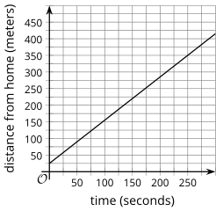 | Graph B  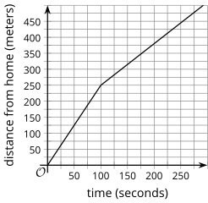 | Graph C  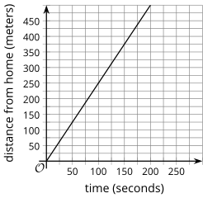
Graph D  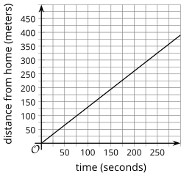 | Graph E  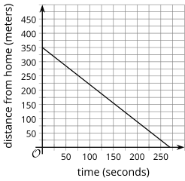 | Graph F  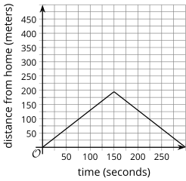
- Mai begins at home and walks away from her home at a constant rate.
Answer: Graph A
- Jada begins at a neighbor’s house and walks away from home at a constant rate.
Answer: Graph E
- Clare begins her walk at school and walks home at a constant rate.
Answer: Graph C

- Elena begins at home and runs away from her home at a constant rate.
Answer: Graph F
- Lin begins at home and walks away from home for a while, then walks back home.
Answer: Graph C
- Priya begins at home and runs away from home, then walks for a while.
Answer: Graph D

Lesson 4.2: Function Notation

Q# | Standard
1-4 | MATH.8.11(A) Construct a scatter plot and describe the observed data to address questions of association such as linear, non-linear, and no association between bivariate data.
For questions 1 - 4, use the following scenario.
The temperature for a city is a function of time after midnight. The graph shows the values on a particular spring day.
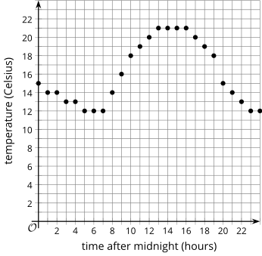
- What does the point on the graph where x = 15 mean?
  - Answer: At 3 p.m., the temperature is 21 degrees Celsius.
- What is the temperature at 5 p.m.?
  - Answer: 20 degrees Celsius
- What is the hottest it gets on this day?
  - Answer: 21 degrees Celsius
- What is the coldest it gets on this day?
  - Answer: 12 degrees Celsius

Lesson 4.3: Interpreting & Using Function Notation

Q# | Standard
1-8 | ALG.12(B) Evaluate functions, expressed in function notation, given one or more elements in their domains.
For questions 1 - 5, use the following information to write each of the coordinate pairs in function notation.
A function is given by the equation $y = f(x)$.

      - (2, 3) Answer: $f(2) = 3$

      - (-1, 4) Answer: $f(-1) = 4$
      - (0, 3) Answer: $f(0) = 3$
      - (4, 0) Answer: $f(4) = 0$
      - (2/3, 3/4) Answer: $f(2/3) = 3/4$

For questions 6 - 8, use the following information to write the coordinate pair for the point associated with the given values in function notation.
A function is given by the equation $h(x) = 5x - 3$.
- $h(3)$ Answer: (3, 12)
- $h(-4)$ Answer: (-4, -23)
- $h(\frac{2}{5})$ Answer: ($\frac{2}{5}$, -1)

Lesson 4.4: Using Function Notation to Describe Rules, Part 1

Q# | Standard
1-2 | ALG.12(B) Evaluate functions, expressed in function notation, given one or more elements in their domains.
3-4 | ALG.5(A) Solve linear equations in one variable, including those for which the application of the distributive property is necessary and for which variables are included on both sides.
For question 1 - 4, use the following scenario.
A machine in a laboratory is set to steadily increase the temperature inside. The temperature in degrees Celsius inside the machine after being turned on is a function of time, in seconds, given by the equation $f(t) = 22 + 1.3t$.
- What does $f(3)$ mean in this situation?
Answer: It means the temperature inside the machine 3 seconds after it is turned on.
- Find the value of $f(3)$ and interpret that value.
Answer: 25.9 degrees Celsius. It means the inside of the machine is 25.9 degrees Celsius after 3 seconds.
- What does the equation $f(t) = 35$ mean in this situation?
Answer: It means the time when the temperature inside the machine is 35 degrees Celsius.
- Solve the equation to find the value of $t$ for the previous question.
Answer: 10 seconds

Lesson 4.5: Using Function Notation to Describe Rules, Part 2

Q# | Standard
1-4 | MATH.7.7(A) Represent linear relationships using verbal descriptions, tables, graphs, and equations that simplify to the form $y = mx + b$.
Use the equations to complete the table of values.
Answer:
$$y = 3x - 2$$ | $$y = 5 - 2x$$
  $$x$$ | $$y$$
  1 | Answer: 1
  3 | Answer: 7
  -2 | Answer: 8
  $$x$$ | $$y$$
  0 | Answer: 5
  3 | Answer: -1
  5 | Answer: -5
$$y = \frac{1}{2}x + 2$$ | $$y = 2x - 10$$
  $$x$$ | $$y$$
  -4 | Answer: 0
  3 | Answer: $\frac{7}{2}$
  6 | Answer: 5
  $$x$$ | $$y$$
  3 | Answer: 4
  7 | Answer: -4
  -8 | Answer: -26

Lesson 4.6: Features of Graphs

Q# | Standard
1-6 | MATH.8.11(A) Construct a scatter plot and describe the observed data to address questions of association such as linear, non-linear, and no association between bivariate data.
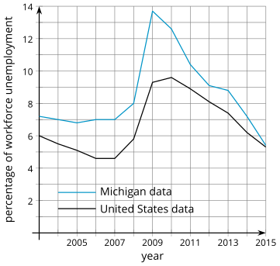
This graph shows the percentage of the workforce that is unemployed in the United States and Michigan for several years.
- For the United States, what is the highest point on the graph?
Answer: (2010, 9.6)
- What do the values for the highest point mean in the situation?
Answer: The highest point means that the greatest unemployment percentage for the years shown in the United States occurred in 2010 at 9.6%.
- For the United States, what is the lowest point on the graph?
Answer: (2007, 4.6)
- What do the values for the lowest point mean in the situation?
Answer: The lowest point means that the least unemployment percentage for the years shown in the United States occurred in 2007 at 4.6%.
- For Michigan, what is the highest point on the graph? What does the point mean in this situation?
Answer: (2009, 13.7). The highest point means that the greatest unemployment percentage for the years shown in Michigan occurred in 2009 at 13.7%.
- For Michigan, what is the lowest point on the graph? What does the point mean in this situation?
Answer: (2015, 5.4). The lowest point means that the least unemployment percentage for the years shown in Michigan occurred in 2015 at 5.4%.

Lesson 4.7: Finding Slope

Q# | Standard
1 | MATH.8.4(A) Use similar right triangles to develop an understanding that slope, $m$, given as the rate comparing the change in $y$-values to the change in $x$-values, $\frac{y_{2} - {y_{1}}_{}}{x_{2} - x_{1}}$, is the same for any two points ($x_{1}$, $y_{1}$) and ($x_{2}$,$y_{2}$) on the same line.
Examine the graphs of the lines given below.
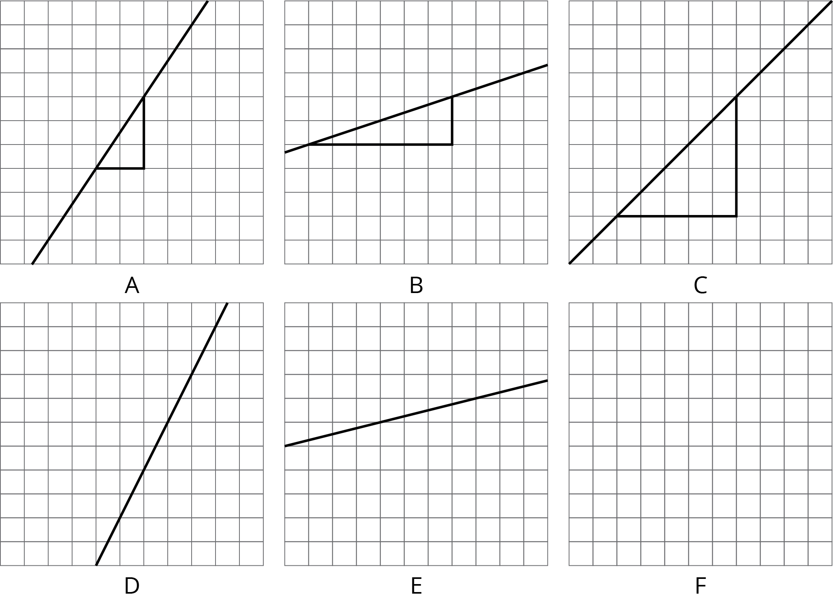
      - Label each line shown with a slope from this list:
  - 1/3 Answer: B
  - 2 Answer: D
  - 1 Answer: C
  - 0.25 Answer: E
  - 3/2 Answer: A
  - ½ See Graph
- One of the given slopes does not have a line to match. Draw a line with this slope on the empty grid.
Answer:
Graph F = $\frac{1}{2}$
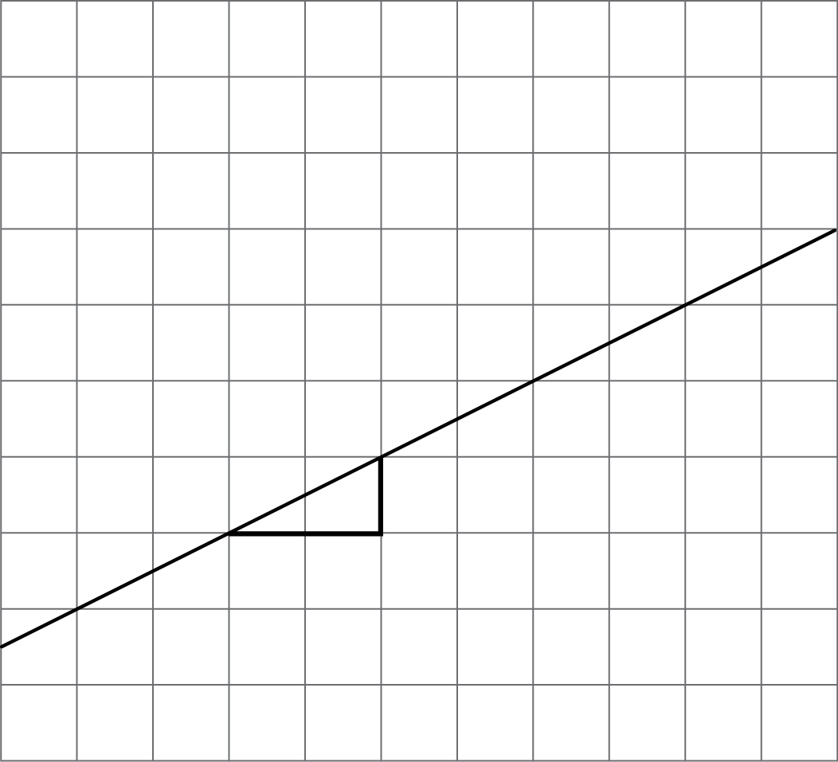

Lesson 4.8: Using Graphs to Find Average Rate of Change

Q# | Standard
1-5 | MATH.8.4(A) Use similar right triangles to develop an understanding that slope, $m$, given as the rate comparing the change in $y$-values to the change in $x$-values, $\frac{y_{2} - {y_{1}}_{}}{x_{2} - x_{1}}$, is the same for any two points ($x_{1}$, $y_{1}$) and ($x_{2}$,$y_{2}$) on the same line.
Find the slope of the line that connects the given points. If needed, use the provided graph.
- (0, 0) and (3, 2)  Answer: ⅔ | 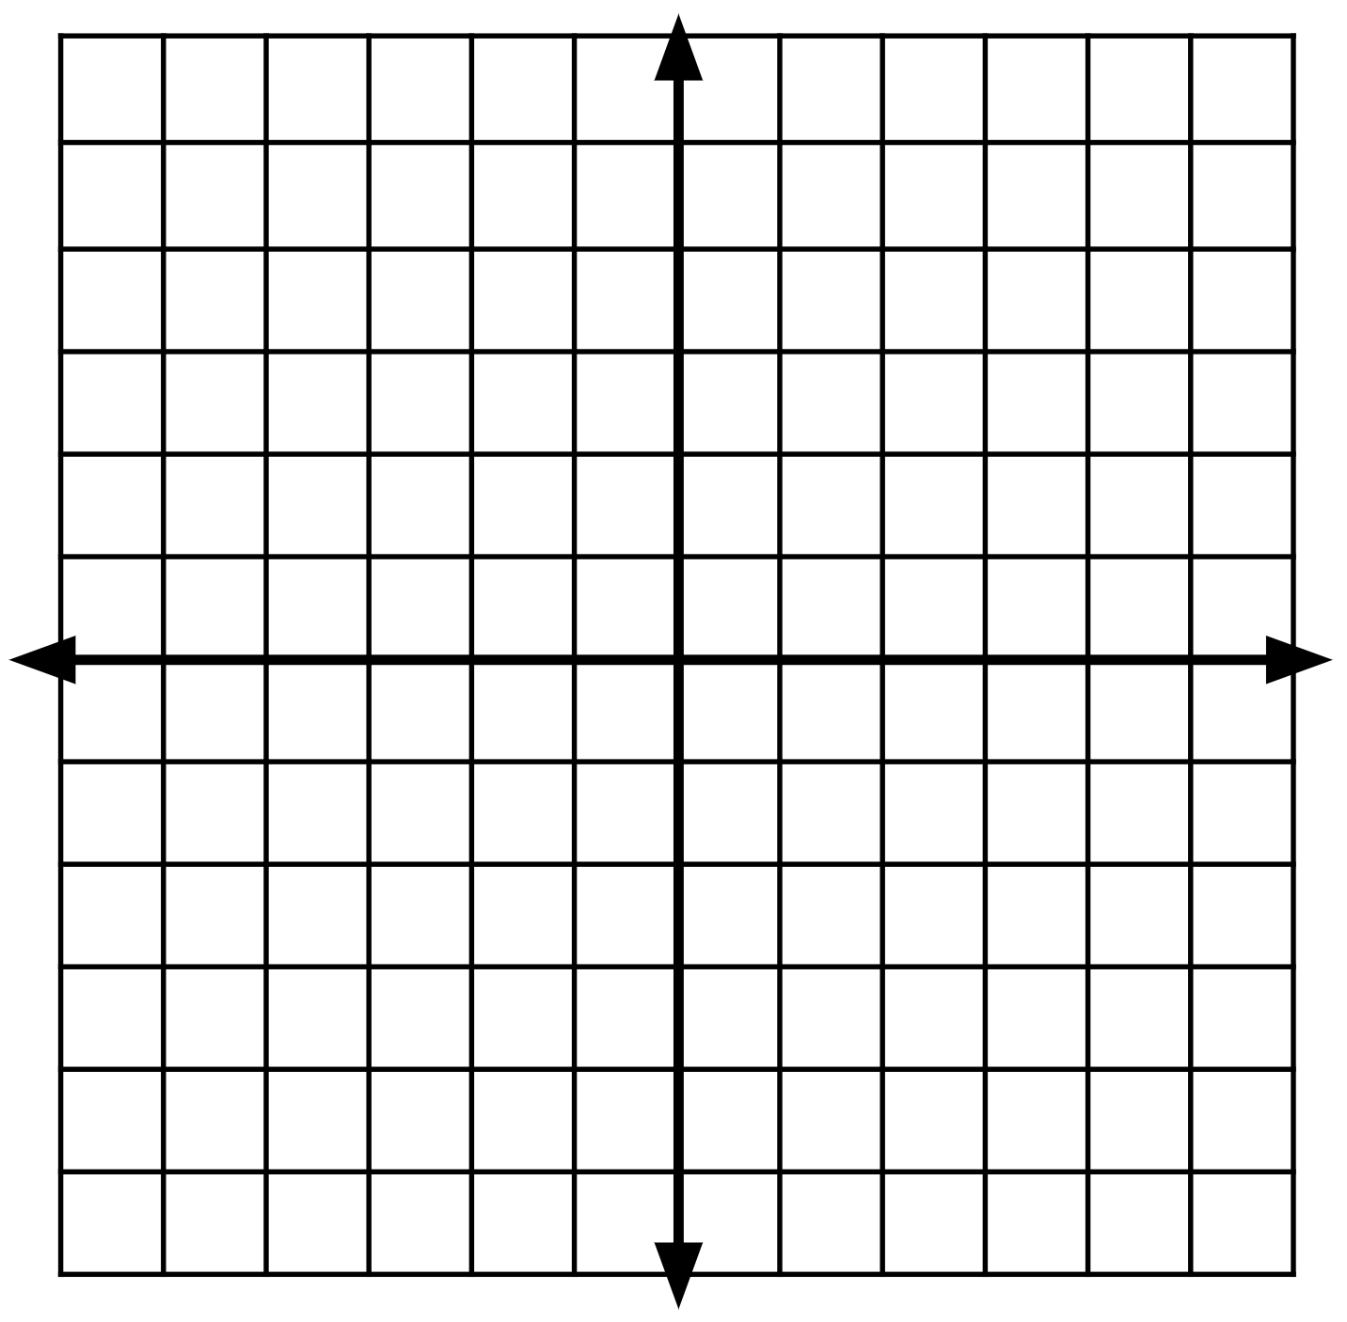
- (4, 2) and (10, 7)
Answer: ⅚

- (1, -2) and (2, 5)
Answer: 7

- (-3, 4) and (-5, -2)
Answer: 3

- (8, 3) and (10, -9)
Answer: -6

Lesson 4.9: Interpreting and Creating Graphs

Q# | Standard
1-3 | ALG.3(B) Calculate the rate of change of a linear function represented tabularly, graphically, or algebraically in context of mathematical and real-world problems.
For questions 1 - 3, examine the following graphs representing how busy restaurants are at different times of the day.
Restaurant A  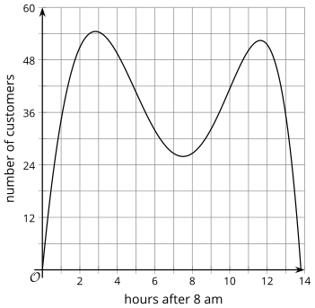 | Restaurant B  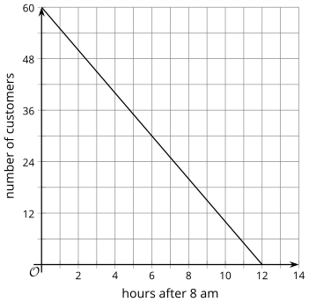
Restaurant C  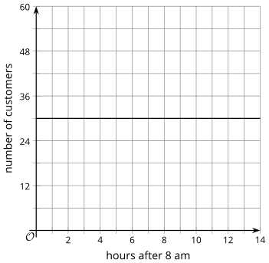 | Restaurant D  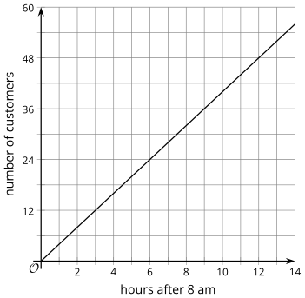

For each situation, select the best restaurant and explain your reasoning.
- Which restaurant is busy in the morning, then has fewer customers in the evening?
- Restaurant A
- Restaurant B [Answer]
- Restaurant C
- Restaurant D
Explanation:
Answer: Explanations will vary.
- If Lin’s mom wants to go to a popular dinner restaurant, which restaurant should Lin take her mom to eat?
- Restaurant A
- Restaurant B
- Restaurant C
- Restaurant D [Answer]
Explanation:
Answer: Explanations will vary.

- Noah’s dad prefers breakfast places with few customers so that he can start on work while eating. Which restaurant should Noah’s dad go to for breakfast?
- Restaurant A [Potential Answer]
- Restaurant B
- Restaurant C
- Restaurant D [Potential Answer]
Explanation:
Answer: Explanations will vary.

Lesson 4.10: Comparing Graphs

Q# | Standard
1-4 | MATH.6.2(D) Order a set of rational numbers arising from mathematical and real-world contexts.
5-7 | ALG.12(B) Evaluate functions, expressed in function notation, given one or more elements in their domains.
For each pair of numbers, write =, < or > in the blank to make a true equation or inequality. Be prepared to share your reasoning.
      - -6 ________ -9
Answer: >
      - $\frac{7}{3}$ ________ $\frac{13}{6}$
Answer: >
      - 5.2 ________ $\frac{53}{11}$
Answer: >
      - 5(3 – 6) ________ 15 – 6
Answer: <
For questions 5-7, use the following function.
$$f(x) = 5 - 2x$$
      - $f(3)$ _________ $f(5)$
Answer: >
      - $f(-3)$ _________ $f(-4)$
Answer: <
      - $f(-1)$ _________ $f(1)$
Answer: >

Lesson 4.11: Graphing a Function Using Transformations

Q# | Standard
ALL | ALG.2(B) Write linear equations in two variables in various forms, including$y = mx + b$, $Ax + By = C$, and $y - y_{1} = m(x - x_{1})$, given one point and the slope and given two points.
The following linear equations are given in point-slope form. Identify the point and slope that is given in each equation.
Answers:
Equation | Point | Slope
$$(y - 3) = \frac{2}{3}(x - 6)$$ | Answer: (6, 3) | Answer: $m = \frac{2}{3}$
$$(y + 1) = -2(x - 7)$$ | Answer: (7, -1) | Answer: $m = -2$
$$(y - 2) = -\frac{1}{2}(x + 4)$$ | Answer: (-4, 2) | Answer: $m = -\frac{1}{2}$
$$y - 4 = \frac{5}{2}(x + 8)$$ | Answer: (-8, 4) | Answer: $m = \frac{5}{2}$
$$y - 0 = 1(x - 0)$$ | Answer: (0, 0) | Answer: $m = 1$

Lesson 4.12: Domain and Range, Part 1

Q# | Standard
ALL | ALG.12(B) Evaluate functions, expressed in function notation, given one or more elements in their domains.
For each function, draw a line to all of the possible inputs that could be used in the function. Be prepared to explain your reasoning for whether you include each input or not.
↓ Functions | Possible Inputs ↓
$f(person) =$ the person’s height in feet | 0  -1
$$g(x) = 2x + 1$$ | George
$C(\#students in class)$ = 1.99 $∙$(# students in class) | 6
$P(equilateral triangle's side length) =$ 3 $∙$ (side length) | 9.3

Answers:
- $f(person)$ >> Simone Biles
- $g(x)$ >> 6, 9.3, 0, -1
- $h(item)$ >> George Washington
- $P(equilateral triangle side length)$ >> 6, 9.2
- $C(number of students)$ >> 6, 0

Lesson 4.13: Domain and Range, Part 2

Q# | Standard
1-3 | ALG.2(A) Determine the domain and range of a linear function in mathematical problems; determine reasonable domain and range values for real-world situations, both continuous and discrete; and represent domain and range using inequalities.
For questions 1 - 3, examine the graph. Then, for the graph, give an example value that is in the domain, is not in the domain, is in the range, and is not in the range.
1.  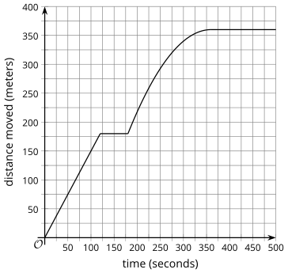 | Example in domain:  Answer: Answers will vary, but here are some samples.  180 seconds
Example NOT in domain:
Answer: Answers will vary, but here are some samples.
1 trillion seconds
Example in range:
Answer: Answers will vary, but here are some samples.
200 meters
Example NOT in range:
Answer: Answers will vary, but here are some samples.
-5 meters

2.  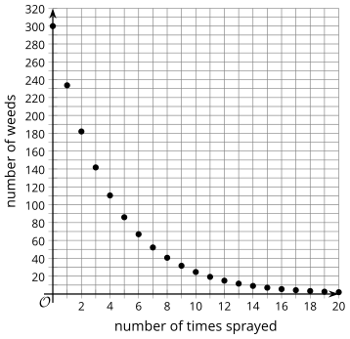 | Example in domain:  Answer: Answers will vary, but here are some samples.  8 sprays
Example NOT in domain:
Answer: Answers will vary, but here are some samples.
1.6 sprays
Example in range:
Answer: Answers will vary, but here are some samples.
40 weeds
Example NOT in range:
Answer: Answers will vary, but here are some samples.
800 weeds

3.  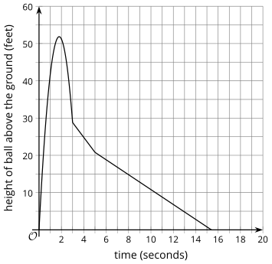 | Example in domain:  Answer: Answers will vary, but here are some samples.  5.3 seconds
Example NOT in domain:
Answer: Answers will vary, but here are some samples.
-80 seconds
Example in range:
Answer: Answers will vary, but here are some samples.
25 feet
Example NOT in range:
Answer: Answers will vary, but here are some samples.
80 feet

Lesson 4.14: Sequences

Q# | Standard
1-4 | MATH.5.4(D) Recognize the difference between additive and multiplicative numerical patterns given in a table or graph.
For questions 1 - 4, fill in the blanks to continue the patterns.
1. 3, 6, 9, ______, ______
Answer:
3, 6, 9, 12, 15
- 1, ______, 9, 13, ______
Answer:
1, 5, 9, 13, 17
- 3, 6, 12, ______, ______
Answer:
3, 6, 12, 24, 48
- 128, 64, ______, ______, 8
Answer:
128, 64, 32, 16, 8

Lesson 4.15: Introducing Geometric Sequences

Q# | Standard
1-3 | ALG.11(B) Simplify numeric and algebraic expressions using the laws of exponents, including integral and rational exponents.
- Identify all the expressions that are equivalent to $2 ∙ 2 ∙ 2 ∙ 2 ∙ 2 ∙ 2$.
Answers:
Expression | Equivalent | Not Equivalent
$$2^{6}$$ | Yes | o
$$2 ∙ 6$$ | o | Yes
$${(2^{2})}^{3}$$ | Yes | o
$$2^{3} + 2^{3}$$ | o | Yes
$$2^{2} + 2^{2} + 2^{2}$$ | o | Yes
$$6^{2}$$ | o | Yes
$$2^{3} ∙ 2^{3}$$ | Yes | o
$${(2^{3})}^{2}$$ | Yes | o

- Which expressions equal $8^{0}?$ Select four equivalent expressions.
- $1$ [Answer]
- $0$
- $8^{3} ∙ 8^{-3}$ [Answer]
- $\frac{8^{2}}{8^{2}}$ [Answer]
- ${11}^{0}$ [Answer]
- Which expressions equal $3^{10}?$ Select four equivalent expressions.
- $3^{5} ∙ 3^{2}$
- ${(3^{5})}^{2}$ [Answer]
- $3^{7} ∙ 3^{3}$ [Answer]
- $3^{13} ∙ 3^{-3}$ [Answer]
- $\frac{3^{10}}{3^{0}}$ [Answer]

Lesson 4.16: Different Types of Sequences

Q# | Standard
1-2 | MATH.5.4(D) Recognize the difference between additive and multiplicative numerical patterns given in a table or graph.
3-4 | MATH.8.5(B) Represent linear non- proportional situations with tables, graphs, and equations in the form of $y = mx + b$, where $b ≠ 0$.
For questions 1 - 2, examine the patterns with their first 5 terms listed. For each pattern, describe a way to produce each new term from the previous term.
- Pattern A: 5, 8, 11, 14, 17, …
Answer: Each new term is 3 more than the previous term.

- Pattern B: ½ , 1, 2, 4, 8, …
Answer: Each new term is double the previous term.

For each of the equations in questions 3 - 4, find the value of $y$ when $x = 1$, 2, and 3.
- $y = 3x - 4$
Answer: -1, 2, 5 (adds three each time)

- $y = 10 - 2x$
Answer: 8, 6, 4 (adds negative two each time)

Lesson 4.17: Sequences are Functions

Q# | Standard
1-2 | ALG.12(B) Evaluate functions, expressed in function notation, given one or more elements in their domains.
3 | ALG.5(A) Solve linear equations in one variable, including those for which the application of the distributive property is necessary and for which variables are included on both sides.
4-6 | MATH.7.7(A) Represent linear relationships using verbal descriptions, tables, graphs, and equations that simplify to the form $y = mx + b$.
For questions 1 - 3, use the following function.
$$f(x) = -3x + 7.$$
- What is $f(0)$?
Answer: $f(0) = 7$

- What is $f(-5)$?
Answer: $f(-5) = 22$

- What is $x$ when $f(x) = -20$?
Answer: $x = 9$
For questions 4 - 6, use the following scenario.
A city bus charges $0.25 per ride if you first buy the $10 discount card. Let B be the total cost, in dollars, of taking n rides on the bus

- Complete the table of values for function $B$ for several inputs.
Answers:
$$n$$ | $$B$$
0 | 10
2 | Answer: 10.5
4 | Answer: 11
10 | Answer: 12.5
- Sketch a graph of the total cost $B$, in dollars, for the number of bus rides from 0 to 10.
Answer:
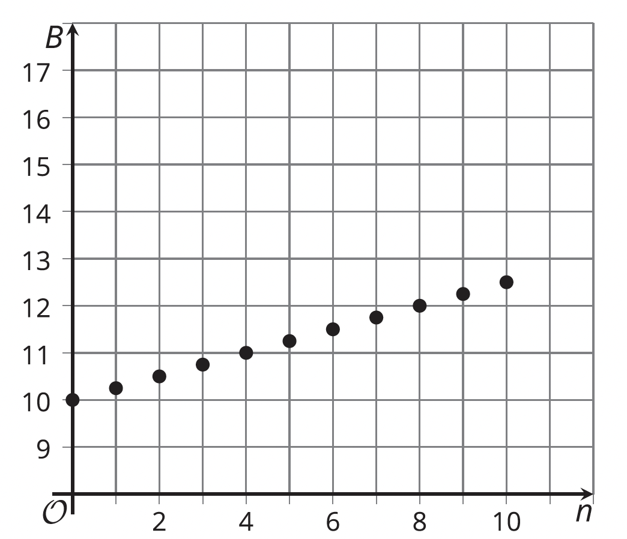
- Write an equation for $B$ as a function of $n$.
Answer: $B = 0.25n + 10$

Lesson 4.18: The nth Term of an Arithmetic Sequence

Q# | Standard
1 | ALG.9(D) Graph exponential functions that model growth and decay and identify key features, including $y$-intercept and asymptote, in mathematical and real-world problems.
2 | ALG.9(B) Interpret the meaning of the values of $a$ and $b$ in exponential functions of the form $f(x) = ab^{x}$ in real-world problems.
Examine the graph of a pattern of numbers where $V$ is a function of $n$. The first point is
(0, 1).
- Plot the next 2 points on the graph that follow the pattern.
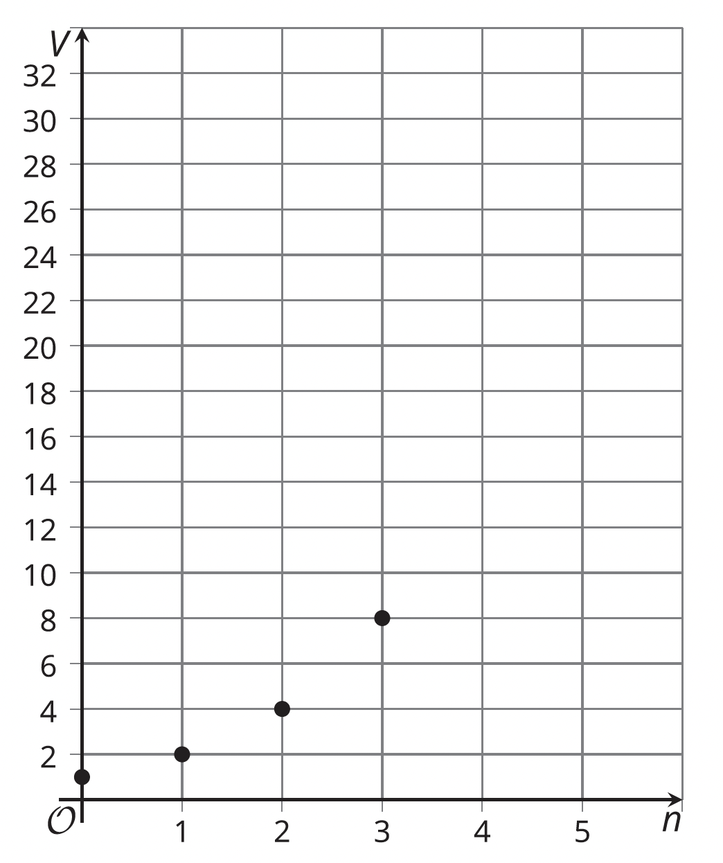 | Answer:  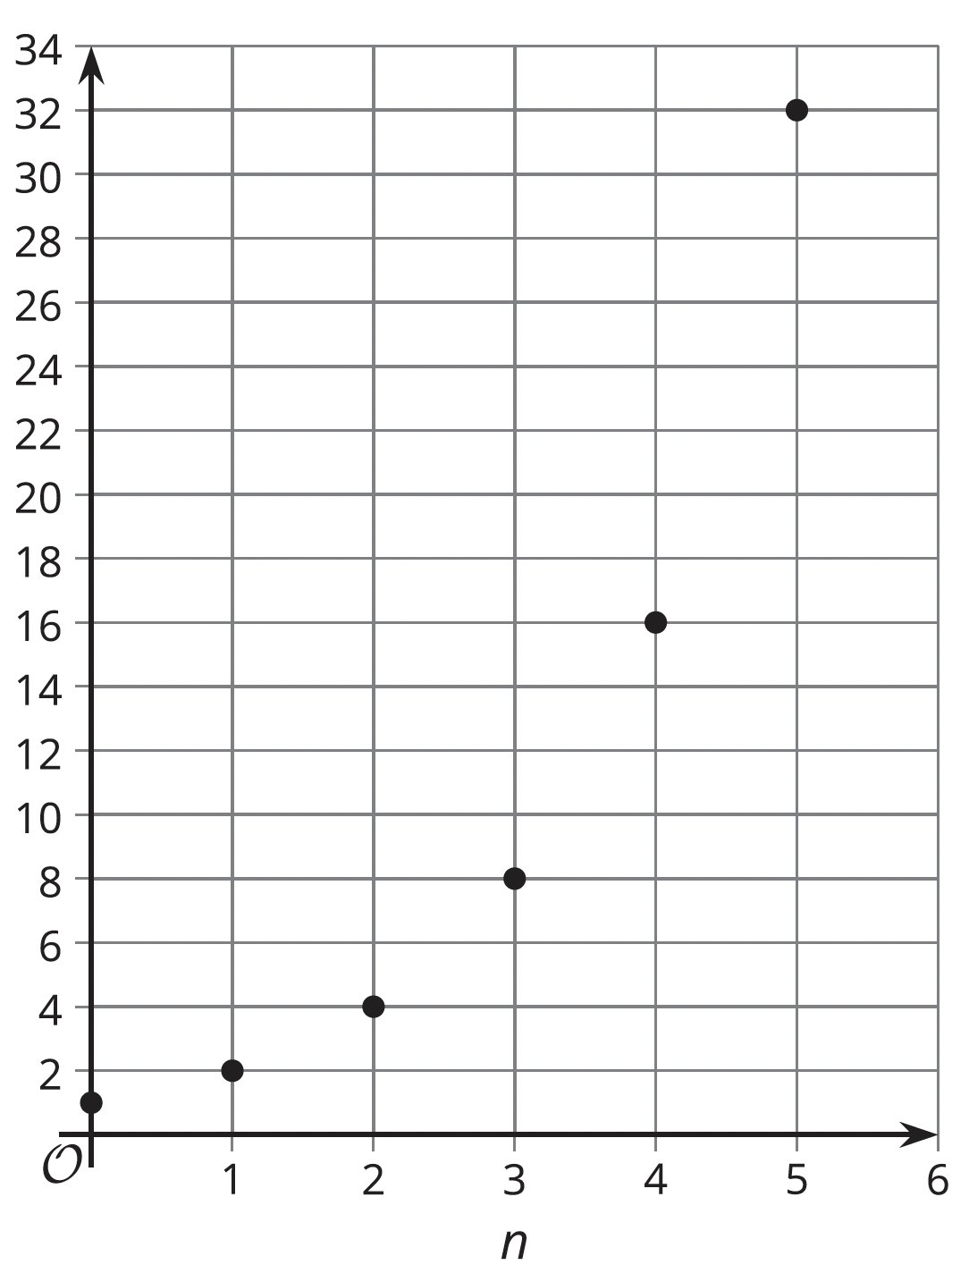
- Write an equation to describe the relationship between $V$ and $n$.
Answer: $V = 1 ∙ 2^{n}$

