Unit 8 Student Diagnostic
These materials, when encountered before the denoted lesson, support access to the lesson and identify potential areas where additional support may be required. Note that the content in these lesson diagnostics represents prerequisite skills and does not address the required rigor for full mastery of the on-grade level standards.
Your students may benefit from using these materials in conjunction with the Unit Overview and Readiness page (quiz and mini-lessons).

Lesson 8.1: Finding Unknown Inputs Check-in 2
Lesson 8.2: When and Why Do We Write Quadratic Equations? Check-in 3
Lesson 8.3: Solving Quadratic Equations by Reasoning Check-in 4
Lesson 8.4: Solving Quadratic Equations with the Zero Product Property Check-in 5
Lesson 8.5: How Many Solutions? Check-in 6
Lesson 8.6: Rewriting Quadratic Expressions in Factored Form, Part 1 Check-in 7
Lesson 8.7: Rewriting Quadratic Expressions in Factored Form, Part 2 Check-in 9
Lesson 8.8: Rewriting Quadratic Expressions in Factored Form, Part 3 Check-in 10
Lesson 8.9: Solving Quadratic Equations by Using Factored Form Check-in 12
Lesson 8.10: Rewriting Quadratic Expressions in Factored Form, Part 4 Check-in 13
Lesson 8.11: Writing Quadratic Equations Given Real Solutions Check-in 14
Lesson 8.12: Using Technology to Find the Quadratic Regression Check-in 15

Lesson 8.1: Finding Unknown Inputs
For questions 1 - 6, examine the representation of a swimming pool.
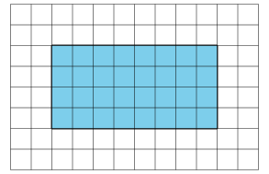
The pool is represented by the shaded region, and the walkway around a pool is tiled as shown in the diagram.
- What is the area of the (shaded) pool if each tile is 1 square foot?

- What is the area of the pool if each tile is 4 square feet?

- What is the area of the walkway and the pool when each tile is 1 square foot?

- What is the area of the walkway and the pool when each tile is 4 square feet?

- What is the area of the walkway ONLY when each tile is 1 square foot?

- What is the area of the walkway ONLY when each tile is 4 square feet?

Lesson 8.2: When and Why Do We Write Quadratic Equations?
For questions 1 - 3, use the following scenario.
The expression 5.25 + 0.85x represents the amount a yogurt shop charges for yogurt with x ounces of toppings.
- What does the equation $5.25 + 0.85x = 7.08$ mean in this situation?

- What would a solution to this equation mean?

- Use technology to graph $y=5.25 + 0.85x$. Where can you see the solution to the equation on the graph?

For questions 4 - 6, use the following scenario.
Drinks cost $1.50, sandwiches cost $4.00, and there is a flat delivery fee of $5 for each delivery regardless of the number of orders.
- Write an expression that represents the amount it costs to have $x$ meals including a drink and a sandwich delivered to an office.

- Write an equation that has a solution representing the number of drink and sandwich orders it would take to cost $80.

- Graph your equation using technology. Where can you see the solution to the equation on the graph?

Lesson 8. 3: Solving Quadratic Equations by Reasoning
For questions 1 - 2, use the following equation.
$$p^{2} = q$$
- Select four pairs of values that could be $p$ and $q$.
- $p = 6, q = 36$
- $p = -6, q = 36$
- $p = -2, q = -4$
- $p = -10, q = 100$
- $p = \frac{1}{2}, q =\frac{1}{4}$
- $p = -0.2, q = 0.4$

- List one other possible pair of values for $p$ and $q$ that makes the equation true.

Lesson 8.4: Solving Quadratic Equations with the Zero Product Property
Evaluate each function for $x = 6$.
- $f(x) = (x + 4)(x-6)$

- $g(x) = (x -6)(x+6)$

- $h(x) = x^{2} - 6x$

- $j(x) = 2(\frac{2}{3}x + 8)(x-6)$

- $k(x) =0.5x^{2} - 3x$

- What do the functions in questions 1 - 6 have in common?

Lesson 8.5: How Many Solutions?
The table below shows Clare’s work to solve some equations. For each problem, circle the step at which Clare made a mistake and explain what she did incorrectly.
Clare’s work | Explanation of her mistake
$$2(x - 1) + 4 = 3x - 2$$  $$2x - 2 + 4 = 3x - 2$$  $$2x + 2 = 3x - 2$$  $$2x = 3x$$  $$-x = 0$$  $$x = 0$$ | Answer
$$3(x - 1) = 5x + 6$$  $$3x - 1 = 5x + 6$$  $$-1 = 2x + 6$$  $$-7 = 2x$$  $$-3.5 = x$$ | Answer
$$(x - 2)(x + 3) = x + 10$$  $$x^{2} + x - 6 = x + 10$$  $$x^{2} -6 = 10$$  $$x^{2} = 16$$  $$x = 4$$ | Answer

Lesson 8.6: Rewriting Quadratic Expressions in Factored Form
For questions 1 - 5, examine the diagram below.
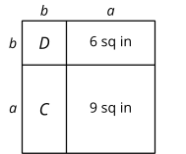
- Find the length $a$ in inches.

- Find the length $b$ in inches.

- Find the area $C$ in square inches.

- Find the area $D$ in square inches.

- Find the area of the entire large rectangle in the figure. Show your reasoning.

Lesson 8. 7: Rewriting Quadratic Expressions in Factored Form
For each question, find a pair of integers with the given product and sum. The first question has been done for you as a model.
- Product = 6; sum = 5
The numbers 2 and 3 multiply to be 6 and add to be 5.

- Product = 6; sum = 7

- Product = 4; sum = -5

- Product = -1; sum = 0

- Product = -6; sum = 1

- Product = -12; sum = -1

- Product = -12; sum = 4

Lesson 8.8: Rewriting Quadratic Expressions in Factored Form, Part 3
Here is a method for multiplying 97 and 103:
97 is 100 – 3  103 is 100 + 3  So, 97 $∙$ 103 = (100 – 3)(100 + 3)  =10,000 + 300 - 300 - 9 = 9991 | 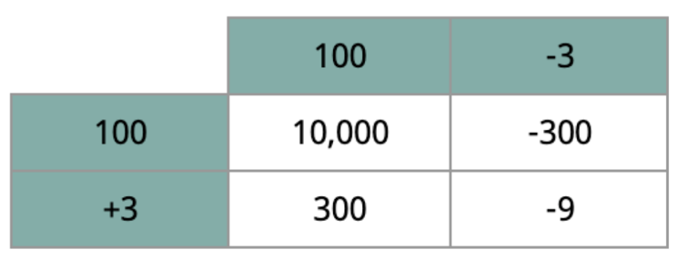
Use this method to compute:
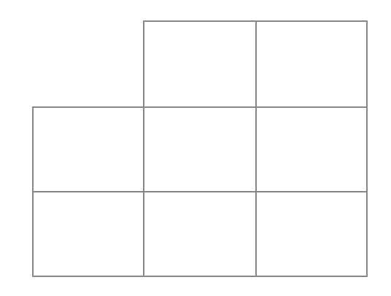
- 7 $∙$ 13

- 102 $∙$ 98

- 995 $∙$ 1,005

Lesson 8.9: Solving Quadratic Equations by Using Factored Form
For each equation, check the appropriate box for any values that are solutions. (Some equations have two solutions, others only have one.)
Equation | -9 | -7 | -6 | -4 | 0 | 3 | 4 | 5 | 6 | 7
$$35 = x^{2} - 1$$ | ¨ | ¨ | ¨ | ¨ | ¨ | ¨ | ¨ | ¨ | ¨ | ¨
$$(x - 5)(x + 7) = 0$$ | ¨ | ¨ | ¨ | ¨ | ¨ | ¨ | ¨ | ¨ | ¨ | ¨
$$0 = (7 - x)∙ x$$ | ¨ | ¨ | ¨ | ¨ | ¨ | ¨ | ¨ | ¨ | ¨ | ¨
$${(x + 3)}^{2} = 36$$ | ¨ | ¨ | ¨ | ¨ | ¨ | ¨ | ¨ | ¨ | ¨ | ¨
$$x^{2} + 8x + 16 = 0$$ | ¨ | ¨ | ¨ | ¨ | ¨ | ¨ | ¨ | ¨ | ¨ | ¨

Lesson 8.10: Rewriting Quadratic Expressions in Factored Form.
Use technology to graph the functions, then find the zeros.
- $f(x) = (x + 2)(x - 5)$

- $g(x) = (5x - 4)(x - 3)$

- $h(x) = x^{2} + 5x + 4$

- $k(x) = x^{2} + 5x + 3$

- $m(x) = 2x^{2} - 13x - 15$

- $n(x) = {2x}^{2} - 13x - 10$

Lesson 8.11: Writing Quadratic Equations Given Real Solutions
Draw a line that matches the expression written in factored form with a function written in standard form.
↓ Expressions in Factored Form | Functions in Standard Form ↓
$$(2a + 5)(a + 4)$$ | $$f(x) = 2a^{2} + 13a + 20$$
$$(3a - 1)(a - 10)$$ | $$g(x) = 16a^{2} - 25$$
$$(a + 7)(5a - 2)$$ | $$h(x) = 5a^{2} + 33a - 14$$
$$(4a - 5)(4a - 5)$$ | $$j(x) = 16a^{2} - 40a + 25$$
$$(4a - 5)(4a + 5)$$ | $$k(x) = 18a^{2} + 71a + 28$$
$$(2a + 7)(9a + 4)$$ | $$m(x) = 3a^{2} - 31a + 10$$

Lesson 8.12: Using Technology to Find the Quadratic Regression
For questions 1 - 4, use the given information to write a quadratic equation in standard form.
$$(y = ax^{2} + bx + c)$$

- $a = 1, b = 6, c = 9$

- $a = 4, b = 12, c = 9$

- $a = -16, b = 4, c = 1$

- $a = 9, b = -30, c = -25$

