Unit 3 STAAR Review

About OpenStax STAAR Review Quizzes
Each STAAR Review Quiz consists of approximately ten questions. While the first half of the quiz focuses on content from the current unit, the last half of the quiz pulls from content in previous units.
In this manner, the STAAR Review Quiz provides an on-going, spiral review of the content reinforcing the evidence-based strategy of spaced retrieval. The questions on the STAAR Review Quizzes have all been selected from released STAAR End of Course Algebra 1 items from the Texas Education Agency [TEA].
The table below shows a summary of the answers and their TEKS information. For the full quiz questions, go to next section.
Review Q# | Answer Letter | TEKS | Exam/ Question# | Relevant Unit
1 | C | A.4(A) | 2017/ Question#19 | 3
2 | C | A.4(C) | 2019/ Question#22 | 3
3 | B | A.4(B) | 2021/ Question#31 | 3
4 | B | A.4(C) | 2018/ Question#12 | 3
5 | D | A.4(B) | 2018/ Question#25 | 3
6 | C | A.5(B) | 2018/ Question#30 | 2
7 | A | A.3(H) | 2021/ Question#13 | 2
8 | A | A.2(I) | 2021/ Question#24 | 2
9 | D | A.5(A) | 2019/ Question#3 | 1
10 | B | A.3(C) | 2021/ Question#9 | 1

Quiz Answers
- The table shows the lengths and widths of several rectangles.
Height (in.) | Length (in.)
70 | 25
21 | 32
34 | 12
10 | 16
92 | 45
54 | 40
24 | 23
35 | 35
42 | 21
66 | 14
What does the correlation coefficient for the data indicate about the strength of the linear association between the height and the length of these rectangles?
  - Weak negative correlation
  - Strong negative correlation
  - Weak positive correlation (Answer)
  - Strong positive correlation

- A company advertises on a website. A worker tracked the number of visits to the website and the number of clicks on the advertisement. The table shows the data for several days. A linear function can be used to model the data.
Number of Visits to Website, $x$ | Number of Clicks on Advertisement, $y$
153 | 14
629 | 38
471 | 30
914 | 53
307 | 21
1,045 | 60
510 | 32
1,106 | 63
Based on the table, what is the best prediction of the number of clicks on the advertisement if 1,500 people visit the website?
  - 77
  - 137
  - 83 (Answer)
  - 105
- Which situation best shows causation?
  - The length of a rectangle affects the width of the rectangle.
  - The amount of time a cell phone is used affects the charge of its battery. (Answer)
  - The number of ice-cream bars sold affects the number of milkshakes sold.
  - The number of soccer balls a team owns affects the number of games the team wins during the soccer season.
- A zookeeper recorded the feeding schedule for a baby rhinoceros for 20 weeks. The table and scatter plot show the percentage of the baby rhinoceros’s body mass that was used to determine the amount of food given at each feeding as a linear function of its age in weeks.
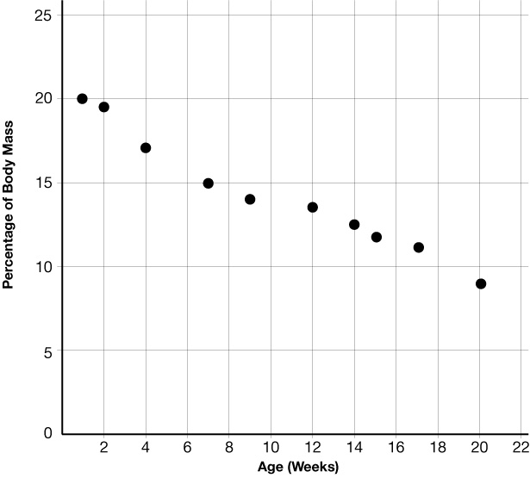
Age  (weeks) | 1 | 2 | 4 | 7 | 9 | 12 | 14 | 15 | 17 | 20
Percentage of Body Mass | 20 | 19.5 | 17 | 15 | 14 | 13.5 | 12.4 | 11.6 | 11 | 9
What is the best prediction of the percentage of the baby rhinoceros’s body mass that should be used to determine the amount of food given at each feeding when it is 25 weeks old?
  - 8.5%
  - 6% (Answer)
  - 2.5%
  - 10%

- Which situation does NOT show causation?
  - When the student population at a school increases, the number of teachers at the school increases.
  - When the amount of sugar in a quart of apple juice is reduced, there are fewer calories in each serving.
  - When there are more workers on a project, the project is completed in less time.
  - When there is more protein in an athlete’s diet, the athlete scores more points in a game. (Answer)

- What is the solution set for $-4x + 10 ≥ 5x + 55$?
  - $x ≥ 5$
  - $x ≥ 45$
  - $x ≤ -5$ (Answer)
  - $x ≤ 5$

- Which graph best represents the solution set to this system of inequalities?
$$\left\{\begin{aligned}x+y<1 \\ x-y≤2\end{aligned}\right.$$

- (Answer)
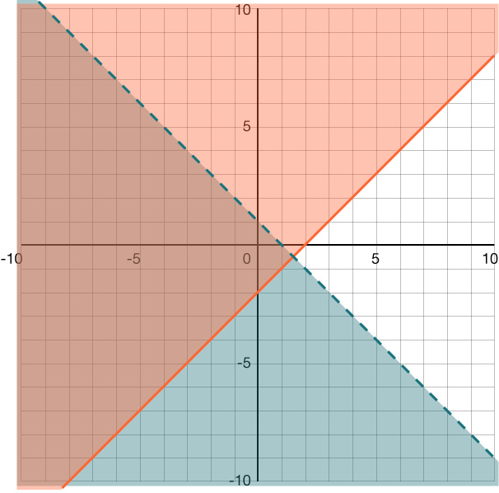

- 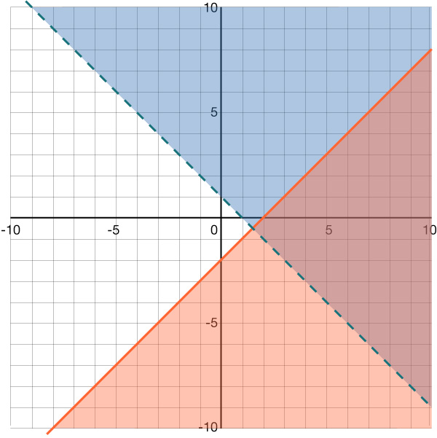
- 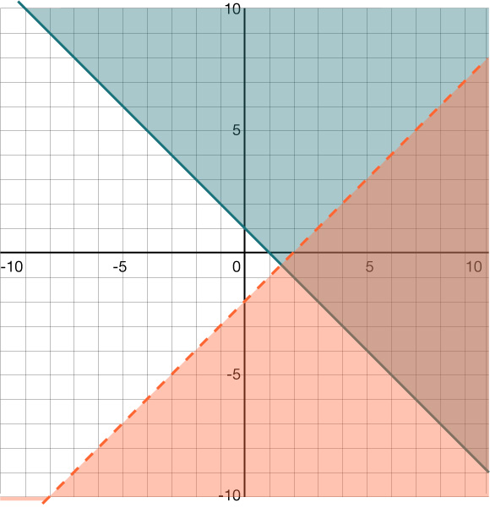

- 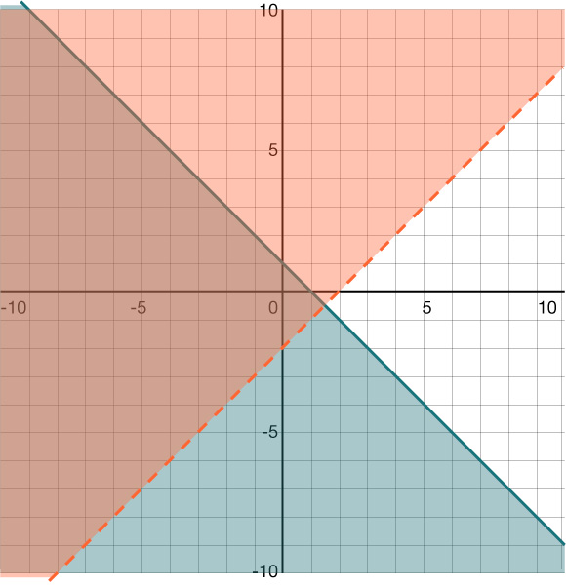

- The tables of ordered pairs represent some points on the graphs of lines $f(x)$ and $g(x)$.
$$x$$ | $$y$$
2 | 7
4 | 10.5
7 | 15.75
11 | 22.75
$$x$$ | $$y$$
-3 | 4
-2 | 0
1 | -12
4 | -24

Which system of equations represents lines $f$ and $g$?
  - $\left\{ \begin{aligned}y = 1.75x + 3.5 \\ y = -4x - 8\end{aligned}\right.$ (Answer)
  - $\left\{ \begin{aligned}y = 1.75x + 3.5 \\ y = -4x - 2\end{aligned}\right.$
  - $\left\{ \begin{aligned}y = 3.5x + 1.75 \\ y = -4x - 8\end{aligned}\right.$
  - $\left\{ \begin{aligned}y = 3.5x + 1.75 \\ y = -4x - 2\end{aligned}\right.$
- Which value of $x$ makes the equation $1.25(4x - 10) = 7.5$ true?
  - 3.5
  - −1
  - −0.5
  - 4 (Answer)

- The graph of linear function $g(x)$ passes through the points $(-7,-4)$and $(7,6)$, as shown.
What are the slope and $y$-intercept of the graph of $g$?
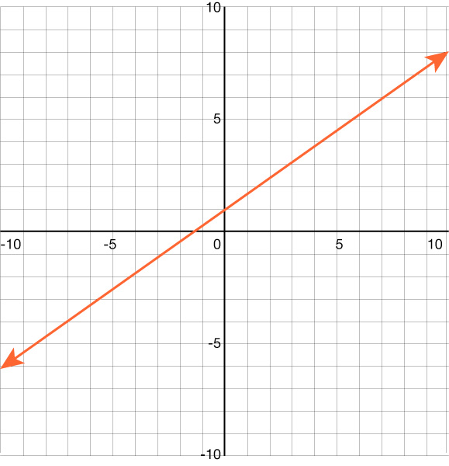
  - The slope is $\frac{5}{7}$, and the $y$-intercept is $-1$.
  - The slope is $\frac{5}{7}$, and the $y$-intercept is $1$. (Answer)
  - The slope is $\frac{7}{5}$, and the $y$-intercept is $-1$.
  - The slope is $\frac{7}{5}$, and the $y$-intercept is $1$.

