Unit 2 Family Support Materials
Get acquainted with the topics and concepts your student will be learning during Unit 2.

Linear Inequalities and Systems
In this unit, students write and graph two equations that represent different parts of the same problem situation. They use the graphs to see possible values that satisfy the constraints of each equation. The work prompts them to think about a pair of values that simultaneously meets multiple constraints in the situation, which in turn helps them make sense of the phrase “a solution to both equations.”

An example of two constraints in the same problem situation
Streaming Company A charges $15 per month plus $3 per new release movie. Streaming Company B charges $10 per month plus $5 per new release movie. The system of equations represents this situation. Where $x$ represents the number of movies streamed and $y$ represents the total cost.
$$\left\{\begin{aligned}y=3x+15 \\ y=5x +10\end{aligned}\right.$$

Here are the graphs that represent the situation
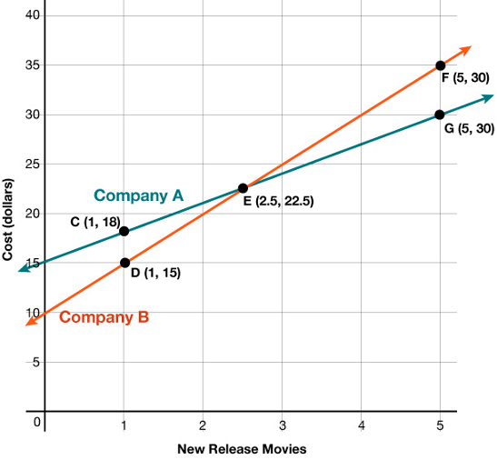 | - Points $C(1,18)$ and $G(5,30)$ are solutions of the equation $y=3x+15.$ Point $C$ represents the total cost of $18 for the monthly fee plus 1 new release movie.  - Points $D(1, 15)$and $F(5, 35)$ are solutions to the equation $y=5x+10.$ Point $D$ represents the total cost of $15 for the monthly fee plus 1 new release movie.  - Point $E(2.5,22.5)$ is a solution to both equations, and therefore a solution to the system. It means that the cost for both plans is $22.50 for the monthly fee plus 2.5 new release movies. In this case, you cannot stream part of a movie. However, you can see this is the point where costs are the same.
- To check that $(2.5,22.5)$ is a solution to both equations, substitute 2.5 for $x$ and 22.5 for $y$ into both equations:
  - $y=3x+15;22.5=3(2.5)+15;22.5=7.5+15;22.5=22.5$
  - $y=5x+10;22.5=5(2.5)+10;22.5=12.5+10;22.5=22.5$

Apply

Try this task with your student
Kalib is making a trail mix. He spends $32 on 5 pounds of nuts.
- Each pound of peanuts, $x$, costs $4.
- Each pound of cashews, $y$, costs $8.

The following system and graph represent the situation:
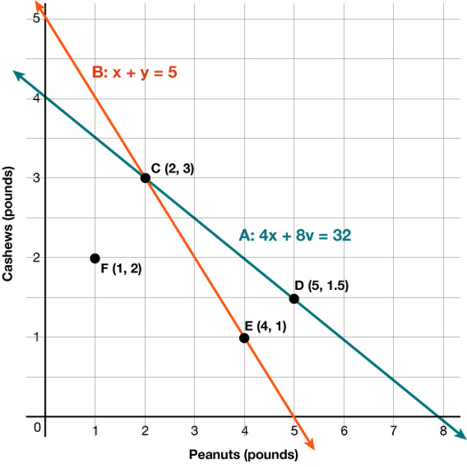
$$\left\{\begin{aligned}x+y=5 \\ 4x+8y=32\end{aligned}\right.$$

Complete the following questions
- Which point or points are solutions to the equation $x+y=5$?
- Which point or points are solutions to $4x+8y=32$?
- Which are solutions to the system?
- How should you interpret the solution?
- How can you check the solution?
- Point $F$ is not on the line. How should we interpret the point?
*You can find the answers on the next page

Hide the answers until you have attempted the questions.
- $C$ and $E$
- $C$ and $D$
- $C$
- 2 pounds of peanuts and 3 pounds of cashews cost $32.
- Substitute 2 for $x$ and 3 for $y$ into each equation.
- 1 pound of peanuts and 2 pounds of cashews is less than 5 pounds of nuts and costs less than $32.

Review

Video lesson summaries for Unit 2: Linear Inequalities and Systems
Each video highlights key concepts and vocabulary that students learn across one or more lessons in the unit. The content of these video lesson summaries is based on the written Lesson Summaries found at the end of lessons in the curriculum. The goal of these videos is to support students in reviewing and checking their understanding of important concepts and vocabulary.

Here are some possible ways families can use these videos:
- Keep informed on concepts and vocabulary students are learning about in class.
- Watch with their students and pause at key points to predict what comes next or think up other examples of vocabulary terms

Video Title | Related Lessons
Solving Systems of Equations | - Writing and Graphing Systems of Equations  - Writing Systems of Equations  - Solving Systems by Substitution  - Solving Systems by Elimination, Part(s) 1, 2, & 3
One-Variable Inequalities | - Systems of Linear Equations and Their Solutions  - Representing Situations with Inequalities  - Solutions to Inequalities
Systems of Inequalities | - Writing and Solving Inequalities in One Variable  - Graphing Linear Inequalities in Two Variables  - Using Linear Inequalities as Constraints  - Solving Problems with Inequalities in Two Variables  - Solutions to Systems of Linear Inequalities in Two Variables

 | If needed, access the digital version of this page at https://openstax.org/r/unit2-family

