Unit 2 STAAR Review

About OpenStax STAAR Review Quizzes
Each STAAR Review Quiz consists of approximately ten questions. While the first half of the quiz focuses on content from the current unit, the last half of the quiz pulls from content in previous units.
In this manner, the STAAR Review Quiz provides an on-going, spiral review of the content reinforcing the evidence-based strategy of spaced retrieval. The questions on the STAAR Review Quizzes have all been selected from released STAAR End of Course Algebra 1 items from the Texas Education Agency [TEA].
The table below shows a summary of the answers and their TEKS information. For the full quiz questions, go to next section.
Review Q# | Answer Letter | TEKS | Exam/ Question# | Relevant Unit
1 | C | A2(I) | 2021/ Question#15 | 2
2 | C | A5(C) | 2021/ Question#50 | 2
3 | A | A3(D) | 2021/ Question#5 | 2
4 | B | A2(H) | 2021/ Question#30 | 2
5 | D | A3(D) | 2021/ Question#46 | 2
6 | D | A5(A) | 2021/ Question#54 | 1
7 | A | A3(A) | 2019/ Question#1 | 1
8 | B | A2(D) | 2019/ Question#54 | 1
9 | B | A2(E) | 2021/ Question#19 | 1
10 | B | A2(G) | 2021/ Question#39 | 1

Quiz Answers
- A customer paid a total of $6.00 for 68 copies at a print shop. Some of the copies were black-and-white copies, and the rest were color copies.
- Each black-and-white copy cost $0.08.
- Each color copy cost $0.15.
Which system of equations can be used to find 𝑏, the number of black-and-white copies, and 𝑐, the number of color copies that the customer paid for at the print shop?
  - $\left\{\begin{aligned}b + c = 6.00 \\ 0.08b + 0.15c = 68\end{aligned}\right.$
  - $\left\{\begin{aligned}b + c = 6.00 \\ 0.15b + 0.08c = 68 \end{aligned}\right.$
  - $\left\{\begin{aligned}b + c = 68 \\ 0.08b + 0.15c = 6.00\end{aligned}\right.$ (Answer)
  - $\left\{\begin{aligned}b + c = 68 \\ 0.15b + 0.08c = 6.00 \end{aligned}\right.$

- What is the value of 𝑦 in the solution to this system of equations?
$$\left\{\begin{aligned}6y + x = -59 \\ x = -2y + 9\end{aligned}\right.$$
  - $43$
  - $-12.5$
  - $-17$ (Answer)
  - $8.5$

- Which ordered pair is in the solution set of $8x + 16y > 32$?
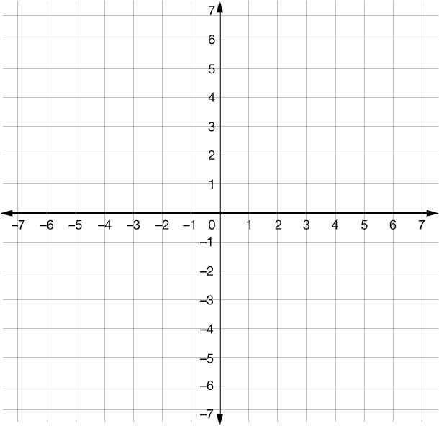
  - $(-3, 5)$ (Answer)
  - $(4, 0)$
  - $(0, 2)$
  - $(-1, 1)$
- Which inequality is best represented by the graph?
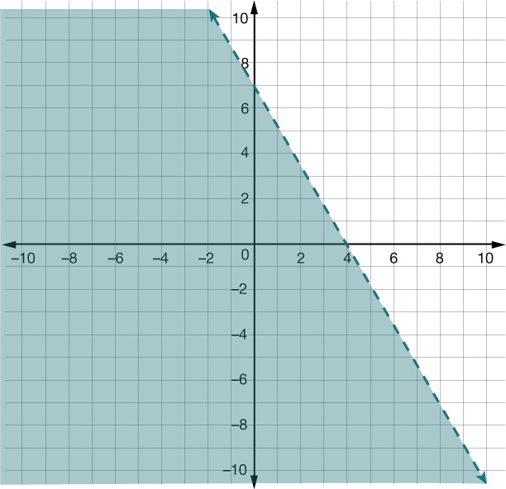
  - $7x + 2y ≤ 28$
  - $7x + 4y < 28$ (Answer)
  - $4x + 7y ≤ 49$
  - $4x + 7y < 49$
- Which graph best represents the solution set of $y ≤ \frac{3}{4}x - 4$?

- 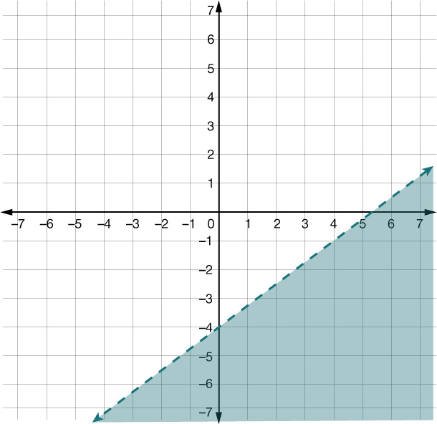

- 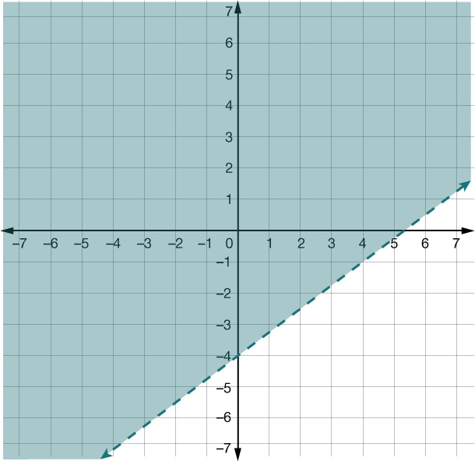
- 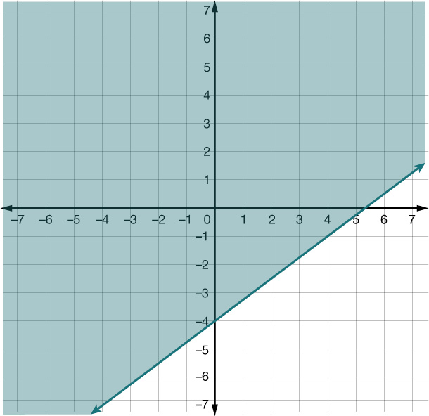

- (Answer)
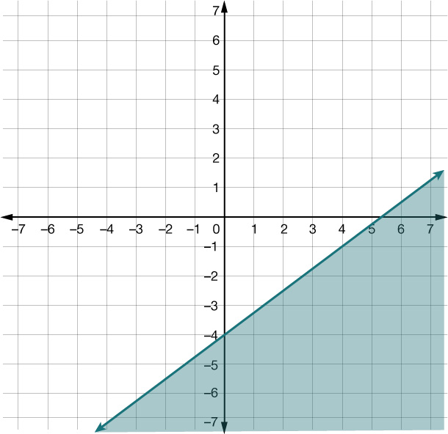
- What is the solution to the equation $-4(2m - 7) = 3(52 - 4m)$?
  - $m = -40.75$
  - $m = 46$
  - $m = -6.4$
  - $m = 32$ (Answer)
- What is the slope of the graph of $y = 12x - 19$?
  - $12$ (Answer)
  - $-19$
  - $-\frac{12}{19}$
  - $\frac{19}{12}$
- The total distance in centimeters a toy robot moves varies directly with the time in seconds. The toy robot moves a total distance of 264 centimeters in 11 seconds. What is the time in seconds the toy robot moves when the total distance is 408 centimeters?
  - 13 seconds
  - 17 seconds (Answer)
  - 37 seconds
  - 24 seconds
- What is the equation in standard form of the line that passes through the point $(6, -1)$ and is parallel to the line represented by $8x + 3y = 15$?
  - $8x + 3y = - 45$
  - $8x + 3y = 45$ (Answer)
  - $8x - 3y = 51$
  - $8x - 3y = - 51$
- Which statement best represents the equation of the line shown on the grid and its relationship to the $x$-axis?
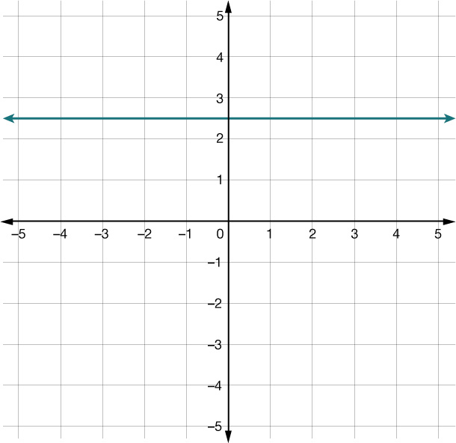
  - The equation of the line is $x = 2.5$, and the line is parallel to the $x$-axis.
  - The equation of the line is $y = 2.5$, and the line is parallel to the $x$-axis. (Answer)
  - The equation of the line is $x=2.5$, and the line is perpendicular to the $x$-axis.
  - The equation of the line is $y=2.5$, and the line is perpendicular to the $x$-axis.

