Unit 4 STAAR Review

About OpenStax STAAR Review Quizzes
Each STAAR Review Quiz consists of approximately ten questions. While the first half of the quiz focuses on content from the current unit, the last half of the quiz pulls from content in previous units.
In this manner, the STAAR Review Quiz provides an on-going, spiral review of the content reinforcing the evidence-based strategy of spaced retrieval. The questions on the STAAR Review Quizzes have all been selected from released STAAR End of Course Algebra 1 items from the Texas Education Agency [TEA].
The table below shows a summary of the answers and their TEKS information. For the full quiz questions, go to next section.
Review Q# | Answer Letter | TEKS | Exam/ Question# | Relevant Unit
1 | D | A.2(C) | 2021/ Question#2 | 4
2 | D | A.2(A) | 2021/ Question#22 | 4
3 | D | A.3(C) | 2021/ Question#41 | 4
4 | A | A.3(B) | 2021/ Question#36 | 4
5 | A | A.12(D) | 2018/ Question#9 | 4
6 | C | A.4(C) | 2016/ Question#26 | 3
7 | D | A.3(D) | 2019/ Question#17 | 2
8 | C | A.5(C) | 2019/ Question#37 | 2
9 | A | A.3(C) | 2019/ Question#7 | 1
10 | C | A.2(B) | 2019/ Question#6 | 1

Quiz Answers
- The graph of a linear function is shown on the grid.
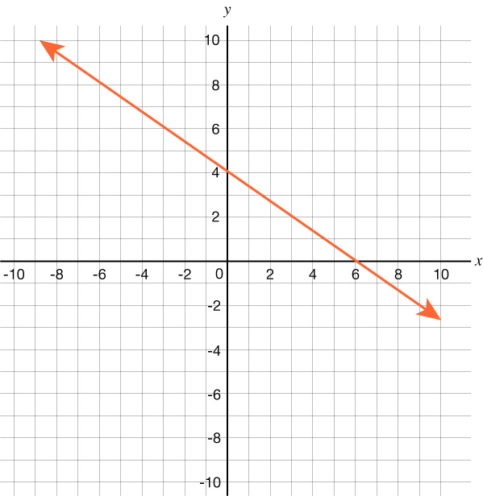
Which function is best represented by this graph?
  - $g(x) = 6x + 4$
  - $g(x) = 4x - \frac{2}{3}$
  - $g(x) = -\frac{3}{2}x + 6$
  - 𝑔(𝑥) = −23𝑥 + 4 (Answer)

- A part of linear function $g$ is graphed on the grid.
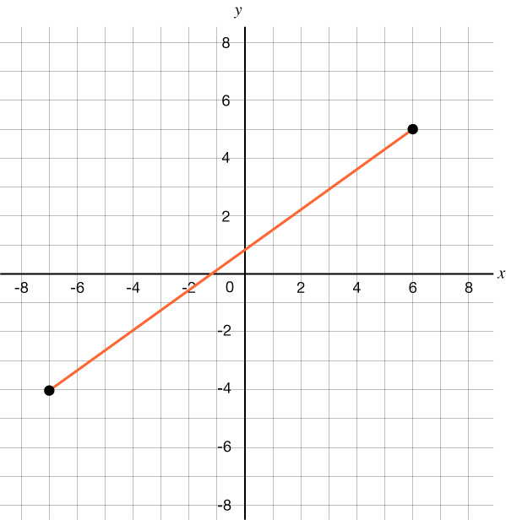
Which inequalities best describe the domain and range of the part shown?
  - Domain: $-4 < x < 5$
Range: $-7 < g(x) < 6$

  - Domain: $-7 < x < 6$
Range: $-4 < g(x) < 5$

  - Domain: $-4 ≤ x ≤ 5$
Range: $-7 ≤ g(x) ≤ 6$

  - Domain: $-7 ≤ x ≤ 6$ (Answer)
Range: $-4 ≤ g(x) ≤ 5$

- Linear function $t$ has an $x$-intercept of –1 and a $y$-intercept of 5. Which graph best represents $t$?

- 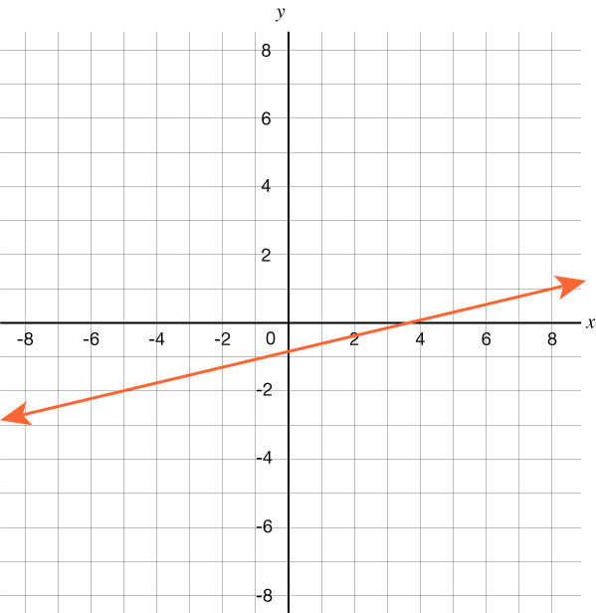

- 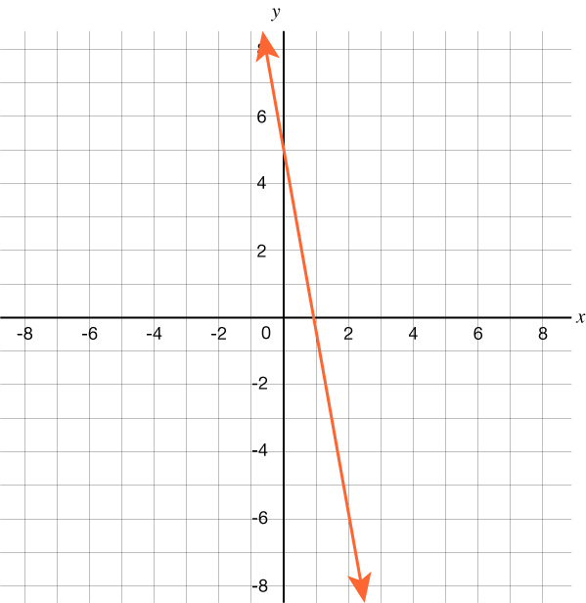
- 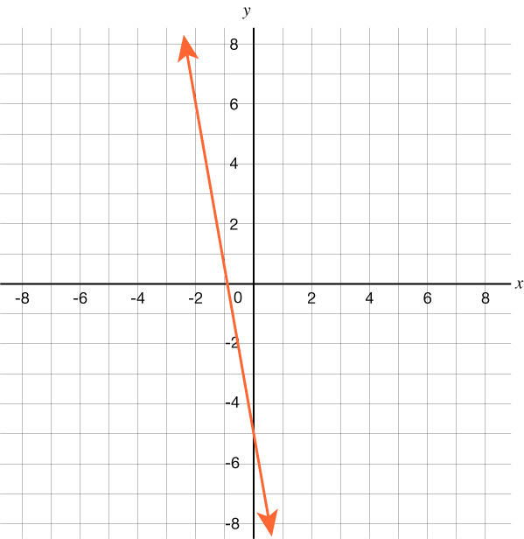

- (Answer)
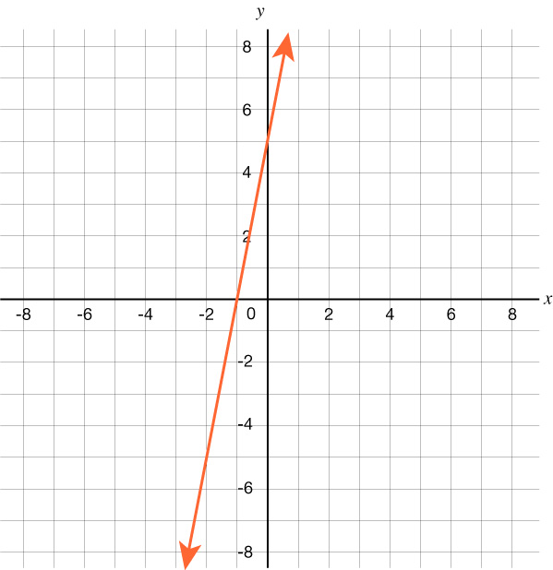

- A contractor’s total earnings from a job include a fixed amount plus an amount based on the number of hours worked. The values in the table represent the linear relationship between the number of hours worked and the contractor’s total earnings in dollars.
Number of Hours Worked | Total Earnings
0 | $20.00
5 | $63.75
15 | $151.25
25 | $238.75
35 | $326.25
40 | $370.00
What is the rate of change of the contractor’s total earnings in dollars with respect to the number of hours worked?
  - $8.75 per hour worked (Answer)
  - $9.25 per hour worked
  - $10.00 per hour worked
  - $20.00 per hour worked
- In a sequence of numbers, $a_{3}=0$, $a_{4}=6$, $a_{5}=12$, $a_{6}=18$, and $a_{7}=24$.
Based on this information, which equation can be used to find the $nth$ term in the sequence, $a_{n}$?
  - $a_{n} = 6n – 18$ (Answer)
  - $a_{n} = -18n + 6$
  - $a_{n} = 6n - 1$
  - $a_{n} = 18n - 6$

- The scatter plot shows the monthly high temperatures for Austin, Texas, in degrees Fahrenheit over a 12-month period.
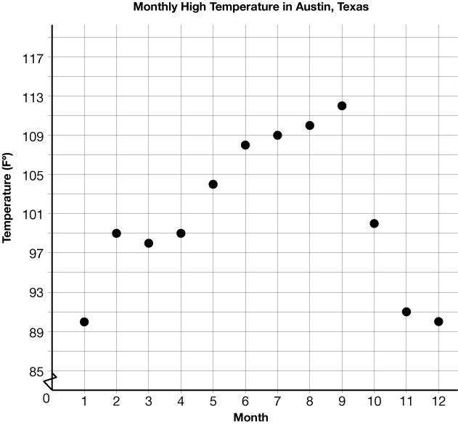
Which function best models the data from Month 1 to Month 9?
  - $y = -1.6x + 111$
  - $y = 3.5x + 85$
  - $y = 2.5x + 90$(Answer)
  - $y = -3.3x + 130$

- Which graph best represents the solution set of $y > 3x - 4$?

- 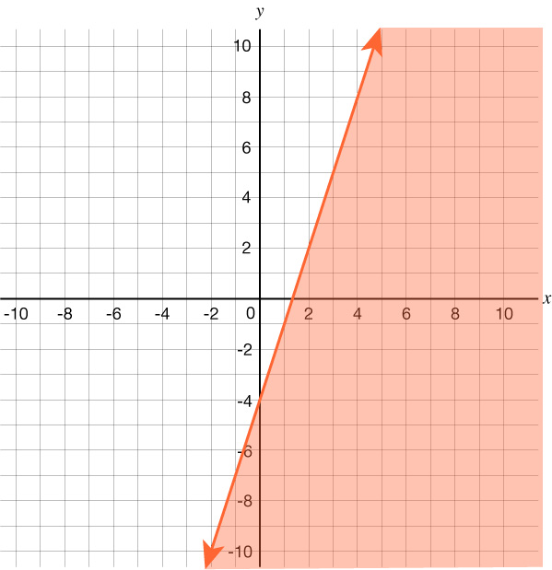

- 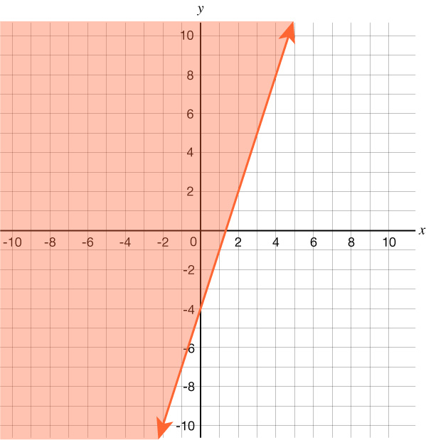
- 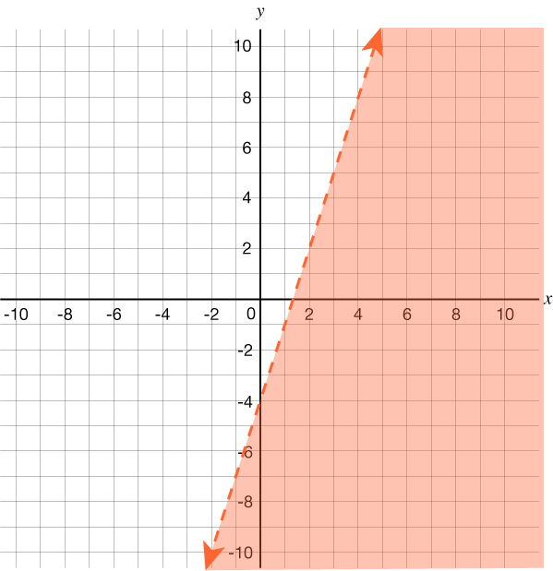

- (Answer)
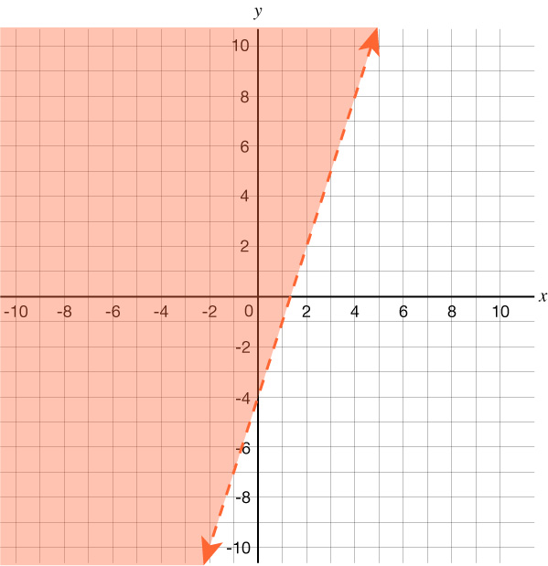

- What is the value of $x$ in the solution to this system of equations?
$$\left\{\begin{aligned}3x - 5y = 22 \\ y = -5x + 32\end{aligned}\right.$$
- – 6.5
- 0.5
- 6.5 (Answer)
- – 0.5

- What is the equation in slope-intercept form of the line that passes through the points $(-4, 2)$and $(12, 6)$?
  - $y = 0.25x + 3$ (Answer)
  - $y = 0.25x - 45$
  - $y = 4x + 18$
  - $y = 4x - 42$

- Which graph best represents $-5y = -6x + 15$?=

- 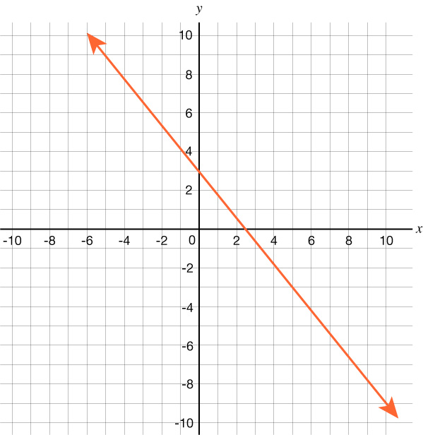

- 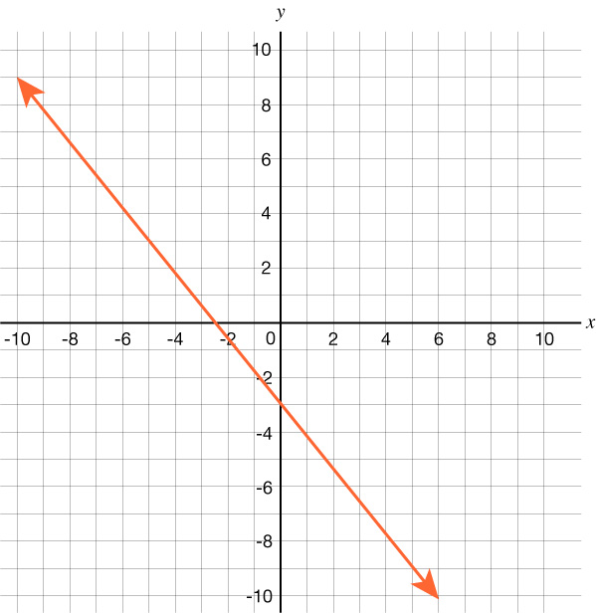
- (Answer)


 