Unit 6 STAAR Review

About OpenStax STAAR Review Quizzes
Each STAAR Review Quiz consists of approximately ten questions. While the first half of the quiz focuses on content from the current unit, the last half of the quiz pulls from content in previous units.
In this manner, the STAAR Review Quiz provides an on-going, spiral review of the content reinforcing the evidence-based strategy of spaced retrieval. The questions on the STAAR Review Quizzes have all been selected from released STAAR End of Course Algebra 1 items from the Texas Education Agency [TEA].
The table below shows a summary of the answers and their TEKS information. For the full quiz questions, go to next section.
Review Q# | Answer Letter | TEKS | Exam/ Question# | Relevant Unit
1 | B | A.10(E) | 2021/ Question#18 | 6
2 | D | A.10(B) | 2021/ Question#29 | 6
3 | A | A.10(F) | 2021/ Question#40 | 6
4 | C | A.10(D) | 2021/ Question#48 | 6
5 | C | A.10(A) | 2019/ Question#16 | 6
6 | D | A.11(B) | 2021/ Question#35 | 5
7 | B | A.2(C) | 2021/ Question#44 | 4
8 | D | A.3(C) | 2017/ Question#12 | 3
9 | B | A.2(I) | 2019/ Question#30 | 2
10 | B | A.2(F) | 2019/ Question#10 | 1

Quiz Answers
- Which expression is a factored form of $2x^{2} - 25x + 63$?
  - $(x + 9)(2x + 7)$
  - $(x - 9)(2x - 7)$ (Answer)
  - $(x + 7)(2x + 9)$
  - $(x - 7)(2x - 9)$
- Which expression is equivalent to $(\frac{3}{2}p + 1)(\frac{1}{2}p + 3)$?
  - $\frac{3}{4}p^{2} + 10p + 3$
  - $4p^{2} + 3$
  - $2p^{2} + 3$
  - $\frac{3}{4}p^{2} + 5p + 3$ (Answer)
- Which expression is equivalent to $9n^{2} - 25$?
  - $(3n + 5)(3n - 5)$ (Answer)
  - ${(3n - 5)}^{2}$
  - $9(n + 4)(n - 4)$
  - $9{(n - 4)}^{2}$
- Which expression is equivalent to $35m^{2} - 63$?
  - $-7(5m^{2} + 9)$
  - $7m(5m - 9)$
  - $7(5m^{2} - 9)$ (Answer)
  - $-7m(5m + 9)$

- Which expression is equivalent to $(10 + 7r - r^{2}) + (-6r^{2} - 18 + 5r)$?
  - $7r^{2} + 2r - 8$
  - $7r^{2} + 12r + 8$
  - $-7r^{2} + 12r – 8$ (Answer)
  - $-7r^{2} + 2r + 8$
- Which expression is equivalent to $(15a^{0}b^{2}c^{34})(3a^{16}b^{-29}c^{0})$ for all values of $a$, $b$, and $c$ where the expression is defined?
  - $\frac{18}{b^{58}}$
  - $\frac{18a^{16}c^{34}}{b^{27}}$
  - $\frac{45}{b^{58}}$
  - $\frac{45a^{16}c^{34}}{b^{27}}$ (Answer)
- The table represents some points on the graph of linear function $f$.
$$x$$ | – 3 | 2 | 5 | 11
$$f(x)$$ | – 130 | 0 | 78 | 234
Which function represents $f$?
  - $f(x) = -2(26x - 1)$
  - $f(x) = 26(x - 2)$ (Answer)
  - $f(x) = 13(x - 2)$
  - $f(x) = - 26(2x - 1)$

- A lifeguard earns $320 per week for working 40 hours plus $12 per hour worked over 40 hours. A lifeguard can work a maximum of 60 hours per week.
Which graph best represents the lifeguard’s weekly earnings in dollars for working $h$ hours over 40?

- 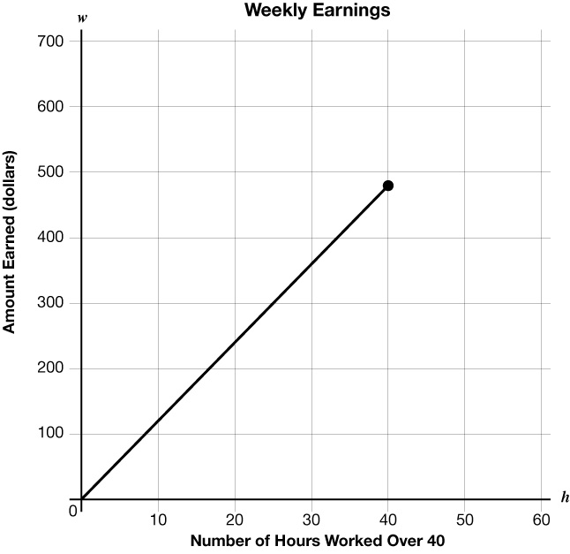

- 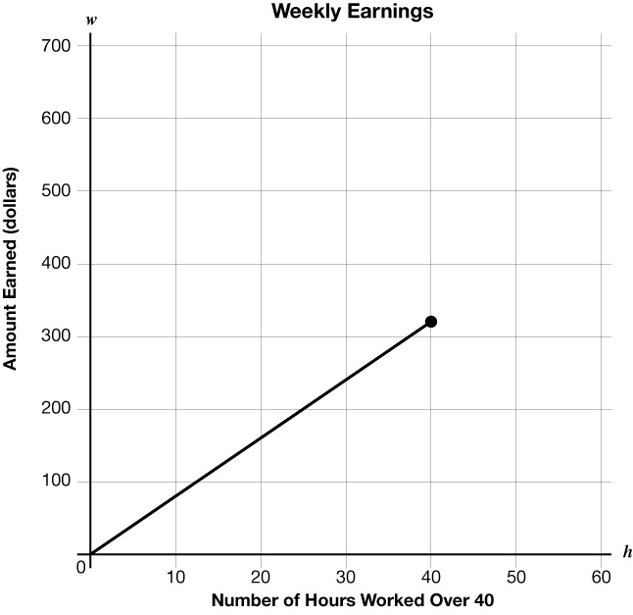
- 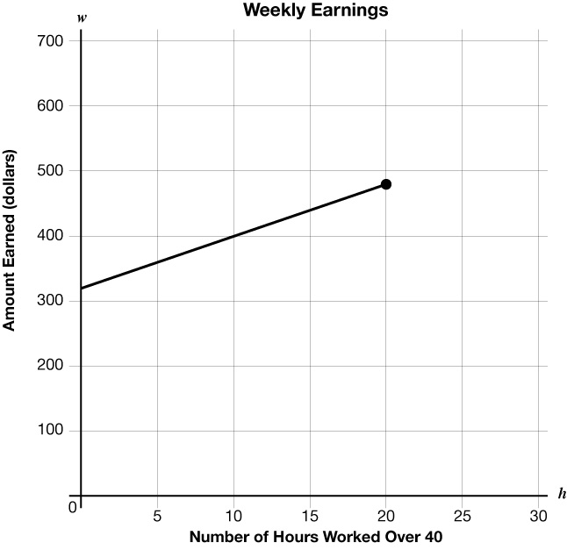

- (Answer)
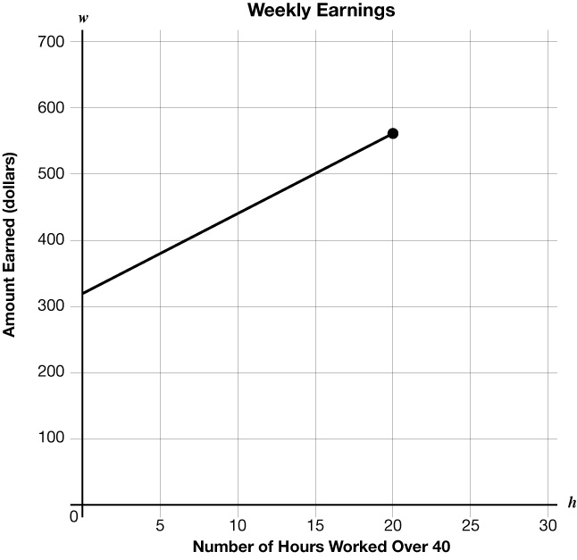
- A system of equations is graphed on the grid.
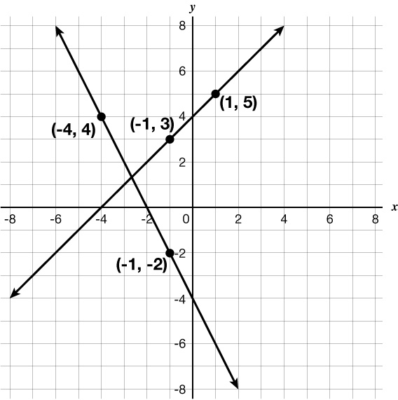
Which system of equations does the graph represent?
  - $\left\{\begin{aligned}y = -x + 4 \\ y = 2x -4\end{aligned}\right.$
  - $\left\{\begin{aligned}y = x + 4 \\ y = -2x - 4\end{aligned}\right.$ (Answer)
  - $\left\{\begin{aligned}y = -x -4 \\ y = 2x - 2\end{aligned}\right.$
  - $\left\{\begin{aligned}y = x - 4 \\ y = -2x - 2\end{aligned}\right.$

- What is the equation in slope-intercept form of the line that crosses the 𝑥-axis at 36 and is perpendicular to the line represented by $y = -\frac{4}{9}x + 5$?
  - $y = \frac{4}{9}x - 16$
  - $y = \frac{9}{4}x – 81$ (Answer)
  - $y = \frac{4}{9}x + 16$
  - $y = \frac{9}{4}x + 81$

