Three Reads Note-catcher

What to Expect

This video will…
- Introduce the Math Language Routine (MLR) Three Reads
- Model Three Reads
- Offer a guide to the routine
- Connect to resources for future inquiry and practice
This video is most effective when…
- Paused at critical reflection points
- Paired with the guide and note-catcher
- Experienced with a coach or colleague
- Viewed multiple times as you grow

Apply
Use the space below to model the routine as you watch the video.
Purpose & First Read: Describe what the situation is about without using numbers

Second Read: What can be counted or measured from the new information?

Third Read: What combinations of turf and gravel meet the homeowner’s constraints?

The Homeowner

The homeowner is worried about the work needed to maintain a grass lawn and flower beds, so she is now looking at some low-maintenance materials.
She is considering a combination of the materials shown to cover the year. Her budget is still $3,000.
- Artificial turf: $15 per square foot
- Gravel: $3 per square foot
The graph to the right represents some constraints in this situation.
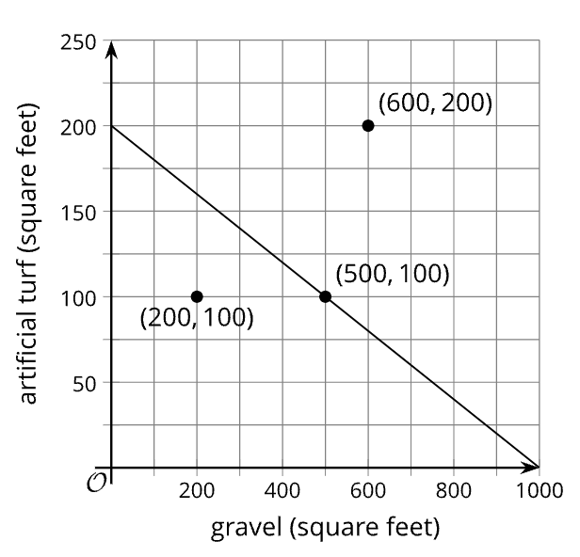

- The graph shows a line going through (500, 100).
  - In this situation, what does the point (500, 100) mean?
  - Write an equation that the line represents.
  - What do the solutions to the equation mean?
- The point (600, 200) is located to the right and above the line.
  - Does that combination of turn and gravel meet the homeowner’s constraints? Be prepared to show your reasoning.
  - Choose another point in the same region (to the right and above the line). Check if the combination meet the homeowner’s constraints.
- The point (200, 100) is located to the left and below the line.
  - Does that combination of turn and gravel meet the homeowner’s constraints? Be prepared to show your reasoning.
  - Choose another point in the same region (to the left and above the line). Check if the combination meet the homeowner’s constraints.
- Write an inequality that represents the constraints in this situation. Explain what the solutions mean and show the solution region on the graph.

Check Your Understanding
Summarize Three Reads as a series of four steps.

During the routine, what are the teacher and students thinking about?
Teacher

Student

Understanding Three Reads

Supporting Sense-Making
Create opportunities for students to comprehend multiple dimensions of the task and scaffold how they make meaning of the mathematical context.
Maximizing Meta-Awareness
Facilitate opportunities for students to think about their own thinking and language use.

Check Your Understanding
Is the goal of Three Reads to solve a mathematical task?

Three Reads Plan
First, identify an Algebra 1 task for the routine:

Second, plan to apply the routine:

Steps to Apply Routine:
- Reading Purpose
- First Read
- Second Read
- Third Read
Third, optimize the routine:

Fourth, extend the routine:

Three Reads Guide
CRITERIA | PLAN | APPLY | OPTIMIZE | EXTEND
Mathematical Language  The teacher leads students to progress to the mathematical learning goal through mathematical language. | The teacher plans to identify a grade-level task worthy of developing sense-making and meta-awareness, describe how sense-making and meta-awareness contribute directly to the mathematical learning goal, and generate interest in using mathematical language. | The teacher leads students to use mathematical vocabulary required by the mathematical learning goal and make connections between mathematical vocabulary and the task context. … | … AND justify how their questions are mathematical. … | … AND increase the use of mathematical vocabulary throughout the lesson.
Foci  The teacher leads students to deeply understand a mathematical task through producing and analyzing questions. | The teacher plans a reading purpose for a grade-level task aligned to both the mathematical learning goal and a series of three distinct yet connected reading foci, and methods to generate interest in problem-comprehension as opposed to answer-getting. | The teacher leads students to understand the reading purpose and read a grade-level task through a series of three distinct yet connected reading foci. … | … AND foci are differentiated by proficiency levels OR through visual aids. … | … AND foci are differentiated by proficiency levels AND through visual aids.
Cognition  The teacher leads students to cognitive engagement through cultivated conversation and meta-awareness. | The teacher plans opportunities and supports for students to negotiate meaning through multiple means of engagement (e.g., individually, pairs, groups, whole class) and times to strengthen the "meta-" connections and distinctions between mathematical ideas, reasoning, and language. | The teacher leads students to create their own meaning of the grade-level task through multiple measures of engagement (e.g., individually, pairs, groups, whole class) and self-monitor their understanding by reflecting on their own and their peers' work. | … AND identify areas for improvement as well as develop strategies to address them. … | … AND deploy these strategies throughout the lesson.

