Unit 7 Student Diagnostic Answer Key
These materials, when encountered before the denoted lesson, support access to the lesson and identify potential areas where additional support may be required. Note that the content in these lesson diagnostics represents prerequisite skills and does not address the required rigor for full mastery of the on-grade level standards.
Your students may benefit from using these materials in conjunction with the Unit Overview and Readiness page (quiz and mini-lessons).

Lesson 7.1: Patterns of Change 2
Lesson 7.2: Introduction to Quadratic Relationships 3
Lesson 7.3: Building Quadratic Functions from Geometric Patterns 4
Lesson 7.4: Comparing Quadratic and Exponential Functions 5
Lesson 7.5: Building Quadratic Functions to Describe Situations, Part 1 6
Lesson 7. 6: Building Quadratic Functions to Describe Situations, Part 2 8
Lesson 7.7: Domain, Range, Vertex, and Zeros of Quadratic Functions 9
Lesson 7.8: Equivalent Quadratic Expressions. 10
Lesson 7.9: Standard Form and Factored Form 11
Lesson 7.10: Graphs of Functions in Standard and Factored Forms 12
Lesson 7.11: Graphing from the Factored Form 14
Lesson 7.12: Graphing the Standard Form, Part 1 15
Lesson 7.13: Graphing the Standard Form, Part 2 16
Lesson 7.14: Graphs That Represent Situations. 17
Lesson 7.15: Vertex Form 18
Lesson 7. 16: Graphing from the Vertex Form 19
Lesson 7.17: Changing the Vertex 20

Lesson 7.1: Patterns of Change
Rectangle A has a side length of 5 cm. Complete the table for Rectangle A and be prepared to explain your reasoning.
Length (cm) | Width (cm) | Perimeter (cm) | Area (sq cm)
5 | 1 | _______ | _______
5 | 2 | _______ | _______
5 | 4 | _______ | _______
5 | _______ | 20 | _______
5 | _______ | _______ | 40
5 | _______ | 28 | _______
5 | _______ | _______ | 50
5 | $$x$$ | _______ | _______

Lesson 7.2: Introduction to Quadratic Relationships
Examine the pattern of dots.
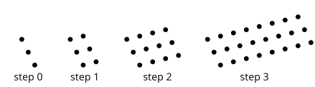
- Describe how you see the pattern growing.

- Draw or describe the next step.

- Complete the table to continue the pattern.
Step | 0 | 1 | 2 | 3 | 4 | 6 | $$n$$
No. of Dots | 3 | 6 | _______ | _______ | _______ | _______ | _______

- Is the relationship between step number and number of dots linear, exponential, or neither? Explain how you know.

Lesson 7.3: Building Quadratic Functions from Geometric Patterns
A rectangle is partitioned into smaller rectangles. Explain why each of these expressions represents the area of the entire rectangle.
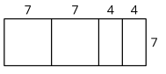
- $7(7+7+4+4)$

- $7(2∙7 + 2∙4)$

- $7^{2} + 7^{2} + 4∙7 + 4∙7$

- $2(7^{2}) + 2(4∙7)$

Lesson 7.4: Comparing Quadratic and Exponential Functions
Evaluate each expression.
- $4∙2^{x}$ when $x$ is 3

- $19 + x^{2}$ when $x$ is 9

- $16∙2^{x}$ when $x$ is 0

- $\frac{1}{2}∙2^{x}$ when $x$ is 4

- $x^{2} + 1$ when $x$ is 7

Lesson 7.5: Building Quadratic Functions to Describe Situations, Part 1
For problems 1 - 4, use the following scenario.
A person is walking from home to a part that is 2.473 feet away. They are walking 280 feet per minute.
- How far away from home are they after 0, 1, 2, 3, 5, $t$ minutes?
Minutes | 0 | 1 | 2 | 3 | 5 | $$t$$
Distance from Home (ft) | _______ | _______ | _______ | _______ | _______ | _______
- How far away from the park are they after 0, 1, 2, 3, 5, $t$ minutes?
Minutes | 0 | 1 | 2 | 3 | 5 | $$t$$
Distance from Park (ft) | _______ | _______ | _______ | _______ | _______ | _______
- Create a rough sketch of a graph for how far away a person is from home over time. Label the coordinates of the intercepts.
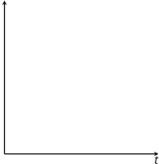

- Create a rough sketch of a graph for how far away a person is from the part over time. Label the coordinates of the intercepts.

Lesson 7. 6: Building Quadratic Functions to Describe Situations, Part 2
A tank has 50 gallons of water and drains at a constant rate of 2 gallons per minute. Below and to the right is a graph representing the situation.
- Label each axis to show what it represents. Be sure to include units.
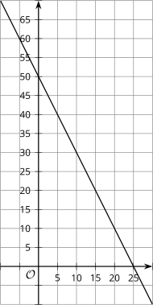
- Complete the table.
$$t$$ | $$v(t)$$
0 | 50
1 | 48
2 | 46
3 | 44
10 | _______
20 | _______
$$t$$ | _______

- Write a function modeling this situation.

- What is a reasonable domain for this function, based on the situation it models?

Lesson 7.7: Domain, Range, Vertex, and Zeros of Quadratic Functions
For questions 1 - 4, use the following scenario.
At the concession stand, popcorn costs $2 and bananas cost $1. Carla spent $16 on popcorn and bananas for her family.

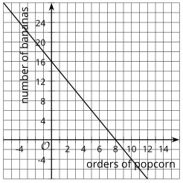
For questions 1 - 3, explain why each of the points on the graph to the right do not make sense in the situation.
      - (-2, 20)

      - (1.5, 13)

      - (10, -4)

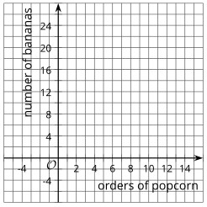
      - Sketch a graph that better represents the situation. Explain your reasoning.

Lesson 7.8: Equivalent Quadratic Expressions.
- Select the four expressions that are equivalent to $4(2 + 3x)$. Be prepared to explain or show how you know.
- $8 + 12x$
- $8 + 3x$
- $4(5x)$
- $12x + 8$
- $2(4) + 3x(4)$
- $12x + 2$
- $2(2 + 3x) + 2(2 + 3x)$

For questions 2 - 5, each of the expressions represents the area of a rectangle. Name a possible length and width of each rectangle. Be prepared to explain or show how you know.
- $3x + 21$

- $4(9) + 4(20)$

- $8^{2} + 8a$

- $(30)(30) + 30(4) + 30(b)$

Lesson 7.9: Standard Form and Factored Form
In each row, write the equivalent expression. If you get stuck, use a diagram to organize your work.
- The first row is provided as an example.
- Diagrams are provided for the first three rows.
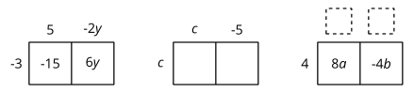

Factored | Expanded
$$-3(5 - 2y)$$ | $$-15 + 6y$$
$$c(c - 5)$$ | _______
_______ | $$8a - 4b$$
$$-3(2w - 7z)$$ | _______
$$-(3y - 2x)$$ | _______
_______ | $$12x - 14x^{2}$$

Lesson 7.10: Graphs of Functions in Standard and Factored Forms
Examine the graphs below.
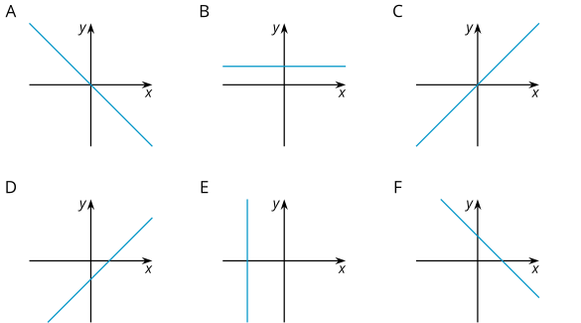
Match each graph to one or more equations that it could represent. Complete as many as you can in the time allowed. Check the boxes that match.
Equation | A | B | C | D | E | F
$$y = 8$$ | ¨ | ¨ | ¨ | ¨ | ¨ | ¨
$$y = 3x - 2$$ | ¨ | ¨ | ¨ | ¨ | ¨ | ¨
$$x + y = 6$$ | ¨ | ¨ | ¨ | ¨ | ¨ | ¨
$$0.5x = -4$$ | ¨ | ¨ | ¨ | ¨ | ¨ | ¨
$$y=x$$ | ¨ | ¨ | ¨ | ¨ | ¨ | ¨
$$-\frac{2}{3}x = y$$ | ¨ | ¨ | ¨ | ¨ | ¨ | ¨
$$12 - 4x = y$$ | ¨ | ¨ | ¨ | ¨ | ¨ | ¨
$$x - y = 12$$ | ¨ | ¨ | ¨ | ¨ | ¨ | ¨
$$2x + 4y = 16$$ | ¨ | ¨ | ¨ | ¨ | ¨ | ¨
$$3x = 5y$$ | ¨ | ¨ | ¨ | ¨ | ¨ | ¨

Lesson 7.11: Graphing from the Factored Form
Examine the functions and some possible inputs for the functions. Check the box for each input that would give an output of 0 for the functions.
Function | $$-5$$ | $$-3$$ | $$-2$$ | $$-1$$ | $$0$$ | $$1$$ | $$2$$ | $$3$$ | $$5$$
$$a(x) = x-5$$ | ¨ | ¨ | ¨ | ¨ | ¨ | ¨ | ¨ | ¨ | ¨
$$b(x) = x + 5$$ | ¨ | ¨ | ¨ | ¨ | ¨ | ¨ | ¨ | ¨ | ¨
$$c(x) = x - 3$$ | ¨ | ¨ | ¨ | ¨ | ¨ | ¨ | ¨ | ¨ | ¨
$$g(x) = 3x + 6$$ | ¨ | ¨ | ¨ | ¨ | ¨ | ¨ | ¨ | ¨ | ¨
$$h(x) = (x + 5)(x + 3)$$ | ¨ | ¨ | ¨ | ¨ | ¨ | ¨ | ¨ | ¨ | ¨

Lesson 7.12: Graphing the Standard Form, Part 1
Evaluate each expression when $x$ is -5.
- $-2x$

- $x^{2}$

- $-2x^{2}$

- $-x^{2}$

Lesson 7.13: Graphing the Standard Form, Part 2
An archer shoots an arrow. The arrow’s height above the level ground, in feet, is modeled by the equation $h(t) = (1 + 2t)(18-8t)$, and also represented by the graph below. The time $t$ is measured in seconds.

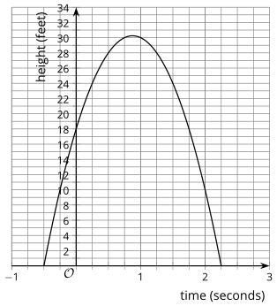
- On the graph, label the $x$- and $y$-intercepts, vertex, and axis of symmetry.

- Use the critical points from question 1 to identify -
  - The height at which the arrow is launched.

  - The maximum height the arrow reaches.
  - The time when the arrow hits the ground.

  - The time at which the arrow reaches its maximum height.

Lesson 7.14: Graphs That Represent Situations.
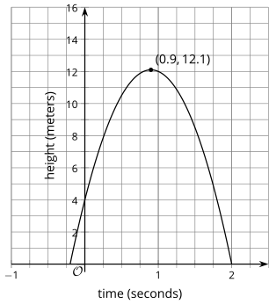
An object is thrown into the air. The height of the object in meters, is modeled by the function $p$, represented by the graph.
- What is the time at which the object hit the ground?

- What is the height from which the object was thrown?

- What is the maximum height of the object?

- What is the time at which the object reached its maximum height?

Lesson 7.15: Vertex Form
Without graphing, predict the location of the $x$- and $y$-intercepts of the graphs of these equations.
- $y = 4x + 8$

- $y = 4(x + 8)$

- $y = 5x - 10$

- $y = 5(x - 10)$

Lesson 7. 16: Graphing from the Vertex Form
Evaluate each expression when $x$ is -7.
- $x + 4$

- ${(x + 4)}^{2}$

- $-{(x+4)}^{2}$

- $-{(x + 4)}^{2} + 5$

Lesson 7.17: Changing the Vertex
The parent quadratic function is $f(x) = x^{2}$. Draw a line to match the function that will affect the original graph in the way described.
Shift Description | Matching Function
- Shift the vertex of the graph left 1 unit. | $$y = x^{2} + 1$$
- Shift the vertex of the graph up 1 unit. | $$y = {(x+ 1)}^{2}$$
- Shift the vertex of the graph right 1 unit and up 1 unit. | $$y = {3x}^{2}$$
- Make the graph of the parent function narrower. | $$y = {(x-1)}^{2} + 1$$
- Make the graph of the parent function narrower and shift the vertex 1 unit to the right. | $$y = {3(x-1)}^{2}$$

