Unit 2 Student Diagnostic Answer Key
These materials, when encountered before the denoted lesson, support access to the lesson and identify potential areas where additional support may be required. Note that the content in these lesson diagnostics represents prerequisite skills and does not address the required rigor for full mastery of the on-grade level standards.
Your students may benefit from using these materials in conjunction with the Unit Overview and Readiness page (quiz and mini-lessons).

Lesson 2.1: Writing and Graphing Systems of Equations 2
Lesson 2.2: Writing Systems of Equations 4
Lesson 2.3: Solving Systems by Substitution 6
Lesson 2.4: Solving Systems by Elimination, Part 1 7
Lesson 2.5: Solving Systems by Elimination, Part 2 8
Lesson 2.6: Solving Systems by Elimination, Part 3 9
Lesson 2.7: Systems of Linear Equations and Their Solutions 10
Lesson 2.8: Representing Situations with Inequalities 11
Lesson 2.9: Solutions to Inequalities 13
Lesson 2.10: Writing and Solving Inequalities in One Variable 15
Lesson 2.11: Graphing Linear Inequalities in Two Variables 16
Lesson 2.12: Using Linear Inequalities as Constraints 17
Lesson 2.13: Solving Problems with Inequalities in Two Variables 18
Lesson 2.14: Solutions to Systems of Linear Inequalities in Two Variables 19
Lesson 2.15: Solving Problems with Systems of Linear Inequalities in Two Variables 20

Lesson 2.1: Writing and Graphing Systems of Equations

Q# | Standard
1 | MATH.7.7(A) Represent linear relationships using verbal descriptions, tables, graphs, and equations that simplify to the form $y = mx + b$.
2 | MATH.8.9(A) Identify and verify the values of $x$ and $y$ that simultaneously satisfy two linear equations in the form $y = mx + b$ from the intersections of the graphed equations.
- Draw a line that matches each pair of graphs to a situation.
Graph A | Graph B | Graph C
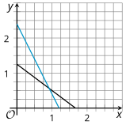 | 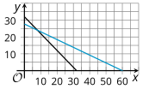 | 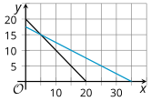

Situation A | Situation B | Situation C
A restaurant has a total of 20 tables - round tables that seat 2 people and rectangular tables that seat 4 people. All 70 seats in the restaurant are occupied. | A family buys a total of 32 tickets at a carnival. Ride tickets cost $1.50 each and food tickets cost $3.25 each. The family pays a total of $90 for the tickets. | Tyler and Andre are shopping for snacks in bulk at the grocery store. Tyler pays $10 for 6 ounces of almonds and 8 ounces of raisins. Andre pays $12 for 10 ounces of almonds and 5 ounces of raisins.
Answer:
- Situation A: Restaurant matches graph C
- Situation B: Carnival matches graph B
- Situation B: Snack matches graph A

- At what point do the graphs intersect?
  - Graph A
Answer: approximately (0.92, 0.56)
  - Graph B
Answer: (8. 24)
  - Graph C
Answer: (5, 15)

Lesson 2.2: Writing Systems of Equations
Q# | Standard
1-4 | MATH.7.7(A) Represent linear relationships using verbal descriptions, tables, graphs, and equations that simplify to the form $y = mx + b$.
Draw lines to match each table of values to a graph. Then, draw a line from each graph to the equation it represents.
Table 1 | A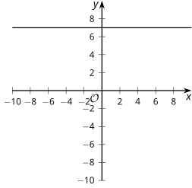 | $$x + y = 7$$
  x | -2 | -1 | 0 | 1
  y | 7 | 7 | 7 | 7
Table 2 | B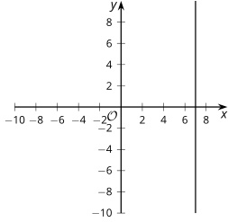 | $$y = 7$$
  x | 7 | 7 | 7 | 7
  y | -2 | -1 | 0 | 1
Table 3 | C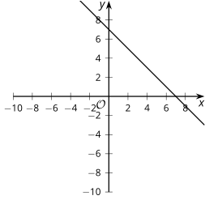 | $$x = 7$$
  x | -2 | -1 | 0 | 1
  y | -8 | -4 | 0 | 4
Table 4 | D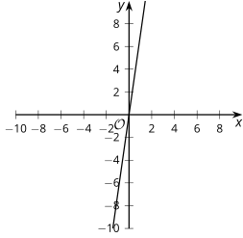 | $$y = 4x$$
  x | -2 | -1 | 0 | 1
  y | 9 | 8 | 7 | 6

Answers:
Table 1 - Graph C - $y = 7$
Table 2 - Graph A - $x = 7$
Table 3 - Graph D - $y = 4x$
Table 4 - Graph B - $x + y = 7$

Lesson 2.3: Solving Systems by Substitution
Q# | Standard
1-4 | MATH.7.11(A) Model and solve one-variable, two-step equations and inequalities.
Find the value of $y$ when $x = 5$.
- $y = 3x - 4$
Answer: $y = 11$

- $y = \frac{2}{5}x + 4$
Answer: $y = 6$
- $y = 2x + 3 + \left(3x - 1\right)$
Answer: $y = 27$
- $y = 4x - (x + 1)$
Answer:$y = 14$

Lesson 2.4: Solving Systems by Elimination, Part 1

Q# | Standard
1-5 | MATH.6.7(D) Generate equivalent expressions using the properties of operations: inverse, identity, commutative, associative, and distributive properties.
Rewrite each expression by combining like terms.
- $11x - 2x$
Answer: $9x$
- $5t + 3z - 2t$
Answer: $3z + 3t$
- -$4x + 6r - (7x + 2r)$
Answer: $-11x + 4r$ or $4r - 11x$
- $8x - 3y + (3y - 5x)$
Answer: $3x$
- $9x - 2y -3(3x + y)$
Answer: $-5y$

Lesson 2.5: Solving Systems by Elimination, Part 2
Q# | Standard
1-5 | MATH.6.7(D) Generate equivalent expressions using the properties of operations: inverse, identity, commutative, associative, and distributive properties.
For each row in the table, the equations are equivalent. Explain how the equations are related to each other.
Answers:
Equation A | Equation B | Relationship
$$3x - 1 = 5$$ | $$6x - 2 = 10$$ | Answer: The equation in column B is 2 times the equation in column A.
$$4(x+1) = 3x - 12$$ | $$4x + 4 = 3(x - 4)$$ | Answer: In each column, one side of the equation is the distributed form of the same side of the equation in the other column.
$$14x + 10 = 4x + 6$$ | $$7x + 5 = 2x + 3$$ | Answer: The equation in column B is ½ of the equation in column A.
$$2x + 6y = 10$$ | $$5x + 15y = 25$$ | Answer: The equation in column B is $\frac{5}{2}$ of the equation in column A.
$$4x+5y = 2-4x+5y$$ | $$4x+9y=2+9y-4x$$ | Answer: The equation in column B has $4y$ added to both sides of the equation from column A.

Lesson 2.6: Solving Systems by Elimination, Part 3
Q# | Standard
1-3 | MATH.6.7(D) Generate equivalent expressions using the properties of operations: inverse, identity, commutative, associative, and distributive properties.
For each question, determine what number is needed to multiply the equation by to get the targeted coefficient. Then, determine the new equation after the original has been multiplied by that value.
- Multiply the equation $3x + 4y = 8$ so that the coefficient of $x$ is $9$.
Multiply by …
Answer: 3
The new equation is …
Answer: $9x + 12y = 24$

- Multiply the equation $8x + 4y = -16$ so that the coefficient of $y$ is $1$.
Multiply by …
Answer: ¼
The new equation is …
Answer: $2x + y = -4$

- Multiply the equation $10x - 4y = 17$ so that the coefficient of $y$ is $-8$.
Multiply by …
Answer: 2
The new equation is …
Answer: $20x - 8y = 34$

Lesson 2.7: Systems of Linear Equations and Their Solutions
Q# | Standard
1-5 | MATH. 8.8(C) Model and solve one-variable equations with variables on both sides of the equal sign that represent mathematical and real-world problems using rational number coefficients and constants.
Determine if the equation has one solution that makes it true, an infinite number, or no real solutions. Check the box that represents your answer.
Answers:
Equation | One Solution | Infinitely Many Solutions | No Solutions
$$3x+1 = 10$$ | 🗹 | ¨ | ¨
$$2x+12=2x+10+2$$ | ¨ | 🗹 | ¨
$$2x = x + 2$$ | 🗹 | ¨ | ¨
$$3(x+4) = 3x + 4$$ | ¨ | ¨ | 🗹
$$\frac{2x + 6}{2} = x + 6$$ | ¨ | ¨ | 🗹
$$x + 3x - 4 = 7(x - \frac{4}{7})$$ | 🗹 | ¨ | ¨

Lesson 2.8: Representing Situations with Inequalities
Q# | Standard
1 | MATH.5.2(B) Compare and order two decimals to thousandths and represent comparisons using the symbols >, <, or =.
2 | MATH.6.2(C) Locate, compare, and order integers and rational numbers using a number line.
- Place an inequality symbol to correctly complete the comparison.
  - 5 _________ 10
Answer: <
  - 5 _________ -10
Answer: >
  - -5 _________ -10
Answer: >
  - $\frac{1}{5}$_________ $\frac{1}{10}$
Answer: >
- Write an inequality for each of the graphs.

Answer: $x > 20$

Answer: $x < -20$

Answer: $x ≥ 20$

Answer: $x ≥ -20$

Lesson 2.9: Solutions to Inequalities
Q# | Standard
1-2 | MATH.7.11(B) Determine if the given value(s) make(s) one-variable, two-step equations and inequalities true.
For each expression, pick a number you would like to evaluate, and tell whether it makes the inequality true. Be prepared to explain what made you choose your number.
- $\frac{4}{3}y + 10 > 19$
- Pick a number you would like to test in place of $y$: -1, 0, 1, 3, 4, or 5. Explain why you chose your number.
Answer: Answers will vary, but here is a sample.
0 or 3 because I will get a whole number. Neither of these make the inequality true.
- Does your number make the inequality true?
Answer: Answers will vary, but here is a sample.
No (based on the example values 0 and 3).
- What is a different number that is definitely a solution? How do you know?
Answer: Answers will vary, but here is a sample.
100, because if you multiply 100 by a positive number and add a positive number to the result, the final result will definitely be more than 19.
- What is a different number that is definitely not a solution? How do you know?
Answer: Answers will vary, but here is a sample.
-100 because the left side of the inequality will come out to a negative number, which is definitely less than 19.

2. $10 - 3y < 5$
- Pick a number you would like to test in place of $y$: -100, -3, -1, 0, $\frac{1}{3}$, $\frac{5}{3}$, 33, or 100. Explain why you chose your number.
Answer: Answers will vary, but here is a sample.
0 or ⅓ because after multiplying, I’ll get 0 or 1, which are easy to work with. Neither of these make the inequality true.
- Does your number make the inequality true?
Answer: Answers will vary, but here is a sample.
No (based on the example values of 0 and ⅓ )
- What is a different number that is definitely a solution? How do you know?
Answer: Answers will vary, but here is a sample.
10, because 10 - 30 will be negative, so definitely less than 5.
- What is a different number that is definitely not a solution? How do you know?
Answer: Answers will vary, but here is a sample.
A negative number, because subtracting a negative will make a larger number, and 10 is already larger than 5.

Lesson 2.10: Writing and Solving Inequalities in One Variable
Q# | Standard
1-3 | ALG.5(B) Solve linear inequalities in one variable, including those for which the application of the distributive property is necessary and for which variables are included on both sides.
Solve each inequality. Then, check your answer using a value that makes your solution true.
- $-2x < 4$
  - Solve the inequality.
Answer: $x > -2$

  - Check your answer using a value that makes your solution true.
Answer: Answers will vary.

- $3x + 5 >6x - 4$
  - Solve the inequality.
Answer: $x < 3$

  - Check your answer using a value that makes your solution true.
Answer: Answers will vary.

- $-3(x + 1) ≥ 13$
  - Solve the inequality.
Answer: $x ≤ - 5.33$

  - Check your answer using a value that makes your solution true.
Answer: Answers will vary.

Lesson 2.11: Graphing Linear Inequalities in Two Variables
Q# | Standard
1-3 | MATH.7.4(A) Represent linear relationships using verbal descriptions, tables, graphs, and equations that simplify to the form $y = mx + b$.

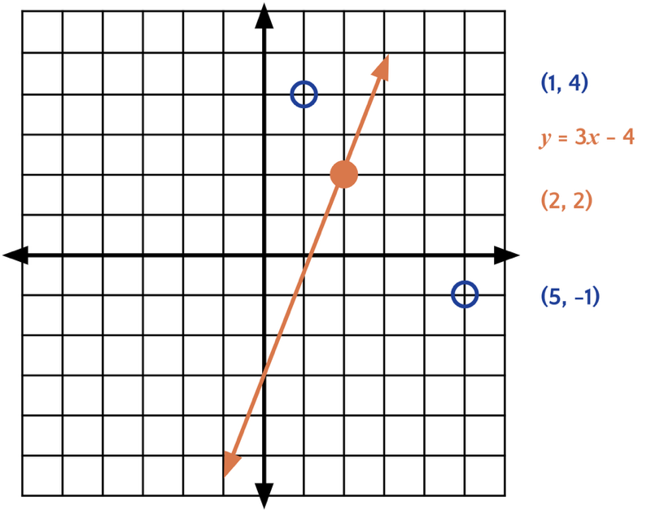
- Graph the line that represents $y = 3x - 4$.
Answer: (see right)
- Is the point (4, 8) on the line?
Answer: Yes
- Determine and draw 3 points on the graph according to the following information.
  - Determine a value for $a$ so that $(2, a)$ is on the line.
Answer: $a = 2$ so the point is (2, 2)

  - Determine a value for $b$ so that $(1, b)$ so it is above the line.
Answer: Answers will vary, but here is a sample.
$b = 4$ so the point (1, 4) would be above the line.

  - Determine a value for $c$ so that $(c, -1)$ so it is below the line.
Answer: Answers will vary, but here is a sample.
$c = 5$ so the point is (5, -1)

Lesson 2.12: Using Linear Inequalities as Constraints
Q# | Standard
1-2 | ALG.3(C) Graph linear functions on the coordinate plane and identify key features, including $x$-intercept, $y$-intercept, zeros, and slope, in mathematical and real-world problems.

- Graph the boundary line for the inequality $2y ≥ 4x - 8$.
Answer: (see right)
  - What is the $x$-intercept for the graph of its boundary line?
Answer: (2, 0)

  - What is the $y$-intercept for the graph of its boundary line?
Answer: (0, -4)
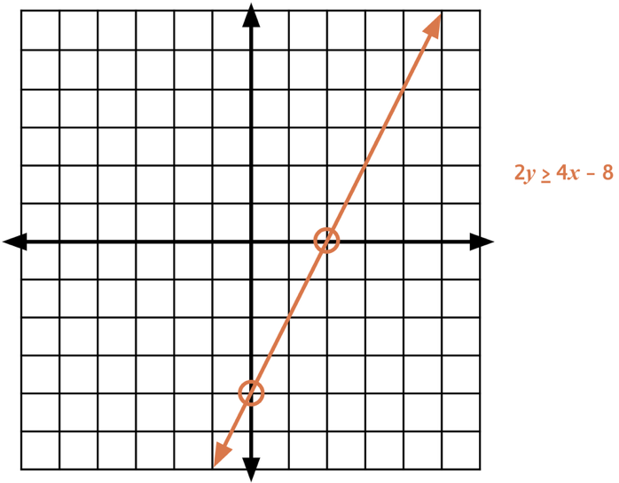

- Graph the boundary line for the inequality $2x + 3y < 12$.
Answer: (see right)

  - What is the $x$-intercept for the graph of its boundary line?
Answer: (6, 0)

  - What is the $y$-intercept for the graph of its boundary line?
Answer: (0, 4)
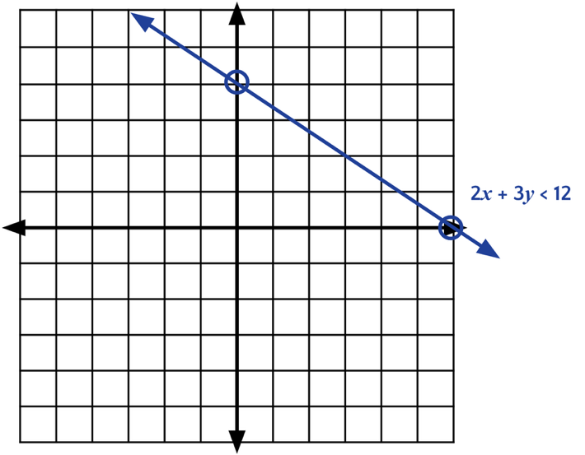

Lesson 2.13: Solving Problems with Inequalities in Two Variables
Q# | Standard
1-4 | ALG.2(C) Write linear equations in two variables given a table of values, a graph, and a verbal description.
For questions 1 - 4, use the following scenario.
Jada received $100 on her birthday. She has a savings account and a checking account that she can deposit the money in.
- Which of the following could represent Jada’s deposits into each account? Select three choices for the deposits.
- $50 in each account [Answer]
- $100 in each account
- $20 in one account and $60 in the other account [Answer]
- $60 in each account
- $40 in one account and $60 in the other account [Answer]
- $40 in one account and $75 in the other account
- What did you check to be sure the totals worked for the constraint in the scenario?
Answer: The amounts had to add up to no more than $100.
- What are the quantities in the scenario that are being tested?
Answer: Amount deposited in checking and amount deposited in savings.
- Which algebraic statement could best represent the scenario?
  - $x + y < 100$
  - $x+ y ≤ 100$ [Answer]
  - $x + y > 100$
  - $x + y ≥ 100$
  - $x + y = 100$

Lesson 2.14: Solutions to Systems of Linear Inequalities in Two Variables
Q# | Standard
1-5 | ALG.2(I) Write systems of two linear equations given a table of values, a graph, and a verbal description.
For questions 1-5, examine the following riddle.
Joey was thinking of two numbers. Their sum is 15. Their difference is 1.
- Find a pair of numbers that satisfy the first condition (sum to 15).
Answer: Answers will vary, but here is a sample.
2 and 13

- Find a pair of numbers that satisfy the second condition (difference of 1).
Answer: Answers will vary, but here is a sample.
3 and 2

- Find a pair of numbers that satisfy both conditions.
Answer: 7 and 8.

- Can you find more than one pair of numbers that satisfy both conditions? If so, state as many as you can find. If not, explain why not.
Answer: No, this is the only pair of numbers that add to 15 and subtract to be 1.

- Write a system of equations or inequalities that represent the riddle.
Answer: Answers will vary, but here is a sample.
$$x + y = 15$$
$$y - x = 1$$

Lesson 2.15: Solving Problems with Systems of Linear Inequalities in Two Variables
Q# | Standard
1-2 | ALG.3(H) Graph the solution set of systems of two linear inequalities in two variables on the coordinate plane.
The graph shows the lines $y = x + 1$ and $y = -x -2$.
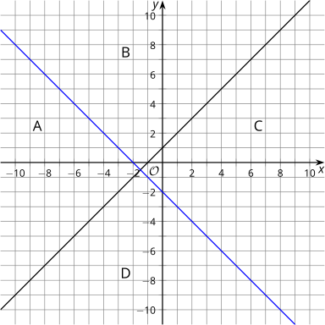
- For each of the 4 regions, write a coordinate pair for a point in that region.
Region A
Answer: Answers will vary, but here is a sample.
(-10, 0)
Region B
Answer: Answers will vary, but here is a sample.
(-2, 6)
Region C
Answer: Answers will vary, but here is a sample.
(6, -1)
Region D
Answer: Answers will vary, but here is a sample.
(1, -10)

- Change the equations represented by the lines into inequalities so that the region labeled as A is shaded by both inequalities.
$y$ _________ $x + 1$
Answer: $>$or $≥$
$y$ _________ $-x-2$
Answer: $<$or $≤$

- Use the coordinate pair you chose for region A to verify your inequalities algebraically.
Answer: Answers will vary, but here is a sample.
Using (-10, 0)
0 > -10 + 1 and 0 < 10 – 2 are both true.

