Project 6 Polynomials and Rectangles: Rectangles Images

Rectangle A
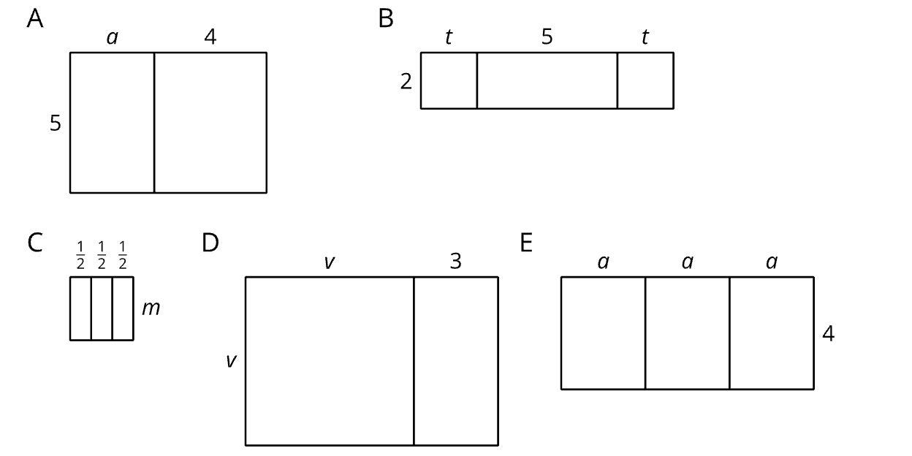

Rectangle B

Rectangle C

Rectangle D

Rectangle E

