Unit 5 STAAR Review

About OpenStax STAAR Review Quizzes
Each STAAR Review Quiz consists of approximately ten questions. While the first half of the quiz focuses on content from the current unit, the last half of the quiz pulls from content in previous units.
In this manner, the STAAR Review Quiz provides an on-going, spiral review of the content reinforcing the evidence-based strategy of spaced retrieval. The questions on the STAAR Review Quizzes have all been selected from released STAAR End of Course Algebra 1 items from the Texas Education Agency [TEA].
The table below shows a summary of the answers and their TEKS information. For the full quiz questions, go to next section.
Review Q# | Answer Letter | TEKS | Exam/ Question# | Relevant Unit
1 | B | A.9(C) | 2021/ Question#11 | 5
2 | D | A.11(B) | 2021/ Question#8 | 5
3 | A | A.9(E) | 2021/ Question#21 | 5
4 | A | A.9(C) | 2021/ Question#38 | 5
5 | B | A.9(A) | 2021/ Question#49 | 5
6 | A | A.3(B) | 2021/ Question#3 | 4
7 | A | A.2(A) | 2021/ Question#33 | 4
8 | B | A.4(B) | 2017/ Question#9 | 3
9 | C | A.2(H) | 2019/ Question#15 | 2
10 | C | A.2(C) | 2019/ Question#23 | 1

Quiz Answers
- The graph shows the number of game consoles sold in millions since 2009.
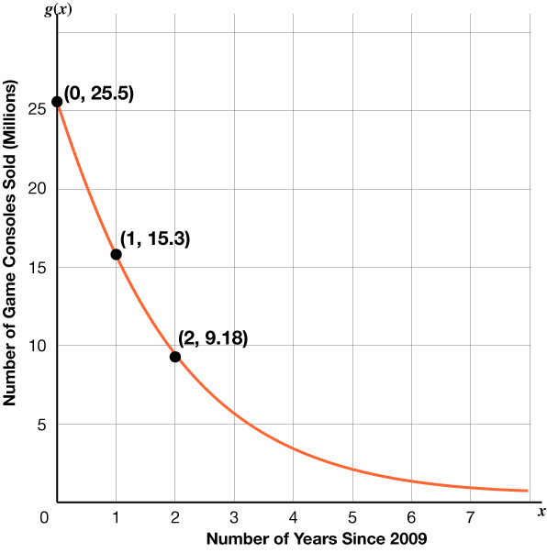
Based on this information, which function best models the number of game consoles sold, in millions, $x$ years since 2009?
  - $g(x) = 6.12{(25.5)}^{x}$
  - $g(x) = 25.5{(0.6)}^{x}$ (Answer)
  - $g(x) = 0.6{(25.5)}^{x}$
  - $g(x) = 25.5{(6.12)}^{x}$

- Which expression is equivalent to ${(x^{9}yz^{4})}^{5}$?
  - $x^{14}y^{6}z^{9}$
  - $x^{45}yz^{20}$
  - $x^{14}y^{5}z^{9}$
  - $x^{45}y^{5}z^{20}$ (Answer)

- A conservation agency tracks the sea turtle population by counting the number of nesting sites where the turtles lay their eggs. The table shows the numbers of nesting sites for several years since 2001. The data can be modeled by an exponential function.
Number of Years Since 2001  $$x$$ | Number of Nesting Sites  $$f(x)$$
1 | 46,125
2 | 37,994
3 | 40,513
4 | 29,368
5 | 34,082
6 | 31,746
7 | 27,691
Which function best models the data?
  - $n(x) = 46,797.94{(0.93)}^{x}$(Answer)
  - $n(x) = 25,956.80{(1.08)}^{x}$
  - $n(x) = 0.93{(46,797.94)}^{x}$
  - $n(x) = 1.08{(25,956.80)}^{x}$

- The table represents some points on the graph of an exponential function.
$$x$$ | $$f(x)$$
2 | 36
3 | 54
4 | 81
5 | 121.5
6 | 128.25
Which function represents this relationship?
  - $f(x) = 16{(\frac{3}{2})}^{x}$ (Answer)
  - $f(x) = 16{(\frac{2}{3})}^{x}$
  - $f(x) = 36{(\frac{3}{2})}^{x}$
  - $f(x) = 36{(\frac{2}{3})}^{x}$

- A part of exponential function $f$ is graphed on the grid.
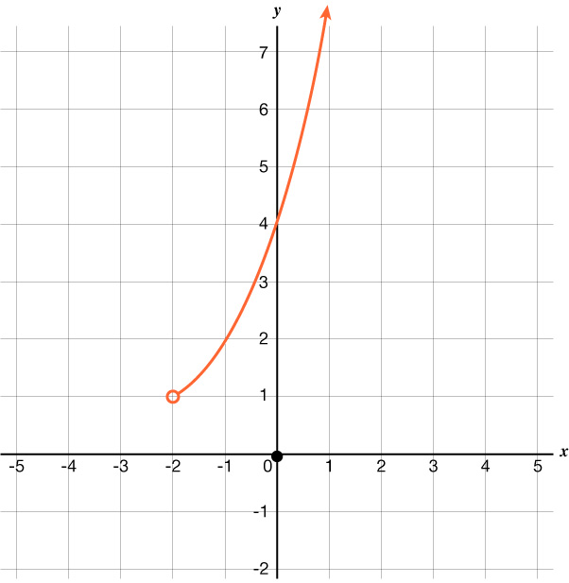
Which inequality best represents the domain of the part shown?
  - $y > -2$
  - $x > - 2$ (Answer)
  - $y > 1$
  - $x > 1$

- The values in the table represent a linear relationship between $x$ and $y$.
$$x$$ | – 8.5 | – 6.5 | – 2.5 | – 1
$$y$$ | – 92 | – 72 | – 32 | – 17
What is the rate of change of $y$ with respect to $x$?
  - 10 (Answer)
  - – 17
  - – 10
  - 17
- Which graph represents a function with a domain of all real numbers less than or equal to 6?

- (Answer)
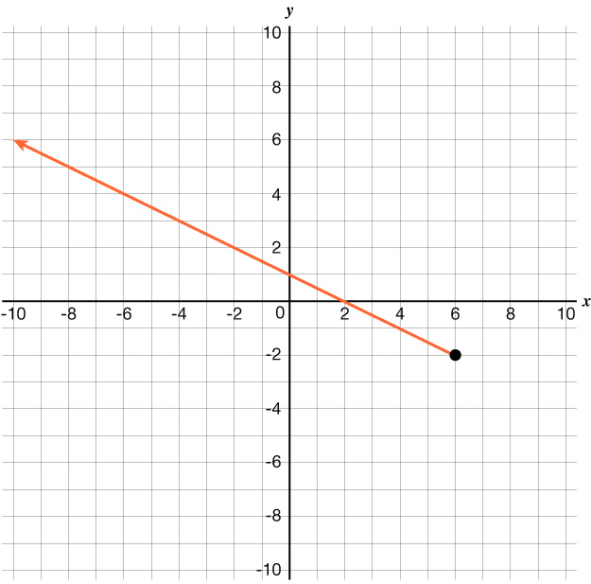

- 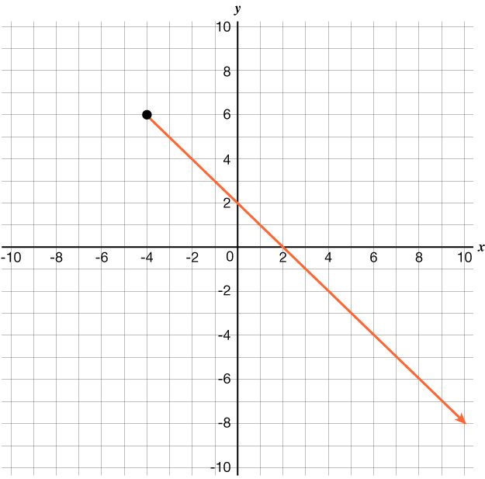
- 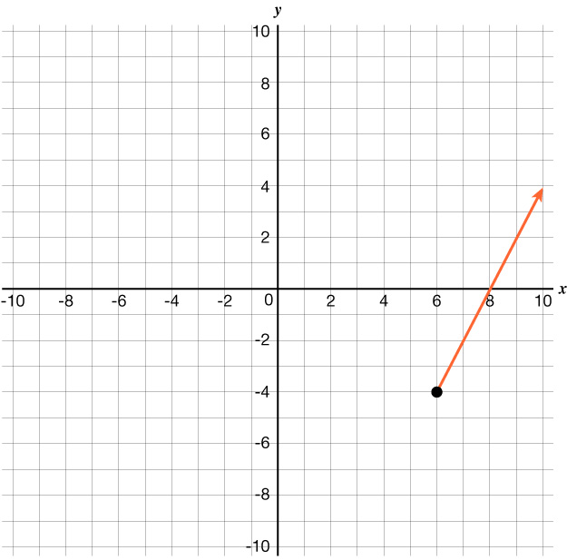

- 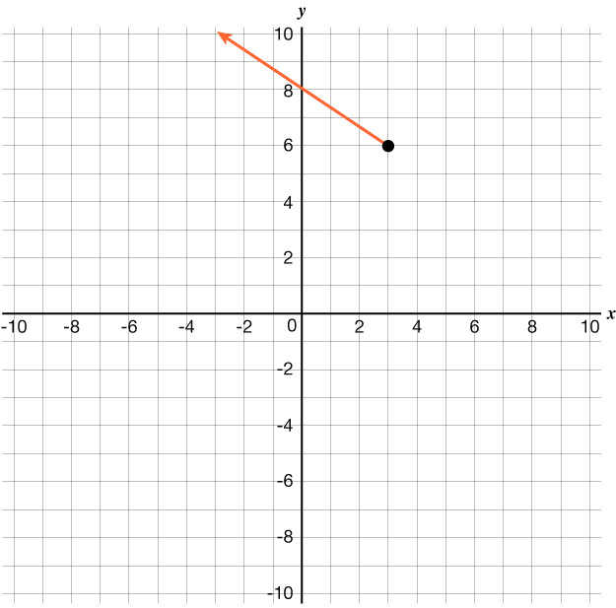

- Which situation best represents causation?
  - When fewer firefighters report to a house fire, the damage caused by the fire decreases.
  - When it rains several inches, the water level of a lake increases. (Answer)
  - When ice cream sales increase, incidents of sunburn increase.
  - When the number of bus stops increases, the number of car sales decreases.

- A grill at a barbecue restaurant will be used to cook sausage links that are 2 lb. each and briskets that are 6 lb. each. No more than 120 lb. of sausage links and briskets will be cooked on the grill.
Which inequality represents all possible combinations of $x$, the number of sausage links that will be cooked on the grill, and $y$, the number of briskets that will also be cooked?
  - $6x + 2y > 120$
  - $2x + 6y ≥ 120$
  - $2x + 6y ≤ 120$ (Answer)
  - $6x + 2y < 120$

- The graph of a linear function is shown on the grid.
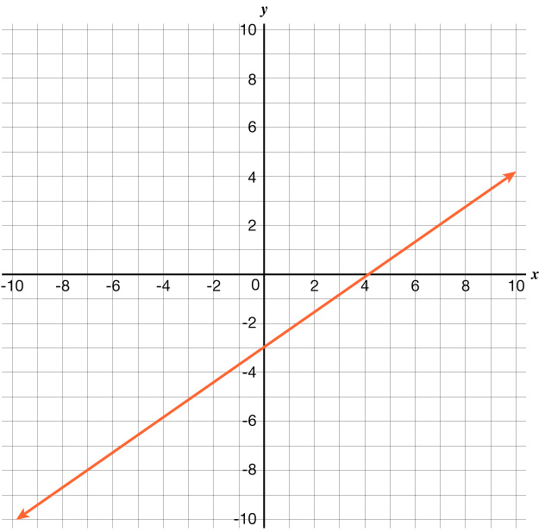
Which equation is best represented by this graph?
  - $y + 2 = \frac{5}{7}(x + 7)$
  - $y - 2 = \frac{7}{5}(x - 7)$
  - $y - 2 = \frac{5}{7}(x - 7)$ (Answer)
  - $y + 2 = \frac{7}{5}(x + 7)$

