Unit 7 STAAR Review

About OpenStax STAAR Review Quizzes
Each STAAR Review Quiz consists of approximately ten questions. While the first half of the quiz focuses on content from the current unit, the last half of the quiz pulls from content in previous units.
In this manner, the STAAR Review Quiz provides an on-going, spiral review of the content reinforcing the evidence-based strategy of spaced retrieval. The questions on the STAAR Review Quizzes have all been selected from released STAAR End of Course Algebra 1 items from the Texas Education Agency [TEA].
The table below shows a summary of the answers and their TEKS information. For the full quiz questions, go to next section.
Review Q# | Answer Letter | TEKS | Exam/ Question# | Relevant Unit
1 | C | A.7(B) | 2021/ Question#4 | 7
2 | D | A.6(A) | 2021/ Question#12 | 7
3 | B | A.7(A | 2021/ Question#7 | 7
4 | B | A.7(C) | 2021/ Question#52 | 7
5 | C | A.6(C) | 2021/ Question#16 | 7
6 | B | A.11(B) | 2021/ Question#26 | 6
7 | D | A.10(E) | 2021/ Question#32 | 6
8 | B | A.3(B)  A.9(C) | 2019/ Question#9 | 5
9 | D | A.12(A) | 2019/ Question#44 | 4
10 | C | A.6(A) | 2019/ Question#25 | 2

Quiz Answers
- Given $g(x) = x^{2}- 6x - 16$, which statement is true?
  - The zeros are $x = -8$ and $x = 2$ because the factors of $g$ are $(x + 8)$and $(x - 2)$.
  - The zeros are $x = -8$ and $x = -2$ because the factors of $g$ are $(x + 8)$ and $(x$ $+$ $2)$.
  - The zeros are $x = -2$ and $x = 8$ because the factors of $g$ are $(x$ $+$ $2)$ and $(x - 8)$. (Answer)
  - The zeros are $x = 2$ and $x = 8$ because the factors of $g$ are $(x - 2)$ and $(x - 8)$.

- A ball is placed in a machine that throws the ball up in the air. The table represents some points on the graph of a function that models the ball’s distance from the ground with respect to the time since the ball has been thrown.
Time Since Thrown from Machine (seconds) | 0 | 0.25 | 0.50 | 0.75 | 1.00 | 1.25 | 1.50 | 1.75
Distance from Ground (meters) | 0 | 2.76 | 4.90 | 6.43 | 7.35 | 7.66 | 7.35 | 6.43
What is the range for this situation?
  - All real numbers less than or equal to 1.25
  - All real numbers less than or equal to 7.66
  - All real numbers greater than or equal to 0 and less than or equal to 1.25
  - All real numbers greater than or equal to 0 and less than or equal to 7.66. (Answer)
)
- Two characteristics of quadratic function $p$ are given.
- The axis of symmetry of the graph of $p$ is $x = -3$.
- Function $p$ has exactly one zero.
Based on this information, which graph could represent $p$?

- 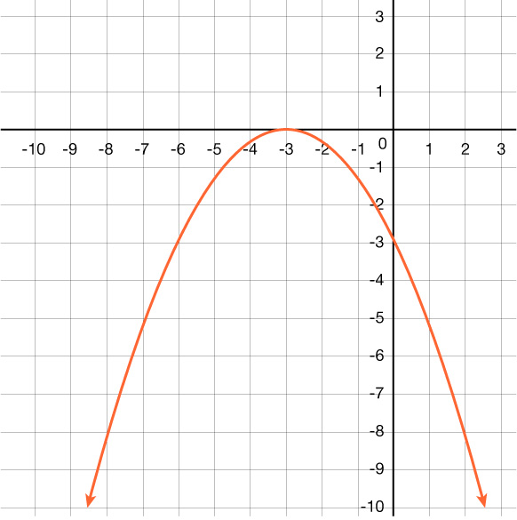

- (Answer)
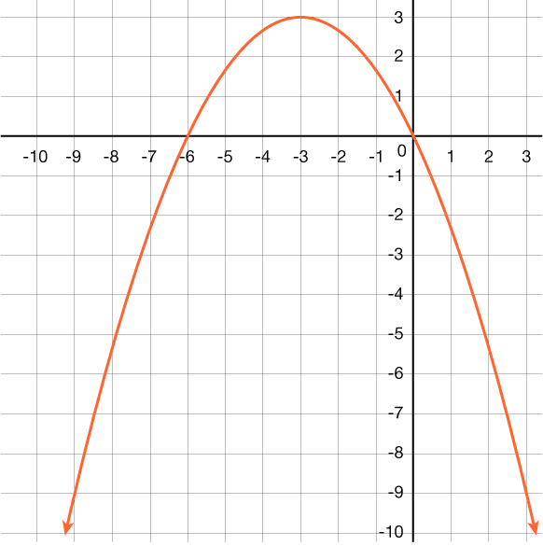
- 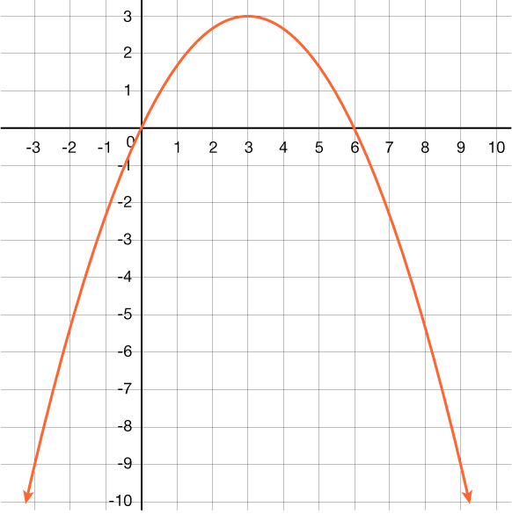

- 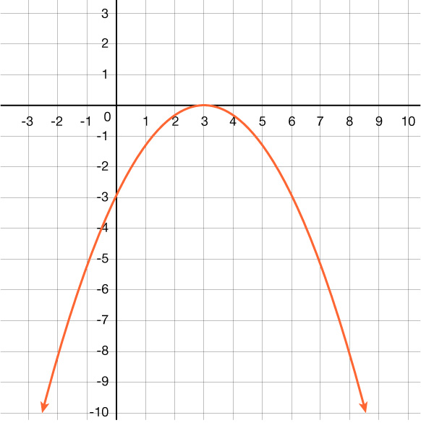

- The graph of $f(x) = x^{2}$ was translated 4.5 units to the left to create the graph of function $g$. Which function represents $g$?
  - $g(x) = {(x-4.5)}^{2}$
  - $g(x) = {(x+4.5)}^{2}$ (Answer)
  - $g(x) = x^{2}- 4.5$
  - $g(x) = x^{2} + 4.5$

- The graph of a quadratic function is shown on the grid.
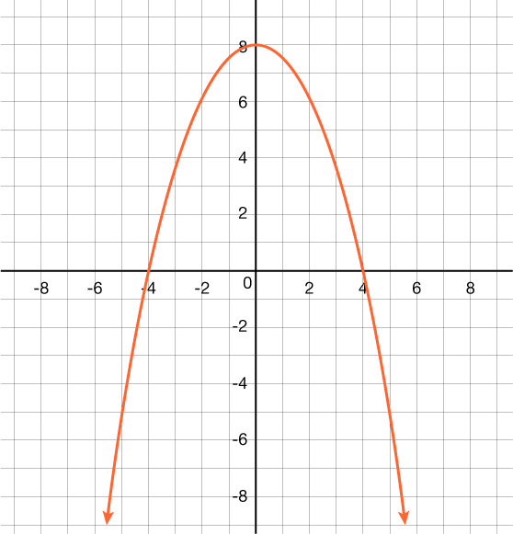
Which function is best represented by this graph?
  - $f(x) = -\frac{1}{2}x^{2} + 16$
  - $f(x) = -x^{2} + 16$
  - $f(x) = -x^{2} + 8$ (Answer)
  - $f(x) = -\frac{1}{2}x^{2} + 8$

- Which expression is equivalent to $\frac{36x^{4}y^{5}}{{(3xy)}^{2}}$ for all values of 𝑥 and 𝑦 where the expression is defined?
  - $12x^{3}y^{4}$
  - $27x^{2}y^{3}$ (Answer)
  - $4x^{2}y^{3}$
  - $6x^{3}y^{4}$

- Which expression is equivalent to $16w^{2} + 24w + 9$?
  - ${(4w + 3)}^{2}$
  - ${(4w -3)}^{2}$
  - ${(8w + 3)}^{2}$
  - ${(4w - 3)}^{2}$ (Answer)

- An exponential function is graphed on the grid.
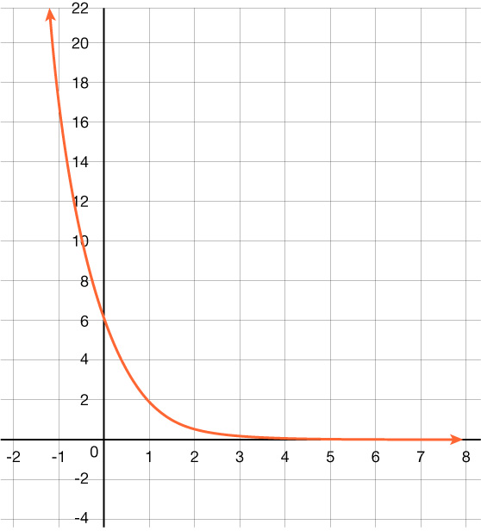
Which function is best represented by the graph?
  - $g(x) = 6{(\frac{1}{3})}^{x}$
  - $g(x) = 6{(3)}^{x}$ (Answer)
  - $g(x) = 6{ - (\frac{1}{3})}^{x}$
  - $g(x) = 6 - {(3)}^{x}$

- Which table shows $y$ as a function of $x$?

$$x$$ | – 13 | – 13 | – 13 | – 13
$$y$$ | – 2 | 0 | 5 | 7

$$x$$ | – 6 | – 1 | – 1 | 10
$$y$$ | 3 | – 1 | 5 | – 9

$$x$$ | 1 | 3 | 7 | 12
$$y$$ | 4 | 4 | 4 | 4

- (Answer)
$$x$$ | – 9 | – 2 | 0 | 0
$$y$$ | – 7 | – 5 | 0 | 6
- A college student completed some courses worth 3 credits and some courses worth 4 credits. The student earned a total of 59 credits after completing 18 courses.
How many courses worth 3 credits did the student complete?
  - 5
  - 13
  - 20 (Answer)
  - 39

