Unit 8 STAAR Review

About OpenStax STAAR Review Quizzes
Each STAAR Review Quiz consists of approximately ten questions. While the first half of the quiz focuses on content from the current unit, the last half of the quiz pulls from content in previous units.
In this manner, the STAAR Review Quiz provides an on-going, spiral review of the content reinforcing the evidence-based strategy of spaced retrieval. The questions on the STAAR Review Quizzes have all been selected from released STAAR End of Course Algebra 1 items from the Texas Education Agency [TEA].
The table below shows a summary of the answers and their TEKS information. For the full quiz questions, go to next section.
Review Q# | Answer Letter | TEKS | Exam/ Question# | Relevant Unit
1 | C | A.8(A) | 2021/ Question#23 | 8
2 | D | A.8(A) | 2021/ Question#37 | 8
3 | B | A.8(B) | 2021/ Question#47 | 8
4 | B | A.8(B) | 2019/ Question#19 | 8
5 | C | A.6(C) | 2019/ Question#28 | 8
6 | B | A.6(A) | 2021/ Question#43 | 7
7 | D | A.10(E) | 2021/ Question#45 | 7
8 | B | A.9(C) | 2019/ Question#31 | 5
9 | D | A.3(B) | 2021/ Question#25 | 4
10 | C | A.2(I) | 2019/ Question#51 | 2

Quiz Answers
- Which value of $x$ is a solution to the equation $3x^{2} - 30x - 72 = 0$?
  - $x = - 12$
  - $x = - 4$
  - $x = - 2$ (Answer)
  - $x = - 6$

- What is the solution set for $2x^{2} + 15 = -11x$?
  - $\{-5, -1.5\}$
  - $\{2.5, 3\}$
  - $\{1.5, 5\}$
  - $\{-3, -2.5\}$ (Answer)

- The scatterplot and table show the weekly profit in dollars earned from the sale of pastries at seven different prices. The data can be modeled by a quadratic function.
$$x$$ | $$y$$
2.25 | 145
2.50 | 154
2.75 | 168
3.00 | 172
3.25 | 160
3.50 | 137
3.75 | 126
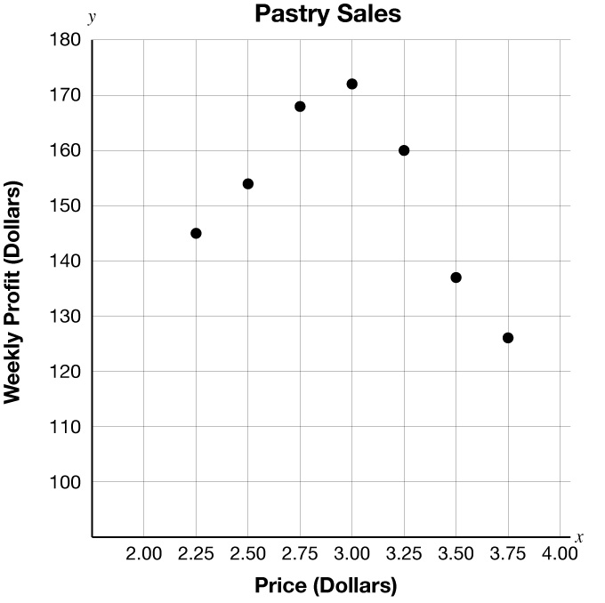
Which function best models the data?
  - $y = 0.001x^{2} - 0.426x + 35.672$
  - $y = -60.4x^{2} + 348.1x - 334.2$ (Answer)
  - $y = 0.001x^{2} + 35.672$
  - $y = -60.4x^{2} - 334.2$

- A company collected data for the number of text messages sent and received using a text-message application since October 2011. The table shows the number of text messages sent and received in billions over time. The data can be modeled by a quadratic function.
Number of Months since October, 2011  $$t$$ | Number of Text Messages  $$n(t)$$  in billions
5 | 3
10 | 10
15 | 17
20 | 27
25 | 44
30 | 64
35 | 84
40 | 112
Which function best models the data?
  - $n(t) = -0.002t^{2} + 0.55t + 5.02$
  - $n(t) = 0.072t^{2}- 0.15t + 2.73$ (Answer)
  - $n(t) = -0.002t^{2} + 5.02$
  - $n(t) = 0.072t^{2} + 2.73$

- The graph of a quadratic function is shown on the grid.
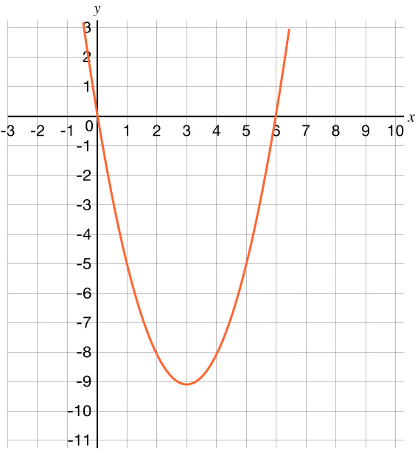
Which function is best represented by this graph?
  - $h(x) = x^{2} - 3x - 9$
  - $h(x) = x^{2}+ 3x - 9$
  - $h(x) = x^{2} - 6x$ (Answer)
  - $h(x) = x^{2} + 6x$

- A quadratic function is graphed on the grid.
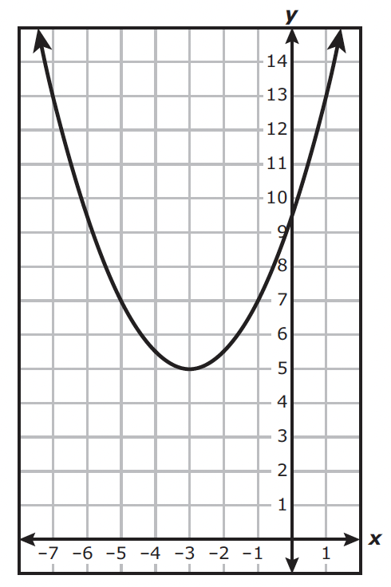
Which answer choice best represents the domain and range of the function?
  - Domain: $x ≥ -3$
Range: $y ≥ 5$
  - Domain: All real numbers
Range: $y ≥ 5$
  - Domain: $x ≥ -3$
Range: All real numbers
  - Domain: $y ≥ 5$ (Answer)
Range: $x ≥ -3$

- Which expression is equivalent to $x^{2} + 10x + 24$?
  - $(x$ $+ 1)(x + 24)$
  - $(x$ $+ 2)(x + 12)$
  - $(x + 3)(x + 8)$
  - (𝑥 + 4)(𝑥 + 6) (Answer)

- The table represents some points on the graph of an exponential function.
$$x$$ | $$y$$
– 2 | 12.5
– 1 | 15
0 | 18
1 | 21.6
2 | 25.92
Which function represents the same relationship?
  - $f(x) =15{(\frac{5}{6})}^{x}$
  - 𝑓(𝑥) =18(65)𝑥 (Answer)
  - $f(x) =15{(\frac{6}{5})}^{x}$
  - $f(x) =18{(\frac{5}{6})}^{x}$

- The graph of a linear function is shown on the grid.
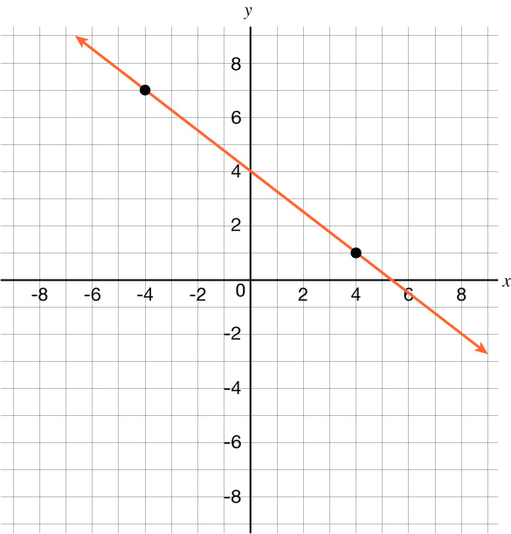
What is the rate of change of $y$ with respect to $x$ for this function?
  - $\frac{7}{9}$

  - $-\frac{7}{9}$

  - $\frac{3}{4}$

  - −34 (Answer)

- A customer at a store paid $64 for three large candles and four small candles. At the same store, a second customer paid $4 more than the first customer for one large candle and eight small candles.
The price of each large candle is the same, and the price of each small candle is the same.
Which system of equations can be used to find the price in dollars of each large candle, 𝑥, and each small candle, 𝑦?
  - $\left\{\begin{aligned}4y = 3x + 64 \\ 8y = x + 68\end{aligned}\right.$
  - $\left\{\begin{aligned}4y = 3x + 64 \\ 8y = x + 60\end{aligned}\right.$
  - $\text{3x + 4y = 64}$𝑥 + 8𝑦 = 68 (Answer)
  - $\left\{\begin{aligned}3x + 4y = 64 \\ x + 8y = 60\end{aligned}\right.$

