Unit 5 Student Diagnostic
These materials, when encountered before the denoted lesson, support access to the lesson and identify potential areas where additional support may be required. Note that the content in these lesson diagnostics represents prerequisite skills and does not address the required rigor for full mastery of the on-grade level standards.
Your students may benefit from using these materials in conjunction with the Unit Overview and Readiness page (quiz and mini-lessons).

Lesson 5.1: Properties of Exponents 2
Lesson 5.2: Rational Exponents 3
Lesson 5.3: Patterns of Growth 4
Lesson 5.4: Representing Exponential Growth 5
Lesson 5.5: Representing Exponential Decay 6
Lesson 5.6: Negative Exponents and Scientific Notation 8
Lesson 5.7: Analyzing Graphs 9
Lesson 5.8: Exponential Situations as Functions 10
Lesson 5.9: Interpreting Exponential Functions 12
Lesson 5.10: Looking at Rates of Change 13
Lesson 5.11: Modeling Exponential Behavior 14
Lesson 5.12: Reasoning about Exponential Graphs, Part 1 15
Lesson 5.13: Reasoning about Exponential Graphs, Part 2 16
Lesson 5.14: Which One Changes Faster? 17
Lesson 5.15: Changes Over Equal Intervals 18

Lesson 5.1: Properties of Exponents
Simplify the following expressions.
- $-2 + -2 + -2 + -2$

- $(-2)(-2)(-2)(-2)$

- $5 + 5$

- $(5)(5)$

- $(½)(½)(½)$

- $\frac{8x}{24y}$

- $\frac{-5}{-5}$

- $\frac{12}{12}$

Lesson 5.2: Rational Exponents
Simplify the following expressions.
- $x^{3} ∙ x^{3}$

- $y^{2} ∙ y^{2} ∙ y^{2}$

- $z^{3} ∙ z^{3} ∙ z^{3} ∙ z^{3}$

Determine if the simplified answer for each of the following is positive or negative. Circle your response.

- ${\left(-9\right)}^{2}$ positive negative

- $-9^{2}$ positive negative
- ${\left(-9\right)}^{3}$ positive negative

- $-9^{3}$ positive negative

Lesson 5.3: Patterns of Growth

Complete the table by filling in the blanks.
Expanded Form | Exponential Form
$$2 ∙ 2 ∙ 2$$ | $$2^{3}$$
$$3 ∙ 3 ∙ 3 ∙ 3$$ | _______
_______ | $$5^{2}$$
$$x∙x∙x∙x∙x∙x∙x$$ | _______
_______ | $$y^{3}$$
_______ | $${(x ∙ y)}^{2}$$

Lesson 5.4: Representing Exponential Growth

- Compare each pair of expressions, then determine if they are equal. Circle the appropriate answer.
Expression 1 | Expression 2 | = | ≠
$$2 ∙ 3$$ | $$2^{3}$$ | - = | - ≠
$$2^{5}$$ | $$5^{2}$$ | - = | - ≠
$${100}^{1}$$ | $$1^{100}$$ | = | ≠
$$3 ∙ \frac{8}{2}$$ | $$\frac{8 ∙ 3}{2}$$ | = | ≠
- For the expressions above that were not equal, identify which quantity was greater by circling it in the table.

Lesson 5.5: Representing Exponential Decay

Evaluate the following expressions in questions 1 - 4.
- $1 - \frac{1}{2}$

- $1 - \frac{1}{10}$

- $1 - \frac{3}{10}$

- $1 - \frac{5}{17}$

For questions 5 - 6, suppose a driver is traveling from one city to another. Use the provided diagrams to answer the questions.
- If the distance between the cities is 60 miles and the driver has driven $\frac{1}{3}$ of the way.
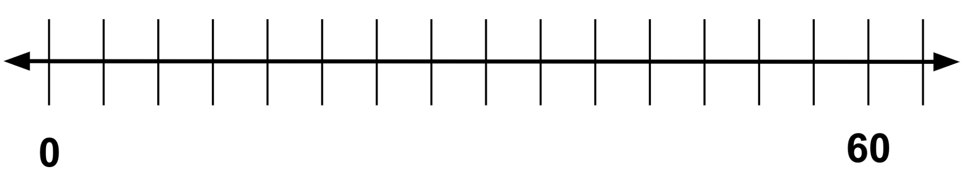
  - How many miles has she driven?

  - How many miles remain?

- If the distance between the cities is 60 miles and the driver has driven $\frac{2}{5}$ of the way.

  - How many miles has she driven?

  - How many miles remain?

Lesson 5.6: Negative Exponents and Scientific Notation

Complete as much of the table as you can by filling in the blanks.
Fraction Form | Exponential Form | Calculations | Number Form
_______ | $$2^{5}$$ | _______ | _______
_______ | _______ | _______ | $$16$$
$$\frac{2^{4}}{2^{}} = 2^{4-1} = 2^{3}$$ | $$2^{3}$$ | _______ | _______
$$\frac{2^{3}}{2^{}} = 2^{3-1} = 2^{2}$$ | $$2^{2}$$ | _______ | $$4$$
_______ | _______ | $$4 ∙ \frac{1}{2} = 2$$ | $$2$$
_______ | _______ | $$2 ∙ \frac{1}{2} = 1$$ | $$1$$
_______ | $$2^{-1}$$ | _______ | $$\frac{1}{2}$$
_______ | _______ | $$\frac{1}{2} ∙ \frac{1}{2} = \frac{1}{4}$$ | $$\frac{1}{4}$$
_______ | $$2^{-3}$$ | _______ | _______
_______ | $$2^{-4}$$ | _______ | _______
_______ | _______ | _______ | $$\frac{1}{32}$$

Lesson 5.7: Analyzing Graphs
For the following multiplication and division equations, write the missing pieces in the blanks. The first problem is completed as an example.
Division Equation | Multiplication Equation
$$6 ÷ 2 = 3$$ | $$2 ∙ 3 = 6$$
$$20 ÷4 = 5$$ | _______
_______ | $$1.5 ∙ 12 = 18$$
$$9 ÷ \frac{1}{4} = 36$$ | _______
$$12 ÷ 15 = _______$$ | _______
$$a ÷ b = c$$ | _______

Lesson 5.8: Exponential Situations as Functions

The table below contains seven scenarios accompanied by different questions in column 1. Use the instructions below to fill in the remaining three columns.
Column 2: For each scenario, determine if the question that is posed can be answered or not. If it can be answered, check the box in the second column. If not, leave the box in that cell unchecked.
Column 3: Then, determine if the relationship in the scenario represents a function. If the relationship is a function, check the box in the third column. If not, leave the box in that cell unchecked.
Column 4: For scenarios that are functions, use the last column to write a statement explaining which variable depends on which. Use the sentence stem, “ ____ is a function of ___.” If the scenario is not a function, leave the box in that cell blank.
Scenario | Yes, we can answer this question. | Yes, this scenario describes a function. | I can restate the scenarios that are functions using the sentence stem:  … is a function of …
It is 50 miles to Tucson.  Can we figure out how many kilometers it is to Tucson? | ¨ | ¨ | … is a function of …
It is 200 kilometers to Saskatoon.  Can we figure out how many miles it is to Saskatoon? | ¨ | ¨ | … is a function of …
A number is -3.  Can we figure out its absolute value? | ¨ | ¨ | … is a function of …
The absolute value of a number is 8.  Can we figure out the number? | ¨ | ¨ | … is a function of …
A circle has a diameter of 8 cm.  Can we figure out its circumference? | ¨ | ¨ | … is a function of …
A square has a side length of 6 units.  Can we figure out its perimeter? | ¨ | ¨ | … is a function of …
A rectangle has a perimeter of 30 meters.  Can we figure out its width? | ¨ | ¨ | … is a function of …

Lesson 5.9: Interpreting Exponential Functions
For questions 1 - 3, examine the following description of a relationship between quantities.
The admission to the state park is $5.00 per vehicle plus $1.50 per passenger. The total admission for one vehicle is a function of the number of passengers, p, defined by the equation a(p) = 5 + 1.50p.
- Make a table of at least 5 pairs of values that represent the relationship by filling in the blanks.
$$p$$ | $$a$$
_______ | _______
_______ | _______
_______ | _______
_______ | _______
_______ | _______
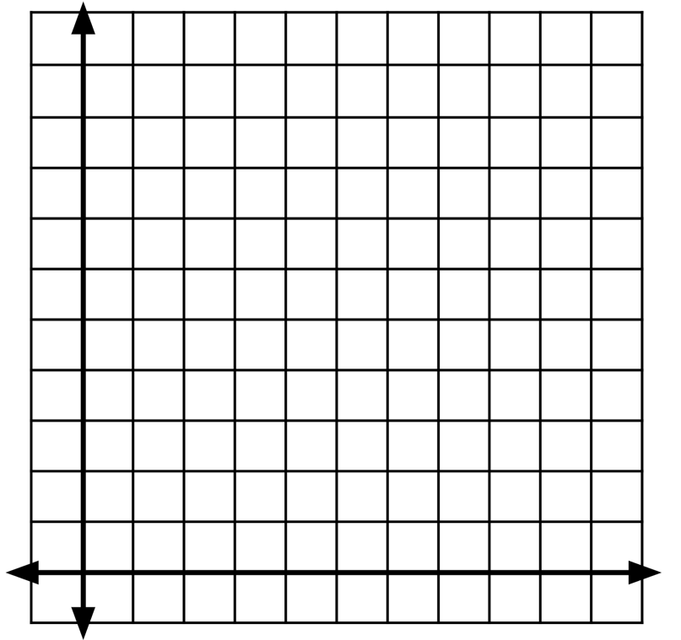
- Plot the points. Be sure to label the axes of the graph.

- Determine: Should the points on the graph be connected? Are there any input or output values that don’t make sense? Explain.

Lesson 5.10: Looking at Rates of Change
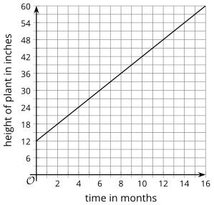
The graph represents function, $h$, which gives the height in inches of a bamboo plant $t$ months after it has been planted.
- What does this statement mean? $h(4) = 24$?
- What is the value of $h(10)$?

- What is $c$ if $h(c) = 30$?

- What is the value of $h(12) - h(2)$?

- How many inches does the plant grow each month? How can you see this on the graph?

Lesson 5.11: Modeling Exponential Behavior

Draw a line that matches each situation to one of the data tables.
Situation A | Situation B | Situation C | Situation D
A person starts with $24,000 in a savings account. Each month, she deposits an additional $2,000 in the account. | A 30-year old puts $24,000 in a retirement account that increases by 10% each year. | The value of a car depreciates by a factor of $\frac{4}{5}$ of the car’s value every year. The car initially cost $24,000. | A farmer has stored 24,000 pounds of grain. His cows eat 4,800 pounds of grain per month.

Data  Set A  $$x$$ | Data  Set A  $$y$$ | Data  Set B  $x$ | Data  Set B  $$y$$ | Data  Set C  $$x$$ | Data  Set C  $$y$$ | Data  Set D  $$x$$ | Data  Set D  $$y$$
0 | 24000 | 0 | 24000 | 0 | 24000 | 0 | 24000
1 | 19200 | 1 | 26000 | 1 | 19200 | 1 | 26400
2 | 15360 | 2 | 28000 | 2 | 14400 | 2 | 29040
3 | 12288 | 3 | 30000 | 3 | 9600 | 3 | 31944

Lesson 5.12: Reasoning about Exponential Graphs, Part 1
Each function represents the amount in a bank account after $t$ weeks. Draw a line from the function to the description in words that matches how the money in the account is changing week by week.
(HINT: If needed, make a table for each bank account showing the money in the account at 0, 1, 2, and 3 weeks.)
Function | Description
$$A(t) = 500$$ | Decreasing by a set amount each week
$$B(t) = 500 + 40t$$ | Decreasing by a common factor each week
$$C(t) = 500 - 40t$$ | Increasing by a set amount each week
$$D(t) = 500 ∙ {(1.5)}^{t}$$ | Not changing
$$E(t) = 500 ∙ {(0.75)}^{t}$$ | Increasing by a common factor each week

Lesson 5.13: Reasoning about Exponential Graphs, Part 2
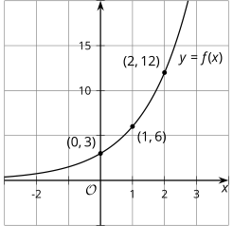
Consider the corresponding table and graph of $f(x) = 3∙ 2^{x}$.

$$x$$ | $$f(x)$$
0 | 3
1 | 6
2 | 12

- Using the first two points, what is the growth factor?

- Using the second two points, what is the growth factor?

- Where do you see this growth factor in the equation?

- Where do you see the growth factor on the graph?

- What is the vertical intercept ($y$-intercept) of the graph?

- How can you tell from the equation that this is the $y$-intercept?

Use graphing technology (such as Desmos) to create a graph of $y = {10}^{x}$.

Lesson 5.14: Which One Changes Faster?
Use graphing technology (such as Desmos) to create a graph of $y = {10}^{x}$.
Using the parameters below, change the graphing windows for the graph and examine how it changes the appearance of the graph. (HINT: If using Desmos, the window settings are accessed through the wrench icon.)
- Window A: $-10 < x < 10$ and $-10 < y < 10$
- Window B: $-1 < x < 1$ and $-10 < y < 10$
- Window C: $-50 < x < 50$ and $-10 < y < 10$
- Window D: $-1 < x < 1$ and $-50 < y < 50$

- Which graphing window makes the graph look the steepest?
- Window A
- Window B
- Window C
- Window D

- Determine a new graphing window that makes the graph look even steeper than the steepest one you identified.
_______ < $x$ < _______
_______ < $y$ < _______

- Which graphing window makes the graph look the flattest?
- Window A
- Window B
- Window C
- Window D
- Determine a new graphing window that makes the graph look even flatter than the flattest one you identified.
_______ < $x$ < _______
_______ < $y$ < _______

Lesson 5.15: Changes Over Equal Intervals
Answer the questions.
- Find the slope of the line that passes through (2, 2) and (3, 6).

- Find the slope of the graph of $f(x) = -2 + \frac{1}{3}x$.

- For the following graphs, show where the slope can be seen. In other words, illustrate how you can find the slope from a graph.
  - 
   