Algebra 1 Implementation Handbook

Introduction to this Handbook 1
Algebra 1 at a Glance 2
Unit Summaries 2
Course Level Resources 4
Unit Level Resources 6
Unit Internalization Protocol Graphic Organizer 7
Lesson Level Resources 9
Lesson Internalization Protocol Graphic Organizer 10

Introduction to this Handbook
The OpenStax Algebra 1 course is meant to be implemented in an environment where teachers have frequent interactions with students and their learning. As such, it is not meant to be an independent learning resource for students. Students should collaborate with each other while using the course content to explore and consolidate thoughts and responses.

The following guides are meant to support teachers with understanding the structure of this course and planning for the diverse needs of their students. While there is no substitute for time spent in using and studying a curriculum, these protocols streamline the process by highlighting key features in the course and focusing on the primary elements needed for instruction.

Algebra 1 at a Glance
The Openstax Algebra 1 curriculum consists of nine units that build on students’ prior knowledge in K-8 mathematics to seamlessly lead students from linear to exponential to quadratic functions.
Each unit has been listed below along with a short summary of their contents and the approximate number of days it takes to complete them, for a total of 165 days.
The number of days is roughly calculated according to the following:
- 1 day for each lesson (45 minutes)
- ½ day for each section quiz throughout the unit (2 - 4 total)
- 1 day each for for the unit quiz, STAAR review, and culminating project
For the full pacing guide, as well as more about the lessons and checkpoints, click here. For more about the contents of each unit, review the Course Overview and Scope and Sequence located here.

Unit Summaries

Unit 1: Linear Equations (~21 days)
Write, solve, and model linear equations using various forms (standard, slope-intercept, point slope) and multiple representations.

Unit 2: Linear Inequalities and Systems (~21 days)
Write and solve systems of linear equations and inequalities of one and two variables through various methods.

Unit 3: Two-Variable Statistics (~11 days)
Assess linear functions and numerical data by computing lines of best fit. Explore correlation and causation.

Unit 4: Functions (~27 days)
Identify relations as functions and then interpret and evaluate them. Graph and identify key features of linear functions. Analyze transformations of the parent function $f(x) = x$.

Unit 5: Introduction to Exponential Functions (~21 days)
Use the laws of exponents to simplify numeric and algebraic expressions. Write, interpret, and graph exponential functions in the form $f(x) = ab^{x}$ for mathematical and real world situations, including growth and decay.

Unit 6: Working with Polynomials (~14 days)
Add, subtract, multiply, divide, and factor polynomials.
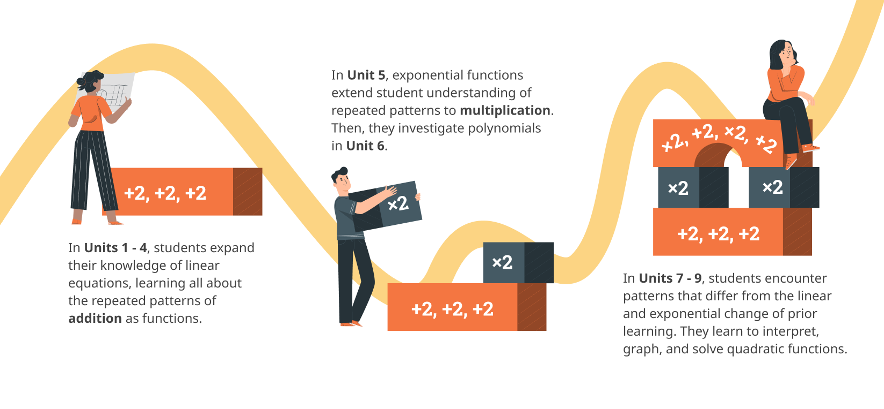Algebra 1 Learning Progression: Students learn patterns of repeated addition with linear functions in Units 1 - 4. In Unit 5, they extend their understanding of repeated patterns to multiplication via exponential functions, which leads them to polynomials in Unit 6. Units 7 - 9 introduce them to quadratic functions, which do not follow the rules of either repeated addition or multiplication.

Unit 7: Introduction to Quadratic Functions (~23 days)
Identify, interpret, and graph quadratic functions in standard, factored, and vertex form.

Unit 8: Quadratic Equations (~18 days)
Solve quadratic equations by using square roots or the zero product property.

Unit 9: More Quadratic Equations (~17 days)
Solve quadratic equations by completing the square and using the quadratic formula.

Course Level Resources
Special topics applicable to the whole course have been placed in sections at the front of the teacher guide. The following list highlights content crucial during initial implementation, ordered by where they are in the navigation and.

Getting Started ➤ Teachers Start Here
- Quick Start - explains how to navigate the course 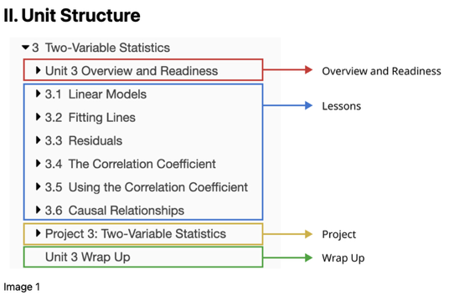
- Additional Resources
  - Scope & Sequence - lists units, learning goals, TEKS, and time allotment
  - End of Course Exam Prep - lists topics and activities to review for STAAR EOC
  - Student Resources - includes Spanish-English glossary and STAAR reference material

Supporting All Learners
- Supporting English Language Learners
  - Navigating Resources - explains how to use embedded differentiation suggestions
  - Mathematical Language Routines - describes each routine and includes “how to” guides, student documents, and videos
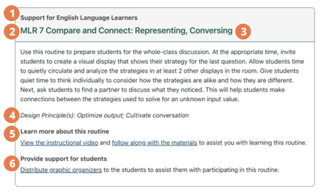
- Supporting Students with Disabilities
  - Navigating Resources - explains how to use embedded differentiation suggestions
  - Strategies to Support Mathematical Processes - explains the connections between UDL and Texas’ Inclusion Strategies
- Preparing for Success
  - Study Tips - includes suggestions for how to study, take a test, etc.
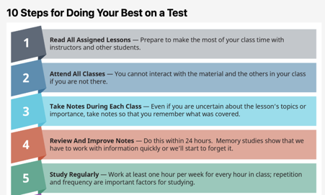
  - Creating Your Best Self - gives time management tools and mental health strategies
  - Building Relationships - includes information on how to work in cooperative groups

Appendix
- Course Design
  - Unit Sequence and Resources - explains the organizations of the units and the type of information provided on each Unit Teacher Guide.
- Implementing This Course
  - Pacing Guides - includes 3 options where the method for calculating the number of days for each unit has been provided

Special Highlights
- Using Desmos - Explains keystrokes for entering Desmos commands and provides links to more extensive resources
[located in ➤ Getting Started ➤ Teachers Start Here]
- Assessment Blueprints - Provide a blueprint indicating the number of items and the TEKS alignment for all assessments
[located in ➤ Appendix ➤ Course Design ➤ Assessment Types …]

Unit Level Resources
⏲ Suggested time to complete: 45 minutes

Purpose of the Unit Internalization Protocol
To assist teachers with understanding the structure of the unit, identify what students are expected to learn and how they will demonstrate it, in addition to determining the needed support for students who are under prepared or might struggle to achieve the learning targets.

Brief Synopsis of Protocol
- What is this unit about?
- What should students know and be able to do?
- How will students demonstrate what they know and are able to do?
- How will students demonstrate what they know and are able to do?
- What other supports might help my students?

Special Highlights
- Overview Videos - Contain information about learning goals, crucial activities, pacing suggestions, and potential instructional strategies
[located in ➤ Unit Teacher Guide ➤ Overview and Readiness]

- Vertical Alignment Supports - Provide a video explanation of on-level expectations as well as prior learning, links to TEA’s vertical alignment chart, and a list of sections from the OpenStax PreAlgebra book to address prerequisite skills
[located in ➤ Unit Teacher Guide ➤ Overview and Readiness]

- Family Support Materials - Include a brief summary of the unit, practice questions with answers, and a list of videos aligned to lessons in the unit (available in Spanish and English)
[located in ➤ Unit Teacher Guide ➤ Family Support Materials]

Unit Internalization Protocol Graphic Organizer
Use this tool to denote your ideas and thinking as you analyze Unit:
1 What is this unit about?
- Read the Unit Narrative and watch the Overview videos.  - List the Learning Targets.  - Graph the learning progression for this unit. | Notes
2 What should students know and be able to do?
- Unpack the standards (TEKS & ELPS).  - Identify “I can” statements for each part of the learning progression. | Notes
3 How will students demonstrate what they know and are able to do?
- Complete all of the quizzes in the unit as if you are a student (create an exemplar).  - Read the Unit Project narrative and review the teacher guide.  - Locate where each “I can” statement on the lesson progression is assessed (identify the quiz).  - Identify potentially challenging areas or questions. | Notes

4 What support will my students need in order to meet the learning targets?
- Watch the Vertical Alignment video.  - Compare your list of potential areas of challenge with prerequisite skills students should have.  - Review the provided OpenStax Pre-algebra content.  - Plan questions and strategies to scaffold student learning and identify/schedule when these interactions might take place. | Notes
5 What other support might help my students?
- Read the Family Support Materials for the unit, then prepare how to share the information with parents and guardians.  - Read the Building Character resources, then identify where you might place these supports along the students’ learning progression. | Notes

Lesson Level Resources
⏲ Suggested time to complete: 45 minutes

Purpose of the Lesson Internalization Protocol
To review the lesson material and specify teacher moves in a way that personalizes the instruction for both the students and teacher. Annotations, notes, and data are some of the resources teachers may incorporate as they adopt the lesson to be their own.

Brief Synopsis of the Protocol
What are the learning outcomes?
- Read the narrative on the Lesson Overview for the specific Lesson Teacher Guide.
- Complete the Practice problems at the end of the lesson.
- Review the TEKS, ELPS, and learning targets of the lesson.
- Examine the academic vocabulary terms students should use during the lesson.

Which instructional strategies optimize the learning?
- Read the Lesson Teacher Guide page for each primary learning activity.
- Complete the Warm Up and Cool Down activities for the lesson.

Special Highlights
- Quizlet Vocabulary sets - Provide links to two sets of digital flashcards that can be shared with students for vocabulary development (in Spanish and English)
[located in ➤ Lesson Overview ➤ Lesson Vocabulary]
- Projects - Include a teacher guide with differentiation supports and a link to a student activity page that can be printed. Units 4 and 6 also include a special inquiry project to start each unit of study.
[located in ➤ Unit Project]

Lesson Internalization Protocol Graphic Organizer
Use this tool as you review or annotate Lesson:
0 Optional step/Prework
Notes | Watch the Section Overview video and read the Section Overview narrative to determine how this set of lessons are positioned within the unit and how they contribute to the learning goals of the unit.
1 Understanding the Learning Outcomes
Notes | Step 1 - Read the lesson narrative on the Lesson Overview for the specific Lesson Teacher Guide.  - Read the Lesson Narrative.  - Identify where the lesson fits within the unit’s learning progression.  Step 2 - Complete the Practice problems at the end of the lesson.  - Create a student exemplar by working out the questions in the Practice.  Step 3 - Review the TEKS, ELPS, and learning targets of the lesson.  - Unpack the TEKS and ELPS for this lesson.  - List the Learning Goals for the lesson in a display for students (slide deck, class agenda board, etc.).  Step 4 - Examine the academic vocabulary terms for the lesson.  - Review the Academic Vocabulary terms students should read, speak, and hear.  - Prepare word wall, create anchor charts, share links to vocabulary sets, etc.
2 Optimizing the Learning
Notes | Step 5 - Read the Lesson Teacher Guide page for each primary learning activity. [You may wish to print the Teacher Guide page for each.]  - Read the Teacher Guide: Activity, Self Check, and Additional Resources.  - Create an exemplar by working through the questions in each activity part.  - Develop a plan for how to use/implement the activity (select which questions to emphasize, which activity synthesis questions to use, etc.).  Step 6 - Complete the Warm Up and Cool Down activities for the lesson.  - Create exemplar student answers for the warm up and cool down.  - Reflect on how the warm up activity provides entry into the mathematics of the lesson. Discern if additional scaffolds are needed for access.  - Determine if or how to use the cool down as a measure of understanding of the learning goals (exit ticket, discussion, etc.).
3 Setting the Procedures for Learning
Notes | Step 7 - Plan how to use the Activities and needed mini-lessons.  - Make annotations on a printed Teacher Guide for how the activities will be used. If not printed, take notes or develop a plan for instruction.  - Select which differentiation supports for emerging bilingual students, students with disabilities, and gifted students to use or identify alternatives.  - Prepare for how to gather data from the Self Checks, Cool Down, etc.  - Determine how to respond to collected data (small groups, tutoring, etc.).  Step 8 - Determine time allotments for each portion of the lesson.  - Finalize time allotments for each activity in the lesson.  - Assign student groups and arrange the room as needed.

