Unit 1 STAAR Review

About OpenStax STAAR Review Quizzes
Each STAAR Review Quiz consists of approximately ten questions. While the first half of the quiz focuses on content from the current unit, the last half of the quiz pulls from content in previous units. Because there are no units prior to Unit 1, this quiz only has five questions.
In this manner, the STAAR Review Quiz provides an on-going, spiral review of the content reinforcing the evidence-based strategy of spaced retrieval. The questions on the STAAR Review Quizzes have all been selected from released STAAR End of Course Algebra 1 items from the Texas Education Agency [TEA].
The table below shows a summary of the answers and their TEKS information. For the full quiz questions, go to next section.
Review Q# | Answer Letter | TEKS | Exam/ Question# | Relevant Unit
1 | B | A.2(B) | 2021/ Question#6 | 1
2 | C | A.5(A) | 2021/ Question#10 | 1
3 | D | A.3(A) | 2021/ Question#17 | 1
4 | D | A.2(D) | 2021/ Question#42 | 1
5 | B | A.3(C) | 2021/ Question#51 | 1

Quiz Answers
- What is the equation in slope-intercept form of the line that passes through the points $(-26, -11)$and $(39, 34)$?
  - $y = \frac{9}{13}x - 7$
  - $y = \frac{9}{13}x + 7$ (Answer)
  - $y = -\frac{9}{13}x - 7$
  - $y =- \frac{9}{13}x + 7$
- What is the solution to $4(y - 3) + 19 = 8(2y + 3) + 7$?
  - $2$
  - $-\frac{1}{2}$
  - $-2$ (Answer)
  - $\frac{1}{2}$
- The table of values shows a linear relationship between $x$ and $y$.
$$x$$ | $$y$$
-7 | 9
-2 | 1
3 | -7
8 | -15
What is the slope of the line represented by the table of values?
  - $\frac{5}{8}$
  - $\frac{8}{5}$
  - $-\frac{5}{8}$
  - $-\frac{8}{5}$ (Answer)
- The value of 𝑦 is directly proportional to the value of $x$. When $x = 3.5$, the value of $y$ is 14. What is the value of $y$ when $x = 28$?
  - 14
  - 32
  - 128
  - 112 (Answer)
- The graph models the linear relationship between the number of monthly payments made on a loan and the remaining balance in dollars left to pay on the loan.
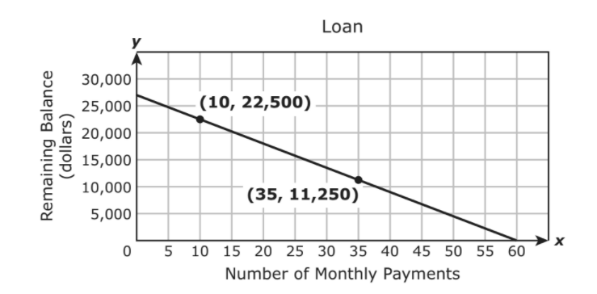
Which statement describes the $x$-intercept of the graph?
  - The $x$-intercept is 60, which represents the initial balance in dollars of the loan.
  - The $x$-intercept is 60, which represents the number of monthly payments needed to repay the loan. (Answer)
  - The $x$-intercept is 27,000, which represents the initial balance in dollars of the loan.
  - The $x$-intercept is 27,000, which represents the number of monthly payments needed to repay the loan.

