Unit 3 Student Diagnostic Answer Key
These materials, when encountered before the denoted lesson, support access to the lesson and identify potential areas where additional support may be required. Note that the content in these lesson diagnostics represents prerequisite skills and does not address the required rigor for full mastery of the on-grade level standards.
Your students may benefit from using these materials in conjunction with the Unit Overview and Readiness page (quiz and mini-lessons).

Lesson 3.1: Linear Models 2
Lesson 3.2: Fitting Lines 4
Lesson 3.3: Residuals 4
Lesson 3.4: The Correlation Coefficient 6
Lesson 3.5: Using the Correlation Coefficient 7
Lesson 3.6: Causal Relationships 9

Lesson 3.1: Linear Models
Q# | Standard
1-7 | MATH.8.11(A) Construct a scatter plot and describe the observed data to address questions of association such as linear, non-linear, and no association between bivariate data.
For questions 1 - 7, use the tables and scatter plot representing the number of students’ absences and their final exam scores.
Student | No. of Absences | Final Exam Score
A | 1 | 94
B | 5 | 71
C | 1 | 98
D | 5 | 70
E | 3 | 67
F | 2 | 94
G | 6 | 71
H | 4 | 89
I | 5 | 77
J | 0 | 90
K | 2 | 91
L | 11 | 60
M | 7 | 68
N | 8 | 65
O | 20 | 42
P | 10 | 63
Q | 11 | 63
R | 20 | 50
S | 15 | 67
T | 16 | 40
U | 4 | 86
V | 8 | 82

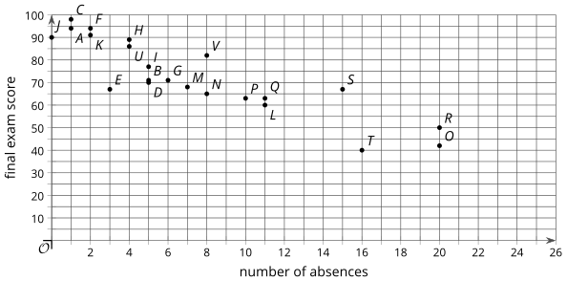
- What are the coordinates of the point in the scatter plot that represents student G?
Answer: (6, 71)
- What are the coordinates of the point in the scatter plot that represents student R?
Answer: (20, 50)
- What is the final exam score of the student who has perfect attendance?
Answer: 90
- What are the final exam scores of the students with the most absences?
Answer: 42 and 50
- How many absences does the student with the highest score have?
Answer: 1 absence
- How many absences does the student with the lowest score have?
Answer: 16
- If student W has 12 absences, what final exam scores do you estimate the student will have?
Answer: Answers will vary, but here is a sample.
60 or anything between 50 and 70.

Lesson 3.2: Fitting Lines
Q# | Standard
1-2 | MATH.7.4(A) Represent constant rates of change in mathematical and real-world problems given pictorial, verbal, numeric, graphical, and algebraic representations, including $d = rt$.

Each situation can be modeled using a linear equation. Describe the rate of change for each situation.
- Andre started his no-interest savings account with $1,000. He makes the same deposit each week, and there is $1,600 in the account after 6 weeks.
Answer: Andre deposited $100 each week.

- Kiran starts with $748 in his checking account. After 4 weeks of spending the same amount each week, he has $716 left.
Answer: Kiran spent $8 each week.

Lesson 3.3: Residuals
Q# | Standard
1 | MATH.7.7(A) Represent linear relationships using verbal descriptions, tables, graphs, and equations that simplify to the form $y = mx + b$.
Priya’s family keeps track of the number of miles on each trip they take over the summer and the amount spent on gas for the trip. The model, represented by $y = 50 + 0.15x$, is graphed with a scatter plot.
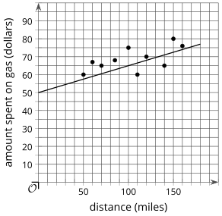
Use the equation to complete the table.
Answer:
Distance (miles) | Actual Amount Spent on Gas (dollars) | Estimated Amount Spent on Gas (dollars)
50 | 60 | Answer: 57.50
70 | 65 | Answer: 60.50
100 | 75 | Answer: 65
60 | 67 | Answer: 59
110 | 60 | Answer: 66.50
140 | 65 | Answer: 71
80 | 68 | Answer: 62.75
150 | 80 | Answer: 72.50
160 | 76 | Answer: 74

Lesson 3.4: The Correlation Coefficient
Q# | Standard
1-4 | MATH.6.2(D) Order a set of rational numbers arising from mathematical and real-world contexts.
Order the numbers from least to greatest.
- 20.2, 18.2, 19.2
Answer: 18.2, 19.2, 20.2
- -14.6, -16.7, -15.1
Answer: -16.7, -15.1, -14.6
- -0.43, -0.87, -0.66
Answer: -0.87, -0.66, -0.43
- 0.50, -0.52, 0.05
Answer: -0.52, 0.05, 0.50

Lesson 3.5: Using the Correlation Coefficient
Q# | Standard
1-4 | MATH.6.6(A) Identify independent and dependent quantities from tables and graphs.  MATH.6.6(B) Write an equation that represents the relationship between independent and dependent quantities from a table.
For each pair of variables, do you expect there to be a relationship? That is, do you think a change in one variable is accompanied by a change in the other variable? How do you expect the second variable to change if the first variable is increased?
- Hours of sleep and energy level
Relationship (select one) | - Likely [Answer] | - Not Likely
When the first variable increases … | The second variable …  Answer: When the hours of sleep increases, energy level should also increase (up to a point).
- Length of hair and energy level
Relationship (select one) | - Likely | - Not Likely [Answer]
When the first variable increases … | The second variable …  Answer: When length of hair increases, I cannot guess how that will affect energy level.
- Number of school events each week and time spent watching videos online each week
Relationship (select one) | - Likely [Answer] | - Not Likely
When the first variable increases … | The second variable …  Answer: When the number of events at school increases, there is likely less time to watch videos online.
- Temperature and watermelon sales
Relationship (select one) | - Likely [Answer] | - Not Likely
When the first variable increases … | The second variable …  Answer: When the temperature increases, watermelon sales likely also increase.

Lesson 3.6: Causal Relationships
Q# | Standard
1-2 | MATH.6.6(A) Identify independent and dependent quantities from tables and graphs.
For questions 1-2, use the following scenario.
Maisy is training for the upcoming track season by running 8 laps around the school track each morning before school. She records her time to complete the 8 laps and notices that she is finishing faster and faster as time goes on. She also notices that she feels better in the morning and her grades in her first class are improving as her times improve.
- In addition to the 2 listed, what other variables are changing in this situation?
- time to complete 8 laps
- number of mornings Mai has run 8 laps
- Answer: Answers will vary, but here is a sample.
Maisy’s grades in her first class
- Answer: Answers will vary, but here is a sample.
Maisy’s average speed during her run

- Select 3 pairs of variables from the list. For each pair determine if they are related, then decide whether you think one variable causes the other to change. Explain your reasoning.
- Answer: Answers will vary, but here is a sample.
time to complete 8 laps and Maisy’s grades in her first class.
The variables are related. As Maisy’s time to complete 8 laps decreases, her grades in her first class are increasing. I don’t think the time to complete her run is causing her grades to increase, but maybe they’re both related to her level of fitness as she gets better at running.
- Answer: Answers will vary, but here is a sample.
time to complete 8 laps and Maisy’s average speed during her run.
These two variables are related. As her speed increases on the runs, it should cause her time to complete the laps should decrease.
- Answer: Answers will vary, but here is a sample.
number of mornings Maisy has run 8 laps and Maisy’s grades in her first class.
These two variables are related. As time passes, Maisy has run more often and her grades are improving. The number of mornings she has run probably does not cause her grades to increase, but maybe she is learning more in the class as the school year progresses and her grades are improving because she is getting more used to the class.

