Unit 5 Student Diagnostic Answer Key
These materials, when encountered before the denoted lesson, support access to the lesson and identify potential areas where additional support may be required. Note that the content in these lesson diagnostics represents prerequisite skills and does not address the required rigor for full mastery of the on-grade level standards.
Your students may benefit from using these materials in conjunction with the Unit Overview and Readiness page (quiz and mini-lessons).

Lesson 5.1: Properties of Exponents 1
Lesson 5.2: Rational Exponents Check-in Answers 3
Lesson 5.3: Patterns of Growth Check-in Answers 4
Lesson 5.4: Representing Exponential Growth 5
Lesson 5.5: Representing Exponential Decay 6
Lesson 5.6: Negative Exponents and Scientific Notation 8
Lesson 5.7: Analyzing Graphs 10
Lesson 5.8: Exponential Situations as Functions 11
Lesson 5.9: Interpreting Exponential Functions 13
Lesson 5.10: Looking at Rates of Change 15
Lesson 5.11: Modeling Exponential Behavior 16
Lesson 5.12: Reasoning about Exponential Graphs, Part 1 17
Lesson 5.13: Reasoning about Exponential Graphs, Part 2 18
Lesson 5.14: Which One Changes Faster? 20
Lesson 5.15: Changes Over Equal Intervals 22

Lesson 5.1: Properties of Exponents

Q# | Standard
1-8 | MATH.7.3(A) Add, subtract, multiply, and divide rational numbers fluently.
Simplify the following expressions.
- -2 + -2 + -2 + -2
Answer: -8
- (-2)(-2)(-2)(-2)
Answer: 16
- 5 + 5
Answer: 10
- (5)(5)
Answer: 25
- (½)(½)(½)
Answer: $\frac{1}{8}$
- $\frac{8x}{24y}$
Answer: $\frac{x}{3y}$
- $\frac{-5}{-5}$
Answer: 1
- $\frac{12}{12}$
Answer: 1

Lesson 5.2: Rational Exponents Check-in Answers

Q# | Standard
1-7 | MATH.6.7(A) Generate equivalent numerical expressions using order of operations, including whole number exponents and prime factorization.
Simplify the following expressions.
- $x^{3} ∙ x^{3}$
Answer: $x^{6}$
- $y^{2} ∙ y^{2} ∙ y^{2}$
Answer: $y^{6}$
- $z^{3} ∙ z^{3} ∙ z^{3} ∙ z^{3}$
Answer: $z^{12}$
Determine if the simplified answer for each of the following is positive or negative. Check the box to select your response.
- ${\left(-9\right)}^{2}$ positive [Answer] negative

- $-9^{2}$ positive negative [Answer]
- ${\left(-9\right)}^{3}$ positive negative [Answer]

- $-9^{3}$ positive negative [Answer]

Lesson 5.3: Patterns of Growth Check-in Answers

Q# | Standard
1-6 | MATH.6.7(A) Generate equivalent numerical expressions using order of operations, including whole number exponents and prime factorization.
Complete the table.
Answers:
Expanded Form | Exponential Form
$$2 ∙ 2 ∙ 2$$ | $$2^{3}$$
$$3 ∙ 3 ∙ 3 ∙ 3$$ | Answer: $3^{4}$
Answer: $5∙5$ | $$5^{2}$$
$$x∙x∙x∙x∙x∙x∙x$$ | Answer: $x^{7}$
Answer: $y∙y∙y$ | $$y^{3}$$
Answer: $(x∙y)(x∙y)$ | $${(x ∙ y)}^{2}$$

Lesson 5.4: Representing Exponential Growth

Q# | Standard
1 | MATH.6.7(A) Generate equivalent numerical expressions using order of operations, including whole number exponents and prime factorization.
2 | MATH.6.2(D) Order a set of rational numbers arising from mathematical and real-world contexts.
- Compare each pair of expressions, then determine if they are equal. Check the appropriate box.
Expression 1 | Expression 2 | = | ≠
$$2 ∙ 3$$ | $$2^{3}$$ | = | ≠
$$2^{5}$$ | $$5^{2}$$ | = | ≠
$${100}^{1}$$ | $$1^{100}$$ | = | ≠
$$3 ∙ \frac{8}{2}$$ | $$\frac{8 ∙ 3}{2}$$ | = | ≠
- For the expressions above that were not equal, identify which quantity was greater by circling it in the table.
Answers: (additionally, see above)
$2^{3}$ (which equals 8) is greater than $2 ∙ 3$ (which equals 6).
$5^{2}$ (which equals 25) is less than $2^{5}$ (which equals 32).
${100}^{1}$ (which equals 100) is greater than $1^{100}$ (which equals 1).
$3 ∙ \frac{8}{2}$ equals $\frac{8 ∙ 3}{2}$. These each equal 12.

Lesson 5.5: Representing Exponential Decay

Q# | Standard
1-4 | MATH.7.3(A) Add, subtract, multiply, and divide rational numbers fluently.
5-6 | MATH.6.4(E) Represent ratios and percents with concrete models, fractions, and decimals.
Evaluate the following expressions in questions 1 - 4.
- $1 - \frac{1}{2}$
Answer: $\frac{1}{2}$
- $1 - \frac{1}{10}$
Answer: $\frac{9}{10}$
- $1 - \frac{3}{10}$
Answer: $\frac{7}{10}$
- $1 - \frac{5}{17}$
Answer: $\frac{12}{17}$
For questions 5 - 6, suppose a driver is traveling from one city to another. Use the provided diagrams to answer the questions.
- If the distance between the cities is 60 miles and the driver has driven $\frac{1}{3}$ of the way.
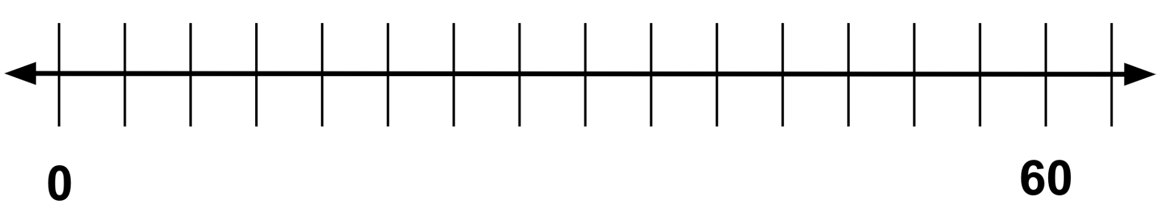
  - How many miles has she driven?
Answer: 20
  - How many miles remain?
Answer: 40

Graph Answer: 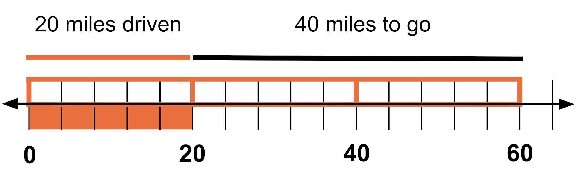

- If the distance between the cities is 60 miles and the driver has driven $\frac{2}{5}$ of the way.
  - How many miles has she driven?
Answer: 24
  - How many miles remain?
Answer: 36

Graph Answer:
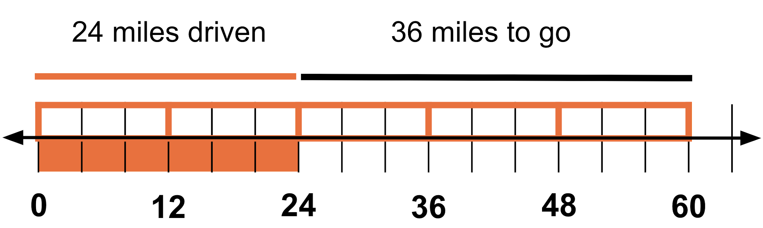

Lesson 5.6: Negative Exponents and Scientific Notation

Q# | Standard
ALL | ALG.11(B) Simplify numeric and algebraic expressions using the laws of exponents, including integral and rational exponents.
Complete as much of the table as you can.
Answers:
Fraction Form | Exponential Form | Calculations | Number Form
$$\frac{2^{6}}{2^{}} = 2^{6-1} = 2^{5}$$ | $$2^{5}$$ | Answer: $64 ∙ \frac{1}{2} =32$ | Answer:  $$32$$
Answer: $\frac{2^{5}}{2^{}} = 2^{5-1} = 2^{4}$ | Answer:  $$2^{4}$$ | Answer: $32 ∙ \frac{1}{2} =16$ | $$16$$
$$\frac{2^{4}}{2^{}} = 2^{4-1} = 2^{3}$$ | $$2^{3}$$ | Answer: $16 ∙ \frac{1}{2} =8$ | Answer:  $$8$$
$$\frac{2^{3}}{2^{}} = 2^{3-1} = 2^{2}$$ | $$2^{2}$$ | $$8 ∙ \frac{1}{2} =4$$ | $$4$$
Answer: $\frac{2^{2}}{2^{}} = 2^{2-1} = 2^{1}$ | Answer:  $2^{1}$ | $$4 ∙ \frac{1}{2} = 2$$ | $$2$$
Answer: $\frac{2^{1}}{2^{}} = 2^{1-1} = 2^{0}$ | Answer:  $$2^{0}$$ | $$2 ∙ \frac{1}{2} = 1$$ | $$1$$
Answer: $\frac{2^{0}}{2^{}} = 2^{0-1} = 2^{-1}$ | $$2^{-1}$$ | Answer:  $\frac{1}{2}$ | $$\frac{1}{2}$$
Answer: $\frac{2^{-1}}{2^{}} = 2^{-1-1} = 2^{-2}$ | Answer:  $2^{-2}$ | $$\frac{1}{2} ∙ \frac{1}{2} = \frac{1}{4}$$ | $$\frac{1}{4}$$
Answer: $\frac{2^{-2}}{2^{}} = 2^{-2-1} = 2^{-3}$ | $$2^{-3}$$ | Answer: $\frac{1}{2} ∙ \frac{1}{2}∙ \frac{1}{2} = \frac{1}{8}$ | Answer:  $\frac{1}{8}$
Answer: $\frac{2^{-3}}{2^{}} = 2^{-3-1} = 2^{-4}$ | $$2^{-4}$$ | Answer: $\frac{1}{2}∙\frac{1}{2}∙\frac{1}{2}∙\frac{1}{2}$  $$= \frac{1}{16}$$ | Answer:  $\frac{1}{16}$
Answer: $\frac{2^{-4}}{2^{}} = 2^{-4-1} = 2^{-5}$ | Answer: $2^{-5}$ | Answer: $\frac{1}{2}∙\frac{1}{2}∙\frac{1}{2}∙\frac{1}{2}∙\frac{1}{2}$  $$= \frac{1}{32}$$ | $$\frac{1}{32}$$

Lesson 5.7: Analyzing Graphs
Q# | Standard
1-6 | MATH.3.4(F) Recall facts to multiply up to 10 by 10 with automaticity and recall the corresponding division facts.
For the following multiplication and division equations, write the missing pieces inside the brackets. The first problem is completed as an example.
Answers:
Division Equation | Multiplication Equation
$$6 ÷ 2 = 3$$ | $$2 ∙ 3 = 6$$
$$20 ÷4 = 5$$ | Answer: $\left[4∙5 = 20\right]$
Answer: $\left[18 ÷ 1.5 = 12\right]$ | $$1.5 ∙ 12 = 18$$
$$9 ÷ \frac{1}{4} = 36$$ | Answer: $\left[\frac{1}{4} ∙ 36 = 9\right]$
Answer: $12 ÷ 15 = \left[\frac{4}{5} or 0.8\right]$ | Answer: $\left[15 ∙\frac{4}{5} = 12\right]$
$$a ÷ b = c$$ | Answer: $\left[b ∙ c = a\right]$

Lesson 5.8: Exponential Situations as Functions
Lesson 5.8: Exponential Situations as Functions Check-in Answers
Q# | Standard
1-7 | ALG.12(A) Decide whether relations represented verbally, tabularly, graphically, and symbolically define a function.
The table below contains seven scenarios accompanied by different questions in column 1. Use the instructions below to fill in the remaining three columns..
Column 2: For each scenario, determine if the question that is posed can be answered or not. If it can be answered, check the box in the second column. If not, leave the box in that cell unchecked.
Column 3: Then, determine if the relationship in the scenario represents a function. If the relationship is a function, check the box in the third column. If not, leave the box in that cell unchecked.
Column 4: For scenarios that are functions, use the last column to write a statement explaining which variable depends on which. Use the sentence stem, “ ____ is a function of ___.” If the scenario is not a function, leave the box in that cell blank.
Answers:
Scenario | Yes, we can answer this question. | Yes, this scenario describes a function. | I can restate the scenarios that are functions using the sentence stem:  … is a function of …
It is 50 miles to Tucson.  Can we figure out how many kilometers it is to Tucson? | Yes | Yes | Answer:  Distance in kilometers is a function of distance in miles
It is 200 kilometers to Saskatoon.  Can we figure out how many miles it is to Saskatoon? | Yes | Yes | Answer: Distance in miles is a function of distance in kilometers
A number is -3.  Can we figure out its absolute value? | Yes | Yes | Answer: Absolute value is a function of the number’s value
The absolute value of a number is 8.  Can we figure out the number? | No | No | Answer: (This cell was deliberately left blank.)
A circle has a diameter of 8 cm.  Can we figure out its circumference? | Yes | Yes | Answer: Circumference is a function of diameter
A square has a side length of 6 units.  Can we figure out its perimeter? | Yes | Yes | Answer: Perimeter of a square is a function of side length
A rectangle has a perimeter of 30 meters.  Can we figure out its width? | No | No | Answer: (This cell was deliberately left blank.)

Lesson 5.9: Interpreting Exponential Functions
Q# | Standard
1-3 | MATH.6.6(C) Represent a given situation using verbal descriptions, tables, graphs, and equations in the form $y = kx$ or $y = x + b$.
For questions 1 - 3, examine the following description of a relationship between quantities.
The admission to the state park is $5.00 per vehicle plus $1.50 per passenger. The total admission for one vehicle is a function of the number of passengers, p, defined by the equation a(p) = 5 + 1.50p.
- Make a table of at least 5 pairs of values that represent the relationship.
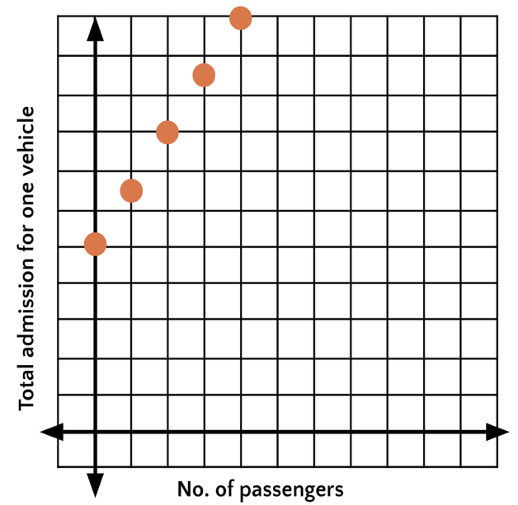
Answers: Answers will vary, but here are some samples.
$$p$$ | $$a$$
0 | 5
1 | 6.50
2 | 8
3 | 9.50
4 | 11
- Plot the points. Be sure to label the axes of the graph.
Answer: Answers will vary, but here are some samples.

- Determine: Should the points on the graph be connected? Are there any input or output values that don’t make sense? Explain.
Answer: Answers will vary, but here are some samples.
Connecting the points does not make sense. You cannot have part of a passenger in the car. Only whole number input values greater than or equal to 1 make sense (since the car has to have at least one passenger: the driver). Only certain values of the output make sense, corresponding to $y$-coordinates of points on the graph.

Lesson 5.10: Looking at Rates of Change
Q# | Standard
1-4 | ALG.12(B) Evaluate functions, expressed in function notation, given one or more elements in their domains.
5 | MATH.8.4(C) Use data from a table or graph to determine the rate of change or slope and $y$-intercept in mathematical and real-world problems.
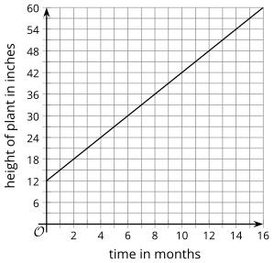
The graph represents function, $h$, which gives the height in inches of a bamboo plant $t$ months after it has been planted.
- What does this statement mean? $h(4) = 24$?
Answer: At 4 months, the height of the plant is 24 inches.
- What is the value of $h(10)$?
Answer: 42
- What is $c$ if $h(c) = 30$?
Answer: 6
- What is the value of $h(12) - h(2)$?
Answer: 30, because 48 - 18 = 30.
- How many inches does the plant grow each month? How can you see this on the graph?
Answer: 3 inches. Reasons will vary, but here are some samples. Every time the time increases by 1 month, the height increases by 3 inches. Choose any two points on the line and use them to calculate the line’s slope

Lesson 5.11: Modeling Exponential Behavior
Q# | Standard
A-D | MATH.7.4(D) Solve problems involving ratios, rates, and percents, including multi-step problems involving percent increase and percent decrease, and financial literacy problems.
Draw a line that matches each situation to one of the tables.
Situation A | Situation B | Situation C | Situation D
A person starts with $24,000 in a savings account. Each month, she deposits an additional $2,000 in the account. | A 30-year old puts $24,000 in a retirement account that increases by 10% each year. | The value of a car depreciates by a factor of $\frac{4}{5}$ of the car’s value every year. The car initially cost $24,000. | A farmer has stored 24,000 pounds of grain. His cows eat 4,800 pounds of grain per month.

Data  Set A  $$x$$ | Data  Set A  $$y$$ | Data  Set B  $x$ | Data  Set B  $$y$$ | Data  Set C  $$x$$ | Data  Set C  $$y$$ | Data  Set D  $$x$$ | Data  Set D  $$y$$
0 | 24000 | 0 | 24000 | 0 | 24000 | 0 | 24000
1 | 19200 | 1 | 26000 | 1 | 19200 | 1 | 26400
2 | 15360 | 2 | 28000 | 2 | 14400 | 2 | 29040
3 | 12288 | 3 | 30000 | 3 | 9600 | 3 | 31944
Answer:
- Situation A: Savings account matches Data Set B;
- Situation B: Retirement account matches Data Set D;
- Situation C: Depreciating car matches Data Set A;
- Situation D: Farmer matches Data Set C.

Lesson 5.12: Reasoning about Exponential Graphs, Part 1

Q# | Standard
A-E | MATH.8.8(C) Model and solve one- variable equations with variables on both sides of the equal sign that represent mathematical and real-world problems using rational number coefficients and constants.  ALG.9(B) Interpret the meaning of the values of $a$ and $b$ in exponential functions of the form $f(x) = ab^{x}$ in real-world problems.
Each function represents the amount in a bank account after $t$ weeks. Draw a line from the function to the description in words that matches how the money in the account is changing week by week.
(HINT: If needed, make a table for each bank account showing the money in the account at 0, 1, 2, and 3 weeks.)
Function | Description
$$A(t) = 500$$ | Decreasing by a set amount each week
$$B(t) = 500 + 40t$$ | Decreasing by a common factor each week
$$C(t) = 500 - 40t$$ | Increasing by a set amount each week
$$D(t) = 500 ∙ {(1.5)}^{t}$$ | Not changing
$$E(t) = 500 ∙ {(0.75)}^{t}$$ | Increasing by a common factor each week
Answer:
- $A$: not changing.
- $B$: Increasing by $40 each week.
- $C$: Decreasing by $40 each week.
- $D$: Increasing by a factor of 1.5 each week.
- $E$: Decreasing by a factor of 0.75 each week.

Lesson 5.13: Reasoning about Exponential Graphs, Part 2

Q# | Standard
1-6 | ALG.9(D) Graph exponential functions that model growth and decay and identify key features, including $y$-intercept and asymptote, in mathematical and real-world problems.
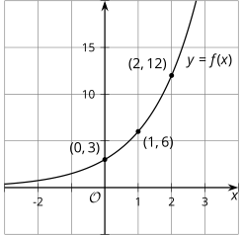
Consider the corresponding table and graph of $f(x) = 3∙ 2^{x}$.

$$x$$ | $$f(x)$$
0 | 3
1 | 6
2 | 12

- Using the first two points, what is the growth factor?
Answer: 2, because $6÷3=2$
- Using the second two points, what is the growth factor?
Answer: 2, because $12÷6=2$
- Where do you see this growth factor in the equation?
Answer: The base of the exponent is 2.
- Where do you see the growth factor on the graph?
Answer: Each $y$-coordinate is double the previous.
- What is the vertical intercept ($y$-intercept) of the graph?
Answer: $(0, 3)$ or 3
- How can you tell from the equation that this is the $y$-intercept?
Answer: The vertical intercept is the output when $x$ is 0:
$$3 ∙ 2^{0} = 3 ∙ 1 = 3$$

Lesson 5.14: Which One Changes Faster?

Q# | Standard
1-4 | ALG.9(E) Write, using technology, exponential functions that provide a reasonable fit to data and make predictions for real-world problems.
Use graphing technology (such as Desmos) to create a graph of $y = {10}^{x}$.
Using the parameters below, change the graphing windows for the graph and examine how it changes the appearance of the graph. (HINT: If using Desmos, the window settings are accessed through the wrench icon.)
- Window A: -10 < $x$ < 10 and -10 < $y$ < 10
- Window B: -1 < $x$ < 1 and -10 < $y$ < 10
- Window C: -50 < $x$ < 50 and -10 < $y$ < 10
- Window D: -1 < $x$ < 1 and -50 < $y$ < 50

- Which graphing window makes the graph look the steepest?
- Window A
- Window B
- Window C [Answer]
- Window D
- Determine a new graphing window that makes the graph look even steeper than the steepest one you identified.
_______ < $x$ < _______
_______ < $y$ < _______
Answer: Answers will vary, but here is a sample.
-100 < $x$ < 100 and -10 < $y$ < 10

- Which graphing window makes the graph look the flattest?
- Window A
- Window B
- Window C
- Window D [Answer]
- Determine a new graphing window that makes the graph look even flatter than the flattest one you identified.

_______ < $x$ < _______

_______ < $y$ < _______
Answer: Answers will vary, but here is a sample.
-1 < $x$ < 1 and -100 < $y$ < 100

Lesson 5.15: Changes Over Equal Intervals

Q# | Standard
1-2 | ALG.3(A) Determine the slope of a line given a table of values, a graph, two points on the line, and an equation written in various forms, including $y = mx + b$, $Ax + By = C$, and $y - y_{1} = m(x - x_{1})$.
3 | MATH.8.4(A) Use similar right triangles to develop an understanding that slope, $m$, given as the rate comparing the change in $y$-values to the change in $x$-values, $\frac{y_{2} - {y_{1}}_{}}{x_{2} - x_{1}}$, is the same for any two points ($x_{1}$, $y_{1}$) and ($x_{2}$,$y_{2}$) on the same line.
Answer the questions.
- Find the slope of the line that passes through (2, 2) and (3, 6).
Answer: 4
- Find the slope of the graph of $f(x) = -2 + \frac{1}{3}x$.
Answer: $\frac{1}{3}$
- For the following graphs, show where the slope can be seen. In other words, illustrate how you can find the slope from a graph.
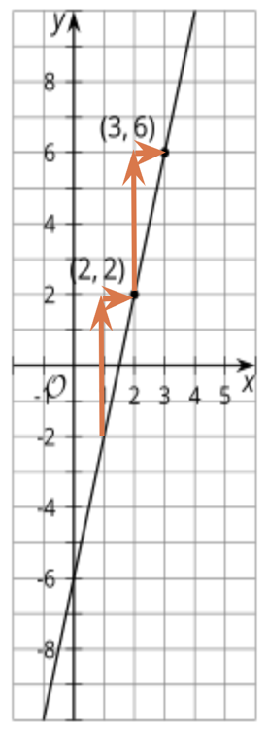
  - 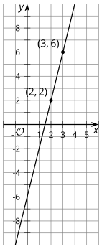 Answer:
  - 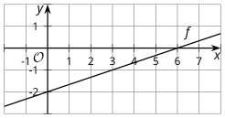
Answer:
